

**ATSB Transport Safety Report**

Rail Occurrence Investigation

RO-2015-021

Final – 4 May 2017

Safe Working irregularity involving Controlled Signal Blocking

Between Allandale and Farley, Hunter Valley, NSW, on 30 October 2015

**Cover photo**: Australian Rail Track Corporation

Released in accordance with section 25 of the *Transport Safety Investigation Act 2003*

**Publishing information**

**Published by:** Australian Transport Safety Bureau

**Postal address:** PO Box 967, Civic Square ACT 2608

**Office:** 62 Northbourne Avenue Canberra, Australian Capital Territory 2601

**Telephone:** 1800 020 616, from overseas +61 2 6257 4150 (24 hours)

Accident and incident notification: 1800 011 034 (24 hours)

**Facsimile:** 02 6247 3117, from overseas +61 2 6247 3117

**Email:** [atsbinfo@atsb.gov.au](mailto:atsbinfo@atsb.gov.au)

**Internet:** [www.atsb.gov.au](http://www.atsb.gov.au/)

© Commonwealth of Australia 2017



**Ownership of intellectual property rights in this publication**  
Unless otherwise noted, copyright (and any other intellectual property rights, if any) in this publication is owned by the Commonwealth of Australia.

**Creative Commons licence**  
With the exception of the Coat of Arms, ATSB logo, and photos and graphics in which a third party holds copyright, this publication is licensed under a Creative Commons Attribution 3.0 Australia licence.

Creative Commons Attribution 3.0 Australia Licence is a standard form license agreement that allows you to copy, distribute, transmit and adapt this publication provided that you attribute the work.

The ATSB’s preference is that you attribute this publication (and any material sourced from it) using the following wording: *Source:* Australian Transport Safety Bureau

Copyright in material obtained from other agencies, private individuals or organisations, belongs to those agencies, individuals or organisations. Where you want to use their material you will need to contact them directly.

**Addendum**

|  |  |  |
| --- | --- | --- |
| Page | Change | Date |
|  |  |  |
|  |  |  |

Safety summary

What happened

On 30 October 2015, following the completion of planned track maintenance work undertaken by the Australian Rail Track Corporation, a safe working irregularity occurred on the rail corridor between Allandale and Farley in the Hunter Valley region of NSW.

While exiting the rail corridor, a road vehicle involved in the maintenance work became bogged in a drain. The vehicle was located outside the danger zone, and therefore there was no requirement to employ a work on track method to retrieve the vehicle. Nevertheless, the protection officer in charge of the worksite made a safety assessment to exclude rail traffic from the portion of track to ensure the presence of workers in the rail corridor did not alarm a driver of an approaching train.

The protection officer contacted the network controller and requested controlled signal blocking. During this conversation and a subsequent conversation, the parties did not confirm their common understanding about the location of the worksite. Consequently, when controlled signal blocking was put into effect, a train had already passed the signal and was travelling toward the worksite.

Workers on the site assumed the track was protected and were preparing to remove the vehicle when they noticed an approaching train.

There were no injuries to people or damage to property.

What the ATSB found

The Australian Transport Safety Bureau found that communication between the protection officer and network controller resulted in the misunderstanding of information that contributed to a safe working irregularity where controlled signal blocking was issued with a train (HV130) located between the protecting signal and the worksite.

The rule and procedure associated with the issuing of controlled signal blocking did not manage the sequential communication of sufficient information to identify the worksite location before controlled signal blocking was acted upon.

There is also no requirement in the rule or procedure applicable to controlled signal blocking to keep a permanent record detailing the specific information relating to its implementation, therefore increasing the likelihood of error during the read-back process.

What's been done as a result

The Australian Rail Track Corporation has undertaken a review of ANWT 308 controlled signal blocking and will be seeking to amend and retitle ANWT 308 controlled signal blocking to ANWT 308 absolute signal blocking. The revised rule will include the requirement for the network control officer and protection officer to keep a permanent record about the Absolute Signal Blocking details. Including when the protection officer requests absolute signal blocking, the network control officer is informed of the location of the worksite and that the protection officer must identify the signals to be set and kept at stop with blocking facilities applied.

Safety message

It is vital that individuals planning work in the rail corridor ensure the communication of sufficient information to validate the worksite location in relation to approaching train movements.

# The occurrence

On 30 October 2015, the Australian Rail Track Corporation (ARTC) scheduled track maintenance work (placement of ballast) to occur between Braxton and Farley on the Up main north line, Hunter Valley in NSW. To facilitate the work, the *network controller*[1] at the ARTC network control centre north (NCCN) situated at Broadmeadow issued the *protection officer*[2] a *work on track authority*.[3] The authority excluded rail traffic from the defined track section between Allandale and Farley, permitting safe access for the work to proceed (Figure 1).

Figure 1: Location of the Allandale to Farley track section.

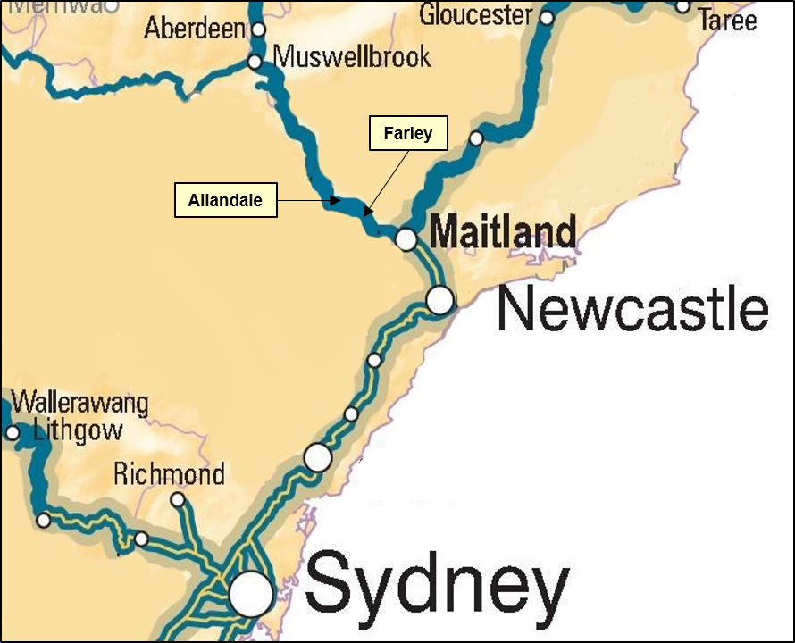

Source: Base map Australasian Railways Association, annotated by the ATSB

At about 0856, the track work was completed and the protection officer contacted the network controller to fulfil the work on track authority and return the track for rail traffic.

While travelling on the access road within the rail corridor, a maintenance vehicle became bogged in a drain. The vehicle was situated approximately five metres from the nearest rail of the *Up Relief line*.

The protection officer contacted the network controller to report the situation and requested permission to work within the rail corridor to retrieve the vehicle. The network controller authorised the work to commence, but only outside of the *danger zone*.[4] After initial attempts to recover the vehicle failed, they decided that a front-end loader was required to free the vehicle.

Although the recovery of the vehicle would not infringe on the danger zone, the protection officer was concerned that approaching train drivers may become alarmed when sighting the front-end loader and workers close to the running line. With this in mind, the protection officer decided to utilise *controlled signal blocking*[5] (CSB) to exclude rail traffic from the Up Relief line adjacent to the proposed worksite.

At about 1022, the protection officer contacted the network controller to obtain a CSB and nominated signal AE88UR as the *controlled signal*.[6] The protection officer also mentioned that a train was currently passing their location. The network controller referred to the Phoenix train display monitor at their workstation to establish train activity in the area, and noted that train HV130 was approaching signal AE88UR.

At that point in time, the protection officer had not yet informed the network controller of their location, which was at the 198.260 km mark about 6.6 km ahead of signal AE88UR (Figure 2). Coincidently, a second train (MB916) was in the section near the proposed worksite and bogged vehicle (Figure 2).

In an attempt to identify the train adjacent the worksite, the network controller asked the protection officer if they had obtained the locomotive number of the train that had just passed them. Unable to provide this, the network controller advised the protection officer to call back in five minutes. The intent was to allow time for the train to move clear of the protection officer’s location.

Figure 2: Extract of Phoenix replay showing indications displayed to the network controller at 1022 on 30 October 2015.

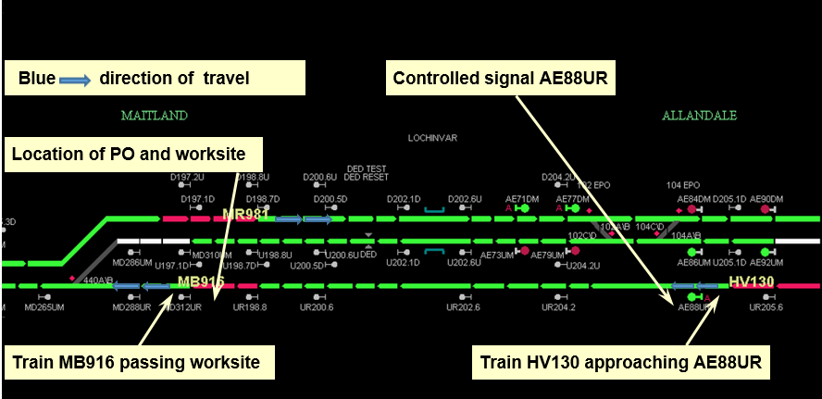  
Figure depicts the location of trains MB916 and HV130 travelling on the UP Relief Line when the protection officer requested controlled signal blocking from the network controller. Train MR981 on the Down Main (upper line shown in the screenshot) had no relevance to this occurrence. Source: Australian Rail Track Corporation

At about 1026, the protection officer again contacted the network controller to request CSB on signal AE88UR. During the discussion, the network controller requested the kilometre location of the proposed worksite. Initially, the protection officer could not provide this information, but after consulting with other workers in the group, confirmed that the worksite was located at the 198.260 km mark.

The network controller also informed the protection officer that a train was in the section (ahead of signal AE88UR) and it had gone past signal UR200.6. The network controller asked if the train was well clear of the worksite, to which the protection officer responded ‘yes’. However, the protection officer was referring to a train (MB916) that had recently cleared the proposed worksite, while the network controller was referring to a train (HV130) that was still approaching the worksite location (Figure 3).

Figure 3: Extract of Phoenix replay showing indications displayed to the network controller at 10:28 am on the 30 October 2015.

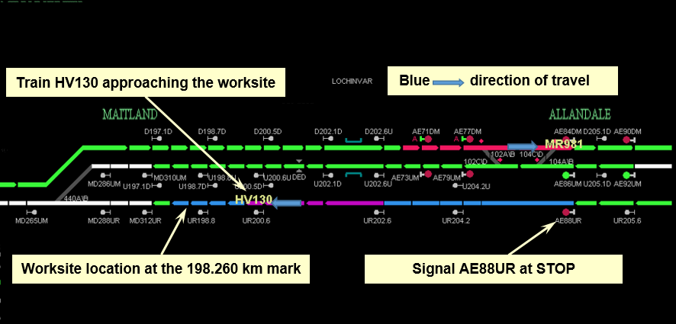  
Figure depicting the location of train HV130 as it approached the worksite at the 198.260 kilometre mark. At this time, the network controller had issued the protection officer with Controlled Signal Blocking. Source: Australian Rail Track Corporation

Prior to finalising the CSB, the network controller requested the protection officer to repeat back the details relating to the CSB. While repeating back information, the protection officer stated that UR200.6 (signal ID) had passed the worksite, instead of the train number. The network controller corrected the protection officer, advising it was ‘Hunter Valley 130’ that had passed signal UR200.6 and the train was now approaching signal UR198.8.

During the subsequent conversation, the network controller mentioned that when the protection officer initially requested the CSB, train HV130 was passing signal AE88UR. The conversation finished with the network controller confirming that signal AE88UR was in the stop position with blocking facilities applied to prevent the signal from clearing. The network controller informed the protection officer that they were ‘…right to proceed there on your CSB at AE88UR…’

At about 1031, approximately 1 minute and 15 seconds after issuing CSB, train HV130 passed unexpectedly through the worksite location. There was no injury to people or damage to property.

# Safety analysis

## Communication

It was evident that a misunderstanding occurred between the protection officer and network controller, relating to the relative location of the worksite and the trains in the vicinity.

Based on the recorded communication exchange and the available visual cues from the train display monitor, the network controller likely formed an understanding that the protection officer was located at or near to signal AE88UR. This was the result of a number of factors:

* The communication began by discussing the requirements for CSB at signal AE88UR.
* The conversation coincided with both a train passing the worksite (MB916) and a train passing signal AE88UR (HV130).
* When asked, the protection officer could not provide the locomotive number of the train that had passed the worksite therefore the train identity was not verified.
* The protection officer, at that time, had not communicated the location of the worksite by providing the km mark or any other location reference.

During the second conversation (5 minutes after the initial request), the network controller had preconceived the protection officer’s location in the field, based on their previous information exchange. However, the protection officer and the network controller missed a number of cues in respect to the movement of train HV130 relative to various signal locations, which may have resolved the misunderstanding and identified that train HV130 was approaching the worksite. This was likely the result of *confirmation bias*[7], which is a phenomenon were humans seek to confirm assumptions rather than disconfirm them. As a result, it is likely that the protection officer and network controller perceived only the information that confirmed their individual assumption and not the contradicting information.

## Phoenix train display system

The network control centre north at Broadmeadow used the Phoenix train display system to provide real time train monitoring through a graphical display. The system also allowed the network controller to interact directly with the rail network in controlling signals, points and other signalling equipment. The Phoenix system displays location names, signal numbers, point numbers, and train numbers. However, it does not display kilometre marks along the track segments of the network.

It was the normal practice for operational staff to communicate their location on the rail network to the network controller by providing a kilometre mark. The ARTC Glossary defined ‘location’ as: ‘*A place in the ARTC network with a designated name, identification number or kilometreage’.*

On the day of the occurrence, during the later stages of the communication exchange, the protection officer provided the network controller with a kilometre mark to indicate the location of the worksite. In the absence of kilometreage detail on the train display monitor, the potential for misunderstanding between the protection officer and network controller increased. While other ancillary systems/documents may have existed to help correspond kilometreage and display references, these were not readily available to the network controller at the time as they were being utilised by another user.

## ARTC Network Rules and Procedures

The ARTC had a documented suite of rules and procedures relevant to protecting personnel undertaking work on the ARTC rail network. If work was to be performed in the danger zone, one of the following five methods for working safely on track were to be applied – Local Possession Authority, Track Occupancy Authority, Track Work Authority, Controlled Signal Blocking or Lookout Working.

On the day of the safe working irregularity, the protection officer identified that the work for recovery of the vehicle would not intrude on the danger zone. Therefore, there was no requirement to employ a work on track method to retrieve the vehicle. Nevertheless, the protection officer decided to exclude rail traffic from the portion of track to ensure the presence of workers in the rail corridor did not alarm a driver of an approaching train. The method of protection chosen for excluding rail traffic from the worksite was suitable in this instance.

### ARTC rules and procedures for Controlled Signal Blocking

ARTC rule ANWT 308 – *Controlled Signal Blocking* and procedure ANPR 703 – *Working Using Controlled Signal Blocking* prescribed the requirements for applying CSB on the ARTC network. In principle, the rule and procedure provided instruction and guidance to operational staff on how to implement the CSB method of protection when working in the danger zone.

Rule ANWT 308 stated that a protection officer may request CSB and that they must seek confirmation that the relevant signals have been set at STOP, blocking facilities applied, and that no rail traffic is approaching the worksite. The rule provided no requirement to communicate the location of the worksite. Procedure ANPR 703 stated that a protection officer must communicate the location of the work, but provided no guidance on a method to clearly define and identify the location.

On this occasion, the protection officer communicated the location of the work as required by the procedure. However, a misunderstanding occurred between the protection officer and the network controller since the method used to identify location (km mark) when requesting CSB did not provide a common reference for both parties.

## Rail industry safety and standards

The Rail Industry Safety and Standards Board (RISSB) was responsible for the development and management of rail industry standards, rules, codes of practice and guidelines, all of which had national application.

One of their objectives was to develop, manage and promote a suite of standards, rules, guidance materials and other documents, including the *ACOP*[8] and *ANRP*[9], to assist the rail industry to manage rail safety, improve efficiency and achieve safety outcomes through standardisation, interoperability and harmonisation. Many rail operators draw down on the RISSB documentation for developing their network specific rules and procedures. Controlled signal blocking is a common method of worksite protection used by the rail industry throughout Australia. The ATSB examined the RISSB ANRP to identify the potential for similar inconsistencies between the rule and procedure.

The RISSB rule and procedure equivalent to the ARTC rule and procedure were ANRP 3011 –*Absolute Signal Blocking* (ASB) and ANRP 3012 – *Using Absolute Signal Blocking*.

Although the objectives for both sets of rules and procedures were similar, a number of requirements in the RISSB documents did not have corresponding requirements in the ARTC documents. The tables below illustrate the variances (highlighted in bold) between the respective sets of rules (Table 1) and procedures (Table 2).

Table 1: Comparison of prescribed actions between the RISSB and ARTC rules

|  |  |
| --- | --- |
| **Rule** | |
| **RISSB, ANRP 3011 – ASB** | **ARTC, ANWT 308 – CSB** |
| Requesting ASB, the protection officer must:   * tell the network controller the location of the worksite * request permission for ASB * identify the signals to be set and kept at STOP with blocking facilities applied * keep a permanent record about the ASB details. | Requesting CSB, the protection officer must:   * **no equivalent criteria** * request permission for CSB * identify the signals to be set and kept at STOP with blocking facilities applied * **no equivalent criteria.** |

Table 2: Comparison of prescribed actions between the RISSB and ARTC procedures

|  |  |
| --- | --- |
| **Procedure** | |
| **RISSB, ANRP 3012 – Using ASB (implementation stage)** | **ARTC, ANPR 703 – Working Using CSB (implementation stage)** |
| Protection Officer   1. Make sure that your safety assessment shows that a work on track authority is not necessary for the work. 2. Tell the network controller:  * your name and contact details * the type of work * the identification of the signals to be used to protect the limits of the ASB * the intended start and finish times * the location of the work, including the track name and at least one of the following identifiers:   + section and kilometre location   + station name   + points identification   + permanent structures such as a bridge, roadway or overpass used only in conjunction with one of the above identifiers.  1. Ask the network controller to exclude rail traffic from the portion of track by:  * setting and keeping controlled absolute signals at stop with blocking facilities applied, or * authorising the placing of points to normal mode to set controlled absolute signals at stop.  1. Before work begins, confirm with the Network Control Officer that:  * controlled absolute signals have been set at STOP and blocking facilities applied, and * the track is clear of rail traffic between the controlled absolute signals being used for protection and the proposed worksite, and * any rail traffic that has passed complete beyond the proposed worksite will not return. * the agreed safety measures are in place. | Protection Officer   1. Make sure that your safety assessment shows that a work on track authority is not necessary for the work. 2. Tell the Signaller:  * your name * **no equivalent criteria** * **no equivalent criteria** * the intended start and finish times * the location of the work   + **no equivalent sub-criteria.**  1. Ask the Signaller to exclude rail traffic from the portion of track by:  * setting and keeping controlled signals at stop with blocking facilities applied to the signal controls, or * authorising the removal of the ESML handle to set signals at stop.  1. Before work begins, confirm with the Signaller that:  * signals have been set at stop and blocking facilities applied * there is no rail traffic in the area between the controlled signals being used for protection and the workers * **no equivalent criteria** * **no equivalent criteria.** |

The rules prescribed the actions required for implementing an ASB/CSB. The procedures described the methodology and sequencing of these actions to ensure the effective implementation of the rules.

While the ARTC rule did not specifically state that the protection officer communicate the worksite location, the ARTC procedure did. However, a key difference between the ARTC and the RISSB procedure was the RISSB’s inclusion of options for additional *identifiers*[10] for describing a location. The provision of such identifiers may provide a location reference common to both parties and assist the network controllers with identifying a worksite location with respect to the protecting signals and any approaching rail traffic.

The combination of identifiers communicated by a protection officer should be consistent with the information readily available to the network controller.

The ARTC rule also varied from the RISSB rule in that the ARTC does not specifically require a permanent record with the implementation of CSB. In the rail industry, it is common to produce permanent records on appropriately formatted documents for the safe working arrangement. The document not only provides a permanent record, but also acts as a checklist to standardise the communication steps required in the process, ensuring that important details are not overlooked.

On the day of the occurrence, the network controller requested that the protection officer repeat back the details relating to the CSB. The absence of a permanent (written) record made it more difficult to verify CSB details through a read-back process, increasing the likelihood of errors as occurred in this case.

# Findings

From the evidence available, the following findings are made with respect to the safe working irregularity that occurred between Allandale and Farley, NSW on 30 October 2015. These findings should not be read as apportioning blame or liability to any particular organisation or individual.

**Safety issues, or system problems, are highlighted in bold to emphasise their importance.** A safety issue is an event or condition that increases safety risk and (a) can reasonably be regarded as having the potential to adversely affect the safety of future operations, and (b) is a characteristic of an organisation or a system, rather than a characteristic of a specific individual, or characteristic of an operating environment at a specific point in time.

**Contributing factors**

* A misunderstanding of information relayed during spoken communications occurred when identifying the location of the proposed worksite with respect to rail traffic.

**Other factors that increased risk**

* The Australian Rail Track Corporation rule and procedure for Controlled Signal Blocking did not ensure the sequential communication of sufficient information to identify the worksite location before the CSB was acted upon. The Controlled Signal Blocking rule and procedure did not specify a location referencing method that was common and verifiable to both the protection officer and the network controller.
* The Australian Rail Track Corporation rule and procedure for the implementation of Controlled Signal Blocking did not specify a requirement to keep a permanent record about the details. The absence of a permanent (written) record made it more difficult to verify details through a read-back process, increasing the likelihood of errors.

# Safety actions

Whether or not the ATSB identifies safety issues in the course of an investigation, relevant organisations may proactively initiate safety action in order to reduce their safety risk. The ATSB has been advised of the following proactive safety action in response to this occurrence

### Safety action taken by the Australian Rail Track Corporation

The Australian Rail Track Corporation has undertaken a review of ANWT 308 Controlled Signal Blocking and will be seeking to amend and retitle ANWT 308 Controlled Signal Blocking to ANWT 308 Absolute Signal Blocking. The revised rule will include the requirement for the network control officer and protection officer to keep a permanent record about the Absolute Signal Blocking details. Including when the protection officer requests Absolute Signal Blocking, the network control officer is informed of the location of the worksite and that the protection officer must identify the signals to be set and kept at stop with blocking facilities applied.

# General details

## Occurrence details

|  |  |  |
| --- | --- | --- |
| Date and time: | 30 October 2015 – 1031 EST | |
| Occurrence category: | Incident | |
| Primary occurrence type: | Safe Working Irregularity | |
| Location: | At the 298.260 km mark – between Allandale and Farley in the Hunter Valley region, NSW | |
|  | Latitude: 32° 43.371’ S | Longitude: 151° 29.701’ E |

## Train details

|  |  |  |
| --- | --- | --- |
| Train operator: | Pacific National | |
| Registration: | HV130 | |
| Type of operation: | Freight | |
| Persons on board: | Crew – 2 | Passengers – 0 |
| Injuries: | Crew – 0 | Passengers – 0 |
| Damage: | None | |

# Sources and submissions

## Sources of information

The sources of information during the investigation included the:

* Australian Rail Track Corporation
* Rail Industry Safety and Standards Board

## References

* Australian Rail Track Corporation Procedure – ANPR 721 Spoken and Written Communication (NSW) Issue/Revision 2.0, 11 October 2015
* Australian Rail Track Corporation Procedure – ANPR 703 Working Using Controlled Signal Blocking (NSW) Issue/Revision 2.0, 11 October 2015
* Australian Rail Track Corporation Rule – ANWT 308 Controlled Signal Blocking (NSW) Issue/Revision 2.0, 11 October 2015
* Australian Rail Track Corporation Rule – ANWT 300 Planned Working in the Rail Corridor(NSW) Issue/Revision 3.0, 11 October 2015
* Australian Rail Track Corporation Rule – ANGE 204 Network Communication (NSW) Issue/Revision 2.0, 11 October 2015
* RISSB Australian Network Rules and Procedures 3011 – Absolute Signal Blocking, Version 1.5 | 19 June 2015
* RISSB Australian Network Rules and Procedures 3012 – Using Absolute Signal Blocking, Version 1.5 | 19 June 2015

## Submissions

Under Part 4, Division 2 (Investigation Reports), Section 26 of the *Transport Safety Investigation Act 2003* (the Act), the Australian Transport Safety Bureau (ATSB) may provide a draft report, on a confidential basis, to any person whom the ATSB considers appropriate. Section 26 (1) (a) of the Act allows a person receiving a draft report to make submissions to the ATSB about the draft report.

A draft of this report was provided to:

* Australian Rail Track Corporation
* protection officer
* network controller
* Office of the National Rail Safety Regulator

Submissions were received from the Australian Rail Track Corporation, the Office of the National Rail Safety Regulator and the network controller. The submissions were reviewed and where considered appropriate, the text of the report was amended accordingly.

# Australian Transport Safety Bureau

The Australian Transport Safety Bureau (ATSB) is an independent Commonwealth Government statutory agency. The ATSB is governed by a Commission and is entirely separate from transport regulators, policy makers and service providers. The ATSB’s function is to improve safety and public confidence in the aviation, marine and rail modes of transport through excellence in independent investigation of transport accidents and other safety occurrences; safety data recording, analysis and research; fostering safety awareness, knowledge and action.

The ATSB is responsible for investigating accidents and other transport safety matters involving civil aviation, marine and rail operations in Australia that fall within Commonwealth jurisdiction, as well as participating in overseas investigations involving Australian registered aircraft and ships. A primary concern is the safety of commercial transport, with particular regard to operations involving the travelling public.

The ATSB performs its functions in accordance with the provisions of the *Transport Safety Investigation Act 2003* and Regulations and, where applicable, relevant international agreements.

## Purpose of safety investigations

The object of a safety investigation is to identify and reduce safety-related risk. ATSB investigations determine and communicate the factors related to the transport safety matter being investigated.

It is not a function of the ATSB to apportion blame or determine liability. At the same time, an investigation report must include factual material of sufficient weight to support the analysis and findings. At all times the ATSB endeavours to balance the use of material that could imply adverse comment with the need to properly explain what happened, and why, in a fair and unbiased manner.

## Developing safety action

Central to the ATSB’s investigation of transport safety matters is the early identification of safety issues in the transport environment. The ATSB prefers to encourage the relevant organisation(s) to initiate proactive safety action that addresses safety issues. Nevertheless, the ATSB may use its power to make a formal safety recommendation either during or at the end of an investigation, depending on the level of risk associated with a safety issue and the extent of corrective action undertaken by the relevant organisation.

When safety recommendations are issued, they focus on clearly describing the safety issue of concern, rather than providing instructions or opinions on a preferred method of corrective action. As with equivalent overseas organisations, the ATSB has no power to enforce the implementation of its recommendations. It is a matter for the body to which an ATSB recommendation is directed to assess the costs and benefits of any particular means of addressing a safety issue.

When the ATSB issues a safety recommendation to a person, organisation or agency, they must provide a written response within 90 days. That response must indicate whether they accept the recommendation, any reasons for not accepting part or all of the recommendation, and details of any proposed safety action to give effect to the recommendation.

The ATSB can also issue safety advisory notices suggesting that an organisation or an industry sector consider a safety issue and take action where it believes it appropriate. There is no requirement for a formal response to an advisory notice, although the ATSB will publish any response it receives.

1. A Qualified Worker who authorises, and may issue, occupancies and Proceed Authorities, and who manages train paths to ensure safe and efficient transit of rail traffic in the ARTC Network.
2. The Qualified Worker responsible for protection.
3. An authority in the form of a Local Possession Authority, Track Occupancy Authority or Track Work Authority to perform work on track
4. Everywhere within 3m horizontally from the nearest rail and any distance above or below this 3m, unless a safe place exists or has been created.
5. A method used by Qualified Workers to carry out work on track using controlled signals set and kept at STOP.
6. A signal that is, or may be, controlled or operated by a Signaller or a Qualified Worker.
7. Confirmation bias (or confirmatory bias) is a tendency to search for or interpret information in a way that confirms one's preconceptions.
8. Australian Code of Practice
9. Australian Network Rules and Procedures
10. Permanent structures in or near the rail corridor, which are identifiable by the NC. Example – points, signals, platforms, level crossings, overpasses…