

**ATSB Transport Safety Report**

Rail Occurrence Investigation

RO-2015-014

Final – 10 January 2017

Derailment of freight train 532

Near Nala, Tasmania, 6 August 2015

**Cover photo: ATSB**

Released in accordance with section 25 of the *Transport Safety Investigation Act 2003*

**Publishing information**

**Published by:** Australian Transport Safety Bureau

**Postal address:** PO Box 967, Civic Square ACT 2608

**Office:** 62 Northbourne Avenue Canberra, Australian Capital Territory 2601

**Telephone:** 1800 020 616, from overseas +61 2 6257 4150 (24 hours)

Accident and incident notification: 1800 011 034 (24 hours)

**Facsimile:** 02 6247 3117, from overseas +61 2 6247 3117

**Email:** [atsbinfo@atsb.gov.au](mailto:atsbinfo@atsb.gov.au)

**Internet:** [www.atsb.gov.au](http://www.atsb.gov.au/)

© Commonwealth of Australia 2016



**Ownership of intellectual property rights in this publication**  
Unless otherwise noted, copyright (and any other intellectual property rights, if any) in this publication is owned by the Commonwealth of Australia.

**Creative Commons licence**  
With the exception of the Coat of Arms, ATSB logo, and photos and graphics in which a third party holds copyright, this publication is licensed under a Creative Commons Attribution 3.0 Australia licence.

Creative Commons Attribution 3.0 Australia Licence is a standard form license agreement that allows you to copy, distribute, transmit and adapt this publication provided that you attribute the work.

The ATSB’s preference is that you attribute this publication (and any material sourced from it) using the following wording: *Source:* Australian Transport Safety Bureau

Copyright in material obtained from other agencies, private individuals or organisations, belongs to those agencies, individuals or organisations. Where you want to use their material you will need to contact them directly.

**Addendum**

|  |  |  |
| --- | --- | --- |
| Page | Change | Date |
|  |  |  |
|  |  |  |

Safety summary

What happened

Derailed portion of train 532

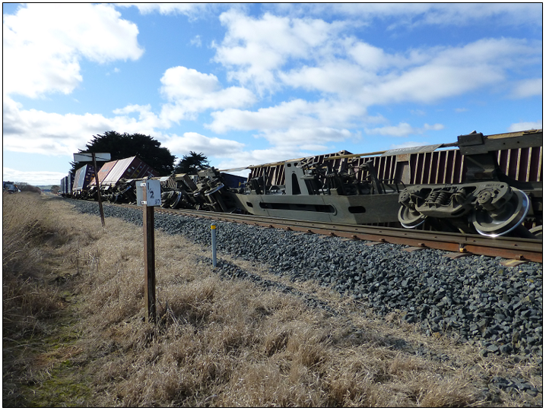

Source: ATSB

On 6 August 2015, TasRail northbound intermodal freight train 532, travelling from Boyer (near Hobart, Tasmania) to Burnie derailed on a section of track near Nala. The train consisted of two locomotives hauling 34 wagons. The train had an overall length of 557.8 m and a trailing mass 1,345.3 t. The driver was uninjured, but there was significant damage to rolling stock and about 200 m of track was destroyed.

What the ATSB found

The ATSB investigation determined that the leading wheelset on the front bogie of container wagon TQMF03G, derailed at the 95.185 km point south (kps). After the wagon derailed, the train travelled a further 2.3 km before it came to a stand.

Post-derailment measurements identified a series of track geometry defects in advance of the point of derailment (PoD). The largest defect exceeded safety limits specified in TasRail’s Track and Structure Maintenance Standard (INF-TS-211). A review of maintenance records found that a defect was identified (near the PoD) three days before the derailment. The defect was categorised as priority 1 requiring immediate attention, but did not result in the maintenance response specified by the standard.

The ATSB also identified that the track through the area had an elevated risk for geometry defects. Difficulty in maintaining track geometry through the area was probably related to poor track formation, ballast quality and the use of steel sleepers, which demand considerable maintenance effort to hold track alignment. However, there was no record of the track having been identified as a hazardous location, so it had not attracted greater analysis focus or maintenance attention.

Computer modelling showed that the TQMF wagons (compare to TQAY wagons) were more susceptible to derailment at a critical speed of 36 km/h, when traversing the track irregularity as existed at the derailment site.

What's been done as a result

TasRail have implemented a range of initiatives to reduce the risk of a similar occurrence including, changes to operational and maintenance procedures, enhanced strategies for responding to twist defects, and the consideration of fitting constant contact side bearers to the TQMF wagon fleet.

Safety message

Early detection, assessment and effective management of track defects are critical in minimising the risk of derailment and maintaining safe rail operations.

Contents

The occurrence 1

Post Occurrence 2

Context 4

Location 4

Environmental conditions 4

Train and train driver information 4

Rolling stock 5

Train driver 6

Examination of the track 8

Post-derailment track measurements 9

Track inspection and maintenance standards 9

Safety analysis 12

Track inspection and maintenance 12

Track history 14

Other occurrences involving track twist irregularities 15

Rolling stock 15

Findings 17

Contributing factors 17

Other factors that increased risk 17

Other findings 17

Safety actions 18

General details 19

Occurrence details 19

Train details 19

Sources and submissions 20

Sources of information 20

References 20

Submissions 20

Australian Transport Safety Bureau 21

Purpose of safety investigations 21

Developing safety action 21

# The occurrence

At about 1554[1] on 6 August 2015, TasRail intermodal freight train 532, (carrying rolls of newsprint and empty containers), departed Boyer in southern Tasmania (Figure 1) for Burnie in the north. The driver (driver only operation) involved in the occurrence booked on for duty, earlier that day (1430) at the East Tamar depot, Launceston. He then drove by car, to Campania where a crew change occurred at 1710. Train 532 departed shortly thereafter, the driver having obtained authority to work through to Parattah.

Figure 1: Location map – TasRail network

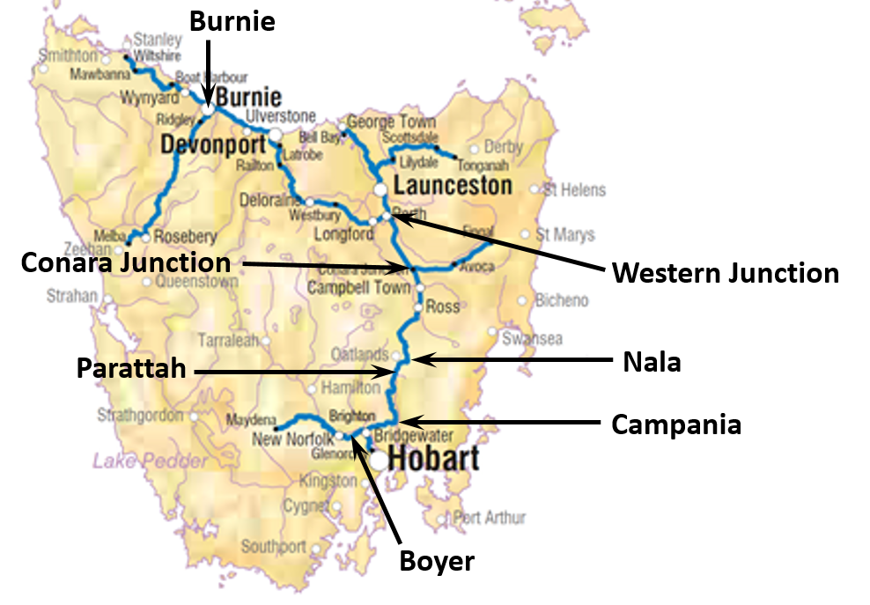

Source: NatMap, Geoscience Australia

The passage of the train through to Colebrook, about 30 km south of Nala, was uneventful. Shortly after departing Colebrook, the driver experienced degraded train performance and needed to stop on several occasions to rectify a fault[2]. At about 1841, the driver cleared the fault and then proceeded towards Parattah.

At 1856, the driver received authority to work through to Conara Junction. The train subsequently passed through Parattah, (about 9 km south of Nala) at 1911. At about 1921, the train passed over the Inglewood Road railway crossing (Figure 2) before entering a sweeping left curve (170 m radius). Just after passing, the 95 km point south, (kps)[3] the train traversed a short straight section of track, and then crossed over the Inglewood rail over-road bridge. The train continued to snake its way north towards Nala.

As the train approached the Nala Road railway crossing, the driver advanced the throttle to maintain speed. However, the train slowed, so the driver opened the train window, looked back towards the rear of the train, and saw sparks part way along the train. At about the same time as the train brakes began to apply automatically, the driver throttled off to reduce power. The lead locomotive TR15 stopped about 120 m past the Nala Road railway crossing.

Figure 2: Derailment site near Nala

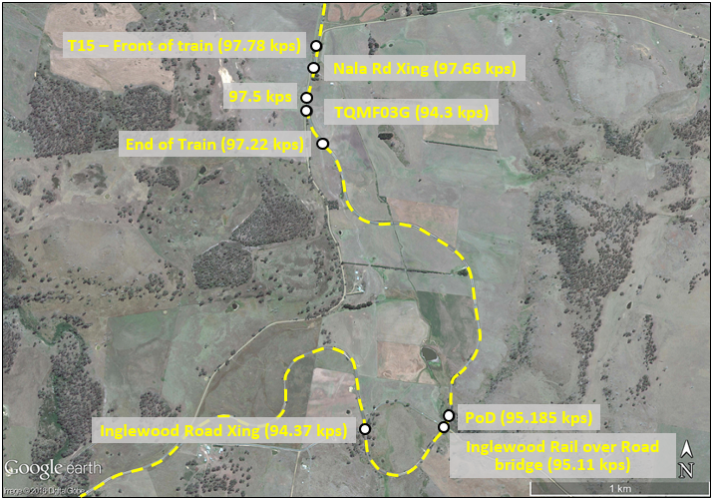

Source: Google Earth

## Post Occurrence

The driver contacted train control to advise that the train had come to a stand just past the Nala Road railway crossing and had probably derailed. After speaking to train control and activating his personal alarm monitor, he detrained and walked the length of the train to inspect for damage. On completing the inspection, he returned to the cab and communicated with train control, advising that a number of wagons had derailed and that there was extensive track damage (Figure 3).

Figure 3: Rear part of train 532 adjacent 97.5 km post

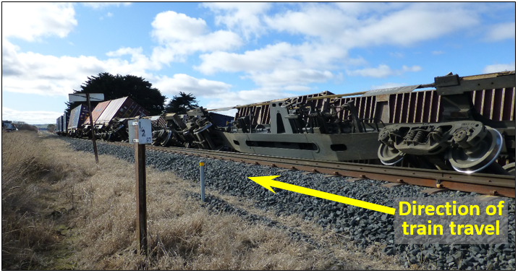

Source: ATSB

At about 1930, train control called the incident co-ordinator. Operations staff, investigation and recovery crews were then dispatched to site.

The line was re-opened to rail traffic at about 0200 on 9 August 2015, three days after the occurrence.

# Context

## Location

The derailment occurred near Nala, which is about 98 km north by rail from Hobart, Tasmania (Figure 1). The track, (south line) connects the north and south of Tasmania.

TasRail own and manage the network, and are based in Launceston.

#### Track information

The track from Boyer (near Hobart) through to Burnie substantially comprises a single line with crossing loops strategically located throughout its length. Authority to travel between sections was by way of a track warrant.

The derailment occurred near Nala, midway between Campania and Conara Junction, (Figure 1) about 98 km north by rail from Hobart, on the south line. The track through the derailment site consisted of narrow gauge (1,067 mm), 41 kg/m rail, mounted on steel sleepers, with resilient fasteners (E Clips) on a nominal 100 mm bed of ballast. Axle loads were limited to a maximum of 18 t. The track leading into the derailment site was on a downgrade of 1:83 (Figure 4) through a nominal 200 m radius left-hand curve (direction of train travel). The track speed limit through the derailment site was 40 km/h and there was no temporary speed restriction (TSR) in place.

Figure 4: Curve and gradient chart, showing Point of Derailment (PoD)

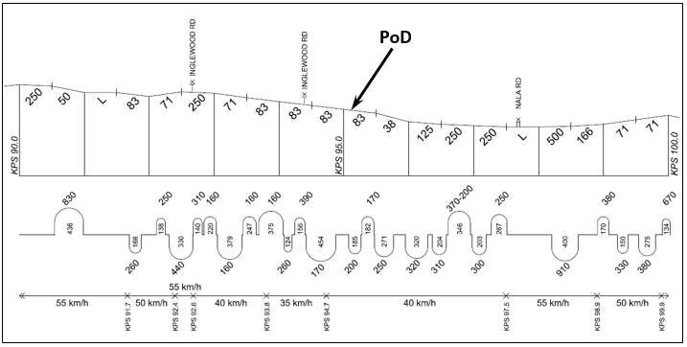

Source: TasRail, annotation ATSB

## Environmental conditions

The closest weather station was located at Tunnack, about 24 km north of Nala. On the day of the derailment, the maximum temperature recorded at Tunnack was 8.1°C, and there was no rainfall recorded in the 24-hour period preceding the derailment. At the time of derailment, the weather was fine and cool, probably about 0°C. It is unlikely that weather was a factor that contributed to the derailment.

## Train and train driver information

Train 532 was a regular TasRail intermodal freight service, carrying newsprint and empty shipping containers. The service operated between Boyer, near Hobart (Tasmania) and the port of Burnie in the north. Train 532 comprised two locomotives (TR15 leading and TR13 trailing) hauling 34 wagons. The train had an overall length of 557.8 m and a trailing mass 1,345.3 t. It was loaded and marshalled in accordance with TasRail requirements: heavy wagons were towards the front and empty wagons towards the rear.

The lead locomotive of train 532 stopped about 2,640 m past the point of derailment. The eighteen wagons that derailed were positioned 14 – 31 (inclusive) behind the locomotives.

### Rolling stock

The majority of wagons (TQAYs) were about one year old and in as new condition. The remaining wagons (TQMF/QM and IB) were refurbished, and considered to be in good condition, and fit for purpose. A post-derailment inspection confirmed that the wagons, (wheels, suspension elements, springs, friction wedges and wear surfaces) were generally in good condition and in compliance with TasRail’s engineering tolerances.

The first seven derailed wagons showed very little in the way of wheel tread damage. Considering the distance from the point of derailment, the lack of damage suggested that they were not part of the initial derailment.

The first wheelset to show significant tread damage (Figure 5 and Figure 6), consistent with a wheelset riding on ballast over an extended distance, was wagon TQMF03G. It was concluded that wagon TQMF03G, located at position 21, was likely to have derailed first. The wagons ahead of TQMF03G (positions 14 to 20) had probably derailed later in the sequence, as train 532 negotiated a number of tight curves.

Figure 5: TQMY03G – Leading bogie, leading wheelset, right wheel (direction of train travel) showing evidence of extensive of tread damage

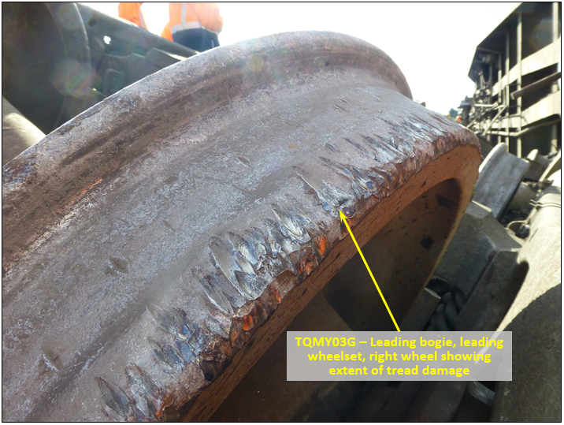

Source: ATSB

Figure 6: Derailed wagon TQMY03G (looking north) showing final positioning of bogies

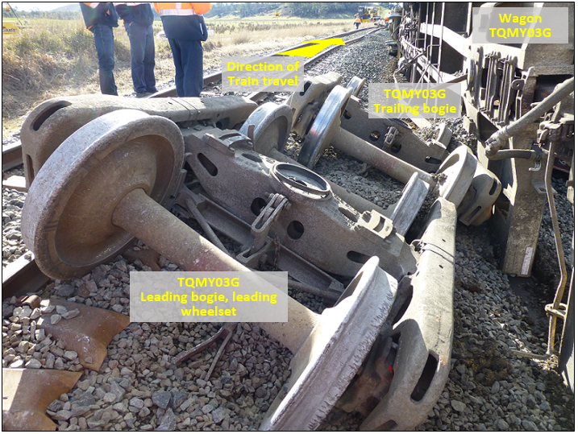

Source: ATSB

At the time of derailment, wagon TQMF03G had an overall length of 16.7 m and gross mass of 47.69 t. The wagon was carrying two 6 m (20’) containers. Inspection of the containers substantiated each was packed with eight 1.265 m diameter (1.6 m high) rolls of newsprint, stacked four long and two wide. The centre of gravity for the wagon was calculated to be 1.38 m above the top of the rail. Examination of newsprint rolls within the containers established that it was unlikely that a load shift had occurred, and loading was within specification.

A review of TasRail records, established that, as part of a major refurbishment program, wagon TQMF03G had all primary springs replaced in May 2012, and the wagon was fully overhauled (including bogies) in July 2014. The wagon was serviced in accordance with TasRail's requirements and there were no outstanding maintenance issues.

Following the derailment, an inspection of TQMF03G included bogie frames, side-bearer assemblies, friction wedges, wheelsets and wheel profiles. All were found to be operationally fit for purpose, and in compliance with maintenance standards.

### Train driver

The driver in control, at time of derailment, had worked for TasRail for about 45 years and had driven trains for the last 25 years. He held the required qualifications to drive trains on the TasRail network and was route certified for the track where the derailment occurred.

An examination of the driver’s records confirmed that he had been assessed as meeting the medical standards prescribed by the *National Standard for Health Assessment of Rail Safety Workers*. The ATSB examined the driver’s roster and determined that fatigue impairment was unlikely to have affected his performance. The driver said he felt well when signing on for duty and at the time of the derailment.

After the derailment, the driver underwent drug and alcohol testing, the results of which were negative.

#### Train Handling

Locomotives TR15 and TR13 were equipped with Wabtec event recorders (loco-log) and CCTV cameras. These systems were used for capturing information such as date/time, speed, brake pipe pressure, throttle position, distance travelled and video imagery. Analysis of the data (Figure 7) established:

* The train was travelling at about 33 km/h (7 km/h below maximum track speed) when the lead locomotive TR15 passed over the point of derailment (PoD).
* The speed of the train increased slightly, on a downgrade of 1:83, reaching 36 km/h (4 km/h below maximum track speed) as TQMF03G passed over the PoD. At the time of derailment, the train was in dynamic brake (DB).
* At 1925:25 the driver moved the throttle to idle (Idle) and then over the duration of about one minute, progressively increased the throttle to position T5 (in anticipation of a grade increase).
* At 1926:29 brake pipe pressure (BPP) began to reduce. At about the same time the driver increased the throttle position to T7, (to maintain speed) and then almost immediately reduced the throttle position to T2, then idle, realising the train may have derailed.
* The train slowed down, coming to a stop at 0926:39, about 2.6 km past the PoD.

Figure 7: Graph derived from Wabtec loco-log data, lead locomotive TR15

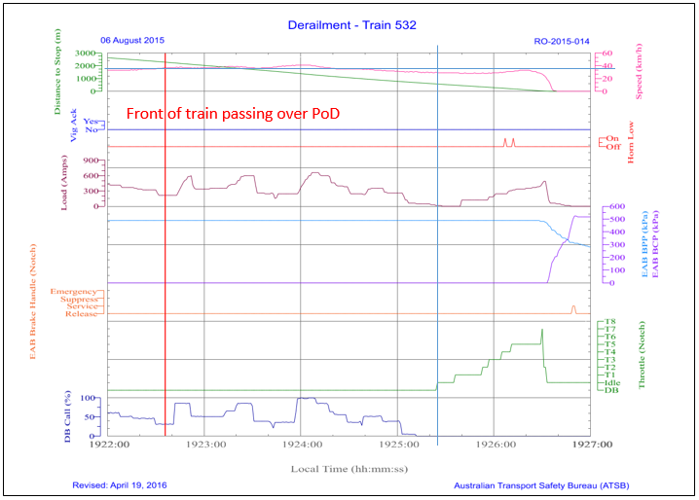

Source: TasRail, graphed by ATSB

A review of the loco-log data corroborates the driver’s recollection of events, and strongly indicates that train handling and driver performance were unlikely to have been factors that contributed to the derailment.

## Examination of the track

The point of derailment (PoD) was identified at the 95.185 kps. The track leading into/out of the derailment site was found to be in fair condition. Both rails were good, with little evidence of side and top wear. There were no broken rails at or before the PoD. However, there did appear to be some geometry and condition irregularities leading up to the PoD. The ballast layer through the derailment site was shallow with evidence of pumping (vertical track movement) and there were signs of ballast fouling (fine materials, dirt/sand within the ballast layer).

Further examination of the track established signs of pre-existing damage to some steel sleepers. The damage was quite minor, probably related to dragging equipment, a previous derailment or similar event, and not considered a factor in this derailment. There was no evidence of track spread leading into or out of the derailment site. Gauge at the PoD was 1,069 mm; this was within TasRail tolerance (Refer Figure 11 – Response code/Tolerance, item re Track Gauge).

At the PoD there was evidence of flange climb,[4] (direction of train travel) on the right side running rail, (high rail) followed by witness marks, over a distance of about 5 m, which is consistent with a wheel flange crossing over the railhead (Figure 8).

Figure 8: Witness marks at PoD (95.185 km) shown by line of arrows on railhead

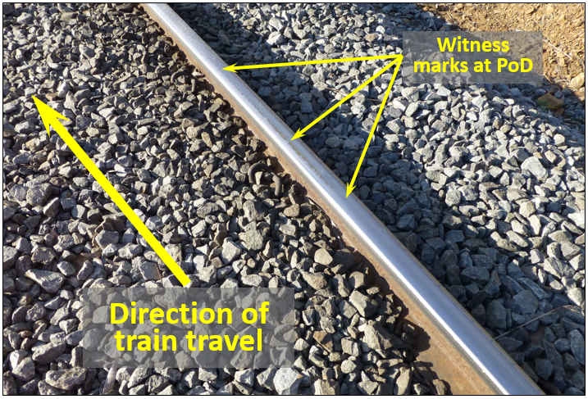

Source: ATSB

Beyond the PoD, the leading wheelset of derailed wagon TQMF03G had dropped off the rails. It damaged the track structure both within the gauge side[5] and on the field side[6] of the track (direction of travel). Initially the damage was not significant.

When locomotives TR15 and TR13 travelled through the PoD, they were initially in dynamic brake (Figure 7). At that time, the trailing wagons were in buff (light compression), almost free rolling. When the locomotives were about 1.8 km from the PoD, the driver began to accelerate the train, for an upcoming grade increase. At that time, the wagons would have gone into draft (tension) and the derailed wagon (TQMF03G) pulled to the right, through the right hand curve, (96.5 kps) where it dropped off the ballast shoulder and rolled over.

This most likely caused the wagons ahead to roll over, and wagons behind to derail, resulting in the multi-wagon pile-up shown at Figure 3. Wagon TQMF03G had travelled about 2.3 km beyond the initial PoD before coming to rest.

While track damage was evident along the 2.3 km length of the line, there was no track damage at or before the PoD. The majority of track damage was about 2 km beyond the PoD. It is therefore most likely that any post incident survey measurements through the derailment site would reflect the condition of the track at the time of derailment. Any measured track defects probably existed prior to the passage of train 532.

### Post-derailment track measurements

The post-derailment survey, undertaken by TasRail, measured a range of track parameters including track gauge, alignment, superelevation, twist and top. Figure 9 illustrates the geometry in terms of track twist[7] – green line at 10 m intervals and the red line at 3 m intervals. The survey confirmed on-site visual observations that a series of geometry irregularities existed leading up to the point of derailment.

Figure 9: Twist measurements taken at derailment site (95.185 kps)

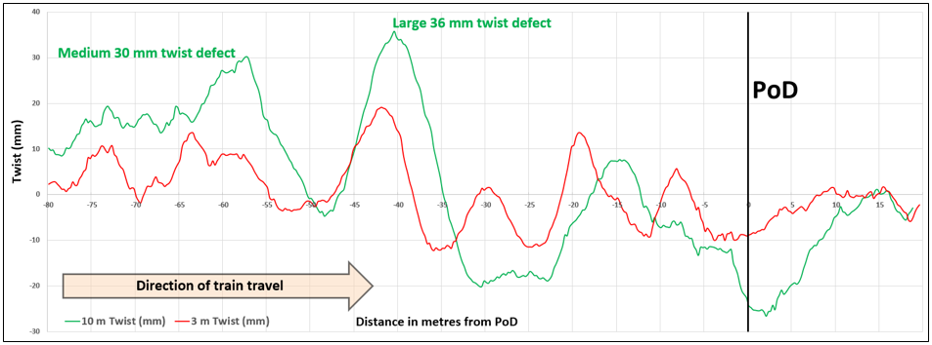

Source: TasRail – annotations ATSB

## Track inspection and maintenance standards

The inspection and maintenance practices used by TasRail for its track and civil infrastructure are prescribed in the ‘Track and Structure Maintenance Standard’ (INF-TS-211 Ver 2.0 dated 26 August 2014).

The standard provides for two inspection routines: unscheduled and scheduled inspections. These routines adopt two main methods for assessing track geometry and identifying defects, visual inspections of track, and the use of mechanised track geometry vehicles.

#### Unscheduled

Unscheduled inspections are generally in response to defined events, such as extreme weather conditions known to increase the risk of geometry defects. Unscheduled inspections can also be triggered by third-party intervention, such as a train driver’s report of a rough riding track.

#### Scheduled

Scheduled inspections, in this case, for continuous steel sleeper track, (section length greater than 200 m) comprise:

* ‘on-track vehicle’ (weekly – No leeway, must complete inspection within 7 days, on or before last inspection date)
* ‘front of loco’ (3 monthly – leeway 2 months)
* ‘foot’ (for curves < 200 m, 18 monthly – leeway 2 months)
* ‘twist trolley’ (10 weekly – leeway 15 days) and
* ‘track geometry vehicle’ (annually, unless specified otherwise – leeway 30 days).

In accordance with the standard, track defects are grouped into one of three tolerance bands/codes, S, M or L, as defined in the table at Figure 10, ‘Track assessment response codes’.[8]

Figure 10: Track assessment response codes

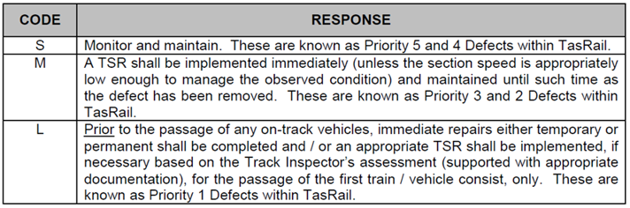

8

Source: TasRail: Track and Structure Maintenance Standard Table 5 (INF-TS-211 Ver 2.0 dated 26 August 2014)

The tolerance limits for each specific defect band/code, are as defined in the table at Figure 11, ‘TasRail Category B Lines where Track Segment Speeds are up to 70km/h’.

Figure 11: TasRail Category B Lines where Track Segment Speeds are up to 70km/h

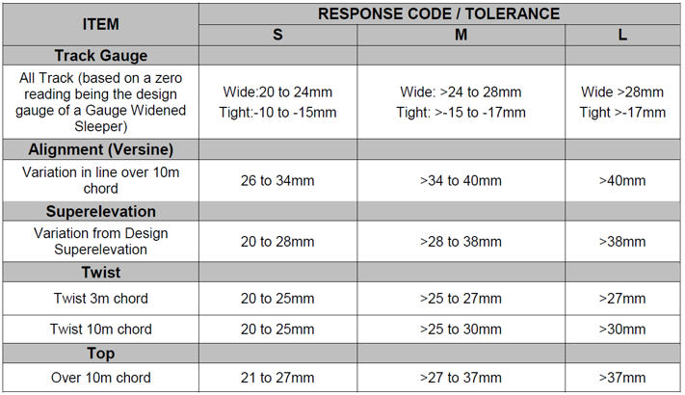

Source: TasRail: Track and Structure Maintenance Standard (INF-TS-211 Ver 2.0 dated 26 August 2014)

The work priority (urgency) assigned against each specific code, S, M or L, is as prescribed in the table at Figure 12 ‘Inspection Guidelines, Prioritisation and Sub-Categorisation of Defects’.

Figure 12: Inspection Guidelines, Prioritisation and Sub-Categorisation of Defects

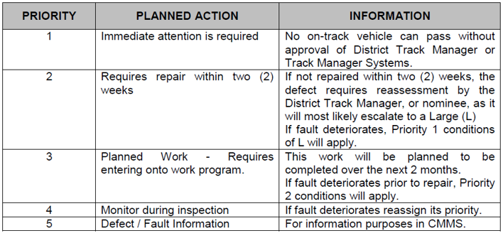

Source: TasRail: Track and Structure Maintenance Standard Table 6(INF-TS-211 Ver 2.0 dated 26 August 2014)

# Safety analysis

On 6 August 2015, TasRail intermodal freight train 532, travelling from Boyer to Burnie, derailed near Nala, Tasmania. The ATSB determined that the derailment was initiated by a track defect (twist irregularity), located just before the 95.185 km point south (kps). It was likely that the track defect induced significant body roll in wagon TQMF03G, and that the right wheel of the leading axle on the leading bogie was in an unloaded state when it contacted the running face of the right hand rail, resulting in flange climb, and subsequent derailment. Consequently, examination of track/rolling stock interaction and track inspection/maintenance operations became necessary to determine whether these areas were factors in the derailment.

## Track inspection and maintenance

An extract of TasRail records (Figure 13) showed that scheduled inspections were regularly performed, and generally met or exceeded target dates. The last on-track vehicle inspection, highlighted in orange (Figure 13), was completed on schedule, three days before the derailment. A track defect was located just before the POD (95.130 kps) during that inspection, and resulted in the issue of a repair job advice on 4 August 2015, as highlighted in orange (Figure 14).

**Figure 13: Scheduled track inspection history, period preceding derailment**

|  |  |  |
| --- | --- | --- |
| Date scheduled | Date completed | Type of inspection |
| 3 May 2015 | 6 May 2015 | Track geometry car |
| 20 Jun 2015 | 18 Jun 2015 | Twist trolley |
| 23 July 2015 | 3 Aug 2015 | Front of loco |
| 28 July 2015 | 27 Jul 2015 | On-track vehicle |
| 31 July 2015 | 30 Jul 2015 | On-track vehicle |
| 3 August 2015 | 3 Aug 2015 | On-track vehicle |

Source: TasRail

Post-derailment analysis suggests that the geometry defects observed following the derailment of train 532 were probably consistent with the defects identified on 3 August 2015. Twist measurements taken post-derailment (Figure 9) showed the existence of a (10 m) twist defect 30 mm (medium) in size, followed by a (large) 36 mm defect, located 60 m and 40 m, respectively, before the PoD. Closer towards the POD were a series of smaller yet significant defects, with a 26 mm (medium) defect at the PoD. The magnitude and cyclic nature of these defects, in advance of the PoD, would have initiated significant body roll in wagons as they travelled through the derailment site.

TasRail maintenance standards prescribe that, for any twist defect greater than 30 mm, (10 m chord) it is mandatory to allocated a code L, and should be given a priority ‘1’ urgency response. Examination of the repair advice sheet (Figure 14) shows that the track inspector identified that spot tamping was required near the 95.130 kps, due to irregular top. The defect was not physically measured and was probably under estimated as a medium defect, M (>25 – 30mm). While the defect was identified as medium, (M) and would typically be allocated a priority 2 or 3 response, on this occasion it was allocated a priority 1 response, which was outside the instructions defined in TasRail’s maintenance standard INF-TS-211. A priority 1 response requires ‘Immediate attention is required’ under TasRail maintenance standard INF-TS-211 (Figure 12). The standard also clearly mandates that ‘No on-track vehicles can pass without the approval of District Track Manager or Track Manager Systems’. However, this response was not undertaken.

**Figure 14: Extract from repair advice sheet dated 4 August 2015**

|  |  |  |  |  |  |  |  |  |  |  |  |
| --- | --- | --- | --- | --- | --- | --- | --- | --- | --- | --- | --- |
| Location kps | Job Title | Defect Cat. | Defect Type | Priority Rating | Defect Cond. | Resp. Code | Cause Code | TSR Spd | Tamp Y/N | Ballast Y/N | Action / Response Instructions |
| 124.600 | Spot Tamp | Trg | Top | 1 | I | M | NA |  | Yes | Yes | Approx 10 m |
| 95. 130 | Spot Tamp | Trg | Top | 1 | I | M | NA |  | Yes | Yes | Approx 40 m |
| 93.200 | Spot Tamp | Trg | Top | 1 | I | M | NA |  | Yes | Yes | Approx 10 m |
| 90.280 | Spot Tamp | Trg | Top | 1 | I | M | NA |  | Yes | Yes | Approx 5 m Plus remove bulge and shoulder ballast/Replace with new ballast |
| 86.250 | Spot Tamp | Trg | Top | 1 | I | M | NA |  | Yes | Yes | Approx 5 m |
| 76.640 | Spot Tamp | Trg | Top | 1 | I | M | NA |  | Yes | Yes | Approx 50 m |

Source: TasRail

An examination of other inspection and maintenance records found:

* A front of loco inspection was also completed on 3 August 2015, 3 days before the occurrence. There were no ride quality issues or defects reported, at or near the derailment site.
* A twist trolley inspection was completed on 18 June 2015, about 2 months before the occurrence. There were no repair advice notifications or identified issues at or near the derailment site. However, it was noted that the report did not include a category for 10 m twist defects.
* The track through the site was examined using a mechanised track geometry inspection car on 5 May 2015, about 3 months before the derailment.

Figure 15 (top portion) is a graphical extract of that track geometry car report of 5 May 2015. It shows a series of twist irregularities before the 95.185 kps location. The largest was a 32 mm twist defect at the 95.179 kps, close to the POD. The twist defect was categorised as a priority 1 defect and recorded in an exceedance report (Figure 15 – bottom portion). TasRail’s maintenance records show no evidence of any corrective action in response to this priority 1 defect.

Subsequent advice by TasRail stated that:

This defect was also not considered a priority in the context of the overall volume of identified defects. Consequently these defects were not scoped and/or repaired prior to 06 August 2015.

This statement, and maintenance action following the identification of a priority 1 defect three days before the derailment, suggests that TasRail did not enforce documented maintenance standards, which required immediate attention and exclusion of vehicles until approval was given by the track manager.

**Figure 15: Extract of track geometry car, report of 5 May 2015 near PoD (95.185 kps)**

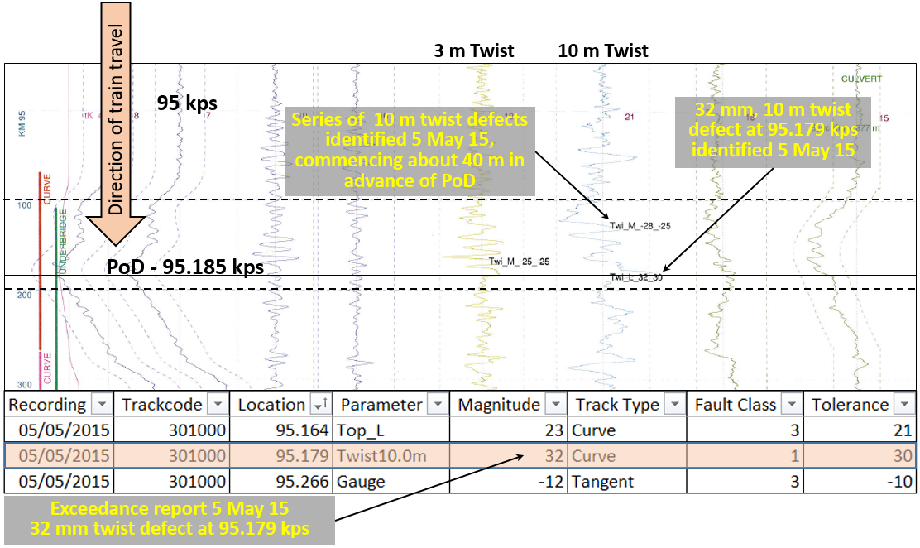

**Source: TasRail – annotations ATSB**

### Track history

An extract of TasRail’s maintenance records (Figure 16) established that there were at least five instances of track geometry/stability issues, (not including the track geometry car inspection of 5 May 2015 and on-track vehicle inspection of 3 August 2015) at or near the PoD requiring maintenance intervention since 2008.

**Figure 16: Extract of maintenance records Campania to Conara Junction (near derailment site)**

|  |  |  |  |  |  |  |  |  |  |  |
| --- | --- | --- | --- | --- | --- | --- | --- | --- | --- | --- |
| **Year** | **Ref No.** | **Issued** | **Km from** | **Km to** | **Normal Speed** | **Speed Rest.** | **Date from** | **Lifted** | **Reason** | **Comment** |
| 2008 | 139 | 21/02/08 | 95 | 95.5 | 40 | 20 | 21/02/08 | 01/05/08 | Track Condition (Other) |  |
| 2008 | 158 | 19/06/08 | 95 | 95.5 | 40 | 20 | 19/06/08 | 31/0708 | Track Condition (Other) | Track tamped |
| 2009 | 504 | 06/10/09 | 95 | 95.1 | 40 | 10 | 06/10/09 | 21/12/09 | Track Stability | Track Buckles Awaiting Tamp |
| 2010 | 763 | 13/09/10 | 95 | 95.5 | 40 | 30 | 13/09/10 | 10/05/11 | Track Geometry Condition | Needing ballast and tamp |
| 2012 | 1015 | 29/01/12 | 95 | 95.5 | 40 | 20 | 29/01/12 | 04/02/12 | Track Stability | Misalignment |

Source: TasRail

TasRail acknowledged that the formation was generally in poor condition through the area. A 100 mm ballast layer over fouled ballast was considered typical. TasRail also identified at least two locations just before the POD that showed evidence of track pumping. This suggested the possibility of voids under the track that may have contributed to track geometry irregularities as vehicles passed through the area.

The track structure through the derailment site adopted the use of steel sleepers. While steel sleepers provide good gauge holding, they demand considerable maintenance effort to manage track stability/alignment. A study in NSW[9] found that steel sleepers need to have correct installation as they do not perform well in situations where the track structure (ballast and formation) is poor. The report highlighted that correct tamping is essential to ensure the insertion of the ballast into the underside of the steel sleeper. Any lack of ballast under the sleeper void is difficult to observe visually and may reduce the structural stability of the track, especially in tight curves.

In this case, steel sleepers had been installed, the track contained a series of tight curves and the structure was known to be in relatively poor condition with fouled ballast. The repetitive nature of track geometry defects identified through track inspections also suggests the area was prone to track stability issues. TasRail’s track and maintenance (INF-TS-211 at section 3.8.1, general item 8) states that track sections prone to stability failure should be identified and managed as hazardous locations. There was no record of the track near the 95.5 kps having been identified as a hazardous location, so it had not attracted greater analysis focus or maintenance attention.

## Other occurrences involving track twist irregularities

The ATSB has previously investigated two derailments in Tasmania involving track twist irregularities involving train 331 near Lowdina, on 9 April 2013 ([RO-2013-012](http://www.atsb.gov.au/)), and train 135 near Kimberley on 25 January 2015 ([RO-2015-001](http://www.atsb.gov.au/)).

Track geometry was identified as the underlying factor in these derailments including the derailment of train 532 on 6 August 2015. All three derailments occurred on steel sleeper track through areas having tight curves, and involved older rolling stock exhibiting less tolerant dynamic performance.

## Rolling stock

To assist in understanding the mechanism of derailment, and help in developing strategies to mitigate the risk of future derailment, TasRail engaged consultants to model the dynamic performance of the older TQMF class of wagon (type that derailed) and TQAY wagons, using the Vampire computer simulation package. The track criterion incorporated into the simulation model was based on survey work undertaken post-derailment. The dynamic performance of the wagons was modelled for varying characteristics and a range of speeds, including the derailment speed of 36 km/h.

The computer modelling clearly showed that the older generation TQMF, when compared to the newer TQAY wagons, were much more susceptible to derailment over the track defect at the 95.185 kps. Modelling suggested that the newer generation TQAY wagons were able to negotiate the same track defect without derailing.

At the critical speed of 36 km/h, the modelling established that the TQMF wagons derailed when traversing the track irregularity. This speed gave rise to the highest wheel unloading at a time when the wheel came into contact with the rail face at the 95.185 kps, resulting in flange climb and subsequent derailment.

It is likely that cyclic body roll due to a series of track irregularities caused the right-hand wheel on the lead axle on the leading bogie (TQMF03G) to lift. At the same time, the process of negotiating a left-hand curve placed that wheel in contact with the right-hand rail running, resulting in flange climb of the lightly loaded wheel and subsequent derailment. Although it was determined that TQMF03G was in good condition, the suspension characteristics of this wagon type, compared to the newer TQAY wagons, were probably key factors that contributed to the derailment.

The results of the computer modelling were used by TasRail to identify a number of strategies that could be used to enhance the dynamic performance of the TQMF wagon and reduce the risk of future derailments, including the use of constant-contact side-bearers.[10] TasRail proposes to adopt the recommendations of the report.

# Findings

On 6 August 2015, TasRail intermodal freight train 532, travelling from Boyer (near Hobart) to Burnie derailed on a section of track near Nala, Tasmania.

From the evidence available, the following findings are made with respect to the derailment and should not be read as apportioning blame or liability to any particular organisation or individual.

## Contributing factors

* The derailment of train 532 was probably initiated by a track defect (twist irregularity), just before the 95.185 km point south (kps).
* The wagon (TQMF03G) suspension characteristics, loading, critical train speed, (36 km/h), and nature of the track defect, were factors that contributed to the derailment.
* A track defect was identified three days before the derailment, categorised as priority 1 requiring immediate attention, but did not result in a maintenance response as specified in TasRail’s maintenance standard INF-TS-211.

## Other factors that increased risk

* TasRail maintenance standard INF-TS-211 does not provide guidelines for the determination of track defect size.
* There were no documents that could establish whether the track inspector met mandated reporting requirements, (specified within TasRail’s maintenance standard INF-TS-211) where on-track vehicles are not permitted to pass a priority 1 defect, without approval of the track manager.
* TasRail records showed a history of track geometry defects near the derailment site, but monitoring strategies did not alert maintenance staff to the possible need for higher vigilance through this area.
* The track stability problems near the derailment site were probably a reflection of poor track formation, ballast quality and the use of steel sleepers, in particular the packing of ballast under the sleeper and at the sleeper ends.

## Other findings

* Train handling and driver performance were not factors that contributed to the derailment.
* Environmental conditions were not factors that contributed to the derailment.

# Safety actions

Whether or not the ATSB identifies safety issues in the course of an investigation, relevant organisations may proactively initiate safety actions in order to reduce their safety risk. The ATSB has been advised of the following proactive safety actions in response to this occurrence.

***Additional safety action taken by TasRail***

TasRail has advised of the following proactive safety actions:

* Computer modelling by Worley Parsons to identify any additional criteria that could be used to interpret geometry measures to identify situations where a combination of defects could contribute to a heightened derailment risk.
* Update the TasRail Operational Risk Register V5 when outcome of modelling known - Hazard 2 - Train Derailment.
* Track Maintenance Standard INF-TS-211 has been updated (Version 3) on 04 April 2016 with respect to various operational and maintenance procedures, including:
  + Removes the requirement to obtain track manager permission to travel over large faults and introduces geometry defect thresholds at which TSRs shall be applied enabling consistent management by the track inspector.
  + Removes hazardous locations and introduces unstable twist defects which are locations that must be measured by inspectors during every patrol to mandate more rigorous monitoring of areas that rapidly deteriorate.
  + Has been updated to include a revised repair advice sheet which now requires that measurements be taken for all reported geometry defects.
  + Includes specific actions to be taken for each defect size
* Geismar digital track geometry trolleys issued to all track inspectors to enable accurate sizing of defects.
* Track geometry vehicle now operated six weekly on busiest lines (South and Western).
* TasRail has committed to invest in its own, vehicle mounted, track geometry measuring equipment enabling more frequent and accurate track monitoring
* Update Infrastructure Derailment Form INF-FRM-019 to include the measurement of voiding following incident investigation.
* Fitting of ‘Constant Contact Side Bearers’ on the fleet of TQMF and IB wagons.
* Update standard RS-TS-006 to include side-bearer gaps clearances.
* Inspect TQMF wagons side-bearer gaps and friction wedges to ensure all are within specification.
* Update 'A' service sheet RS-FRM-242 to include inspection of side-bearer gap clearances measurements.
* Update wagon work instruction RS-Wl-531 to include correct service limits and measurement criteria.

# General details

## Occurrence details

|  |  |  |
| --- | --- | --- |
| Date and time: | 06 August 2015 – 1927 EST | |
| Occurrence category: | Incident | |
| Primary occurrence type: | Derailment | |
| Location: | Near Nala, Tasmania | |
|  | Latitude: 42° 18.656’ S | Longitude: 147° 27.435’ E |

## Train details

|  |  |  |
| --- | --- | --- |
| Train operator: | 532 | |
| Registration: | TasRail | |
| Type of operation: | Freight, 34 wagons, 2 locomotives trailing mass 1,345.3 t, total length 557.8 m | |
| Persons on board: | Crew – 1, driver only operation | Passengers – nil |
| Injuries: | Crew – nil | Passengers – nil |
| Damage: | Substantial | |

# Sources and submissions

## Sources of information

The sources of information during the investigation included:

* TasRail

## References

* ARA Glossary for the National Codes of Practice and Dictionary of Railway Terminology
* Bureau of Meteorology - Weather Observations for Tunnack, Tasmania (6 August 2015)
* Steel Sleeper Introduction on NSW Class 1 Main Line Track.1996 - 2004 (OTSI File Ref: 02619)
* RISSB Glossary of Railway Terminology – Guideline
* [RO-2013-012](http://www.atsb.gov.au/) – Derailment of train 331 near Lowdina, Tasmania on 9 April 2013
* [RO-2015-001](http://www.atsb.gov.au/)– Derailment of TasRail train 135, Kimberley, Tasmania on 25 January 2015
* TasRail – Track and Structure Maintenance Standard (INF-TS-211) Ver 2.0 dated 26 August 2014

## Submissions

Under Part 4, Division 2 (Investigation Reports), Section 26 of the *Transport Safety Investigation Act 2003*, the ATSB may provide a draft report, on a confidential basis, to any person whom the ATSB considers appropriate. Section 26 (1) (a) of the Act allows a person receiving a draft report to make submissions to the ATSB about the draft report.

A draft of this report was provided to:

* Driver of train 532
* Office of National Rail Safety Regulator
* TasRail

Submissions were received from the Office of the National Rail Safety Regulator, and TasRail. The submissions were reviewed and where considered appropriate, the text of the report was amended accordingly.

# Australian Transport Safety Bureau

The Australian Transport Safety Bureau (ATSB) is an independent Commonwealth Government statutory agency. The ATSB is governed by a Commission and is entirely separate from transport regulators, policy makers and service providers. The ATSB’s function is to improve safety and public confidence in the aviation, marine and rail modes of transport through excellence in: independent investigation of transport accidents and other safety occurrences; safety data recording, analysis and research; fostering safety awareness, knowledge and action.

The ATSB is responsible for investigating accidents and other transport safety matters involving civil aviation, marine and rail operations in Australia that fall within Commonwealth jurisdiction, as well as participating in overseas investigations involving Australian registered aircraft and ships. A primary concern is the safety of commercial transport, with particular regard to operations involving the travelling public.

The ATSB performs its functions in accordance with the provisions of the *Transport Safety Investigation Act 2003* and Regulations and, where applicable, relevant international agreements.

## Purpose of safety investigations

The object of a safety investigation is to identify and reduce safety-related risk. ATSB investigations determine and communicate the factors related to the transport safety matter being investigated.

It is not a function of the ATSB to apportion blame or determine liability. At the same time, an investigation report must include factual material of sufficient weight to support the analysis and findings. At all times the ATSB endeavours to balance the use of material that could imply adverse comment with the need to properly explain what happened, and why, in a fair and unbiased manner.

## Developing safety action

Central to the ATSB’s investigation of transport safety matters is the early identification of safety issues in the transport environment. The ATSB prefers to encourage the relevant organisation(s) to initiate proactive safety action that addresses safety issues. Nevertheless, the ATSB may use its power to make a formal safety recommendation either during or at the end of an investigation, depending on the level of risk associated with a safety issue and the extent of corrective action undertaken by the relevant organisation.

When safety recommendations are issued, they focus on clearly describing the safety issue of concern, rather than providing instructions or opinions on a preferred method of corrective action. As with equivalent overseas organisations, the ATSB has no power to enforce the implementation of its recommendations. It is a matter for the body to which an ATSB recommendation is directed to assess the costs and benefits of any particular means of addressing a safety issue.

When the ATSB issues a safety recommendation to a person, organisation or agency, they must provide a written response within 90 days. That response must indicate whether they accept the recommendation, any reasons for not accepting part or all of the recommendation, and details of any proposed safety action to give effect to the recommendation.

The ATSB can also issue safety advisory notices suggesting that an organisation or an industry sector consider a safety issue and take action where it believes it appropriate. There is no requirement for a formal response to an advisory notice, although the ATSB will publish any response it receives.

1. The 24-hour clock is used in this report and is referenced from Eastern Standard Time (EST).
2. The fault was related to the communication of data between the locomotives.
3. Measured from Hobart on the South Line.
4. A derailment in which a wheel flange will climb to the railhead.
5. The area between the two running rails.
6. The area on the ‘out sides’ of each of the running rails.
7. Twist is the variation in cross level over a defined distance, where cross level (cant) is the difference in level of the two rails at a single point along the track.
8. The requirements of a ‘Code L’ response were relaxed on 5 November 2014, vide Infrastructure Waiver 018, by deleting the wording (Figure 10 – red strike through) ‘… for the passage of the first train/vehicle consist, only’. This modification to the standard allowed large defects, to be managed by way of an appropriate TSR.
9. Steel Sleeper Introduction on NSW Class 1 Main Line Track.1996 - 2004 (OTSI - File Ref: 02619)
10. In freight wagons that use three-piece bogies, there is a tendency for the wagon to rock from side to side on the 'centre-plate' to 'centre bowl' connection. To limit the rocking motion of the wagon body, 'side-bearers' are fitted to the bolster. There are variations in the design of side-bearers, and constant-contact side-bearers are used in the more modern designs. Constant-contact side-bearers also provide additional resistance to rotation of the bogie, which improves stability but reduces curving performance.

    Design and Simulation of Rail Vehicles By Maksym Spiryagin, Colin Cole, Yan Quan Sun, Mitchell McClanachan, Valentyn Spiryagin, Tim McSweeney