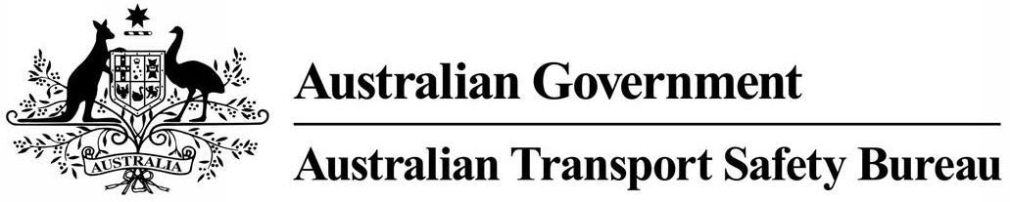
ATSB Transport Safety Report
Rail Occurrence Investigation
RO-2016-010
Final – 19 October 2016

Collision between a road vehicle and V/Line passenger train 8309
Pogue Road level crossing, Toolamba, Victoria, on 27 July 2016

Source: Front cover Chief Investigator, Transport Safety (Vic)
This investigation was conducted under the Transport Safety Investigation Act 2003 by the Chief Investigator, Transport Safety (Victoria) on behalf of the Australian Transport Safety Bureau in accordance with the Collaboration Agreement entered into on 10 January 2013.

Released in accordance with section 25 of the Transport Safety Investigation Act 2003

Publishing information

Published by: Australian Transport Safety Bureau
Postal address: PO Box 967, Civic Square ACT 2608
Office: 62 Northbourne Avenue Canberra, Australian Capital Territory 2601
Telephone: 1800 020 616, from overseas +61 2 6257 4150 (24 hours)
Accident and incident notification: 1800 011 034 (24 hours)
Facsimile: 02 6247 3117, from overseas +61 2 6247 3117
Email: atsbinfo@atsb.gov.au
Internet: www.atsb.gov.au

© Commonwealth of Australia 2016



Ownership of intellectual property rights in this publication
Unless otherwise noted, copyright (and any other intellectual property rights, if any) in this publication is owned by the Commonwealth of Australia.

Creative Commons licence
With the exception of the Coat of Arms, ATSB logo, and photos and graphics in which a third party holds copyright, this publication is licensed under a Creative Commons Attribution 3.0 Australia licence.

Creative Commons Attribution 3.0 Australia Licence is a standard form license agreement that allows you to copy, distribute, transmit and adapt this publication provided that you attribute the work.

The ATSB’s preference is that you attribute this publication (and any material sourced from it) using the following wording: Source: Australian Transport Safety Bureau

Copyright in material obtained from other agencies, private individuals or organisations, belongs to those agencies, individuals or organisations. Where you want to use their material you will need to contact them directly.

Addendum
Page | Change | Date

Collision between a road vehicle and V/Line passenger train 8309

What happened
On the morning of 27 July 2016, V/Line passenger train 8309 departed Melbourne for Shepparton, Victoria. The train consisted of a locomotive hauling four passenger cars and was crewed by a driver and conductor. There were 22 passengers on board when the train approached the regional town of Toolamba, south of Shepparton.
At about 1147 the train had passed Toolamba, and approached the Pogue Road level crossing travelling north at about 100 km/h. At about the same time, a utility vehicle was travelling east along Pogue Road and was approaching the level crossing. The crossing was controlled by a Stop sign (Figure 1) that required road users to stop near the crossing and look for trains.
Figure 1: Pogue Road level crossing viewed from the direction of the car’s approach
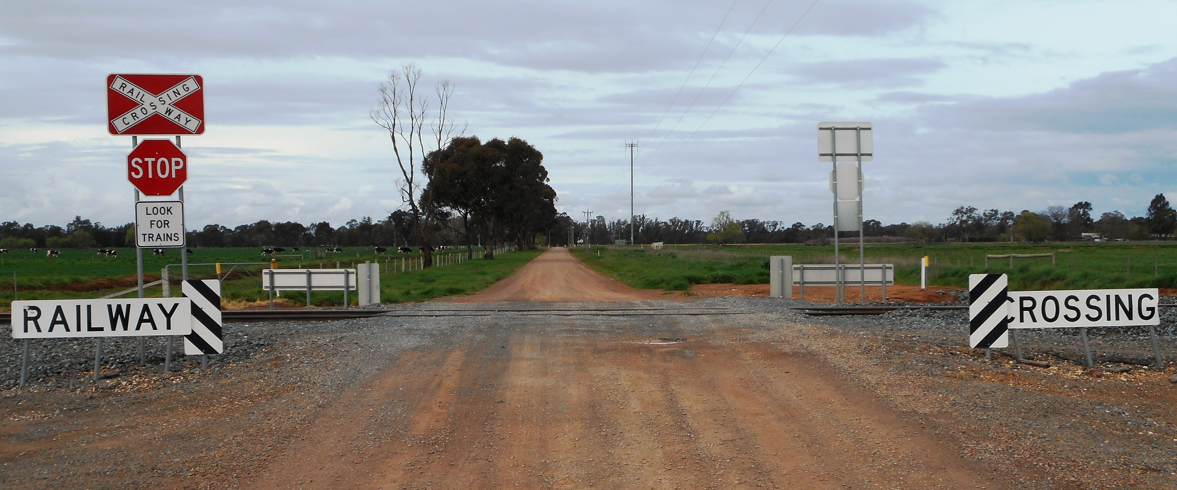
Source: Chief Investigator, Transport Safety (Vic)
The driver of the car travelled this route almost daily and was familiar with the crossing. On this day, he had driven into town earlier that morning and was returning home. On the approach to the crossing, the driver’s view towards the train was obscured by an orchard and road side trees to the south-west of the crossing (Figure 2).
Figure 2: Pogue Road approach to the level crossing. The view to a train approaching from the right was obscured by road-side vegetation and an orchard.
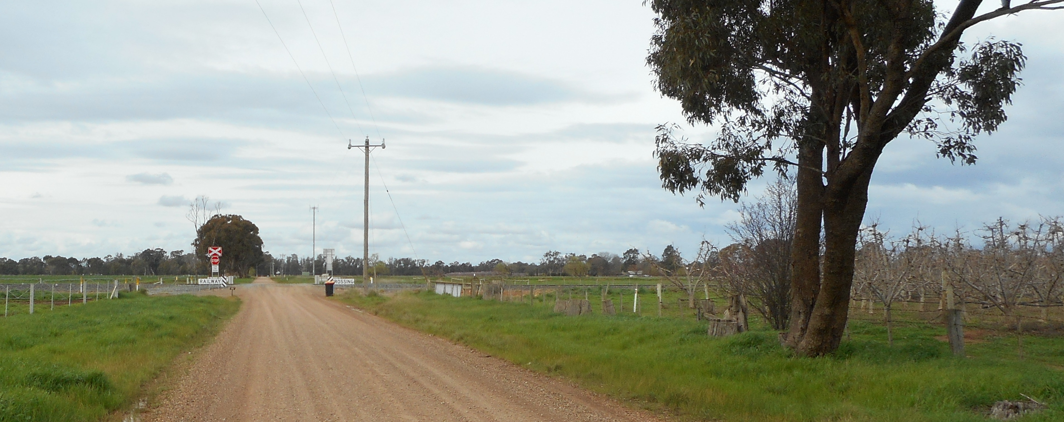
Source: Chief Investigator, Transport Safety (Vic)
When the train came into view, the driver applied the vehicle’s brakes, leaving skid marks on the gravel road about 40 m in length. However, the vehicle could not be stopped before the crossing and collided with the first passenger carriage behind the locomotive. The impact was to the underframe area of the carriage and dislodged a diesel fuel tank from the train. The passenger compartment remained intact and there were no reported passenger injuries. The road vehicle was severely damaged (Figure 3) and its driver suffered bruising injuries.
Figure 3: Damaged road vehicle and the fuel tank from the impacted rail car.
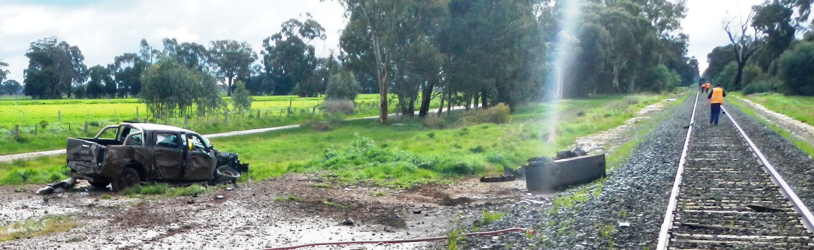
Source: V/Line Pty Ltd
The train driver had sounded the train horn as the train approached the whistle board that was located 400 m from the crossing, and again a short distance before the crossing. He reported that he did not see the road vehicle. The impact of the car on the train alerted the driver to the collision and he made an emergency brake application.

ATSB comment

Road vehicle driver
The driver was very familiar with the crossing and had used it many times without seeing a train, probably reducing his expectation. This factor and possibly other distractions led to the driver approaching the crossing with a reduced level of vigilance.

Level crossing
Pogue Road is a single-lane gravel road with a speed limit of 100 km/h. It intersected the 100 km/h train line to Shepparton at near right angles. The crossing was controlled by Stop signs (passive control) that required road users to come to a stop and check for trains before proceeding. The signage at the crossing and the advanced warning signage on the approach was in good condition and generally consistent with the Australian Standard for railway crossing signage, with minor variations not material to this incident. There have been no previous near-miss or collision incidents reported at this level crossing.
The road-side vegetation and orchard meant that the view to the track was obscured on the approach to the crossing. The provision of Stop sign traffic control measures is consistent with this configuration, as this required road users to stop in a position that would allow them to sight trains.

Passive control measures at level crossings
A range of studies have found that providing active warnings reduces crash rates by 48 to 88 per cent. The same paper recommends further research into low-cost warning devices for passive crossings. On passenger lines, the risk associated with collision extends to rail passengers.

Safety message
Road users are reminded to be vigilant when approaching a passive rail level crossing and check for trains in both directions before crossing.
Rail operators should continue to consider options for reducing the risk of collision at crossings with passive (only) control devices, particularly on passenger line corridors.

General details

Occurrence details
Date and time: | 27 July 2016 – 1147 EST
Occurrence category: | Accident
Primary occurrence type: | Collision
Location: | Pogue Road level crossing, 168.3 km from Melbourne
 | Latitude: 36° 28.3132’ S | Longitude: 145° 20.1947’ E

Train details
Train operator: | V/Line Pty Ltd
Registration: | Train No 8309
Type of operation: | Country Passenger
Persons on board: | Train Driver, Conductor and 22 passengers
Injuries: | None
Damage: | Impact damage to rail car in way of fuel tank and underframe.

About the ATSB
The Australian Transport Safety Bureau (ATSB) is an independent Commonwealth Government statutory agency. The ATSB is governed by a Commission and is entirely separate from transport regulators, policy makers and service providers. The ATSB's function is to improve safety and public confidence in the aviation, marine and rail modes of transport through excellence in: independent investigation of transport accidents and other safety occurrences; safety data recording, analysis and research; and fostering safety awareness, knowledge and action.
The ATSB is responsible for investigating accidents and other transport safety matters involving civil aviation, marine and rail operations in Australia that fall within Commonwealth jurisdiction, as well as participating in overseas investigations involving Australian registered aircraft and ships. A primary concern is the safety of commercial transport, with particular regard to operations involving the travelling public.
The ATSB performs its functions in accordance with the provisions of the Transport Safety Investigation Act 2003 and Regulations and, where applicable, relevant international agreements.
The object of a safety investigation is to identify and reduce safety-related risk. ATSB investigations determine and communicate the safety factors related to the transport safety matter being investigated.
It is not a function of the ATSB to apportion blame or determine liability. At the same time, an investigation report must include factual material of sufficient weight to support the analysis and findings. At all times the ATSB endeavours to balance the use of material that could imply adverse comment with the need to properly explain what happened, and why, in a fair and unbiased manner.

About this report
Decisions regarding whether to conduct an investigation, and the scope of an investigation, are based on many factors, including the level of safety benefit likely to be obtained from an investigation. For this occurrence, a limited-scope, fact-gathering investigation was conducted in order to produce a short summary report, and allow for greater industry awareness of potential safety issues and possible safety actions.

AS1742.7 Manual of uniform traffic control devices, Part 7: Railway crossings.
Edquist, J., Stephan, K., Wigglesworth, E. & Lenne, M. (2009). A Literature Review of Human Factors Safety Issues at Australian Level Crossings, Monash University Accident Research Centre. p40.
Ibid., p82.

