

**ATSB Transport Safety Report**

Aviation Occurrence Investigation

AO-2016-073

Final – 28 September 2016

Precautionary landing involving Cessna 150, VH-TDZ, and Cessna 152, VH-KTL

22 km WSW of Exmouth (ALA), Western Australia, 3 July 2016

Released in accordance with section 25 of the *Transport Safety Investigation Act 2003*

**Publishing information**

**Published by:** Australian Transport Safety Bureau

**Postal address:** PO Box 967, Civic Square ACT 2608

**Office:** 62 Northbourne Avenue Canberra, Australian Capital Territory 2601

**Telephone:** 1800 020 616, from overseas +61 2 6257 4150 (24 hours)

Accident and incident notification: 1800 011 034 (24 hours)

**Facsimile:** 02 6247 3117, from overseas +61 2 6247 3117

**Email:** [atsbinfo@atsb.gov.au](mailto:atsbinfo@atsb.gov.au)

**Internet:** [www.atsb.gov.au](http://www.atsb.gov.au/)

© Commonwealth of Australia 2016



**Ownership of intellectual property rights in this publication**  
Unless otherwise noted, copyright (and any other intellectual property rights, if any) in this publication is owned by the Commonwealth of Australia.

**Creative Commons licence**  
With the exception of the Coat of Arms, ATSB logo, and photos and graphics in which a third party holds copyright, this publication is licensed under a Creative Commons Attribution 3.0 Australia licence.

Creative Commons Attribution 3.0 Australia Licence is a standard form license agreement that allows you to copy, distribute, transmit and adapt this publication provided that you attribute the work.

The ATSB’s preference is that you attribute this publication (and any material sourced from it) using the following wording: *Source:* Australian Transport Safety Bureau

Copyright in material obtained from other agencies, private individuals or organisations, belongs to those agencies, individuals or organisations. Where you want to use their material you will need to contact them directly.

**Addendum**

|  |  |  |
| --- | --- | --- |
| Page | Change | Date |
|  |  |  |
|  |  |  |

# Precautionary landing involving Cessna 150, VH-TDZ, and Cessna 152, VH-KTL

## What happened

On the morning of 3 July 2016, a Cessna 150M aircraft, registered VH-TDZ (TDZ), and a Cessna 152 aircraft, registered VH-KTL (KTL), departed from the Exmouth aircraft landing area (ALA), Western Australia, to conduct whale shark spotting on the western side of the Exmouth peninsula. Each aircraft had only the pilot on board.

The east and west coasts of the Exmouth peninsula are separated by ranges with peaks of about 600 to 1,100 ft. The weather forecast for Learmonth Airport, located about 10 NM south of the Exmouth ALA,[1] included easterly winds and TEMPO[2] periods for reduced visibility and a cloud base of 800 ft. However, both aircraft were able to depart directly to the west from Exmouth ALA and track over the ranges in visual meteorological conditions (VMC).[3]

On the western side of the peninsula, they were joined by two other aircraft, also engaged in whale shark spotting. The four pilots set up vertical and horizontal separation between their aircraft for their whale shark spotting.

At about 1045 Western Standard Time (WST), the pilot of the aircraft operating to the north decided to return to Exmouth due to deteriorating weather approaching from the north. The other three pilots decided to continue whale shark spotting[4] and reported that the weather conditions improved temporarily after the first aircraft departed. However, about one hour later, the cloud base lowered and visibility reduced on the western side of the peninsula, and the three pilots collectively agreed to return to Exmouth.

As the deteriorating weather was approaching from the north, the pilots decided to track to the south and then east across the coastline and peninsula at an altitude of about 1,000 ft. As the aircraft flew eastward, the cloud base and visibility continued to lower. The pilot of TDZ assessed it was unsuitable to continue in that direction and the three aircraft turned around and headed west back to the coastline.

The first aircraft then returned to Exmouth ALA by flying over water around the north of the peninsula below the cloud base. The pilots of KTL and TDZ considered the weather conditions to the north to be unsuitable and therefore they decided to orbit overhead Yardie Creek Road (Figure 1) near the western coast of the peninsula to see if the weather conditions would improve. The pilot of KTL identified a straight section of the road, orientated north-south, as suitable for a precautionary landing. The pilot of TDZ also orbited over the road below the cloud base of about 500 ft.

While orbiting overhead the road, the pilots assessed the weather conditions to the north were continuing to deteriorate and unsuitable to attempt a return flight northward, either around the peninsula or to the Yardie homestead airstrip, located at the north-western end of the peninsula (Figure 1). After about 5–6 orbits, the pilot of KTL assessed that the weather was deteriorating, and after confirming that the road was clear of vehicles and other obstacles, conducted a landing on the road in a southerly direction. The pilot of KTL parked their aircraft at the southern end of the straight section of road and attempted to block the road while waiting for the pilot of TDZ to land.

The pilot of TDZ conducted three approaches to the road and performed go-arounds from the first two approaches due to vehicles on the road and the strength of the easterly wind. At about 1215, on their third approach, the pilot of TDZ landed the aircraft on the road. Both aircraft were subsequently moved clear of the road to allow vehicles to pass. The aircraft did not sustain any damage and the pilots were not injured.

Local police attended the scene and blocked the section of road when the pilots were ready to depart. The pilots inspected their aircraft, and after the weather conditions improved, they took off from the road and returned to Exmouth ALA.

Figure 1: Exmouth peninsula with key locations

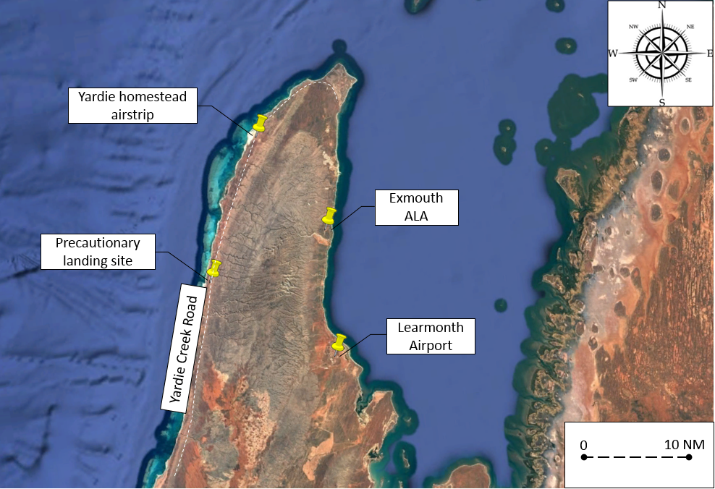

Source: Google earth, annotated by ATSB

### Visual Meteorological Conditions (VMC)

The whale shark spotting flights were local flights in Class G airspace in accordance with VMC procedures. This class of airspace required the following weather conditions when operating an aeroplane below 3,000 ft above mean sea level or below 1,000 ft above ground level, whichever was higher:

* visibility of 5,000 m
* clear of cloud and in sight of ground or water.

The pilots reported that at times when there is low cloud, which prevents them crossing the ranges in VMC, they fly coastal around the peninsula below the cloud base.

### Weather forecast

The pilots’ flight planning included reviewing the Aerodrome Forecast (TAF)[5] for Learmonth Airport and the area forecast (ARFOR).[6] Learmonth was the closest airport to Exmouth ALA with a dedicated weather forecast service and the pilots used the TAF as an indication of local weather conditions for the eastern side of the peninsula. The pilots reported noting the TEMPO periods for reduced cloud base to 800 ft on the TAF (Figure 2).

The highlighted section of Figure 2 indicates the weather may deteriorate for periods between 30 and 60 minutes between 3 July 0800 WST and 4 July 0800 WST for visibility reduced to 3,000 m in rain with a broken[7] cloud base at 800 ft.

Figure 2: Learmonth TAF

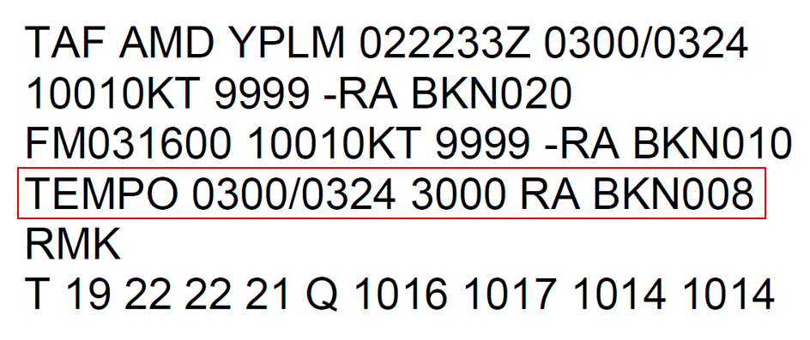

Source: Bureau of Meteorology, annotated by ATSB

The ARFOR indicated rain and low cloud in the area with the possibility of heavy rain offshore. The minimum visibility forecast was 7 km in light rain, reducing to 1,000 m in heavy rain, and the minimum cloud base forecast was broken between 800 ft and 2,000 ft. The forecasted wind was easterly at the surface, but was between north-east and north-west from 1,000 to 10,000 ft.

### Actual weather

At the time of their departure, the pilots noted that the cloud base was ‘well clear’ of the tops of the ranges, which permitted a VMC track to the west from Exmouth ALA. At about 1145, the pilots noted low cloud approaching from the north, which led to their decision to attempt to track south and east across the peninsula.

Figure 3 depicts the rainfall detected by the Learmonth weather radar at 1210, about the time that the pilots conducted their precautionary landing on the west coast.

The pilot of KTL reported that the cloud base was ‘about 300 ft’ and visibility was ‘about 4 km’, but reduced to ‘about 3 km to the north’ at the time of their precautionary landing. The pilot of TDZ, which landed after KTL, reported that the cloud base was ‘about 500 ft’ and visibility was ‘about 2‑3 NM’ at the time of their precautionary landing.

Figure 3: Weather radar image depicting rainfall 1210 WST

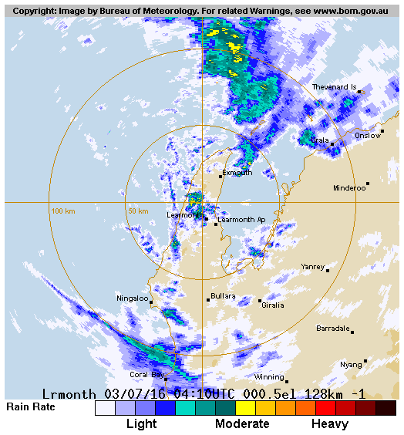

Source: Bureau of Meteorology

## ATSB comment

When the weather deteriorated, the pilots initially attempted to return to Exmouth by tracking across the southern end of the Exmouth peninsula. The deteriorating weather conditions were driven by the northerly winds, which meant that the northern end of the peninsula, including the Yardie homestead airstrip, would be affected by the low cloud and reduced visibility before it reached the southern end of the peninsula.

## Safety action

Whether or not the ATSB identifies safety issues in the course of an investigation, relevant organisations may proactively initiate safety action in order to reduce their safety risk. The ATSB has been advised of the following proactive safety action in response to this occurrence.

### Operator of VH-TDZ

As a result of this occurrence, the aircraft operator of TDZ has advised the ATSB that they have taken the following safety action:

#### Operations manual amendment

The whale shark spotting section of the operations manual was amended to highlight the following:

Pilots are to use their judgement to make an early decision on deteriorating weather conditions. The Yardie Creek Homestead Caravan Park airstrip is to be used as the alternate landing site during periods of rain showers or low cloud and pilots are not to attempt to fly over the range in low cloud.

### Operator of VH-KTL

As a result of this occurrence, the aircraft operator of KTL has advised the ATSB that they are taking the following safety action:

***Operations manual amendment***

Company pilots conducting aerial work operations are to maintain an awareness of meteorological conditions. In the event of deteriorating conditions due to cloud or rain, pilots will make an early decision and depart from the area that is potentially affected by loss of VMC. Pilots are to have an alternate plan in the event of deteriorating weather.

## Safety message

This incident highlights the need for pilots to interpret the weather forecast within the context of their planned operation. In this case the ARFOR indicated low cloud, rain and visibility below VMC could approach their operating area from a northerly direction and affect the pilots’ poor‑weather exit strategy. Fortunately, during their attempt to cross the peninsula, the pilots had a return path to the coast open and were eventually able to safely land on a road and avoid entering instrument meteorological conditions.[8] There are several key factors for a VFR pilot to consider to avoid inadvertently entering IMC, which include:

* thorough pre-flight planning
* having alternate plans in the event of deteriorating weather
* making timely decisions to turn back or divert.

An explanation of what the ARFOR message structure means for pilots is available from the Bureau of Meteorology’s *Aviation Weather Products:* [*Area Forecasts*](http://www.bom.gov.au/aviation/data/education/arfor.pdf).

Further information about pre-flight planning considerations is available from the Civil Aviation Safety Authority’s [*Visual Flight Rules Guide*](http://www.vfrg.com.au/pre-flight-planning/).

## General details

### Occurrence details

|  |  |  |
| --- | --- | --- |
| Date and time: | 3 July 2016 – 1215 WST | |
| Occurrence category: | Incident | |
| Primary occurrence type: | Weather - other | |
| Location: | 22 km WSW of Exmouth ALA, Western Australia | |
|  | Latitude: 22° 06.97’ S | Longitude: 113° 54.15’ E |

### Aircraft details – VH-TDZ

|  |  |  |
| --- | --- | --- |
| Manufacturer and model: | Cessna Aircraft Company 150 | |
| Registration: | VH-TDZ | |
| Serial number: | 15075794 | |
| Type of operation: | Aerial Work - Other | |
| Persons on board: | Crew – 1 | Passengers – 0 |
| Injuries: | Crew – 0 | Passengers – 0 |
| Aircraft damage: | Nil | |

### Aircraft details – VH-KTL

|  |  |  |
| --- | --- | --- |
| Manufacturer and model: | Cessna Aircraft Company 152 | |
| Registration: | VH-KTL | |
| Serial number: | 15285665 | |
| Type of operation: | Aerial Work - Other | |
| Persons on board: | Crew – 1 | Passengers – 0 |
| Injuries: | Crew – 0 | Passengers – 0 |
| Aircraft damage: | Nil | |

## About the ATSB

The Australian Transport Safety Bureau (ATSB) is an independent Commonwealth Government statutory agency. The ATSB is governed by a Commission and is entirely separate from transport regulators, policy makers and service providers. The ATSB's function is to improve safety and public confidence in the aviation, marine and rail modes of transport through excellence in: independent investigation of transport accidents and other safety occurrences; safety data recording, analysis and research; and fostering safety awareness, knowledge and action.

The ATSB is responsible for investigating accidents and other transport safety matters involving civil aviation, marine and rail operations in Australia that fall within Commonwealth jurisdiction, as well as participating in overseas investigations involving Australian registered aircraft and ships. A primary concern is the safety of commercial transport, with particular regard to operations involving the travelling public.

The ATSB performs its functions in accordance with the provisions of the *Transport Safety Investigation Act 2003* and Regulations and, where applicable, relevant international agreements.

The object of a safety investigation is to identify and reduce safety-related risk. ATSB investigations determine and communicate the safety factors related to the transport safety matter being investigated.

It is not a function of the ATSB to apportion blame or determine liability. At the same time, an investigation report must include factual material of sufficient weight to support the analysis and findings. At all times the ATSB endeavours to balance the use of material that could imply adverse comment with the need to properly explain what happened, and why, in a fair and unbiased manner.

## About this report

Decisions regarding whether to conduct an investigation, and the scope of an investigation, are based on many factors, including the level of safety benefit likely to be obtained from an investigation. For this occurrence, a limited-scope, fact-gathering investigation was conducted in order to produce a short summary report, and allow for greater industry awareness of potential safety issues and possible safety actions.

1. Learmonth Airport is the closest airport to Exmouth ALA with a dedicated weather forecast service.
2. A temporary deterioration in the forecast weather conditions, during which significant variation in prevailing conditions are expected to last for periods of between 30 and 60 minutes.
3. Visual Meteorological Conditions is an aviation flight category in which Visual Flight Rules (VFR) flight is permitted – that is, conditions in which pilots have sufficient visibility to fly the aircraft maintaining visual separation from terrain and other aircraft.
4. Several days of whale shark spotting were lost due to inclement weather prior to the day of the incident. The pilots were also aware that the weather conditions forecast for the next few days would unsuitable for further whale shark spotting.
5. Aerodrome Forecasts are a statement of meteorological conditions expected for a specific period of time, in the airspace within a radius of 5 NM (9 km) of the aerodrome.
6. An area forecast issued for the purposes of providing aviation weather forecasts to pilots. Australia is subdivided into a number of forecast areas.
7. Cloud cover is normally reported using expressions that denote the extent of the cover. The expression broken (BKN) indicates that more than half to almost all the sky was covered.
8. Instrument meteorological conditions describes weather conditions that require pilots to fly primarily by reference to instruments, and therefore Instrument Flight Rules, rather than by outside visual references. Typically, this means flying in cloud or limited visibility.