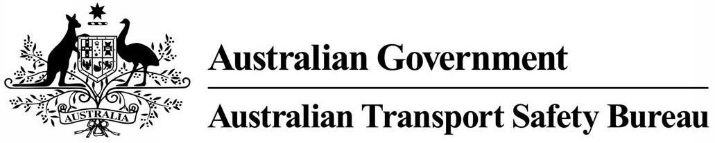
ATSB Transport Safety Report
Rail Occurrence Investigation
RO-2015-024
Final – 21 September 2016
Derailment of intermodal freight train 5PM9
near Rawlinna, Western Australia on 4 December 2015

Cover photo: ATSB

Released in accordance with section 25 of the Transport Safety Investigation Act 2003

Publishing information

Published by: Australian Transport Safety Bureau
Postal address: PO Box 967, Civic Square ACT 2608
Office: 62 Northbourne Avenue Canberra, Australian Capital Territory 2601
Telephone: 1800 020 616, from overseas +61 2 6257 4150 (24 hours)
Accident and incident notification: 1800 011 034 (24 hours)
Facsimile: 02 6247 3117, from overseas +61 2 6247 3117
Email: atsbinfo@atsb.gov.au
Internet: www.atsb.gov.au

© Commonwealth of Australia 2016



Ownership of intellectual property rights in this publication
Unless otherwise noted, copyright (and any other intellectual property rights, if any) in this publication is owned by the Commonwealth of Australia.

Creative Commons licence
With the exception of the Coat of Arms, ATSB logo, and photos and graphics in which a third party holds copyright, this publication is licensed under a Creative Commons Attribution 3.0 Australia licence.

Creative Commons Attribution 3.0 Australia Licence is a standard form license agreement that allows you to copy, distribute, transmit and adapt this publication provided that you attribute the work.

The ATSB’s preference is that you attribute this publication (and any material sourced from it) using the following wording: Source: Australian Transport Safety Bureau

Copyright in material obtained from other agencies, private individuals or organisations, belongs to those agencies, individuals or organisations. Where you want to use their material you will need to contact them directly.

Addendum
Page | Change | Date

Safety summary
What happened
Derailed vehicles looking east
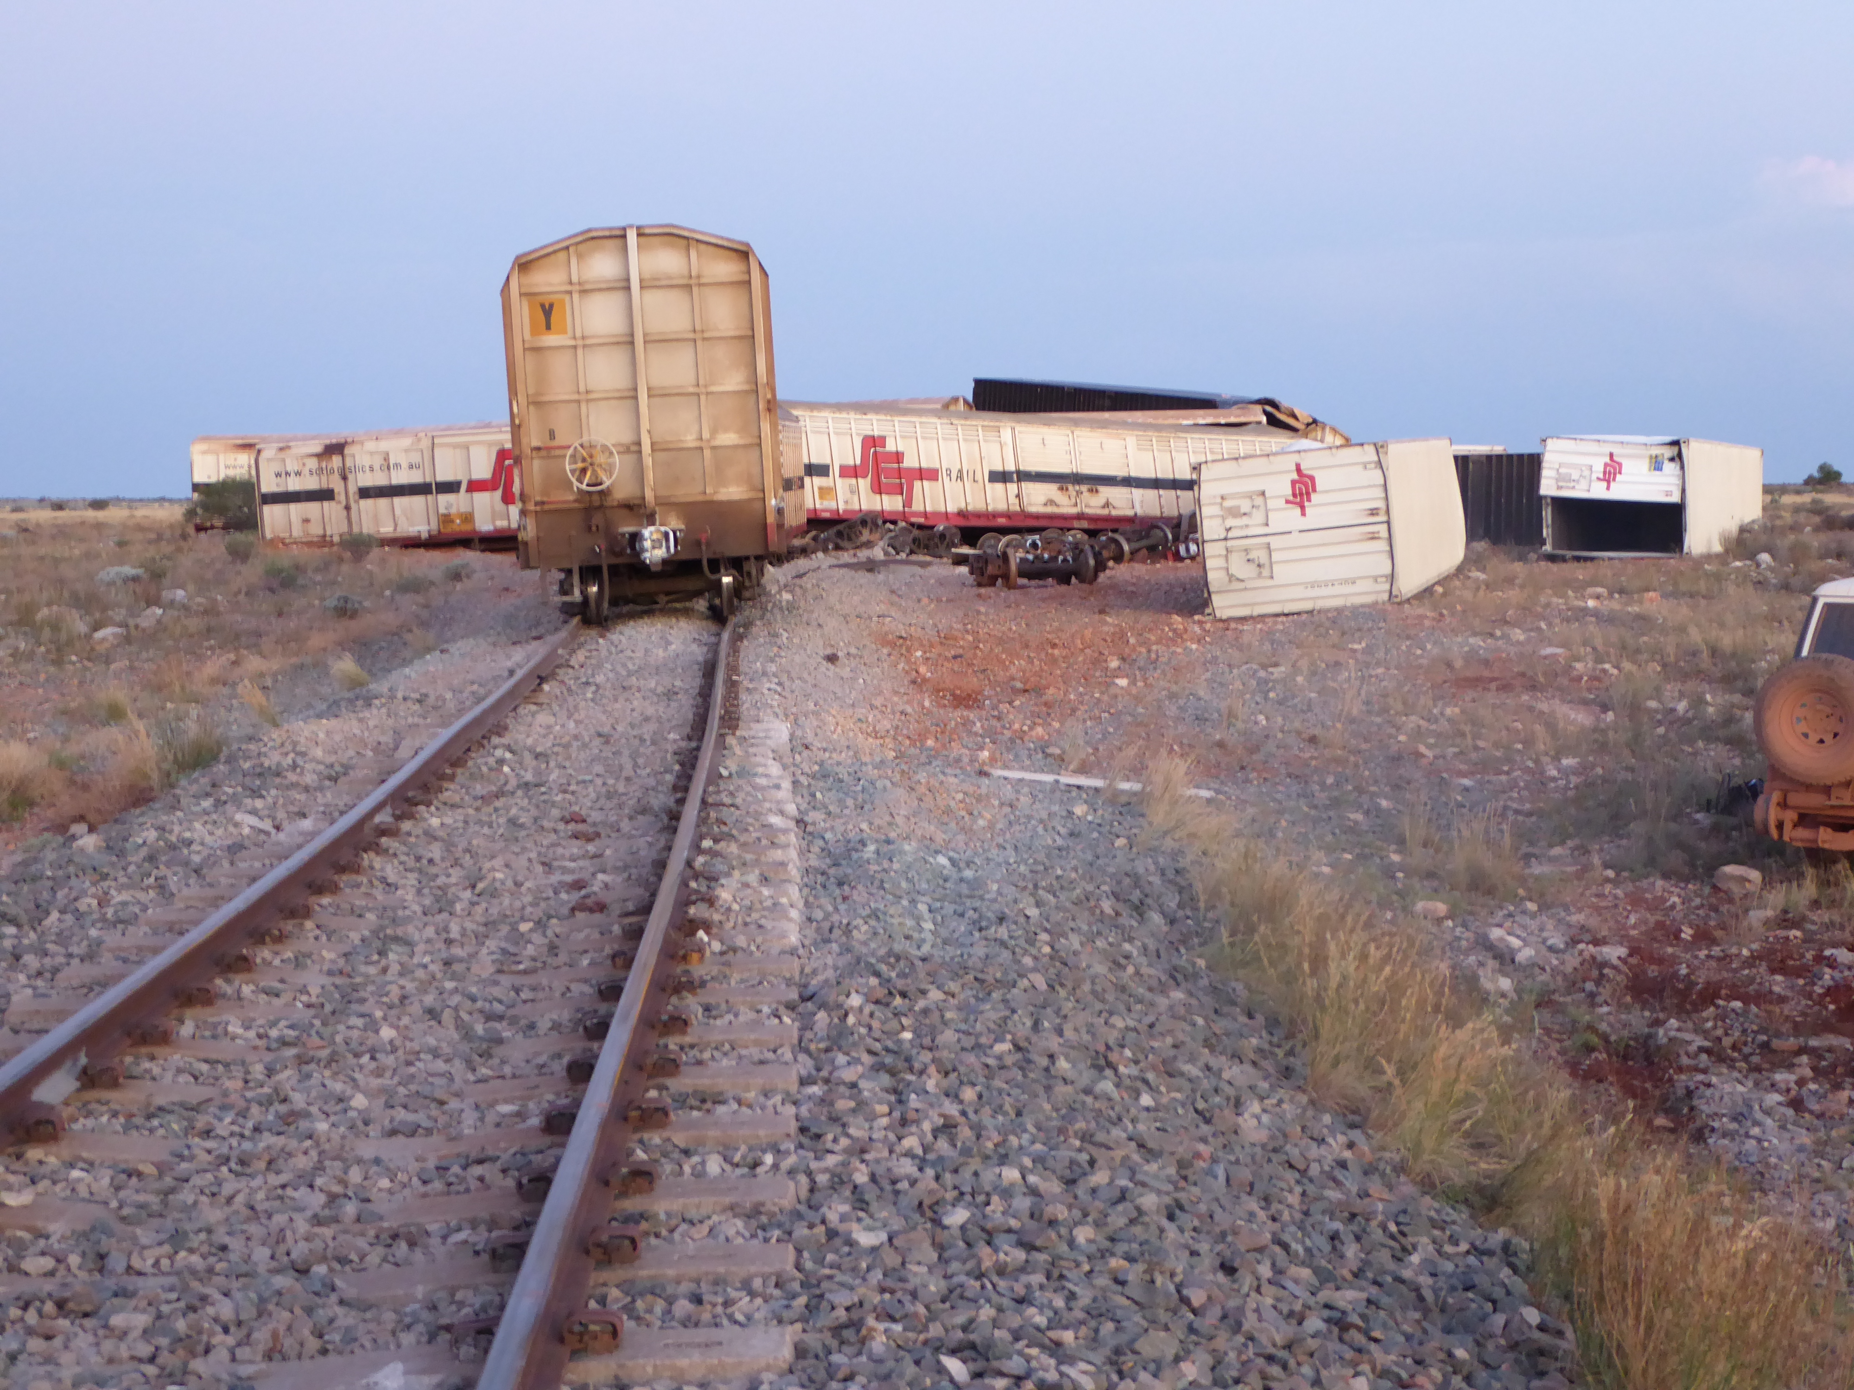
Source: ATSB
At about 1450, near Rawlinna, WA freight train 5PM9 operated by SCT Logistics derailed during a severe storm. There was a combination of 59 vehicles located immediately behind the locomotives. The train broke into two sections, where 39 vehicles had either derailed or overturned, generally to the south side of the track. A fire started within one refrigerated food van about 500 m from the front of the train and later burned itself out. There were no dangerous goods involved in the accident and no fuel spillage.The derailment damaged approximately 550 m of track. There were no physical injuries to the train drivers, but the two relief drivers were badly shaken when the crew van rolled on its side.
What the ATSB found
The ATSB found that the configuration of multiple PBHY ‘High Cube’ vehicles provided a large side surface area that was susceptible to high wind forces. A localised downdraught of cold air in the form of a microburst on the north side (driver side) of the train produced severe winds that were sufficient to initiate the overturning of eight coupled lightly loaded PBHY vehicles. Other laden vehicles, including another eight PBHY vehicles, the crew van and in-line fuel tanker, had progressively derailed and overturned towards the front of the train. These vehicles had derailed through the transference of the rotating force through the couplers, due to rollover of adjacent vehicles.
What's been done as a result
SCT Logistics advised that on 15 December 2015 a rail safety alert was distributed to operations staff advising drivers to slow trains to speeds no greater than 70 km/h when experiencing severe weather conditions involving strong cross winds.
SCT Logistics is also reviewing and amending their Risk Assessment Register – Mainline Operations to include elements of risk to operations due to adverse weather conditions.
The effects of severe weather on safe train operations will be included in a review of driver training modules.
Safety message
This, and similar previous incidents, highlights how rail operators should consider the effects of severe weather conditions involving strong winds and how this can affect the safety of train operations.
Within the geographical regions of their operations, operators should implement risk management strategies to minimise the likelihood of train derailment when severe weather conditions are forecast.

Contents

Contents i
The occurrence 1
Post occurrence 2
Context 5
Location 5
Track information 5
Train and crew of 5PM9 5
Weather 5
Weather Forecast 5
Post event observations 6
Microbursts 7
Local weather observations 8
Track inspections 9
PBHY ‘High Cube’ vehicles 9
Consideration of body roll 10
Consideration of coupled wagons 11
Similar derailments investigated by the ATSB 12
Safety analysis 13
SCT response to severe weather information 13
SCT Logistics assessment of weather risks 14
Driver training 15
Findings 17
Contributing factors 17
Other factors that increased risk 17
Other findings 17
Safety actions 18
Additional safety action 18
General details 19
Occurrence details 19
Train details 19
Sources and submissions 20
Sources of information 20
References 20
Submissions 20
Australian Transport Safety Bureau 21
Purpose of safety investigations 21
Developing safety action 21

The occurrence
SCT Logistics (SCT) train 5PM9 departed Forrestfield (near Perth) on 3 December 2015 and arrived at Kalgoorlie (Figure 1) at 0952 on 4 December.
Weather information released at 0523 on 4 December 2015 had forecast that severe storms would extend from Kalgoorlie to Forrest, Western Australia. The forecast included damaging winds with a high potential of ‘microbursts’ and the possibility of small hail. Temperatures for the region ranged from 36 °C to 40 °C.
Figure 1: Location
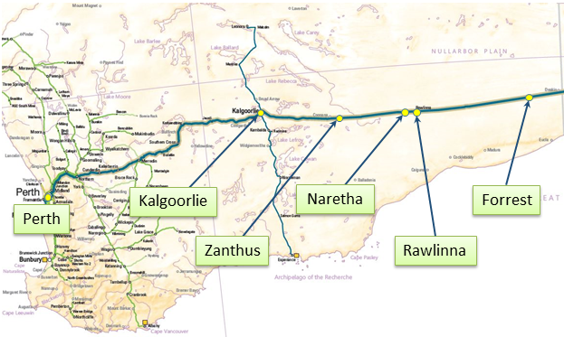
The map illustrates the key locations relevant to the route of train 5PM9. The derailment occurred about 18 km west of Rawlinna.
Source: Base map copyright Australasian Railways Association, annotated by the ATSB.
Train 5PM9 departed Kalgoorlie at 1010 and about 2.5 hours later stopped at Zanthus for a driving crew change. The new driving crew were advised that the air conditioning on lead locomotive SCT 012 had failed. The train departed Zanthus at 1317. While travelling towards Rawlinna, the second driver telephoned the maintenance help desk seeking assistance to rectify the air conditioning failure that saw SCT 012’s cabin temperature rise to 38.8 °C with the windows open.
After departing Naretha at about 1424, the second driver commented to the driver about the lightning and storm to their north that drew closer as the train headed towards Rawlinna.
About five minutes before the accident, the second driver received a call from the maintenance technician who gave options for repairing the air conditioning in the locomotive cabin. The second driver also advised that when he was required to complete safe working paperwork with the windows closed, the cabin temperature would rise to 39.9°C. While the second driver was analysing the air conditioning fault, a gale force northerly wind with heavy rain struck the driver’s side of the locomotive. The drivers said the locomotive lurched violently to the right and left, and it was very noisy with reduced visibility. At the time, the train was travelling at about 94 km/h.
The intensity of the wind was so strong it was forcing rainwater under the (now closed) left side-sliding window into the driver’s cabin. As the driver was reaching for a cloth to stop the water, he felt a bump in the train. Suspecting that he may have knocked the automatic brake handle while reaching for the cloth, he looked at the driver’s console and noticed a flash of the vigilance light.
Both drivers felt a large pull on the train and thought it may have come apart. When seeing the illuminated sanding light on the console and a loss of air, the driver bailed off the independent brake to stretch the train and minimise the risk of derailed trailing vehicles overrunning the crew van and locomotives.
The second driver looked in the rear view mirror, and saw rail vehicles derailing and rolling onto their sides. The first vehicles to derail appeared to be about 10 vehicles behind the locomotives, with subsequent vehicles progressively derailing towards the front of the train. As the train slowed, it jerked backwards and forwards. All the vehicles derailed to the south of the track, including the crew van and in-line fuel tanker coupled immediately behind locomotive SCT 008 (Figure 2).
Figure 2: Leading end of train showing overturned crew van and trailing vehicles.
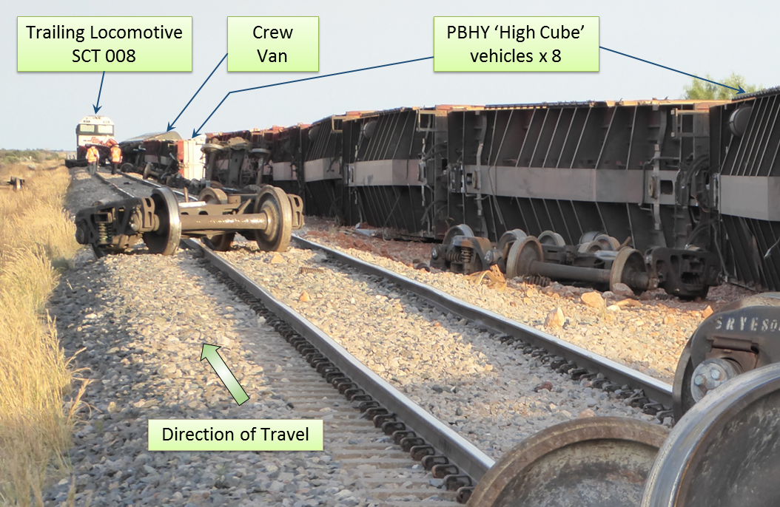
Looking in the direction of travel, this photo shows how the vehicles progressively derailed towards the front of the train while rolling onto their sides south of the track. Source: ATSB:
Data extracted from the locomotives confirmed a steady rise in the airflow volume through the brake pipe indicating that vehicles had separated from the leading end of the train. This lasted for about 26 seconds until the train stopped and the driver moved the throttle to idle. The locomotives had travelled a distance of 472 m from when the airflow volume started to increase. The front of the train came to a stop near the 1420.750 km.

Post occurrence
At about 1451, the second driver made an emergency call on the ICE (In-cab Communications Equipment) radio to the Australian Rail Track Corporation (ARTC) Network Control Officer (NCO) located at Mile End, South Australia. He advised the NCO that train 5PM9 had derailed and that the crew van and in-line fuel tanker had rolled onto their sides and there was a fire in the pileup of vehicles (Figure 3) about 500 m behind the crew van.
At about 1458, the NCO contacted the infrastructure maintainer that was carrying out a track inspection between Rawlinna and Naretha. The NCO requested the maintainer go to the derailment location to assist the train crew. At this time, the maintainer was about 110 km from where the train derailed.
At about 1459, the NCO contacted two signal maintenance workers who were maintaining a point machine at the eastern end of the Rawlinna crossing loop to assist the train crew.
When the drivers alighted the locomotive they described the wind at gale force with heavy rain. They quickly went back with a fire extinguisher to check on the wellbeing of the two drivers that were resting in the crew van. One of the drivers climbed onto the side of the overturned crew van and kicked the jammed doors of the vestibule and kitchen open. He found both drivers were uninjured but badly shaken and assisted their exit onto the ground and to shelter in the cabin of the trailing locomotive.
Figure 3: Panoramic view of derailed vehicles and containers
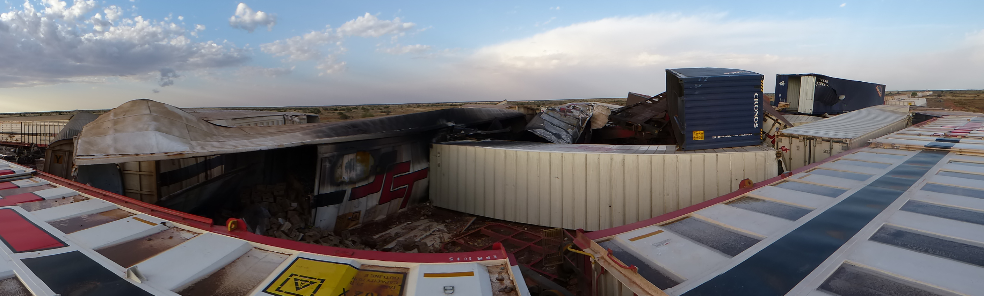
Source: ATSB: Viewed from above train 5PM9 shows where collision damage and a fire has severely damaged some derailed and overturned vehicles. The train was travelling east (right of photo) where all vehicles overturned to the southern side of the track towards trailing locomotive SCT008.
The second driver moved quickly to shut down the generator set that was still powering appliances in the overturned crew van. He then disconnected the fuel lines on the in-line fuel tanker to ensure there was no spillage of diesel.
It was evident that the fire had started in a refrigerated wagon containing food products, probably initiating at the refrigeration unit. The fire was inaccessible for the crew to safely extinguish. The fire subsequently extinguished naturally without spreading to other freight.
The second driver continued to check the train and contacted the ARTC Train Transit Manager (TTM) to update him of the current situation as well as requesting advice about placing protection at each end of the train. At about 1652, he informed the TTM that the rear of the train was protected. The train control graph shows that at 1754 the drivers placed protection at the front of the train. In the meantime, the driver contacted SCT operations centre providing further information about the derailment and state of all drivers.
The signal maintainers, who had already arrived at the derailment site, confirmed that the train crew were uninjured and later contacted the NCO to provided further details of location, vehicles derailed, and the train crew condition. The maintainer also advised that the weather had abated with occasional light rain and winds.
At about 1707, the infrastructure maintainer arrived on site to assist the train crew and assess track damage. Later, with the assistance of the signal maintainers, the crew of train 5PM9 were transported by road to Naretha. At Naretha, they met with Pacific National train 5PS6 that transported the SCT crew back to Kalgoorlie.
On 6 December 2015, the removal of derailed vehicles and track restoration works commenced. To assist the recovery effort and to reduce the amount of time before the resumption of east-west services, track maintenance crews constructed a deviation track on the northern side of the original track alignment to bypass the derailment site. The deviation track opened for traffic about 4 days later on 10 December 2015. On 10 February 2016, with rehabilitation works complete and the new track laid, the deviation track was removed and services recommenced over the original alignment.

Context

Location
Rawlinna is located on the interstate rail network, approximately 375 rail km east of Kalgoorlie, Western Australia (Figure 1). The derailment occurred about 18 km west of Rawlinna near the 1421 km mark.

Track information
The ARTC manages the railway where the derailment occurred, with the movement of rail traffic controlled from the ARTC’s Network Control Centre West located at Mile End in South Australia.
The standard gauge (1435 mm) track at the derailment location consisted of 47 kg/m rail fastened to concrete sleepers by resilient clips. The track formation comprised sand/clay based soil, topped with a capping layer and overlaid with ballast to a nominal design depth of 250 mm – forming the track bed. The track bed supported prestressed concrete sleepers spaced nominally at 667 mm centres.
Approaching from Kalgoorlie, the track through the derailment site was tangent and the terrain was slightly undulating. The track gradient leading to the derailment site transitioned from a gentle rising grade, and was level through the location of the derailment. The maximum track speed was 115 km/h.

Train and crew of 5PM9
Train 5PM9 was a freight service operated by SCT between Perth and Melbourne. The train consisted of two locomotives (SCT012 leading and SCT008 trailing) hauling an in-line fuel tanker, a crew van and 57 freight vehicles. The train was 1390.7 m in length and had a trailing mass of 3060 t.
The crew consisted of four qualified drivers who had commenced duty at Forrestfield, near Perth on 3 December. The plan was for the drivers to work the train in pairs, operating in rotating relay shifts through to Adelaide, South Australia.
The driver and co-driver in charge at the time of derailment had extensive operations and train driving experience. They were assessed as fit for duty in accordance with the requirements of the National Standard for Health Assessment of Rail Safety Workers.
On-site inspection and examination of train data found there was no anomaly in the train speed, train handling, rolling stock condition, or operational performance leading up to the derailment.
No dangerous goods were listed on the consignment sheet for train 5PM9, however there was extensive loss of containment of foodstuffs because of the derailment.

Weather

Weather Forecast
Subscribers to the Early Warning Network (EWN) are provided with a daily Weather Condition overview that is based on information sourced from the Australian Bureau of Meteorology (BoM). The EWN overview issued on 4 December 2015 to the ARTC and SCT at 0523 stated:
Yesterday (3/12/2015) across southern Western Australia severe storms produced a gust of 102km/h at Kalgoorlie. Today severe storms will remain likely but will extend east to Forrest from Kalgoorlie. Damaging wind gusts are the main threats due to the high potential of microbursts but some small hail cannot be ruled out. An extreme fire danger is also current today. Tomorrow expect a few showers and storms to continue east of Zanthus with the further chance that some of these may be severe while some showers and rain/thunder may occur around Kalgoorlie tomorrow night.
The forecast also provided a table of warnings at four prime locations, Kalgoorlie, Zanthus, Rawlinna, and Forrest. All locations had forecast wind speeds of between 15-20 km/h and maximum temperatures between 36 °C and 40 °C. The EWN forecast also alerted subscribing organisations about the ‘high chance of severe storms’ for these four locations.

Post event observations
Commencing at about 1230, thunderstorms progressively developed across the forecast area. Radar images had identified strong cells mainly south and southeast of Kalgoorlie. At about 1400, a thunderstorm developed east of the main activity area peaking between 1440 and 1450. The timing of this thunderstorm corresponds with the time that 5PM9 derailed (Figure 4).
Figure 4: Satellite images
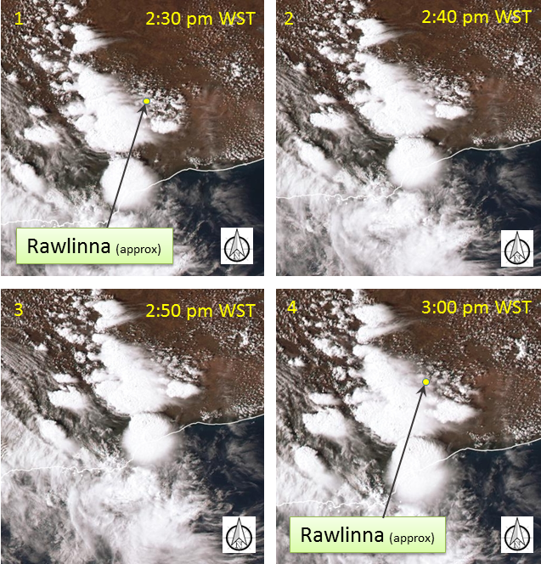
Satellite images showing the cloud masses travelling generally in a south-easterly direction near Rawlinna, WA between 2:30 pm and 3:00 pm (WST) Image Source: Satellite images from Himawari-8 operated by the Japan Meteorological Agency (JMA) and sourced from the Bureau of Meteorology. Annotated by ATSB
At about 1400, the EWN also recorded widespread lightning activity starting at about 40-50 km north of the railway line. The lightning moved slowly in a southerly direction. At about 1440, there was increased intensity near the railway line (Figure 5).
Figure 5: Thunderstorm lightning lifecycle recorded north of Rawlinna, WA – 4 Dec 2015.
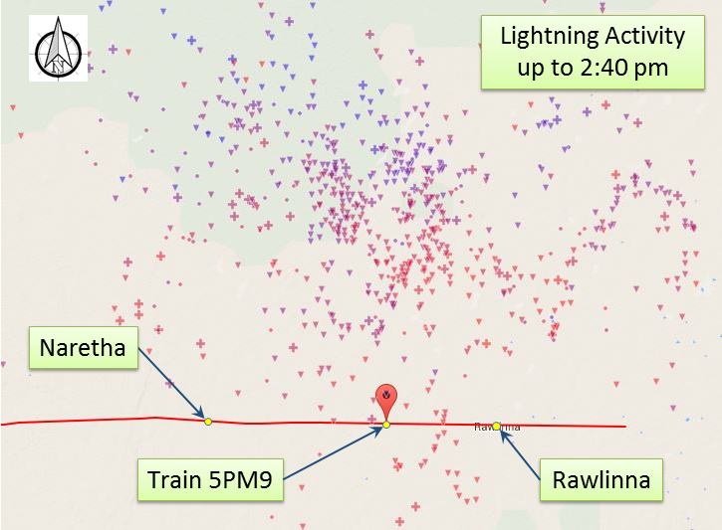
Lightning strikes are displayed as crosses (ground events) or triangles (cloud events). The strikes are colour coded to indicate changes in the time of strike. Blue indicates 60 minutes prior to the image capture and transition to red indicating 30 minutes prior to the image capture. The image illustrates that lightning strikes had moved slowly in a southerly direction towards the railway line.
Image Source: Map data 2015 Google Imagery 2015 TerraMetrics
The EWN reported ‘lightning tends to occur near the transition between the downdraught and updraught indicating the downdraught would have been close to the railway line. At this time, the likely effect would have been a strong out flow of winds and heavy rainfall that could have caused flash flooding.

Microbursts
Intense local weather conditions can often develop that are difficult to detect on standard synoptic charts. A downdraught of cold air usually causes severe winds in thunderstorms. The BoM describes a localised downdraught as downburst, and if they are less than 4 km across, they are referred to as a microburst (Figure 6). Very severe downdraughts (or microbursts) can produce wind speeds of more than 200 km/h while only affecting areas of up to 1 km wide.
Figure 6: Diagram of thunderstorm downdraught/microburst.
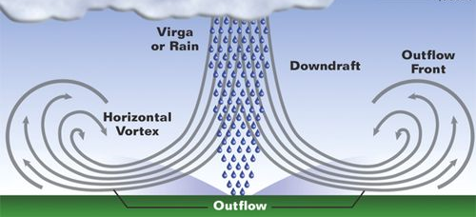
Microbursts often have wind gusts in the 90-100 km/h range – but briefly in small geographic areas. The descending air is forced to spread out laterally near the earth’s surface, often creating severe wind squalls with associated dust.
Source: WDRB Meteorologist Jeremy Kappell.
In this instance the EWN reported that: ‘Severe weather produced was most likely microburst winds. Microbursts often have wind gusts in the 90-100 km/h range – but briefly in small geographic areas’.
The descending air is forced to spread out laterally near the earth’s surface, often creating severe wind squalls with associated dust, similar to that experienced by the crew of train 5PM9.
Wind induced lateral forces, especially that acting on the side of a rail vehicle, contributes significantly to body roll and potential vehicle rollover.
The ATSB closely examined the possibility that the severe environmental conditions at the time of the derailment may have led to a vehicle rollover scenario. Similarly, the factors that serve to resist rollover were also examined.
There was no radar coverage in the vicinity of the derailment site however the ARTC have automatic weather stations located at Rawlinna and Zanthus (Figure 1). Data was recorded at both sites, at 10-minute intervals.
Recordings at Zanthus (about 153 km west of the derailment site), showed the maximum wind speed was 72 km/h at 1430 (about 20 minutes before the derailment). The maximum wind speed 10 minutes before and after this time was no greater than 31km/h.
At the time of the derailment (1450), the maximum wind speed recorded at Rawlinna (about 18 km east of the derailment site) was 15 km/h. Twenty minutes after the derailment (1510), the maximum wind speed at was recorded at 43 km/h.
On 4 December 2015, the recorded average wind direction for both locations was NNE.
Considering the weather systems in the area at the time, it is probable that the downdraught of cold air in the form of a microburst created wind speeds significantly higher than those recorded at the Rawlinna and Zanthus weather stations.

Local weather observations
While working about 18 km east of the derailment site, the two signal maintenance workers observed weather squalls approaching from the north and west. After receiving the call from the NCO requesting their assistance for the crew of 5PM9, the maintenance workers stated that the road was ‘very muddy with large puddles from the recent storm, with water still running along the road a couple of kilometres from the derailment site’. When they arrived at the derailment site about 23 minutes later, they said the storm had passed and reported that ‘it was quite still', and later, ‘there was light rain and wind at times, but not strong’.

Track inspections
The ARTC conducts regular on-track inspections by road / rail vehicles. On the 4 December 2015, the ARTC track inspector commenced a routine on-track inspection and travelled west from Forrest, WA.
At about 1200 the inspector travelled through the locality of Rawlinna. About 20 minutes later the inspector passed the 1421 km mark before taking his vehicle off track near the 1427 km mark to allow for the passage of freight train 5PM1.
Following the derailment later that day, the inspector reported that when travelling through the location of the derailment, near the 1421 km mark:
- the temperature was in upper thirties;
- there were no misalignments;
- no track defects or anything unusual was observed.

PBHY ‘High Cube’ vehicles
Figure 7: Diagram of SCT Logistics PBHY ‘High Cube’ class vehicle.
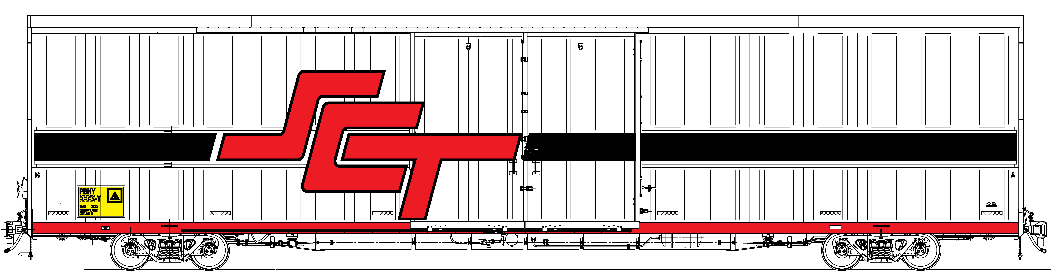
Source: SCT Logistics (diagram not to scale)
In 2005, SCT Logistics (SCT) engaged the Royal Melbourne Institute of Technology University (RMIT) to carry out wind tunnel testing on three rail vehicle profiles. The tests looked at the aerodynamic forces caused by winds that are considered to have a significant influence on vehicle roll-over. Wind tunnel testing determined the relationship between wind angles and the coefficient used to calculate wind force acting on a specific wagon area and shape.
Tests were carried out using 1/15th scale models of a SCT high cube vehicle having a total height of 5590 mm (Figure 7), a ‘high cube’ vehicle with an extra 300 mm added to the roof profile (5890 mm), and a double stacked container well wagon.
The primary objective of the study was to determine if increasing the size of the SCT ‘high cube’ wagon would result in an increased risk of roll-over when compared to commonly used double stacked well wagons. The results of the study also provide the information required for calculating the effects of wind on the wagons involved in the derailment at Rawlinna on 4 December 2015.
Train 5PM9’s consist report shows that the eight PBHY ‘high cube’ vehicles, positioned 13 to 20 behind the locomotive, were unloaded, having a tare weight of 29.60 t each. The total side area of the standard height PBHY vehicle was 105 m² (Figure 8). This configuration is more susceptible to wheel unloading due to wind force. That is, the configuration has a large side surface area, light weight and relatively high centre of side area.
In calculating the percentage of wheel unloading, a simplified method assumes that the vehicle’s centre of mass acts continuously at the centre point between the two rails (that is, the vehicle suspension is rigid and does not permit body roll). For a train travelling at 90 km/h, 100% wheel unloading on a PBHY class of vehicle was calculated to occur when the effective wind speed is about 80 km/h and acting at an angle of between 60 degrees and 80 degrees relative to the direction of travel.
Figure 8: Vehicle profile and side area showing elements used in the estimation of forces acting on a PBHY vehicle.
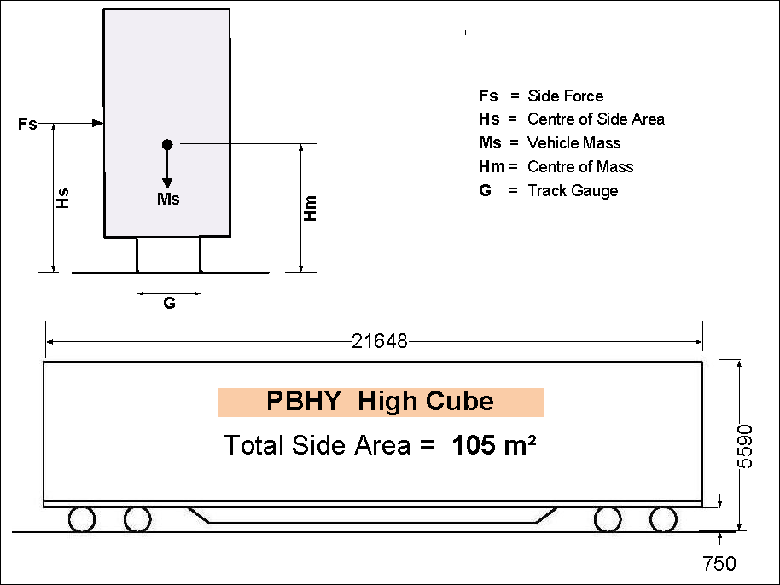

Consideration of body roll
Under normal operating conditions, a vehicle will oscillate on its bogies and suspension, and external forces such as wind loading can increase vehicle body roll from side to side. The consequence of this movement is the vehicle’s combined centre of mass will also shift from side to side, significantly affecting the calculations for predicted rollover risk due to wind. The magnitude of this movement for the same roll angle will increase as the height of the centre of mass increases above rail level. The critical elements are the roll angle and the height of the centre of mass above the rail level.
In this case, the eight-coupled PBHY vehicles (positioned 13 to 20 behind the locomotive) were not loaded. Considering the PBHY vehicle weights documented in SCT’s manifest report for the train, the combined centre of mass was calculated at 1200 mm above rail level. Table 1 illustrates the calculated results for predicted 100% wheel unloading for different roll angles of vehicle tilt.
Table 1: Wind speed and angle for predicted 100% wheel unloading.
Roll angle | Wind speed | Wind Angle
0 degrees | 80 km/h | 80 – 90 deg
5 degrees | 80 km/h | 60 – 70 deg
10 degrees | 70 km/h | 70 – 80 deg
15 degrees | 60 km/h | 60 – 90 deg

There were also eight loaded PBHY vehicles in the consist at the leading end of the train. These were positioned 5 to 12, immediately behind the crew van and coupled in front of the empty PBHY vehicles mentioned above. The gross mass of these vehicles ranged from 79.33 t to 50.37 t, averaging about 64 tonnes each. The centre of mass for this configuration was calculated as increasing to about 2100 mm above rail level.
As described previously, as the height of the centre of mass above the rail level increases, so too does the lateral shift in centre of mass for the same roll angle.
To identify the influence that centre of mass has on wind induced vehicle rollover, calculations were made with the vehicle’s mass increased to 64 t and the centre of mass raised to 2100 mm above the rail level. All other dimensions remained constant.
Table 2 shows the results for predicted 100% wheel unloading at different roll angles when raising the centre of mass to 2100 mm above rail level.
Table 2: Centre of mass lowered to 2.1 m above rail level.
Roll angle | Wind speed | Wind Angle
0 degrees | 120 km/h | 70 – 80 deg
5 degrees | 100 km/h | 70 – 80 deg
10 degrees | 80 km/h | 80 – 90 deg
15 degrees | 60 km/h | 60 – 80 deg

It is evident from the calculations that higher vehicle mass serves to maintain wheel-rail contact at higher wind speeds. However, if a higher mass vehicle begins to tilt, the higher centre of mass serves to increase the potential for wheel unloading and rollover to occur at lower wind speeds.

Consideration of coupled wagons
The second driver described the first wagons to rollover as appearing about 10 vehicles behind the locomotives, suggesting that the empty wagons were most likely the first to derail. This is consistent with the analysis suggesting that lightly loaded wagons were more susceptible to rollover due to strong wind forces.
In this case however, it was also observed that subsequent wagons progressively rolled over towards the front of the train. That is, the loaded wagons considered less susceptible to rollover also began to roll and derail.
It was noted that the couplers on the PBHY wagons involved in this derailment had a bottom retention shelf. Couplers incorporate a bottom shelf to help prevent a mating coupler from falling to the ground, in the event that it had separated from its wagon due to failure. The intent is to reduce the risk of derailment of the following vehicles due to a dislodged coupler passing beneath a wagon.
However, in the context of this derailment, the bottom shelf coupler ensured the adjacent wagon remained coupled during the rollover sequence. This transferred the rotating force between wagons via the coupler. Consequently, the loaded wagons which may have been less susceptible to rollover from wind induced force, also had a rotating force applied through the couplers. This, in conjunction with the higher centre of mass was likely sufficient to cause the progressive rollover of the loaded wagons towards the front of the train consist.

Similar derailments investigated by the ATSB
In its previous published investigations and reports, the ATSB identified a number of factors that should be considered in reducing a vehicle’s risk of wind-induced rollover. These investigations are:

2006012 Tarcoola, South Australia
On 1 November 2006, the ATSB commenced an investigation into a derailment of a freight train near Tarcoola, South Australia. The final report stated it was possible that the combined effects of strong winds at the time and the vehicles’ natural oscillations while travelling could have been sufficient to initiate overturning and derailment of the vehicles lightly loaded with double stacked freight containers. ATSB Tarcoola Investigation Report – RO-2006-012

RO-2008-013 Loongana, Western Australia
On Tuesday 11 November 2008, freight train 2PM6 derailed on the Nullarbor Plain approximately 11 km west of Loongana in Western Australia. The investigation found that the combined effects of atmospheric wind and induced wind due to train movement was likely to have been sufficient to initiate the overturning and subsequent derailment of a lightly loaded, double stacked vehicle and other vehicles. ATSB Loongana Investigation Report – RO-2008-013

RO-2010-012 Cadney Park, South Australia
On Thursday 25 November 2010, freight train 4DA2 derailed on the Central-Australia Railway line, about 5 km south of Cadney Park in South Australia. The investigation determined that a severe weather event, with very strong winds associated with thunderstorm activity, were of sufficient magnitude to initiate the rollover and subsequent derailment of a group of lightly loaded double-stacked container vehicles. ATSB Cadney Park Investigation Report – RO-2010-012
Common elements of each investigation found:
- Severe localised wind events generated from the downdraught of cold air in the form of a microburst had created wind speeds significantly higher than forecast,
- the freight vehicles provided large side profiles that were susceptible to high side wind forces,
- the freight vehicles were lightly loaded or carrying empty double stacked containers and,
- the combined effects of atmospheric wind speeds due to train movement and vehicle body roll were most likely sufficient to initiate the overturning of the lightly loaded freight vehicles.

Safety analysis

SCT response to severe weather information
At about 0915 (ESDT) on 4 December 2015, the SCT Operations Centre in Victoria received a EWN weather forecast report from the ARTC Train Transit Manager advising severe weather conditions for the Kalgoorlie to Forrest track section.
The table attached to the EWN weather forecast included severe weather alerts and comments at key locations along the rail corridor commencing at Kalgoorlie and east to Cootamundra, NSW. The table listed four colour-coded properties that included three alert levels ranging from amber (heightened alert) to black (severe network disruption) (Table 3). The green colour code signifies no threats for a given region.
Table 3: Part table showing severe weather warnings between Kalgoorlie and Forrest issued on 4 December 2015 by the Early Warning Network.
 | Past 24hrs Rainfall | Next 24hrs Rainfall | Forecast Wind Speed | Max Temp | Min Temp | Existing Severe Weather Alerts & Comments | External Alerts
Kalgoorlie | 11mm | 6-12mm | 15-25km/h | 36 | 19 | High chance severe storms | Total Fire Ban  Extreme Fire Danger
Zanthus | 5mm | 5-10mm | 15-25km/h | 37 | 20 | High chance severe storms | Total Fire Ban  Extreme Fire Danger
Rawlinna | 18mm | 2-5mm | 15-25km/h | 38 | 21 | High chance severe storms | Total Fire Ban  Extreme Fire Danger
Forrest | - | - | 15-25km/h | 40 | 23 | High chance severe storms | Total Fire Ban  Extreme Fire Danger

Green | No threats
Amber | Heightened alert
Red | Potential Network disruption
Black | Severe network disruption
The EWN weather forecast also contained weather forecasts for the next two days, Saturday 5 December to Monday 7 December 2015. These three days contained high and extreme temperature alerts, however no severe wind alerts were forecast for this period.
The forecast of severe storms on 4 December stating ‘damaging wind gusts are the main threats due to the high potential of microbursts’ was the prompt for SCT to remain vigilant about the weather threats affecting the safety of their trains travelling through those regions.
RISSB Rail Hazard Register
The Rail Industry Safety and Standards Board (RISSB) is owned by its rail industry members and is responsible for the development and management of rail industry standards, rules, codes of practice and guidelines.
The RISSB has developed a Rail Hazards Register for committees and development groups engaged in the process of developing new RISSB standards.
The items within the RISSB hazards register were compiled with the extensive assistance of rail industry member expertise and also notes that the itemised list is not exhaustive.
The RISSB hazards register was published on17 March 2015. For the specific risk of vehicles overturning, 11 related factors were shown for derailment (5.28). The register also contains references to another RISSB document that uses fault tree diagrams to describe foreseeable hazards and controls. (Table 4).
Table 4: RISSB Rail Hazard Register - Section 5: for Rolling stock, Vehicles overturning (extract).

5.28 Vehicles overturning
5.28.1 Derailment or Collision, Human Error, Track Failure, Track Obstructions, Design Failure, Health Failure, Organisational SMS Failure, Security Breach and or Vandalism
Reference No | Related Factors | RISSB Fault Tree Reference No
5.28.1.1 | Light vehicle masses | 29.4
5.28.1.2 | High centres of gravity | 29.6
5.28.1.3 | Narrow gauges | 29.7
5.28.1.4 | High (cross) wind speeds | 29.8
5.28.1.5 | Large cross-sectional areas | 29.9
5.28.1.6 | Over speed (Overturning at higher speeds to outside of curve) | 29.10
5.28.1.7 | Liquid load moving to one side (Load off to one side) | 29.11
5.28.1.8 | Loads being inadequately restrained (Load off to one side) | 29.12
5.28.1.9 | Poor loading (Load off to one side) | 29.13
5.28.1.10 | Inadequately applied cant (Overturning at higher speeds to outside of curve) | 29.14
5.28.1.11 | Excessively applied cant (Overturning when stationary or at low speed to inside of curve) | 29.15
Items listed in Table 4 that were relevant to the derailment of 5PM9 are 5.28.1.1, 5.28.1.4 and 5.28.1.5.
SCT Logistics is a RISSB member and has ready access to the register for guidance in the management and maintenance of their risk assessment documentation.

SCT Logistics assessment of weather risks
The SCT Logistics Risk Assessment Register – Mainline Operations was compiled in October 2009. At this time, SCT was transitioning from an operator that contracted the services of a ‘hook and pull ’ provider to one that purchased a new locomotive fleet, and directly employed and trained their own train crews.
The SCT risk assessment register identified nine main groups of hazards and risks including:
- Derailment, Train to train collision, Train to object collision, Train collision with infrastructure, Train to motor vehicle collision at level crossing, Fire on train, Explosion on train, Rolling stock runaway and Worker falls from train.
Considering previous similar derailments investigated by the ATSB (noted above) and the derailment of SCT train 3MP9 near Malbooma, SA in 2014, SCT were aware of the derailments and operational hazards associated with weather related events.
SCT’s awareness of weather event risks were not reflected in the risk register and did not identify, assess or record any weather related hazards that could potentially affect the safety of its train operations.
Additionally, although risk management and mitigation notes in SCT’s risk assessment register state that reviews and updates will occur when required or at least annually, the last recorded update to the register was about three years before the derailment of 5PM9 near Rawlinna, WA.

Driver training
SCT contracts Registered Training Organisations (RTO) for the delivery of training for their train crews. The training packages adopted by the RTO’s are developed by the Transport and Logistics Training Skills Council (TILSC).
A review of qualifications achieved by SCT driving crews show two TILSC modules that were likely to include training elements about the awareness of specific weather conditions that may affect the safety of train operations. The modules were titled Responding to abnormal situations and emergencies when driving a train (TLIF4110) and Operate train with due consideration of route conditions (TLIC4023).
An examination of the TILSC documentation shows them to be a framework of qualifications which generally reference a client organisation’s documented procedures and instructions. For example, TLIF4110 includes two elements referring to the identification and response to abnormal situations.
- Identify abnormal situations and emergencies when driving a train.
  - Implications of abnormal situations and emergencies are evaluated in accordance with workplace requirements, and safe working requirements and procedures.
  - Hazards are identified, risks are assessed, and risk control measures are implemented.
- Respond to abnormal situations when driving a train.
  - Abnormal situations are responded to in accordance with organisational procedures, received instructions from relevant personnel, regulatory requirements and emergency response plan, as required.
  - Responsibilities are fulfilled in accordance with organisational procedures, and safe working and/or regulatory requirements.
  - Information is provided to relevant personnel as requested in accordance with regulatory and organisational procedures.
In each case, the performance criteria is generalised and refers to information that should be included within individual organisational procedures. Consequently, the RTO would require the organisational procedures to ensure that specific organisational needs are combined within the driver training modules.
Extreme weather events such as damaging winds, rain and flooding, are conditions that a driver may be required to identify and respond to ensure safety of train operations. Experienced train drivers are generally aware of the effects of wind on their train, however train handling in extreme weather was not included within TLI training or SCT documents.
Before the derailment of train 5PM9, SCT had not developed procedures defining the effects of extreme weather events related to the operation of their freight train services. Consequently, SCT locomotive drivers did not receive formal training with respect to understanding severe weather events, the associated risk of these events, and risk mitigation strategies to minimise the likelihood of train derailment.

Findings
From the evidence available, the following findings are made with respect to the derailment of train 5PM9 near Rawlinna, Western Australia on 4 December 2015. These findings should not be read as apportioning blame or liability to any particular organisation or individual.
Safety issues, or system problems, are highlighted in bold to emphasise their importance. A safety issue is an event or condition that increases safety risk and (a) can reasonably be regarded as having the potential to adversely affect the safety of future operations, and (b) is a characteristic of an organisation or a system, rather than a characteristic of a specific individual, or characteristic of an operating environment at a specific point in time.

Contributing factors
- The PBHY ‘High Cube’ vehicles provided a large side surface area that was susceptible to high wind forces and subsequent wheel unloading.
- It is probable that the downdraught of cold air in the form of a microburst near Rawlinna, WA created wind speeds significantly higher than the winds recorded at the ARTC weather stations located at Rawlinna and Zanthus.
- The combined effects of atmospheric wind, induced wind due to train movement and vehicle body roll, was very likely to have initiated the overturning of the lightly loaded, coupled group of PBHY vehicles.
- It is likely that the transference of rotating force through the couplers, due to rollover of adjacent vehicles, contributed to the rollover of the loaded PBHY vehicles, crew van and in-line fuel tanker.

Other factors that increased risk
- The SCT Logistics Risk Assessment Register – Mainline Operations was not updated in accordance with the SCT safety management system and did not identify and assess extreme weather hazards that could affect safe operations of their intermodal freight train services.
- The SCT Logistics locomotive drivers received no formal training with respect to understanding severe weather events, the associated derailment risk, and mitigation strategies to minimise the likelihood of derailment.

Other findings
- Rail vehicles that are loaded will generally display a greater resistance to wheel unloading and wind induced rollover.

Safety actions

Additional safety action
Whether or not the ATSB identifies safety issues in the course of an investigation, relevant organisations may proactively initiate safety action in order to reduce their safety risk. The ATSB has been advised of the following proactive safety action in response to this occurrence
Additional safety action taken by SCT Logistics
On 15 December 2015, SCT Logistics issued a safety alert (1215-01) to train crews and rail managers advising that to reduce the risk of a rollover/derailment:
- ‘the combination of high cross winds with trains travelling at track speeds hauling empty wagons may increase the risk of rollover/derailment. These events are extremely difficult to predict with any accuracy in advance of the occurrence’.
- ‘Initial engineering advice is that the risk of rollover/derailment is reduced by decreasing speed’.
- ‘As a precaution, it is recommended that drivers reduce their train speed to 70 km/h when experiencing severe weather conditions involving strong cross winds. Once clear of these conditions normal track speed may be resumed’.

SCT Logistics is also reviewing and amending the Risk Assessment Register – Mainline Operations to include elements of risk to operations due to adverse weather conditions.
The effects of severe weather on safe train operations will be included in a review of driver training modules.

General details

Occurrence details
Date and time: | 4 December 2015 – 1450 WST
Occurrence category: | Accident
Primary occurrence type: | Derailment
Location: | At about 1421 km mark, Rawlinna, WA
 | Latitude: 31º 0.383' S | Longitude: 125º 8.495' E

Train details
Train operator: | SCT Logistics
Registration: | 5PM9
Type of operation: | Intermodal Freight
Persons on board: | Crew – 4
Injuries: | Crew – Nil
Damage: | Substantial

Sources and submissions

Sources of information
The sources of information during the investigation included:
- SCT Logistics
- The Australian Rail Track Corporation
- The Australian Bureau of Meteorology
- The Early Warning Network (EWN) weather warning subscription service.
- The drivers of train 5PM9

References
ATSB Investigation: 2006012 - Derailment of Train 3DA2K – Tarcoola, South Australia, 1 November 2006.
ATSB Investigation: RO-2008-013 - Derailment of train 2PM6 – near Loongana, Western Australia, 11 November 2008.
ATSB Investigation: RO-2010-012 - Derailment of freight train 4DA2 near Cadney Park, South Australia, 25 November 2010.
ATSB Investigation: RO-2014-006 - Derailment of freight train 3MP9 near Malbooma, SA on 10 April 2014
Australian Standard AS 7509.2, Railway Rolling Stock - Dynamic Behaviour - Part 2: Freight Rolling Stock.
Australian Industry and Skills Committee, TLIC4023 - Operate train with due consideration of route conditions
Australian Industry and Skills Committee, TLIF4110 - Responding to abnormal situations and emergencies when driving a train
Australasian Railways Association, Railways of Australia Map.
Rail Industry Safety and Standards Board (RISSB) – Australian Code of Practice – Loading of Rail Freight – May 2011.
RISSB Glossary of Railway Terminology ver1 December 2010
RMIT University, An Experimental Investigation of Aerodynamic Properties for Rollover Risk of Double Stacked Container Wagons.
Satellite images from Himawari-8 operated by the Japan Meteorological Agency (JMA) and sourced from the Australian Bureau of Meteorology.

Submissions
Under Part 4, Division 2 (Investigation Reports), Section 26 of the Transport Safety Investigation Act 2003 (the Act), the Australian Transport Safety Bureau (ATSB) may provide a draft report, on a confidential basis, to any person whom the ATSB considers appropriate. Section 26 (1) (a) of the Act allows a person receiving a draft report to make submissions to the ATSB about the draft report.
Submissions were received from SCT Logistics, the Australian Rail Track Corporation and ONRSR. The submissions were reviewed and where considered appropriate, the text of the report was amended accordingly.

Australian Transport Safety Bureau
The Australian Transport Safety Bureau (ATSB) is an independent Commonwealth Government statutory agency. The ATSB is governed by a Commission and is entirely separate from transport regulators, policy makers and service providers. The ATSB’s function is to improve safety and public confidence in the aviation, marine and rail modes of transport through excellence in: independent investigation of transport accidents and other safety occurrences; safety data recording, analysis and research; fostering safety awareness, knowledge and action.
The ATSB is responsible for investigating accidents and other transport safety matters involving civil aviation, marine and rail operations in Australia that fall within Commonwealth jurisdiction, as well as participating in overseas investigations involving Australian registered aircraft and ships. A primary concern is the safety of commercial transport, with particular regard to operations involving the travelling public.
The ATSB performs its functions in accordance with the provisions of the Transport Safety Investigation Act 2003 and Regulations and, where applicable, relevant international agreements.

Purpose of safety investigations
The object of a safety investigation is to identify and reduce safety-related risk. ATSB investigations determine and communicate the factors related to the transport safety matter being investigated.
It is not a function of the ATSB to apportion blame or determine liability. At the same time, an investigation report must include factual material of sufficient weight to support the analysis and findings. At all times the ATSB endeavours to balance the use of material that could imply adverse comment with the need to properly explain what happened, and why, in a fair and unbiased manner.

Developing safety action
Central to the ATSB’s investigation of transport safety matters is the early identification of safety issues in the transport environment. The ATSB prefers to encourage the relevant organisation(s) to initiate proactive safety action that addresses safety issues. Nevertheless, the ATSB may use its power to make a formal safety recommendation either during or at the end of an investigation, depending on the level of risk associated with a safety issue and the extent of corrective action undertaken by the relevant organisation.
When safety recommendations are issued, they focus on clearly describing the safety issue of concern, rather than providing instructions or opinions on a preferred method of corrective action. As with equivalent overseas organisations, the ATSB has no power to enforce the implementation of its recommendations. It is a matter for the body to which an ATSB recommendation is directed to assess the costs and benefits of any particular means of addressing a safety issue.
When the ATSB issues a safety recommendation to a person, organisation, or agency, they must provide a written response within 90 days. That response must indicate whether they accept the recommendation, any reasons for not accepting part or all of the recommendation, and details of any proposed safety action to give effect to the recommendation.
The ATSB can also issue safety advisory notices suggesting that an organisation or an industry sector consider a safety issue and take action where it believes it appropriate. There is no requirement for a formal response to an advisory notice, although the ATSB will publish any response it receives.

The 24 hour clock is used in this report to describe the local time of day, Western Standard Time (WST)
Weather information provided by the Early Warning Network (EWN) is an online weather warning subscription service.
A microburst is a small column of exceptionally intense and localised sinking air that results in a violent outrush of air at the ground.
Bail off is a term used to describe the action of: 1) preventing the locomotive(s) brakes from applying automatically during a train brake application, or 2) releasing the locomotive(s) independent braking during a train brake application.
Distance in rail kilometres from the reference point located at Coonamia, South Australia.
Straight track with no applied cant.
A measure of the rate at which the railway is inclined (rising or falling). Gradients are signed +ve (rising) or –ve (falling) in respect of the direction of travel.
Tests were conducted by the School of Aerospace, Mechanical and Manufacturing Engineering at RMIT University for SCT Logistics prior to production of the SCT PBHY High Cube vehicle fleet.
The effective wind speed is a calculation that considers both the speed/direction of the train and the atmospheric wind speed/direction.
Wind angle describes crosswind yaw angle in the direction of train travel. Results were derived from calculations under a range of crosswind yaw angles, from a full head wind to a crosswind (10-degree increments, 0–90 degrees).
Rolling stock and locomotives are owned by SCT Logistics however; a third party contracts train crews and train operating functions.
RO-2014-006 Derailment of freight train 3MP9 near Malbooma, SA on 10 April 2014
The Transport and Logistics Industry Skills Council is one of 11 independent, not-for-profit Industry Skills Councils established by the Australian Government.

