
ATSB Transport Safety Report
Rail Occurrence Investigation
RO-2015-016
Final – 29 July 2016

Collision involving road-train truck and train 8834N
near Narromine, New South Wales, 23 September 2015

Cover photo: P. Smith

Released in accordance with section 25 of the Transport Safety Investigation Act 2003

Publishing information

Published by: Australian Transport Safety Bureau
Postal address: PO Box 967, Civic Square ACT 2608
Office: 62 Northbourne Avenue Canberra, Australian Capital Territory 2601
Telephone: 1800 020 616, from overseas +61 2 6257 4150 (24 hours)
Accident and incident notification: 1800 011 034 (24 hours)
Facsimile: 02 6247 3117, from overseas +61 2 6247 3117
Email: atsbinfo@atsb.gov.au
Internet: www.atsb.gov.au

© Commonwealth of Australia 2016



Ownership of intellectual property rights in this publication
Unless otherwise noted, copyright (and any other intellectual property rights, if any) in this publication is owned by the Commonwealth of Australia.

Creative Commons licence
With the exception of the Coat of Arms, ATSB logo, and photos and graphics in which a third party holds copyright, this publication is licensed under a Creative Commons Attribution 3.0 Australia licence.

Creative Commons Attribution 3.0 Australia Licence is a standard form license agreement that allows you to copy, distribute, transmit and adapt this publication provided that you attribute the work.

The ATSB’s preference is that you attribute this publication (and any material sourced from it) using the following wording: Source: Australian Transport Safety Bureau

Copyright in material obtained from other agencies, private individuals or organisations, belongs to those agencies, individuals or organisations. Where you want to use their material you will need to contact them directly.

Addendum
Page | Change | Date

Safety summary
What happened
Road-train truck at collision site
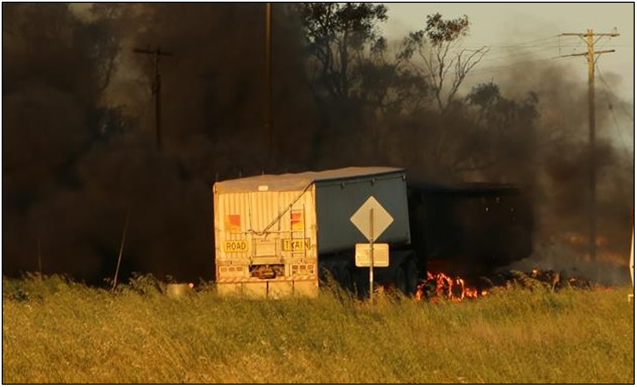
Source: P. Smith
On 23 September 2015, an eastbound road-train truck, hauling grain, collided into the side of Pacific National grain train 8834N, (travelling on the main line between Narromine and Peak Hill) at the Tullamore – Narromine Road railway crossing, about 4 km southwest of Narromine, in New South Wales. The railway crossing was controlled by flashing lights, an audible warning device (bell); passive warning signs installed on the road approaches and road surface markings.
The collision and a post-impact fire destroyed the prime mover and one of the two trailers; the truck driver was fatally injured. The crew of the train were physically unhurt. As a result of the impact two wagons, were damaged, one of which derailed. Some of the railway crossing infrastructure (flashing lights) was destroyed and required replacement.
What the ATSB found
The ATSB found that the driver of the road-train truck was probably travelling too fast for the prevailing conditions, and entered the Tullamore – Narromine Road railway crossing while it was active, and the flashing lights were operating. It was concluded that the truck driver’s attention was probably focussed on negotiating the sweeping right-hand curve that preceded the crossing, at a critical time when he needed to check for the activation of the crossing. It is likely that when the driver perceived that the flashing lights were operating, he was too close to the crossing to stop, and collided with the train.
The ATSB identified a number of areas of potential improvement related to road design (signage and standards associated with railway crossing traffic control) especially with respect to curved approaches, before railway crossings.
What's been done as a result
Furney Flour Mills, the Narromine Shire Council, and Standards Australia have implemented a range of initiatives to reduce the risk of a similar occurrence in the future, including:
- enhanced employee training and medical assessment initiatives
- provision of additional (road) approach passive warning signs, (W7-4) plus a review of road alignment and railway crossing road approach speeds
- a review of AS 1742.7-2016, with respect to railway crossing approaches, in particular curved approaches, and the location of signage.
Safety message
Although the road rules (NSW - Road Rules 2014) make motorists primarily responsible for avoiding a collision with a train at railway crossings, prudent road design and/or advance warning of a train’s presence at railway crossings should be considered as a strategy to lower the risk of road and rail vehicle collisions.
Road and rail authorities should consider added measures to enhance the situational awareness of motorists approaching railway crossings, especially at locations with restricted sighting due to curved approach roads.
It is imperative that road vehicle drivers always approach railway crossings with extreme care. The level of care and attention required increases as road vehicle gross mass increases.

Contents
The occurrence 1
Post-occurrence 6
Context 7
Location 7
Train and Crew 7
Road-train truck information 7
Truck driver information 8
Environmental conditions 8
Railway crossing protection and risk control 8
Traffic control at the Tullamore - Narromine Road railway crossing 9
ALCAM survey, Tullamore – Narromine Road railway crossing 12
Previous occurrences 13
Rail/Road interface coordination planning 13
Safety analysis 14
Introduction 14
Factors influencing the truck driver’s behaviour 14
Driver competence 14
Medical and toxicology 15
Fatigue 15
Conspicuity 16
Expectancy 18
Distraction and workload 18
Austroads - Railway crossings and heavy vehicle studies 20
Findings 22
Contributing factors 22
Other factors that increased risk 22
Other findings 22
Safety actions 24
General details 26
Occurrence details 26
Train details 26
Road-train truck details 26
Infrastructure 26
Sources and submissions 27
Sources of information 27
References 27
Submissions 28
Australian Transport Safety Bureau 29
Purpose of safety investigations 29
Developing safety action 29

The occurrence
At 0615 on 23 September 2015, the truck driver involved in the occurrence commenced work from his home depot in Dubbo, New South Wales. During the first part of the morning, he worked an International T-line series truck from Dubbo to Narromine (Figure 1) and return.
Figure 1: Location of Dubbo, Narromine and Peak Hill, New South Wales
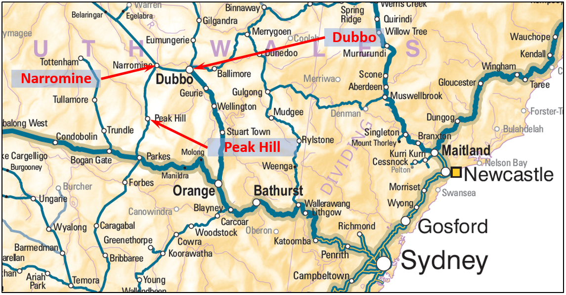
Source: NatMap, Geoscience Australia
Later that morning, about 0930, he set off for a property near Brown’s Lane Road, (about 84.5 km southwest of Dubbo) in a road-train truck to collect a load of grain. He arrived at the property about one hour later. When the truck was loaded, he returned to Dubbo, arriving about 1230. While enroute he passed through the Tullamore - Narromine Road railway crossing (Figure 2).
Figure 2: Road-train truck route from property off Brown’s Lane Road to Dubbo
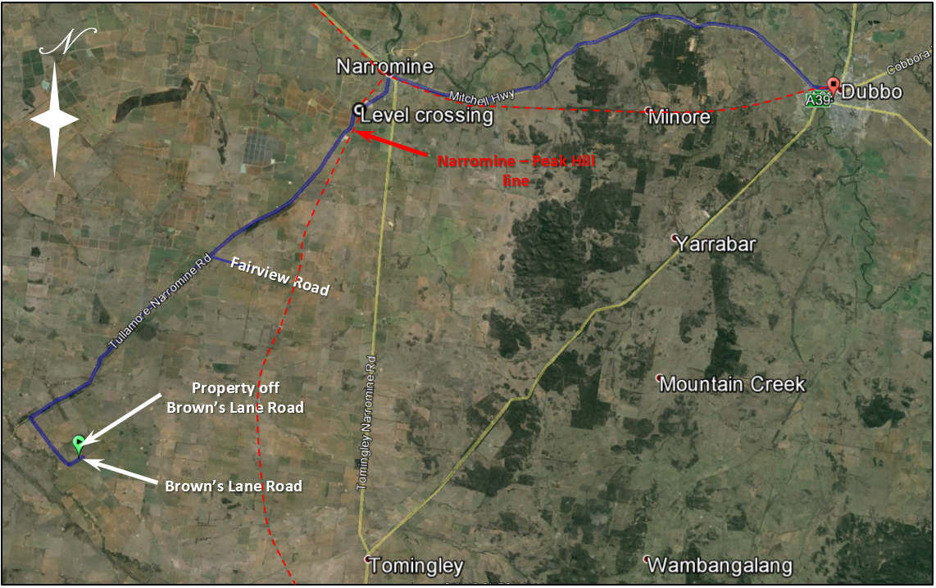
Source: Google Maps, with annotation ATSB
At about the time the truck driver returned to Dubbo (1230) the two train drivers involved in the occurrence had signed on for duty at the Pacific National Parkes Depot in New South Wales. They were rostered to work train 8834N from Nyngan to Manildra. After signing on, they travelled by car from Parkes to Nyngan. While in transit, they were directed to join train 8834N near Nevertire. At 1456, train 8834N stopped before reaching Nevertire, to facilitate the crew changeover. Following the crew change and the train driver completed air brake validation checks, the train departed for Nevertire at 1508. At nearly the same time, the truck driver set off for the Brown’s Lane property, to collect a second load of grain. The truck driver arrived at the Brown’s Lane property about 1610.
At 1636 train, 8834N arrived at and commenced shunting operations within the Narromine yard.
After taking on the second load of grain and completing safety checks, the truck driver was ready to depart the Brown’s Lane property. At about 1644, he received a phone call from a work colleague at Dubbo. The discussion concluded about 2 minutes later (1645:58), after which the truck driver set off for Dubbo.
At about 1705, the driver of a motor vehicle (witness), about to enter the Tullamore - Narromine Road from Fairview Road, (Figure 2) observed the road-train truck coming from the southwest, towards him. He let the truck pass and when safe to do so, entered the Tullamore - Narromine Road.
By this time, train 8834N had completed all shunting operations. At 1707:53 as train 8834N departed Narromine for Peak Hill, the truck was about 12.7 km from the railway crossing.
As 8834N approached the Tullamore - Narromine Road level crossing, the train driver observed the ‘Main Line Indicator’ displaying a pulsating white light, signifying that the level crossing equipment was set for the passage of the train. At 1714:53, with the train heading in a south-westerly direction, (610 m from the railway crossing) the flashing lights began to operate. The truck was now about 950 m from the crossing. The truck continued to approach the crossing with the witness vehicle close behind. At a distance of about 300 m from the railway crossing, (Figure 3 and Figure 4) the truck entered a sweeping right hand curve (85 km/h advisory speed limit); the flashing lights continued to operate. The train driver sounded the locomotive horn when the train was about 200 m from the railway crossing. As the truck continued to progress through the right hand curve, the witness behind noted that the truck was travelling ‘really quickly’, and not slowing for the railway crossing.
Figure 3: Aerial view, truck about 300m from railway crossing
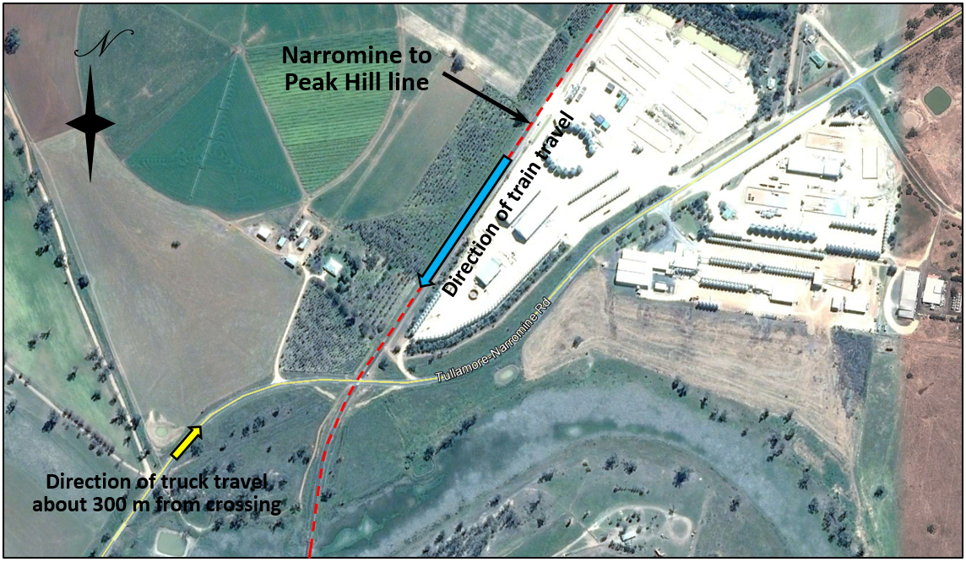
Source: Google Maps, with annotation ATSB
Figure 4: View approaching railway crossing at 300 m (Inset 30 x zoom)
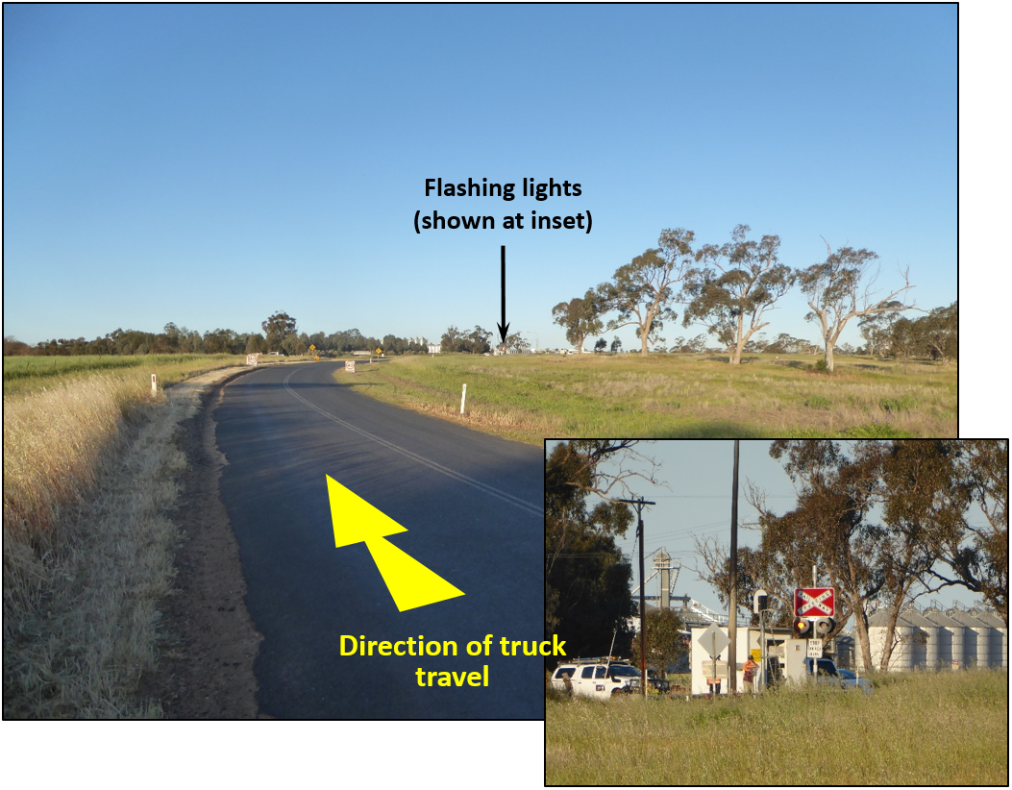
Source: ATSB
At a distance of about 180 m from the railway crossing, (Figure 5 and Figure 6) it is likely the truck driver perceived the operation of the flashing lights, and made an emergency brake application. The witness behind saw the road-train truck brake heavily; smoke billowed from the tyres. Skid marks from the truck were evident about 84 m before the railway crossing (Figure 7).
Figure 5: Aerial view, truck about 180m from railway crossing
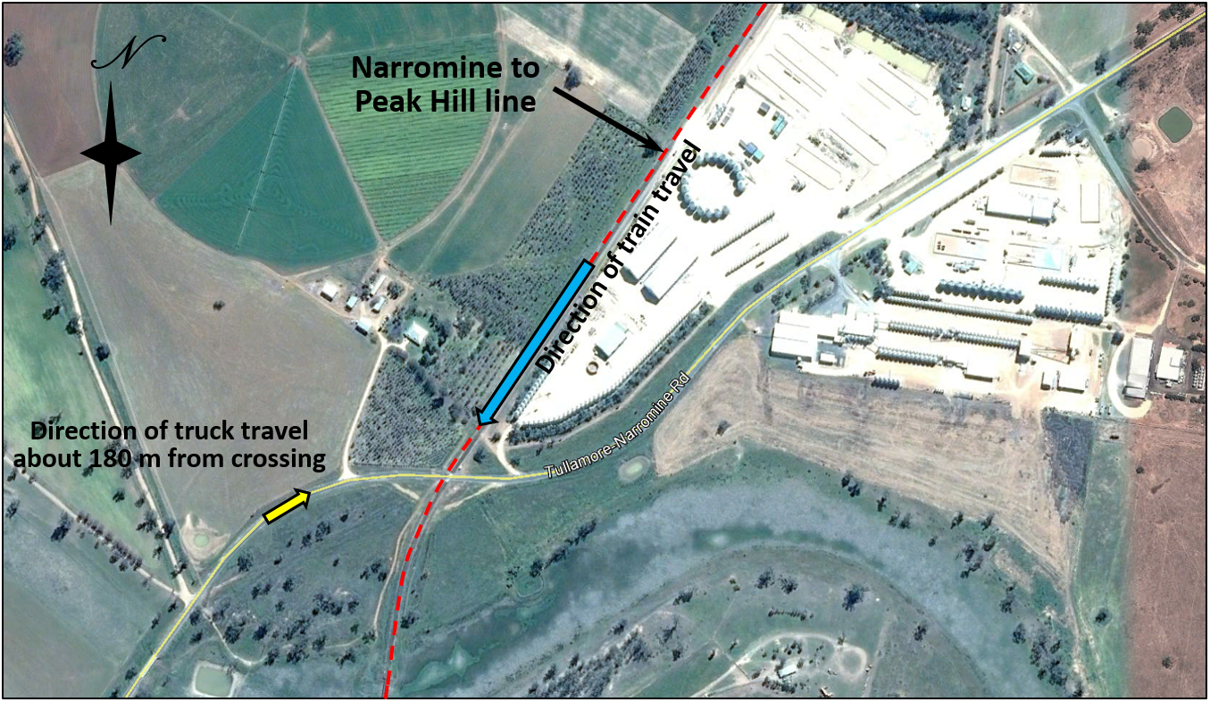
Source: Google Maps, with annotation ATSB
Figure 6: View approaching railway crossing at 180 m (Inset 30 x zoom)
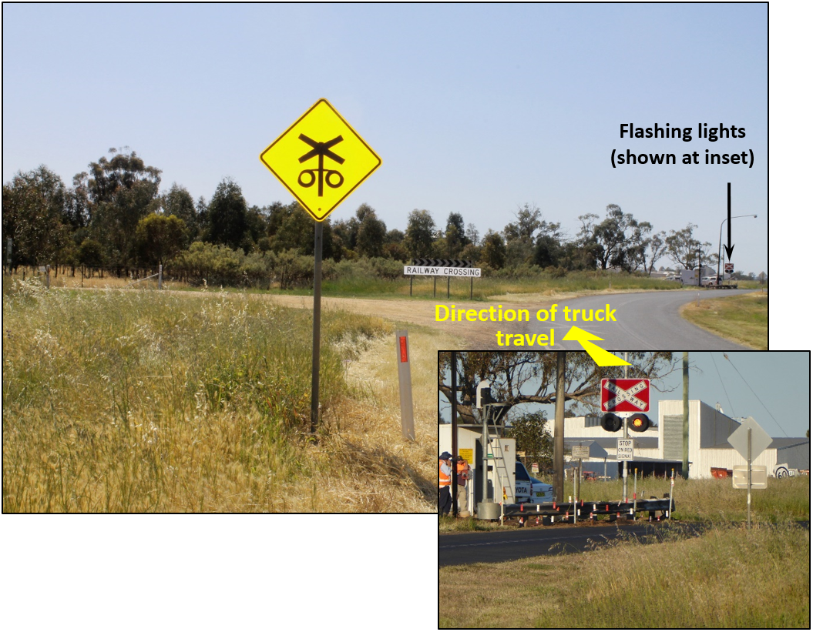
Source: ATSB
Figure 7: View approaching railway crossing at 84 m, evidence of skid marks from road-train truck
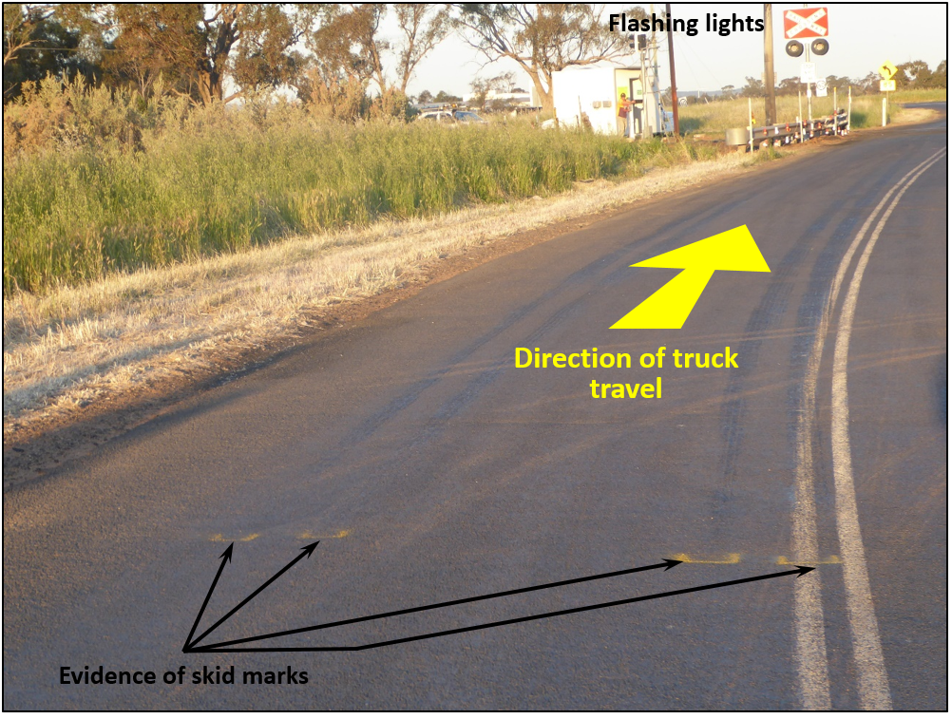
Source: ATSB
At this time, train 8834N was about 60 m from the railway crossing. The train driver again sounded the locomotive horn. The train began to clear an area of low trees and shrubs that was restricting the southwest view of the Tullamore – Narromine Road. Just as the train cleared the vegetation, the two train drivers saw the fast approaching road-train truck. Smoke was billowing from the tyres. The truck was clearly travelling too fast to stop, and a collision was imminent. The train driver made an emergency brake application and sounded the train horn continuously.
The truck rapidly approached the railway crossing before colliding with train 8834N (1715:31) between the second and third wagons. At the time of collision, the train was travelling at 60 km/h. Truck parts scattered in all directions, but generally along the line of train travel. The force of the collision crushed the prime mover’s bodywork and ruptured its fuel tanks, which subsequently caught fire. The motorist (witness) directly behind the truck, pulled over and ran towards the prime mover cabin. The truck driver was not moving, and appeared fatally injured. The witness tried to extract the truck driver from the crushed cabin, but retreated when flames engulfed the cabin (Figure 8).
Figure 8: Post-collision fire, road-train truck (trailers) at Tullamore – Narromine Road railway crossing
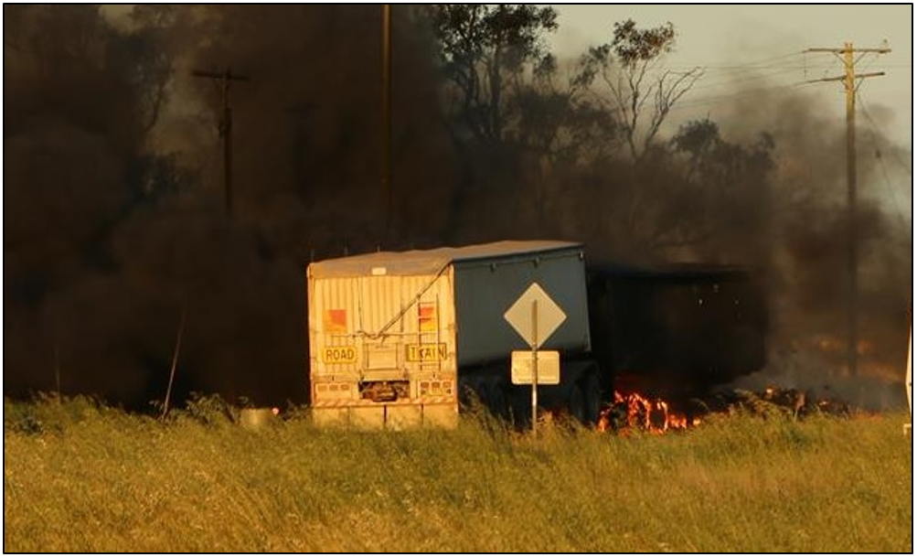
Source: P. Smith
During this time, train 8834N continued under emergency brake application, the train split behind the first wagon (Figure 9). The locomotive came to a stand 777 m beyond the crossing. The second wagon was derailed by the collision, it continued upright along the track, coming to a stand about 551 m beyond the crossing. The train’s second driver made an emergency call to the Australian Rail Track Corporation (ARTC) network control centre – advising the network control officer (NCO) of the collision and requesting attendance by the emergency services.
Emergency services (NSW Police and Ambulance) arrived within minutes, fire services attended within 20 minutes.

Figure 9: Photo of train 8834N while split between first and second wagon was occurring
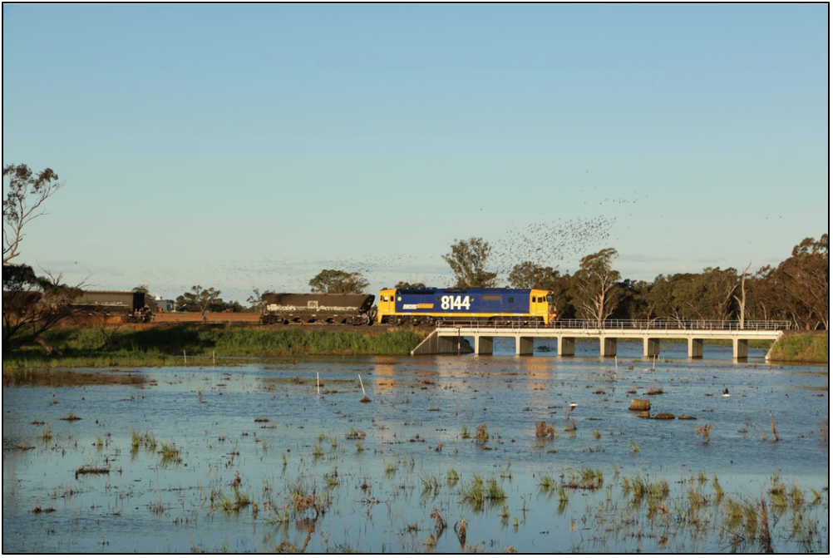
Source: P. Smith

Post-occurrence
NSW Police took control of the accident site until evidence was gathered.
The impact and post-collision fire destroyed the prime mover and damaged the road-train trailers. There was no damage to the locomotive (8144) and the first wagon, but the second and third wagons were damaged by the collision and subsequent derailment. Damage to track infrastructure was mainly confined to the northwest approach flashing lights, which were destroyed by the fire.
The locomotive crew were shaken but otherwise unhurt. The site was handed over to the ARTC (infrastructure manager), following withdrawal of the NSW Police.
There were two independent witnesses, the motorist directly behind the road-train truck, and an amateur photographer, who was located at a distance southwest of the collision site.

Context

Location
The Tullamore – Narromine Road railway crossing (Figure 2) is located on the main line at the 552.956 km point , between Narromine and Peak Hill. It is about 4 km southwest of the township of Narromine, New South Wales. The road approaching the railway crossing from the southwest (direction of road-train truck travel) was fully sealed. The speed limit along the road was 100 km/h, with an 85 km/h advisory speed limit, 455 m before the crossing. The road was gazetted for road-train trucks (the type involved in the collision) up to a maximum permissible speed of 90 km/h.

Train and Crew
Following a review of evidence it was determined that there were no mechanical defects or deficiencies with the train which would have contributed to the collision.
An examination of the train drivers’ records confirmed that they had been assessed as meeting the medical standards prescribed by the National Standard for Health Assessment of Rail Safety Workers. Following a review of the drivers’ rosters in combination with interview evidence, the ATSB determined that fatigue impairment was unlikely to have affected their performance. Both train drivers indicated that they felt well when signing on for duty and just before the collision.
The NSW Police tested the train drivers for drugs and alcohol; (post collision). The results were negative for a drug, within the meaning of the Rail Safety National Law National Regulations 2012, or alcohol.
Train handling and train driver performance were not considered factors in the collision.

Road-train truck information
Furney Flour Mills was the owner/operator of the road-train truck involved in the collision. The company’s primary business is flour milling, stock feed manufacture, baking and farming; these activities involve the substantial transportation of grain.
Figure 10: Western Star prime mover (left photo) and road-train trailers (right photos)
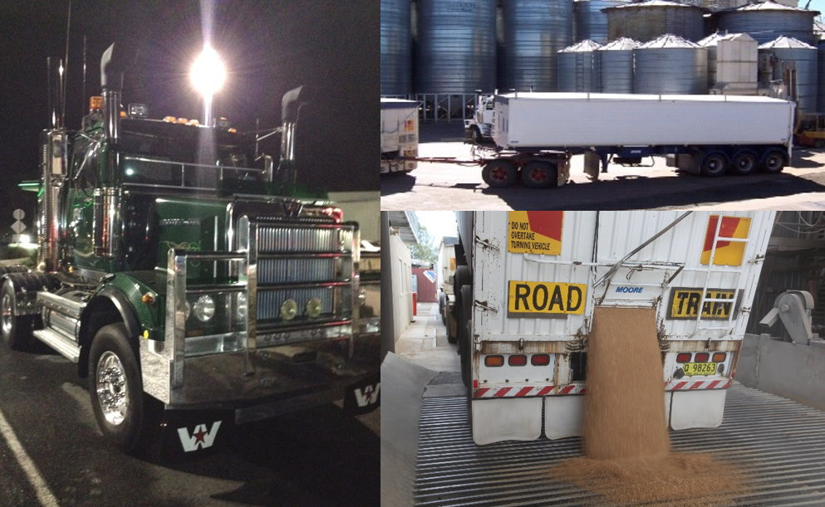
Source: Furney Flour Mills
The company operates a small fleet of trucks, (including road-train trucks) in and around the Dubbo area. The road-train truck (double road train) involved in the collision consisted of a Western Star prime mover (Figure 10) towing two tri-axle trailers connected by a double-axle dolly. The overall length of the road-train truck was about 36 m with a gross mass of about 80 t.
The prime mover had passed NSW heavy vehicle inspection requirements in Dubbo, on 23 March 2015. All vehicles (that is, the prime mover, trailers and dolly) were regularly serviced and well maintained. Records show the prime mover was electronically speed limited to 100 km/h.
Due to the extent of impact and fire damage, the NSW Police were unable to form a comprehensive picture of the mechanical condition of the road-train truck at the time of collision. However, examination of the brake linings determined that these were in good condition. In the moments just before the collision, the train drivers and witness (car behind the road-train truck) all noted that smoke billowed uniformly from all truck and trailer tyres. The post collision examination of the (tyre) skid mark pattern on the road/pavement surface revealed that this was consistent and uniform; there was no evidence of the vehicle skewing under heavy/emergency braking.
These observations in conjunction with maintenance records, strongly suggest that there were no mechanical deficiencies (braking performance) with the prime mover, trailers and dolly.

Truck driver information
The truck driver was a 46-year-old male from Dubbo, NSW. He had extensive experience within the grain transportation sector before working for Furney Flour Mills. He had worked for Furney Flour Mills for about four years, initially as a driver, and later as a driver/manager. He was appropriately qualified/licensed to drive the road-train truck involved in the collision. He had no known prior convictions or traffic offences that may have indicated an increased propensity for this type of collision.

Environmental conditions
Weather information for the Tullamore – Narromine railway crossing was based on data sourced from the Dubbo airport weather station, about 38 km east of the crossing. Maximum temperature on the day was recorded as 17.5°C; no rain had fallen in the 24-hour period preceding the collision. At the time of the collision, the temperature was about 14°C, with a wind speed of 22 km/h from the south.
The weather was fine and unlikely to have been a factor in the collision.

Railway crossing protection and risk control
Given the size and weight of most trains it is not possible for them to brake at anywhere near the rate of a road vehicle. Heavy freight and passenger trains may take several kilometres to stop from high track speeds.
In most circumstances, by the time a train driver is able to sight an approaching motor vehicle, and make a determination as to whether it will stop, the train is relatively close to the railway crossing, by which time a collision may be imminent. In such circumstances a train driver is unable to take any effective action to avoid the collision other than sound the locomotive horn to warn the motorist, and (if time permits) make an emergency brake application.
By comparison, a road vehicle can stop relatively quickly. It is for this reason that, regardless of the type of crossing control, (passive or active) the onus to take appropriate action to avoid a collision rests almost entirely with the motorist.
Consequently, it is important that road traffic controls are effective at alerting the motorist that they are approaching a railway crossing, with sufficient time for them to stop safely before entering the crossing.

Traffic control at the Tullamore - Narromine Road railway crossing
The traffic controls installed at the Tullamore – Narromine Road railway crossing comprised flashing lights, and an audible warning device (bell) at the crossing; road surface markings and passive warning signs on the road approaches to the crossing.
NSW - Road Rules 2014, Part 10, Section 123 stipulate that a road user must not enter a railway crossing if the warning lights (or bell) are operating.

Railway crossing warning time
At the time of the collision, Australian Standard AS 1742.7-2007 Manual of uniform traffic control devices Part 7: Railway crossings, at clause 4.3.1 required that flashing signals commence activation a minimum of 20 s prior to the arrival of a train. Australian Standard AS 7658-2012 Railway Infrastructure: Railway Level Crossings at Appendix D: ‘Operational Timing of Active Traffic Control Devices’, stipulates that flashing light warning signals commence activation, a minimum of 25 s prior to the arrival of a train.
The intent of the two standards is (when lights commence flashing) to allow road vehicles:
- to stop before entering the crossing, or
- if unable to stop, to traverse and clear the crossing, before a train arrives.
The ATSB established that the flashing lights had been operating for 38 s before the arrival of train 8834N at the crossing. Therefore, from a timing perspective, the crossing exceeded the timing requirements of both AS 1742.7-2007 and AS 7658-2012.
AS 1742.7-2007 provides guidance for the determination of stopping sight distance (S₁) for vehicles approaching passive railway crossings. For a road-train truck travelling at 90 km/h, this stopping distance was calculated as 215 m. Utilising the Austroads Guide to Road Design Part 4: Intersections and Crossings – General (AGRD04-09), the calculated stopping distance for a road-train truck travelling at 90 km/h, was 177 m. However, if an allowance of 1.5 s (road-train truck ‘brake delay’) is included, as per AS 1742.7-2007, the stopping distance becomes 215 m, (177 m + distance travelled in 1.5 s at 90 km/h = 38 m); the same as that derived from AS 1742.7-2007.
Assuming that the truck was travelling at a constant 90 km/h, (legal speed limit for road-train truck involved in collision) the flashing lights commenced operating when the truck was about 950 m (25 m/s x 38 s) from the crossing. While this is well in advance of 215 m, (the calculated stopping distance required by a road-train truck) it is likely that the curved approach, (Figure 3 and Figure 4) limited the truck driver’s opportunity to perceive the operating flashing lights until he was significantly closer to the crossing.
AS 7658-2012 – item ‘4. Track & Civil’, section 4.1 clause 2(a) and 2(b) refers to the Austroads guidelines and at clause 3(a) sight distances, obstructions, and clause 3(b) time for road vehicles to traverse and clear the railway crossing. However, there are no specific guidelines for assessing sighting distance requirements for locations with active/flashing light control, or for locations where the requirement to negotiate curved approaches creates potential for compromised driver perception.

Railway crossing compliance and sighting distance
AS 1742.7-2007 prescribes the requirements for road markings, roadside signs and configuration of active traffic controls at railway crossings throughout Australia. Figure 11 (left) shows the minimum treatment as specified in AS 1742.7-2007 and Figure 11 (right), shows the configuration installed at the Tullamore – Narromine Road railway crossing on 23 September 2015.
Figure 11: Signage as required (minimum) by AS 1742.7-2007 (left). Signage as installed at the Tullamore – Narromine Road railway crossing, on 23 Sept. 2015 (right)
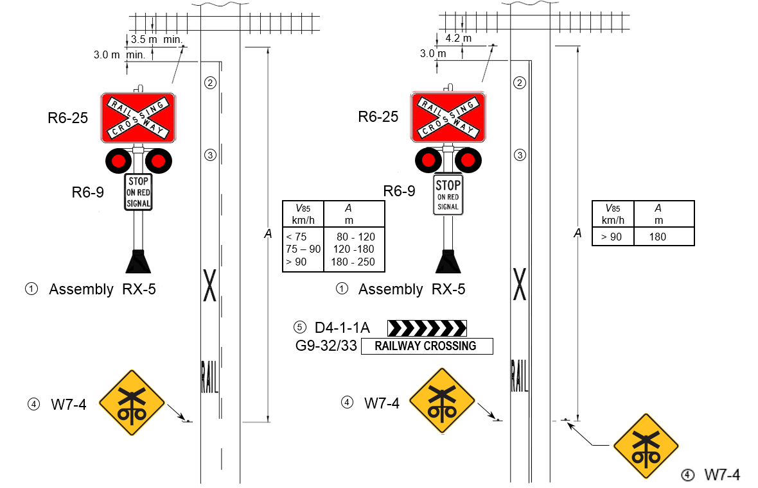
Source: AS 1742.7 and ATSB
A review of the site against the standard established no non-compliances; the following observations are nevertheless provided for completeness:
- The Narromine Shire Council (NSC) exceeded the basic requirements of AS 1742.7-2007 by providing a chevron/railway crossing (D4-1-1A/G9-32/33) sign on the left side of the road 125 m before the crossing. Note: AS 1742.7-2007 suggests the use of yellow chevron alignment markers D4-6 in lieu of the D4-1-1A white chevron markers, in conjunction with the G9-32/33 signs where used.
- Road markings were present and in accordance with AS 1742.7-2007, but faded.
- Two ‘Railway crossing flashing signal ahead’ signs (W7-4), located about 180 m (in lieu of one sign – left side only) before the crossing. The placement of the W7-4 signs at a distance of about 180 m before the flashing light assembly (RX-5) was consistent with AS 1742.7-2007 for road vehicles travelling at 90 km/h (85th percentile). However, AS 1742.7-2007 at clause 2.3.3 allows for the provision of additional advance warning signage (W7-4) at a long distance (e.g. 500 m) in advance of the crossing, with a distance plate below if considered necessary. These were not provided.

Flashing light conspicuity
In Australia, active flashing light hardware (that is the mast, flashing lamp units and bell) generally complies with the Association of American Railroads (AAR) requisites for highway grade crossing signals (Figure 12).
Figure 12: Typical railway crossing signal assembly, (RX-5) complete with four lamp units, ‘Rail Way Crossing’ sign, and ‘Stop on Red Signal’ sign
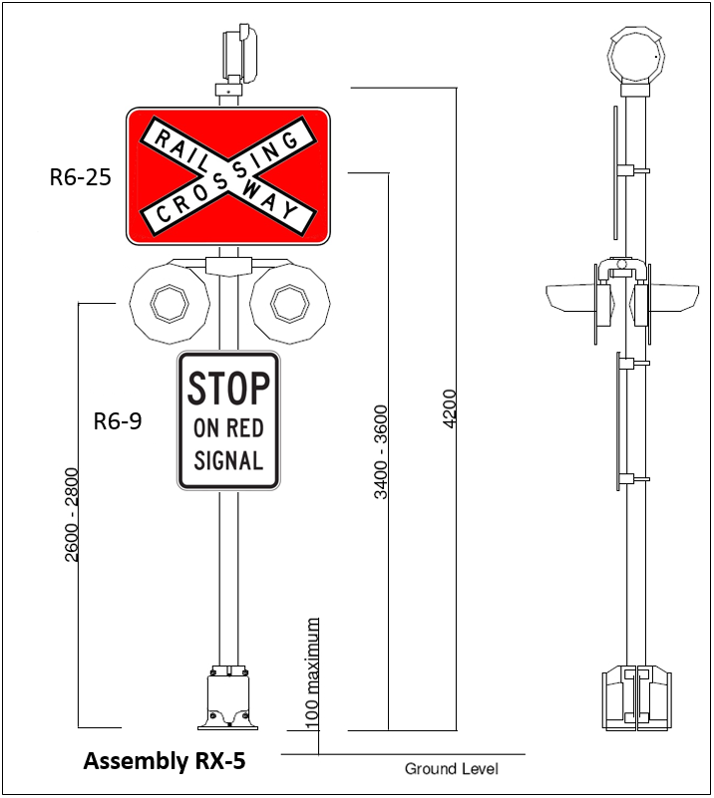
Source: AS 1742.7 and ATSB
The flashing lights at the Tullamore – Narromine railway crossing comprised eight high intensity LED lamp units, in a combination of main-lights and backlights. Examination of data recorded by the railway crossing event logger showed that all LED lamps were functioning at the time of the collision.
LED lamp units provide high intensity illumination over a wide viewing angle and provide good performance (warning) from a road user perspective, compared to traditional incandescent lamps. LED lights are also less susceptible to the effects of sun glare and reflection.
AS 7658-2012 – item ‘3. Signalling’, section 3.4.2 clause 2 specifies that Site-specific focussing diagrams should be prepared to optimise the visibility of flashing light installations at level crossings. While ARTC do not have a site specific alignment diagram for the crossing, the focusing/alignment for flashing lights at this location was covered by ARTC’s standard SMS 13 – (RIC Standard: SC 07 60 01 00 EQ). A site inspection (post-collision) established that the southwest facing flashing lights provided good coverage, from at least 300 m before the crossing, all the way through to the crossing. While the flashing lights did provide good coverage, the approach to the crossing from the southwest, through a sweeping right hand curve, requires that a motorist must continually re-direct their view from the road ahead, to the right, to be able to see the flashing lights.
Note: Although sighting of the flashing lights was unobstructed, should vegetation develop on the right side of the road, (southwest approach) this could compromise sighting in the future.

Audible warning device
Historically, audible devices have been considered an important sensory medium used to warn motorists of an approaching train. However, soundproofing, air conditioning and in-vehicle entertainment systems in modern vehicles raise questions regarding the effectiveness of railway crossing and train audible devices.
The high standard of soundproofing in modern motor vehicles, with closed windows, would require a significant sound volume for any audible device to be heard within the vehicle. Consequently, audible warning devices are more suited to bicycle riders and pedestrians.
Increasing the loudness of railway crossing and/or train audible devices is not considered a practical option, particularly for use in populated areas, as the sound level would exceed reasonable environmental/community standards.
It is considered unlikely that the truck driver would have heard either the railway crossing and/or train horn, and be alerted in sufficient time to take appropriate action.

ALCAM survey, Tullamore – Narromine Road railway crossing
The Australian Level Crossing Assessment Model (ALCAM) is used to assess potential risks at railway crossings and to assist in the prioritisation of safety improvements at railway crossings according to their comparative safety risks. ALCAM is currently applied across Australia and in New Zealand, and is overseen by the National ALCAM Committee, which comprises representatives from the various jurisdictions to ensure its consistency of development and application. NSW is represented on the National ALCAM Committee by Transport for NSW (TfNSW) – a state government department.
ALCAM plays a critical role in planning and developing the NSW Level Crossing Improvement Program (LCIP), which is managed by TfNSW. ALCAM, is used as the principal means of ranking public railway crossings for major upgrades funded under the LCIP. The LCIP also allocates funding towards ALCAM data collection each year to improve the quality of the railway crossing data in the model.
TfNSW undertakes periodic ALCAM surveys of railway crossings throughout NSW. The last ALCAM survey carried out at the Tullamore – Narromine railway crossing, before the collision on 23 September 2015, was on 18 November 2011. The survey identified the crossing in a low to medium risk band, within the control class of active flashing lights. ALCAM data for the Tullamore – Narromine railway crossing, as documented, identified several areas of risk when approaching the crossing from the southwest, including:
- Visibility of traffic control at crossing – This relates to sighting the flashing lights, because of road curvature.
- Distance from advance warning signs (W7-4) to crossing – This relates to the location of the advance passive warning signs, and vehicle (truck) stopping distance/capability.
- Possible sun glare and sighting of the flashing lights.

Previous occurrences
Roads and Maritime Services (NSW) have advised that about 542 road vehicles (standard axle pairs) use the Tullamore – Narromine railway crossing daily, of which about 7 percent are heavy vehicles. About five trains use the crossing daily.
For the period September 1990 through to September 2015, the Office of the National Rail Safety Regulator (ONRSR) recorded only two occurrence events at the Tullamore – Narromine railway crossing (Table 1).
Table 1: ONRSR occurrence data for the Tullamore – Narromine Road railway crossing
Date: | Location - Tullamore – Narromine Road railway crossing
3 September 1990 | Collision with motor vehicle.  At the time of this collision, the railway crossing did not have active flashing light control. Passive warning signs only controlled the crossing.
23 November 2010 | Near miss. Driver of a road-train truck failed to stop for the passage of train 8926.
Source: Office of the National Rail Safety Regulator

Rail/Road interface coordination planning
During the investigation, it was noted that the ARTC and the NSC did not have a formalised ‘Interface Agreement’ covering their respective maintenance responsibilities for this railway crossing. It was also noted that various inconsistencies exist between AS 1742.7-2007 (AS 1742.7-2016), AS 7658 – 2012 and related AustRoad standards. While these issue were not a factor with respect to this collision, the establishment of consistent standards/practices is desirable to ensure that all parties are aware of their responsibilities and accountabilities. For example, road authorities generally provide approach-warning signage. However, it has not always been clear who is responsible and who should fund the capital cost and maintenance of approach warning signage. The lack of consistent standards, and formal agreements potentially expose organisations to risk, particularly where items are not provided or maintained in accordance with mandated standards because the responsibilities between the parties were ill-defined.

Safety analysis

Introduction
Rail is one of the safest modes of transport, but where road and rail interface at railway crossings, accidents can and do occur. Railway crossing accidents frequently result in fatalities, serious injuries and extensive damage to infrastructure.
The collision at the Tullamore – Narromine Road railway crossing, between an eastbound road-train truck and a Pacific National grain train, (8834N) was a serious event – resulting in fatal injuries to the truck driver and extensive damage to infrastructure. Based on a review of evidence the ATSB concluded that:
- The road-train truck was probably travelling at a speed of about 90 km/h as it approached the Tullamore – Narromine Road railway crossing. The truck continued at high speed until about 180 m from the crossing, when it would appear that the truck driver probably saw the flashing lights operating. He made an emergency brake application, but was unable to stop the road-train truck before colliding with the train.
- Inspection of the site established that the passive approach warning signs and flashing lights complied with Australian standards and were functioning. The flashing lights gave a warning well in excess of the mandated 20 s, (AS 1742.7-2007) and should have been distinct and clearly visible to the truck driver approaching from the southwest.
- The train driver could do little to avoid the collision. He sounded the locomotive horn, and made an emergency brake application.

Factors influencing the truck driver’s behaviour
Human information processing is limited, in that each person has finite mental resources, available to attend to information or perform tasks during any particular period. In general, if a person is focussing on one particular task, then their performance on other tasks will be degraded. In the context of a motor vehicle driver approaching an active railway crossing, the extent of performance degradation may depend on factors such as:
- task competence including factors such as driving experience and history of any driving violations/errors
- the influence of other factors such as fatigue, drugs, alcohol or a medical condition
- the extent to which the flashing lights are conspicuous/easy to observe
- the extent to which a train is expected and
- the motorist’s workload at the point in time and the existence of any distractions.
The following section examines possible factors, which may have influenced the truck driver’s actions just before the collision.

Driver competence
In accordance with legislative requirements, 'Heavy Vehicle National Law (NSW) (2013 No 42a)' the truck driver held an MC class licence and was certified to operate a combination heavy vehicle of the type involved in the collision. Based on NSW Police records it was established that he did not have a history of traffic law infringements, and had not been involved in any major road accidents or incidents. There was no evidence in his driving history to suggest a propensity for risky driving behaviour.
It is considered unlikely that the driver was deliberately violating the flashing light warning in trying to run the crossing before the arrival of the train.

Medical and toxicology
A review of the driver’s RMS (Roads and Maritime Services – NSW) ‘Medical Report’ shows that he had a cardiovascular condition, (dilated cardiomyopathy) but was certified medically as fit to drive a heavy vehicle. Post mortem, toxicology testing of the truck driver was negative for alcohol and illicit drugs but corroborated that he had an enlarged and dilated heart, which was associated with the cardiovascular condition.
In conclusion, the post mortem examination established that the driver’s level of cardiac disease was significant. Therefore, it was possible, that he had a sudden abnormal heart related event causing incapacitation while driving/approaching the railway crossing, thus precipitating the collision; but, this could not be validated by the autopsy.
However, witness observations and available evidence, suggest that it was unlikely the truck driver was incapacitated. He was actively controlling the truck through a sweeping curve, followed by an emergency brake application, probably in response to the flashing lights. It is therefore considered unlikely that the truck driver’s medical condition was a factor in the collision, although it cannot be discounted.

Fatigue
In the context of human performance, fatigue is a physical and psychological condition primarily caused by prolonged wakefulness and/or insufficient or disturbed sleep. Fatigue can have a range of influences on performance, such as decreased short-term memory, slowed reaction time, decreased work efficiency, reduced motivational drive, increased variability in work performance, and increased errors of omission. Fatigue impairment has been identified as causal in many transport related accidents.
The truck driver involved in this occurrence was based at the Furney Flour Mills, Dubbo. The business is locally based, drivers rarely undertake overnight haulage activities, and normally operate within 100 km of the depot. The occurrence driver was on a salary, in his driver/manager role, and worked day shift only. His driver’s logbook was destroyed during the post collision fire but reconstruction of the 14-day period preceding the collision, established that he worked about 77 hours, of which 38 percent was involved in driving. On the day of the collision, he booked on for duty at 0615. During the morning, he drove from Dubbo to Narromine and return. Later that morning he collected a load of grain from a property about 85 km west of Dubbo. He returned from the property to Dubbo at 1230. At 1500, he set off to collect a second load of grain from the same property, arriving about 1610. He departed the property about 1646. The collision occurred at 1715. At the time of the collision, he had been on duty for about 11 hours of which 45 per cent was involved in driving.
While records indicate that the occurrence driver did not exceed mandated driving hours, and that he worked a nominal 40 hour week, it is likely that he actually worked in excess of this amount. This was probably related to a self-imposed (high) work ethic, in wanting to meet his management obligations.
Corroborating this observation, (working long hours) a work colleague advised that the occurrence driver expressed concerns about his work-life balance, and was contemplating stepping down from his management role.
If considering just documented hours worked, and the time of day, it would seem unlikely that fatigue was a factor in this collision. However, in his management role, the occurrence driver probably worked in excess of documented hours, and may have experienced elevated levels of stress and associated fatigue. These factors, coupled with truck driver’s medical condition indicate that although fatigue is unlikely, it cannot be ruled out as a possible factor.

Conspicuity
Conspicuity refers to those visual characteristics of an object or condition that determine the likelihood that it will come to the attention of an observer. Some of the key attributes that contribute to the conspicuity of an object are its brightness, contrast and physical size. In general terms, objects that stand out from their visual background are more easily noticed, and, when all else is equal, larger objects are generally easier to see and hence more conspicuous than smaller objects.
There are two key visual conspicuity factors, which can affect this judgement: glare and contrast.
Figure 13: Photo taken at 1715 (4 days after the collision), about 200 m (Inset 30 x zoom) from railway crossing. Sun almost directly behind road-train truck, its position (azimuth and altitude) was similar to that just before collision
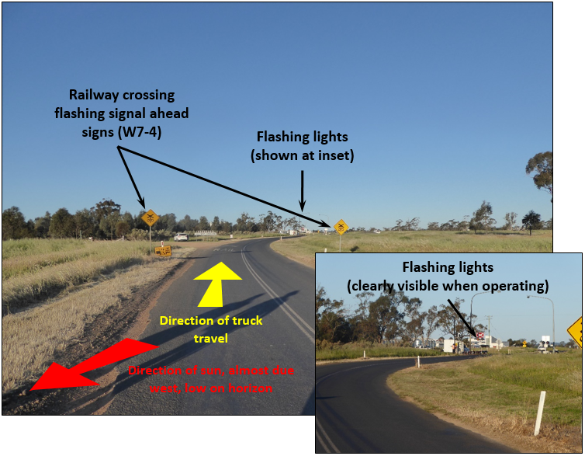
Source: ATSB

Glare and contrast
The collision occurred at 1715, about one hour before sunset. The sun’s azimuth and altitude was 276° 02’ 21” and 9° 31’ 44” respectively. Therefore, the sun was quite low, (close to the horizon) and almost due west. This meant the sun was initially on the truck driver’s left side, about 300 m from the crossing, and then almost directly behind (Figure 13) the truck as it turned east and neared the flashing lights.
With respect to this collision, with the sun being almost directly behind the truck, sun-glare had the potential to reduce the truck driver’s ability to see the flashing lights by shining on them. It was therefore important to inspect the crossing under similar environmental conditions, and at about the same time as the collision, to determine the possible influence of sun-glare.
The inspection was conducted on 28 September 2015 between 1700 and 1730. During the site inspection, (see section on Flashing light conspicuity) the flashing lights were operated to check for the influence of sun-glare. Site observations established that the flashing lights (operating) were clearly visible from at least 300 m before the crossing, all the way through to the crossing.
It was concluded that had the driver been specifically looking for the flashing lights, he would almost certainly have seen them operating. However, the ‘A pillar’ and air snorkel, (prime mover, driver near side, Figure 10) probably restricted the view of the flashing lights (intermittently), as the truck approached the railway crossing (Figure 14).
Figure 14: Typical restrictions on field of view (shown yellow) for a truck/prime mover
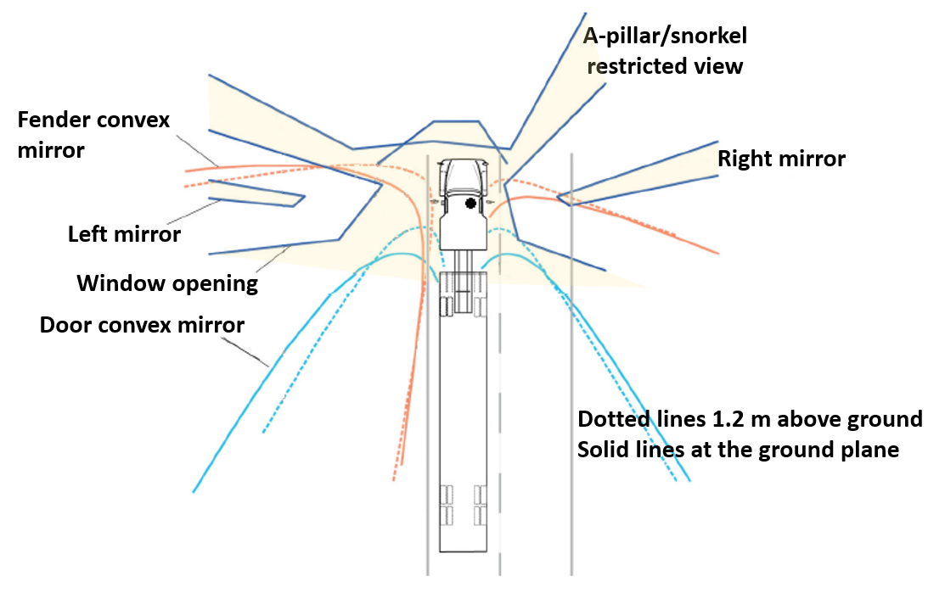
Source: D Blower (2007). Truck Mirrors, Fields of View and Serious Truck Crashes (UMTRI). Original drawing modified by ATSB to reflect right-hand-drive.

Expectancy
Prior to the day of the collision, the truck driver had traversed the Tullamore – Narromine Road railway crossing about 38 times (each direction) in a four-year period. Five days prior to collision, he traversed the crossing, (each direction) and on the day of the collision travelled over the crossing, three times, twice in a westerly direction and once in an easterly direction (same direction as at time of collision).
A road-train truck of the type involved in this collision, travelling at 90 km/h, has a stopping distance of about 215 m (see section ‘determination of stopping sight distance’). Therefore, to be consistent with the intent of the Austroads guidelines (see section on ‘warning time to decelerate to a stop’) it is probably appropriate that the advance warning W7-4 signs are located at a distance of at least 215 m before the railway crossing.
With respect to this collision, the truck driver had regularly used the Tullamore – Narromine Road and would have been well aware of the railway crossing. Consequently, the position of the W7-4 sign was less critical, as an error due to an unawareness of the crossing (for this truck driver) was unlikely.
The frequency of train movements across Tullamore – Narromine Road railway crossing was however, relatively low - about five train movements per day. Therefore, while the truck driver would have been aware of the railway crossing, the probability of him encountering trains was low.
Studies undertaken into motorist behaviour have found that drivers who are familiar with a railway crossing are more likely to be involved in a crossing incident than drivers unfamiliar with the crossing. Where train frequency is relatively low (trains rarely seen), motorists familiar with the crossing, are even less likely to expect a train. This observation was somewhat corroborated by the motorist behind the truck, in that he noted that the truck did not slow down as it approached the railway crossing. It is therefore possible that the truck driver’s familiarity with the railway crossing and a low expectation of encountering a train contributed to him not expecting a train and therefore not looking for the flashing lights.
The truck driver’s failure to react to the flashing lights indicates that his conscious attention was probably not directed towards the task of looking for the flashing lights – very possibly because he was not expecting a train.

Distraction and workload

Driver Distraction
Distraction can be understood as a type of inattention, where a person’s attention is diverted by a particular event or object. Driver distraction has been more specifically defined as ‘the diversion of attention away from activities critical for safe driving toward a competing activity (occurring) voluntarily or involuntarily.’
Driver distraction can involve a range of factors either inside or outside a vehicle that draw on limited human physical, visual and cognitive resources, and can result in a degradation of the driver’s performance. For example, eating, drinking, operating devices integral to (or brought into) the vehicle, (such as a mobile telephone) and smoking, are all activities that may distract from the driving task.
The truck driver had a mobile phone, and used it at 1645 just before departing the Brown’s Lane property. An examination of phone records established that he made no further use of the mobile phone after the 1645 entry. The truck driver was the sole occupant of the road-train truck, so distraction by another person did not occur.
Based on the available evidence, there was nothing to indicate that the driver’s attention had been diverted by a distracting object or event.

Cognitive workload
Human performance is highly variable and subject to a number of influencing factors. The term ‘cognitive workload’, refers to a measure of the nature of work being undertaken with regard to its demands on an individual’s cognitive resources. Cognitive workload can be in overload where the demands on the working memory are excessive, or in underload, brought about by periods of relative inactivity and boredom. Factors influencing workload can include the quantity and complexity of concurrent or consecutive tasks, as well as time requirements for their completion.
With respect to this collision, at about 1705, a motor vehicle entered the Tullamore - Narromine Road and was following close behind the truck. The occupant of the motor vehicle observed the collision. It is likely that the truck driver was also aware of the presence of this vehicle and had probably been monitoring it for potential overtaking/passing manoeuvres.
The Tullamore – Narromine Road, while gazetted for road-train trucks was relatively narrow, with worn shoulders and areas of uneven surface. Travelling in the direction of the road-train truck, (from the southwest) when about 540 m before the crossing, the road passes over a small bridge. Traversing the bridge requires additional driver attention, due to narrowing of the road and transition irregularities. The road then sweeps to the right, (Figure 3 and Figure 4) as it approaches the railway crossing, and would have increased the complexity of the driving task. Austroads Guide to Road Design Part 3: Geometric Design (AGRD03-09) at Section 7 Horizontal Alignment - 7.1 General, recognises a need to consider curved road approaches, in particular for heavy vehicles.
The Austroads guide states that:
Designers should avoid locating features that are likely to require large/special vehicles to brake on curves…’
At Appendix F of AGRD03-09 Transition Curves (Spirals) section F.1.1 Effects on Braking, the Austroads guideline includes the following:
When drivers brake on curves, a combination of forces applies on the tyres, effectively reducing the maximum force that can be developed for braking or cornering. Articulated trucks also have problems with braking on curves because of the tendency of these vehicles to jack-knife.
At a distance of 420 m from the crossing, a local dirt road enters the main road from the left. On this occasion, as the truck driver passed by the road, he would have observed a local resident about to enter the main road. At 145 m from the crossing, a second public dirt road, also on the left, enters the main road.
Therefore, as the truck driver passed through this area it is likely that his attention was directed to the areas of highest perceived risk, notably, monitoring the vehicle behind, handling the truck over the bridge, negotiating a sweeping right hand curve at speed, and scanning for approaching vehicles, all on a narrow section of road. It is most likely as the truck driver’s workload increased with these various tasks, that the majority of his attentional resources were directed towards the road immediately ahead and to the left, and not towards the flashing lights, which were to the right of his direct line of vision.
The Austroads Guide to Traffic Management Part 6: Intersections, Interchanges and Crossings (AGTD03-09) at section 7.2 ‘Horizontal Alignment’ identifies an opportunity for improving motorist awareness when approaching active railway crossings. At section 7.2.2 ‘Active Protection’ the guideline suggests the use of active advanced warning signs (AAWS). That is, alternating flashing yellow lights, located ahead of the railway crossing flashing light signals as a way of:
… improving safety on high-speed road approaches used by heavy vehicles, such as road trains, and where the required visibility to the flashing signals at the crossing cannot be attained by normal measures.

Austroads - Railway crossings and heavy vehicle studies
At railway crossings, visual devices remain the primary method for warning motorists of an approaching train. This may be by way of passive signage or a combination of passive signage and active visual devices such as flashing lights and boom barriers.
Active visual devices are more likely to attract a road user’s attention. Where provided, boom barriers add a further visual cue, and a physical barrier, and as such may provide further protection for drivers who make an error.
In recent times, Austroads has undertaken two studies specifically related to enhancing heavy vehicle safety at railway crossings. The two studies are:
- AP-R347/09: Heavy Vehicle Sight Distance Requirements at Rail Crossings, and
- AP-R370/10: Measures for managing safety of heavy vehicles at passive and active railway level crossings.
In the first study, (AP-R347/09) Austroads identified that:
Drivers of the larger heavy vehicles need sufficient warning time to decelerate to a stop once the signals have been activated by an approaching train. Therefore measures need to be identified and developed to manage the risks at both active and passive rail level crossings.
In the second study, (AP-R370/10) Austroads identified a variety of risk mitigation measures for use at passive and active level crossings (see Table 2) including speed control and the use of AAWS.
AS 1742.7-2007 also identifies the use of AAWS and provides the following guidelines:
The assembly should be considered for use wherever a risk assessment indicates an unacceptable train/road user collision risk or the risk of road user rear-end collision can be reduced by the use of the device. It would generally be expected that the section of road would have a posted speed limit to ensure some uniformity in vehicle speeds and at least one of the following minimum conditions would be met:
(a) The crossing is the first active signal control encountered after a long distance of unencumbered travel.
(b) The railway crossing has a known history of vehicle crashes of a type which cannot reasonably be alleviated by other warning signs or devices.
(c) Available driver stopping sight distance to the primary flashing signals at the railway crossing is below that required for the 85th percentile approach speed and cannot be reasonably increased by other measures.
(d) Driver visibility of the operating railway crossing flashing lights may be reduced by sun-glare, either as a consequence of the sun shining directly upon the signal lenses or due to the sun shining directly into the driver’s line of vision.
In the case of the Tullamore – Narromine Road railway crossing, it is the first active signal control encountered after a long distance of unencumbered travel. AAWS therefore has the capacity to provide an early alert, that a train is approaching the railway crossing, well before a motorist sights the flashing lights at the crossing. Table 2 within AP-R370/10 (below) further identifies a range of risk mitigation strategies that are available for use at passive and active railway crossing that should also be considered for enhancing railway crossing safety.
Table 2: Summary of recommendations on risk mitigation measures and schemes
Items | Measures | Recommendations from the stakeholder workshop
Passive level crossing | Upgrading from passive to active protection. | Generally accepted practice.
 | Alternatives to upgrading from passive to active level crossings. | Various alternative treatments could be implemented in parallel or used as a short, medium or long-term strategy depending on application.
Active level crossing | Lengthen the timing between the onset of the flashing lights and the arrival of the train. | Could be considered for special situations to address RAV safety.  Should be applied based on consistent principles (i.e. extended where required based on specific parameters such as RAV passage rather than applied uniformly at all level crossings).
 | Train predictors. | Generally accepted practice.
 | Active advanced warning signs (AAWS). | Generally accepted practice; however, further evaluation is warranted.
 | Second train warning. | Could be considered for multi-track (i.e. two or more tracks) applications.
 | Combination of flashing lights and boom barriers. | Generally accepted practice.
Traffic management measures | Review sight distance standard. | Sight distance requirements as outlined in AS 1742.7 (2007) to be reviewed.  This is to be undertaken in conjunction with a review of the sight distance requirements outlined in the Guide to Road Design – Part 4: Intersection and crossings – general, Section 10 (Austroads 2009b).  A review of whether the sight distance requirements for level crossing be included in both Section 10 of Austroads (2009b) Guide and AS 1742.7 (2007) or be limited to just Austroads (2009b) should be undertaken.
 | Speed reduction for road and rail users. | A decision on speed reductions at level crossings should be made by the individual jurisdictions.  Should be supported by studies outlining their effectiveness.  Could be applied to RAVs only, e.g. through signage or by a permit system.
 | Rumble strips. | Further investigation is needed.  May not be an effective measure in every application.
 | Crossing conspicuity. | Generally accepted practice.  Need to cater for the eye height of the general vehicle and RAV drivers.
 | Dial-up systems to provide advice about train movements. | A low-cost solution for special situations.
 | CCTV cameras. | Generally accepted practice.
 | Physical treatments (e.g. closing the crossing, grade separation, road design treatment, etc.) | Generally accepted practice.
Governance | Australian Level Crossing Assessment Model (ALCAM). | ALCAM should incorporate risk mitigation measures and modifications to AS 1742.7 (2007) and Austroads (2009b). Austroads to support research to improve the rigor of ALCAM when applied to RAVs.
 | Over dimension/over length permit systems. | Need to develop and agree to a national, consistent permit system.
Education and enforcement | Combination of education and enforcement. | Generally accepted practice.
 | Automated enforcement. | Generally accepted practice.
 | Integration with Intelligent Access Program (IAP). | Integrate level crossing safety with the IAP consistently across Australia.
Source: Austroads (Report AP-R370/10)

Findings
On Wednesday afternoon, the 23 September 2015, an eastbound road-train truck, hauling grain, collided into the side of Pacific National grain train, 8834N, (travelling on the main line between Narromine and Peak Hill) at the Tullamore – Narromine Road railway crossing, about 4 km southwest of Narromine, in New South Wales.
From the evidence available, the following findings are made with respect to the collision and should not be read as apportioning blame or liability to any particular organisation or individual.

Contributing factors
- The driver of the road-train truck entered the railway crossing while the flashing lights were operating; he did not stop and give way to the train as required by the NSW road rules.
- It is likely that the truck driver did not look for, or perceive the flashing lights due to a combination of factors, including:
  - familiarity with the crossing, not expecting a train to be present, and
  - increased cognitive workload associated with handling the truck at higher speeds (driver was probably travelling too fast for the prevailing conditions) through a relatively narrow section of road, around a sweeping curve, while monitoring for surrounding traffic.
- The viewing angle approaching the railway crossing (from the southwest) through the right hand curve meant that at higher road speed there was reduced opportunity for the truck driver to identify that the flashing lights were operating.
- It is likely that when the truck driver perceived that the flashing lights were operating, he was too close to the crossing to stop, and collided with the train.

Other factors that increased risk
- AS 1742.7-2007 does not provide guidance for assessing stopping sight distance for active railway crossings, in particular the standard requires additional considerations for curved approaches.
- While meeting legislative requirements, the control systems used by Furney Flour Mills did not identify the elevated levels of risk for the truck driver’s medical fitness and fatigue.
- The W7-4 signs that were located in advance of the Tullamore – Narromine Road railway crossing (approaching from southwest) were too close to the crossing to be consistent with the Austroads study, AP-R347/09.
- The Australian Rail Track Corporation and Narromine Shire Council do not have a formalised ‘Interface Agreement’ covering their responsibilities with respect to the maintenance of railway crossing signage.

Other findings
- The Tullamore – Narromine Road railway crossing signs were located in accordance with Australian Standard, AS 1742.7-2007.
- The flashing lights were operating as per design, and clearly visible in advance of the road-train truck braking distance.
- Sun-glare was unlikely to have been a factor.
- It is unlikely that there were mechanical deficiencies (braking performance) with the road-train truck involved in the collision.
- Train handling and train driver performance were not considered factors in the collision.

Safety actions
Whether or not the ATSB identifies safety issues in the course of an investigation, relevant organisations may proactively initiate safety actions in order to reduce their safety risk. The ATSB has been advised of the following proactive safety actions in response to this occurrence.
ATSB finding: Railway crossing, approach viewing angle
The viewing angle approaching the railway crossing (from the southwest) through the right hand curve meant that at higher road speed there was reduced opportunity for the truck driver to identify that the flashing lights were operating.
Additional safety action taken by: Narromine Shire Council
The Narromine Shire Council has advised of the following proactive safety action:
Narromine Shire Council is lobbying the Roads and Maritime Services for a speed zone review to occur on the southern approach to the railway crossing, to look at the alignment of the road and the opportunity to reduce the speed limit on the approach. This issue was raised at the Local Traffic Committee held on 2 November, 2015 and is being followed up on a regular basis.
ATSB finding: Stopping sight distance, guidance for active crossings
AS 1742.7-2007 does not provide guidance for assessing stopping sight distance for active railway crossings, in particular the standard requires additional considerations for curved approaches.
Additional safety action taken by: Standards Australia
Standards Australia has advised of the following proactive safety action:
Standards Australia have advised that AS 1742.7-2007 was recently revised, and was superseded by AS 1742.7-2016 on the 21 March 2016. The ATSB report (RO-2015-016) will be referred to the Australian Standard Technical Committee MS-012 - Road Signs and Traffic Signals, to determine whether the revised standard AS 1742.7-2016 adequately addresses the identified ATSB finding.
ATSB finding: Fitness for duty
While meeting legislative requirements, the control systems used by Furney Flour Mills did not identify the elevated levels of risk for the truck driver’s medical fitness and fatigue.
Additional safety action taken by: Furney Flour Mills
In response to this finding, the Furney Flour Mills has advised of the following proactive safety action:
- The company has engaged a registered training organisation to conduct tutoring for drivers, supervisors, schedulers and management in the national recognised courses in:
- TLIF2010A - Applying fatigue management strategies
- TLIF3063A - Administer the implementation of fatigue management strategies
- TLIF0001 - Apply chain of responsibility legislation, regulations and workplace procedures
- TLIF0002 - Administer chain of responsibility policies and procedures.
- Engaged an accredited service provider to develop a fatigue management and chain of responsibility policy.
- Arranged with Dubbo Care Family Practice, for all heavy vehicle drivers, working for Furney Flour Mills, to undergo a comprehensive medical examination to ensure fitness for duty.
- Commissioned an extensive accident review report on this occurrence from both internal and external sources, these prompted a review of our current business practices, resulting in further improvements and implementation of the following:
- Induction policy and procedures revised with a renewed focus given to chain of responsibility and fatigue references.
- Medicals to be conducted yearly for all drivers
- Employment of new drivers to include a medical report, in line with yearly check-ups requirements
- Staff assessments on fatigue and chain of responsibility policy completed yearly as a refresher
- Monthly management meetings now include a section for reporting and discussing risk assessments, non-compliances, training conducted and inductions.
- In house training modules on fatigue and chain of responsibility to be integrated into training schedules for applicable staff
- Continue to encourage all staff to participate with continual improvement program.
- Increased general awareness of fatigue and chain of responsibility laws throughout the company, including signage located in lunchrooms and noticeboards.
ATSB finding: W7-4 signs closeness to railway crossing
The W7-4 signs that were located in advance of the Tullamore – Narromine Road railway crossing (approaching from southwest) were too close to the crossing to be consistent with the Austroads study, AP-R347/09.
Additional safety action taken by: Narromine Shire Council
In response to this finding, the Narromine Shire Council has advised of the following proactive safety action:
Narromine Shire Council will be installing additional W7-4 approach signs on the southern approach at a designated distance on 250m to allow for an additional warning sign for the rail crossing.
ATSB finding: Interface coordination plan
The Australian Rail Track Corporation and Narromine Shire Council do not have a formalised ‘Interface Agreement’ covering their responsibilities with respect to the maintenance of railway crossing signage.
Additional safety action taken by: the Australian Rail Track Corporation and Narromine Shire Council
In response to this finding, the Australian Rail Track Corporation and Narromine Shire Council have advised of the following proactive safety action:
ARTC will continue its efforts to establish an Interface Agreement with Narromine Shire Council.
Narromine Shire Council has been in contact with the IPWEA in regards to the validity of the Interface Agreement as written by ARTC (waiting on advice). Council has signed an Interface Agreement with John Holland. Council is waiting on advice from the IPWEA on the issues that have been identified within the ARTC Agreement.

General details

Occurrence details
Date and time: | 23 September 2015 – 1715 EST
Occurrence category: | Accident
Primary occurrence type: | Collision
Location: | Tullamore – Narromine Road, New South Wales
 | Latitude: 32º 15.449' S | Longitude: 148º 12.940' E

Train details
Train operator: | Pacific National Pty Ltd
Registration: | 8834N
Type of operation: | Grain train (freight)
Train details: | Overall, train length 350.2 m. 23 wagons with a gross trailing mass of 1789.4 t
Persons on board: | Crew – 2 | Passengers – Nil
Injuries: | Crew – Nil | Passengers – Nil
Damage: | Minor

Road-train truck details
Vehicle owner/operator | Furney Flour Mills (Dubbo)
Vehicle type: | Western Star prime mover hauling two tri-axle trailers, connected by a double-axle dolly. Overall length of the road-train truck about 36 m with a gross mass of about 80 t.
Registration: | Private - Furney Flour Mills (Dubbo)
Persons on board: | Driver – 1 | Passengers – Nil
Injuries: | Driver – Fatality | Passengers – Nil
Damage: | Destroyed

Infrastructure
Track manager: | Australian Rail Track Corporation (ARTC)
Track: | Track through the Tullamore – Narromine Road railway crossing comprises standard gauge (1435 mm) 47 kg/m rail fastened to concrete sleepers on a ballast bed.
Flashing lights: | Assembly RX-5 to AS 1742.7-2007. Flashing lights fitted with Light Emitting Diode (LED) - type FL03. Train detection by DC track circuits.  Flashing lights monitored by a Cerberus data logger.
Damage: | Flashing light, northwest corner destroyed.

Sources and submissions

Sources of information
The sources of information during the investigation included the:
- Austroads
- Australian Rail Track Corporation
- Narromine Shire Council
- NSW Police (Dubbo)
- Office of the National Rail Safety Regulator (ONRSR)
- Pacific National Pty Ltd
- Roads and Maritime Services (NSW)
- Furney Flour Mills
- Transport for New South Wales (TfNSW)
- Witness

References
Australian Government, Geoscience Australia
Australian Level Crossing Assessment Model ALCAM
Australian Standard AS 1742.7-2007 – Manual of uniform traffic control devices Part 7: Railway crossings.
Australian Standard AS 7658-2012 – Railway Infrastructure: Railway Level Crossings.
Austroads Guide to Road Design Part 4: Intersections and Crossings – General (AGRD04-09)
Austroads Guide to Road Design Part 3: Geometric Design (AGRD03-09)
Austroads study: Heavy Vehicle Sight Distance Requirements at Rail Crossings (AP-R347/09)
Austroads study: Measures for managing safety of heavy vehicles at passive and active railway level crossings (AP-R370/10)
Battelle Memorial Institute (1998). An Overview of the scientific literature concerning fatigue, sleep, and the circadian cycle. Report prepared for the Office of the Chief Scientific and Technical Advisor for Human Factors, US Federal Aviation Administration.
Blower D. (2007). Truck Mirrors, Fields of View and Serious Truck Crashes. University of Michigan Transportation Research Institute
Gray, R. & Regan, D. (2007). Glare susceptibility test results correlate with temporal safety margin when executing turns across approaching vehicles in simulated low-sun conditions. Ophthalmic & Physiological Optics, 27, 440-450.
Kahneman, D. (2011). Thinking Fast and Slow. Farrar, Straus & Giroux: New York.
National Transport Commission (2008). National Rail Safety Guideline. Management of Fatigue in Rail Safety Workers.
National Transportation Safety Board (1998). Safety at Passive Grade Crossings, Volume 1 Analysis: Safety Study NTSB/SS-98-02: Washington DC.
Olsen, P.L., Dewar, R. & Farber, E. (2010). Forensic Aspects of Driver Perception and Response (3rd ed.). Lawyers and Judges Publishing Company: Tucson. p91.
Regan, M.A., Hallett, C. & Gordon, C.P. (2011). Driver distraction and driver inattention: Definition, relationship and taxonomy. Accident Analysis and Prevention, 43, 1771-1781.
Yeh, M. & Multzer, J. (2008). Driver Behaviour at Highway-Railroad Grade Crossings: A Literature Review from 1990-2006. Human Factors in Railroad Operations. United States Department of Transportation, Federal Railroad Administration: Washington DC.
Young, K.L., Regan, M.A., & Hammer, M. (2003). Driver Distraction: A review of the literature. Monash University Accident Research Centre. Available from: http://www.monash.edu.au/miri/research/reports/muarc206.pdf

Submissions
Under Part 4, Division 2 (Investigation Reports), Section 26 of the Transport Safety Investigation Act 2003, the ATSB may provide a draft report, on a confidential basis, to any person whom the ATSB considers appropriate. Section 26 (1) (a) of the Act allows a person receiving a draft report to make submissions to the ATSB about the draft report.
A draft of this report was provided to:
- ALCAM
- Standards Australia
- Australian Rail Track Corporation
- Coroner – Dubbo, NSW
- Furney Flour Mills
- Narromine Shire Council
- Next of kin (NoK)
- NSW Coroner (Dubbo)
- NSW Police (Dubbo)
- Office of the National Rail Safety Regulator (ONRSR)
- Pacific National
- Rail Industry Safety and Standards Board
- Train drivers
- Transport for New South Wales (TfNSW)
- Witnesses
Submissions were received from ALCAM, the Australian Rail Track Corporation, Furney Flour Mills, Narromine Shire Council, NoK, NSW Police (Dubbo), the Office of the National Rail Safety Regulator, Pacific National, Transport for New South Wales, and witnesses. The submissions were reviewed and where considered appropriate, the text of the report was amended accordingly.

Australian Transport Safety Bureau
The Australian Transport Safety Bureau (ATSB) is an independent Commonwealth Government statutory agency. The ATSB is governed by a Commission and is entirely separate from transport regulators, policy makers and service providers. The ATSB’s function is to improve safety and public confidence in the aviation, marine and rail modes of transport through excellence in: independent investigation of transport accidents and other safety occurrences; safety data recording, analysis and research; fostering safety awareness, knowledge and action.
The ATSB is responsible for investigating accidents and other transport safety matters involving civil aviation, marine and rail operations in Australia that fall within Commonwealth jurisdiction, as well as participating in overseas investigations involving Australian registered aircraft and ships. A primary concern is the safety of commercial transport, with particular regard to operations involving the travelling public.
The ATSB performs its functions in accordance with the provisions of the Transport Safety Investigation Act 2003 and Regulations and, where applicable, relevant international agreements.

Purpose of safety investigations
The object of a safety investigation is to identify and reduce safety-related risk. ATSB investigations determine and communicate the factors related to the transport safety matter being investigated.
It is not a function of the ATSB to apportion blame or determine liability. At the same time, an investigation report must include factual material of sufficient weight to support the analysis and findings. At all times the ATSB endeavours to balance the use of material that could imply adverse comment with the need to properly explain what happened, and why, in a fair and unbiased manner.

Developing safety action
Central to the ATSB’s investigation of transport safety matters is the early identification of safety issues in the transport environment. The ATSB prefers to encourage the relevant organisation(s) to initiate proactive safety action that addresses safety issues. Nevertheless, the ATSB may use its power to make a formal safety recommendation either during or at the end of an investigation, depending on the level of risk associated with a safety issue and the extent of corrective action undertaken by the relevant organisation.
When safety recommendations are issued, they focus on clearly describing the safety issue of concern, rather than providing instructions or opinions on a preferred method of corrective action. As with equivalent overseas organisations, the ATSB has no power to enforce the implementation of its recommendations. It is a matter for the body to which an ATSB recommendation is directed to assess the costs and benefits of any particular means of addressing a safety issue.
When the ATSB issues a safety recommendation to a person, organisation or agency, they must provide a written response within 90 days. That response must indicate whether they accept the recommendation, any reasons for not accepting part or all of the recommendation, and details of any proposed safety action to give effect to the recommendation.
The ATSB can also issue safety advisory notices suggesting that an organisation or an industry sector consider a safety issue and take action where it believes it appropriate. There is no requirement for a formal response to an advisory notice, although the ATSB will publish any response it receives.

The 24-hour clock is used in this report and is referenced from Eastern Standard Time (EST) unless stated otherwise.
All track distances in this report are referenced from the Sydney Central passenger train terminal.
Passive control: Control of the movement of vehicular or pedestrian traffic across a railway crossing by signs and devices, none of which are activated during the approach or passage of a train, and which rely on the road user including pedestrians detecting the approach or presence of a train by direct observation.
Active control: Control of the movement of vehicular or pedestrian traffic across a railway crossing by devices such as flashing signals, gates or barriers, or a combination of these, where the device is activated prior to and during the passage of a train through the crossing.
Revised standard AS 1742.7-2016 was published on 21 March 2016, it supersedes AS 1742.7-2007. While there are variations within the revised standard, in particular with respect to vehicle stopping sight distance (SSD/S₁), and heavy vehicle acceleration dynamics, these variations do not substantially change the findings identified by the ATSB in this report.
Stopping sight distance is the distance travelled by a vehicle between when the driver first sights a requirement to stop, reacts accordingly, applies the brakes and brings the vehicle to a stop.
While the guidelines for calculating the stopping sight distance (S₁), described within AS 1742.7-2007 are for passive crossings, the calculation are also appropriate for calculating the stopping sight distance for railway crossings with active control. AS 1742.7-2016 at appendix D1, clause (a) now uses S₁ calculations (SSD) for active railway crossings.
Appendix B: Derivation of sight distance requirements at Railway Level Crossings.
See AS 1742.7-2007 clause 2.4.2 Railway crossing width marker assembly (Rx-9).
Main-lights: The flashing light assembly facing a motorist and located on the left/approach side of a railway crossing.
Backlights: The flashing light assembly facing a motorist and located on the right/departure side of a railway crossing.
Kahneman, D. (2011). Thinking Fast and Slow. Farrar, Straus & Giroux: New York.
National Transport Commission (2008). National Rail Safety Guideline. Management of Fatigue in Rail Safety Workers.
Battelle Memorial Institute (1998). An Overview of the scientific literature concerning fatigue, sleep, and the circadian cycle, Report prepared for the Office of the Chief Scientific and Technical Advisor for Human Factors, US Federal Aviation Administration.
Olsen, P.L., Dewar, R. & Farber, E. (2010). Forensic Aspects of Driver Perception and Response (3rd ed.). Lawyers and Judges Publishing Company: Tucson. p91.
Gray, R. & Regan, D. (2007). Glare susceptibility test results correlate with temporal safety margin when executing turns across approaching vehicles in simulated low-sun conditions. Ophthalmic & Physiological Optics, 27, 440-450.
Azimuth is the clockwise horizontal angle (in degrees, minutes and seconds) from true north to the sun/moon.
Altitude is the vertical angle (in degrees minutes and seconds) from an ideal horizon, to the sun/moon.
The approach/left set of flashing lights (Figure 13) were destroyed during the collision. They were replaced with equivalent high intensity LEDs, i.e. the same type of flashing light previously installed. Maintenance of flashing lights includes lens cleaning, focus checks, etc. Therefore, the performance of the flashing lights at the time of observation (27 September 2015) following reinstatement would have been comparable to that at the time of collision.
D Blower (2007). Truck Mirrors, Fields of View and Serious Truck Crashes (UMTRI) To the left and right, areas of the driver’s field of view are obstructed by the door, the A-pillars, and the right and left planar mirrors.
Yeh, M. & Multzer, J. (2008). Driver Behaviour at Highway-Railroad Grade Crossings: A Literature Review from 1990-2006. Human Factors in Railroad Operations. United States Department of Transportation, Federal Railroad Administration: Washington DC.
Regan, M.A., Hallett, C. & Gordon, C.P. (2011). Driver distraction and driver inattention: Definition, relationship and taxonomy. Accident Analysis and Prevention, 43, 1771-1781.
Young, K.L., Regan, M.A., & Hammer, M. (2003). Driver Distraction: A review of the literature. Monash University Accident Research Centre. Available from: http://www.monash.edu.au/miri/research/reports/muarc206.pdf
National Transport Commission. (2008). National Rail Safety Guideline. Management of Fatigue in Rail Safety Workers. Available from: http://www.ntc.gov.au/Media/Reports/(B8FFAA63-E7F4-D48E-385C-2D87B3332177).pdf
Various findings identified through these two studies have now be incorporated in the revision of AS 1742.7-2007, that is, AS 1742.7-2016.
Revised standard AS 1742.7-2016 was published on 21 March 2016, it supersedes AS 1742.7-2007. While there are variations within the revised standard, in particular with respect to vehicle stopping sight distance (SSD/S₁), and heavy vehicle acceleration dynamics, these variations do not fully address issues such as curved road approaches.
IPWEA – Institute of Public Works Engineering Australasia

