
ATSB Transport Safety Report
Aviation Short Investigations
AB-2016-014
Final – 13 April 2016

Aviation Short Investigations Bulletin
Issue 47

Released in accordance with section 25 of the Transport Safety Investigation Act 2003

Publishing information

Published by: Australian Transport Safety Bureau
Postal address: PO Box 967, Civic Square ACT 2608
Office: 62 Northbourne Avenue Canberra, Australian Capital Territory 2601
Telephone: 1800 020 616, from overseas +61 2 6257 4150 (24 hours)
Accident and incident notification: 1800 011 034 (24 hours)
Facsimile: 02 6247 3117, from overseas +61 2 6247 3117
Email: atsbinfo@atsb.gov.au
Internet: www.atsb.gov.au

© Commonwealth of Australia 2016



Ownership of intellectual property rights in this publication
Unless otherwise noted, copyright (and any other intellectual property rights, if any) in this publication is owned by the Commonwealth of Australia.

Creative Commons licence
With the exception of the Coat of Arms, ATSB logo, and photos and graphics in which a third party holds copyright, this publication is licensed under a Creative Commons Attribution 3.0 Australia licence.

Creative Commons Attribution 3.0 Australia Licence is a standard form license agreement that allows you to copy, distribute, transmit and adapt this publication provided that you attribute the work.

The ATSB’s preference is that you attribute this publication (and any material sourced from it) using the following wording: Source: Australian Transport Safety Bureau

Copyright in material obtained from other agencies, private individuals or organisations, belongs to those agencies, individuals or organisations. Where you want to use their material you will need to contact them directly.

Contents

Turboprop aircraft
Collision with a vehicle, involving an Air Tractor AT-502B, VH-FNX 1
Collision with a pole involving an Air Tractor AT-502B, VH-PTF 7
Flight crew incapacitation involving a SOCATA TBM 700, VH-YZZ 11
Piston aircraft
Collision with coral reef involving a de Havilland Canada DHC-2, VH-AWI 16
VFR into IMC involving a Piper PA28 aircraft, VH-TAU 21
Low fuel event involving a Piper PA-31P, VH-OGW 28
Helicopters
Tail rotor strike of slung load involving a Eurocopter AS 350, VH-NPS 32
Wirestrike and collision with terrain involving a Robinson R44, VH-HXY 35
Separation issues
Separation issue involving a de Havilland DH-82A (Tiger Moth), VH-BJE and a Robinson R44, VH-HOQ 39
Separation issue between a Kavanagh Balloons E-300, VH-LPG, and freight train 4K26 44

Turboprop aircraft

Collision with a vehicle, involving an Air Tractor AT-502B, VH-FNX
What happened
On 17 September 2015, the pilot of an Air Tractor 502B aircraft, registered VH-FNX, was conducting aerial application (spraying) operations on a property about 23 km to the west of Hay Aerodrome, New South Wales. The spray application area consisted of a block of nine adjoining paddocks, separated by combination of irrigation channels and access roads that allowed for movement of plant and equipment. There was a single paddock included in the spray application area that joined the larger block at the eastern end, separated from the other paddocks by an irrigation channel. The pilot planned to spray the group of paddocks as a single block (Figure 1).
Figure 1: Spray application area - a block of nine paddocks with another adjoining paddock at the eastern end
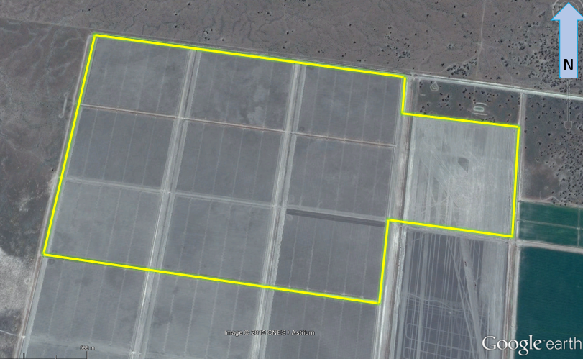
Source: Google earth (supplied by the agricultural company and annotated by the ATSB)
As per normal procedure, while en route to the spray application area, the pilot had made a broadcast on UHF Channel 25 advising that spraying operations were about to commence, and also, the area where that would occur. UHF Channel 25 was monitored by employees on the property, and used for general communications.
At the time the pilot made the broadcast, there was a tractor operating in the southern part of the spray application area, and the tractor driver responded to the pilot’s broadcast. The pilot determined that although the tractor was inside the spray application area, there was no likelihood of an immediate conflict with the spraying operations. Due the southerly wind, the pilot intended to commence spraying runs along the northern edge of the block and gradually work toward the south. The pilot advised the tractor driver that they would be able to safely continue in that southern area, without creating any conflict for spraying operations, for about an hour. Without hearing any other responses to the broadcast, the pilot switched to a different UHF frequency (Channel 20), in accordance with their normal practice.
The pilot commenced spraying operations at about 1100 Eastern Standard Time (EST). The pilot was flying a left hand race-track pattern, in an east-west direction; moving the pattern further south with each spray run. After a short time, the pilot departed the spray application area to reload with more chemical mixture at a nearby property.
The pilot then returned to the spray allocation area, and resumed spraying operations at about 1130. The pilot did not make another UHF radio broadcast upon the resumption of spraying operations.
At about 1145, as part of the continual southerly movement of the race-track spray pattern, the pilot was conducting a spray run in an easterly direction, along a roadway that divided some of the paddocks inside the spray application area. The pilot intended to continue the run, across the irrigation channel, and along the southern boundary of the eastern most paddock in the spray area (Figure 2).
During this run, the pilot reported seeing a white Toyota Hilux Double Cab utility vehicle turn onto an irrigation channel crossing ahead of the aircraft (Figure 2). However, the Hilux appeared to the pilot to be slowing to a stop, short of the intersection/irrigation channel crossing. The pilot assumed that the driver of the Hilux had seen the aircraft, and was stopping to allow the aircraft to continue its run over the channel crossing.
Figure 2: Layout of accident site, showing path of the aircraft, path of the tractor and Hilux along the irrigation channel bank, the south-eastern border of the spray application area, and the point where the collision occurred
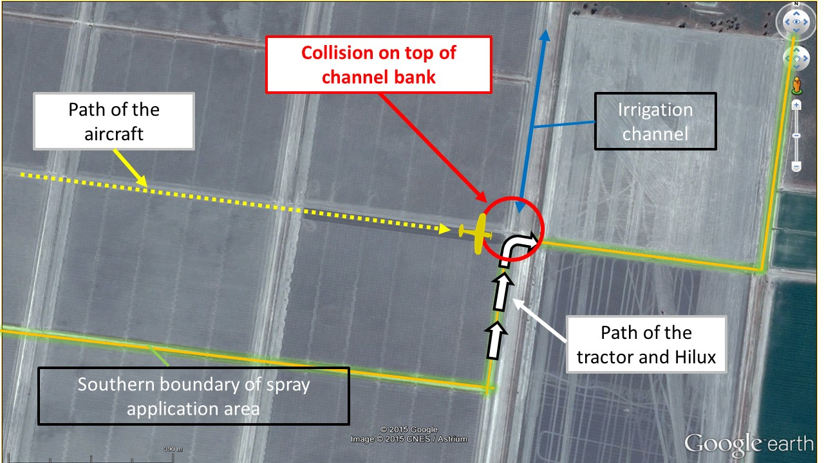
Source: Google earth (supplied by the agricultural company and annotated by the ATSB)
Confident that the vehicle was stopping, the pilot continued the spray run and, as per normal routine, checked the spray pressure gauge, and momentarily looked to each side of the aircraft to confirm that no spray nozzles were blocked. As the pilot then turned their attention forward again, and commenced a short climb to clear the raised channel bank, they saw that the Hilux had not stopped, but had continued along the road, turned right, and was climbing up over the raised channel bank. (Note: the agricultural company report advised that the tractor was ahead of the Hilux and already moving down the other side of the channel bank at this stage – refer section titled ‘Movement of Hilux’).
The pilot immediately stopped the spray and continued to climb, but was unable to clear the Hilux. The left wheel of the aircraft struck the tray headboard of the Hilux. As the vehicle and aircraft were both heading east, the aircraft struck the Hilux from behind.
Following the collision, the pilot climbed the aircraft to a higher altitude. The pilot checked that the aircraft was handling normally, including a brake pressure check, to confirm that the landing gear was still attached. The pilot saw that the driver had exited the vehicle, so made a broadcast on UHF Channel 25, advising farm personnel of the accident and requesting assistance for the driver. The driver of the vehicle responded to that broadcast. The pilot then flew back to the loading area and conducted a fly-by to enable the support crew to inspect the landing gear, prior to an uneventful landing.
The pilot was unhurt, but the driver of the vehicle sustained a shoulder injury.
Subsequent inspection of the aircraft revealed that the parts of the left landing gear were damaged, particularly in the area where the leg of the landing gear attaches to the aircraft structure. The vehicle was substantially damaged in the collision, particularly the tray headboard and roof structure on the passenger side of the cabin area (Figures 3 and 4).
Figure 3: Rear view showing damage to the Hilux headboard | Figure 4: Roof structure damage on passenger side
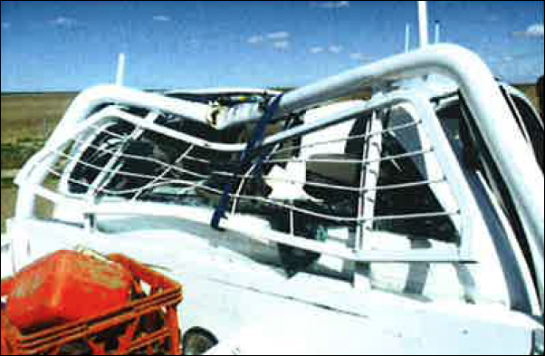 | 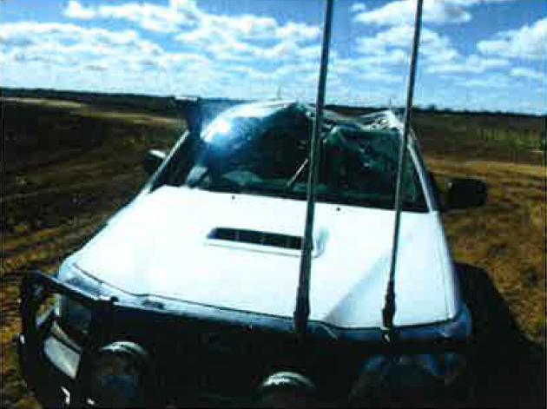
Source: Agricultural company | Source: Agricultural company

Movement of the Hilux
The Hilux driver had been attending to other tasks on another property (unrelated to the spraying operations) during the morning of the accident, but was aware of the spraying operations. Although the driver commented that notification regarding the spraying operations from the agricultural company was not provided until relatively late, the driver had been emailed about the spraying the day before, and the topic was again discussed on the phone on the morning of the accident. The driver was planning to assist with the logistics associated with moving the tractor from its location inside the spray application area to another part of the property. The tractor driver was relatively new to the property, so the Hilux driver intended to coordinate the move, and provide guidance to the tractor driver.
While en route to the property to coordinate movement of the tractor, the driver heard the pilot’s broadcast on UHF Channel 25 regarding commencement of spraying operations. The driver recalled hearing that the pilot intended to start spraying at the northern boundary of the spray application area. The Hilux driver attempted to respond to the broadcast, but was unable to establish contact, perhaps because the vehicle was still some distance away at the time. In any case, the Hilux driver was aware that the tractor driver had responded to the pilot’s broadcast.
As they prepared to move the tractor, the Hilux driver noted that the aircraft appeared to be still operating in the northern part of the spray application area (having returned from a chemical mixture reload). With that in mind, and because the planned route of the tractor and Hilux was along the south-eastern perimeter of the spray application area, the driver believed this would keep them clear of the spraying operation. Furthermore, the Hilux driver was of the impression that the pilot was operating to the north to accommodate movement of the tractor. The Hilux driver therefore elected not to contact the pilot as they were moving the tractor, because they believed that the move could be conducted safely without disrupting the pilot.
The Hilux driver was proceeding slowly, so as to monitor the progress of the tractor ahead. The driver’s attention was on the tractor as it turned right towards the east, to negotiate the raised channel crossing.
Following the tractor, the Hilux driver turned right to cross the channel. Near the top of the crossing, the aircraft collided with the vehicle from behind. The driver was unaware of the approaching aircraft until hearing the sound of the engine immediately before the collision.

Pilot and driver comments
The pilot commented that with the benefit of hindsight, it was unwise to assume that the Hilux driver had seen the aircraft and was travelling slowly for that reason. The pilot and driver both commented that the accident highlighted the importance of effective communication.

Agricultural company investigation
The agricultural company conducted a Workplace Health and Safety investigation into the accident. In general terms, contributing factors identified by the investigation related substantially to ‘assumptions’ and ‘ineffective communication’.
The agricultural company investigation also identified that the Pesticide Application Management Plan (PAMP) had expired at the end of June 2015. Notwithstanding expiry of the document, the investigation report identified some areas where, in the opinion of the investigator, PAMP instructions were not effectively applied. The report also noted that the PAMP did not require that aerial application operators use the same UHF channel as that used by farm employees, apart from a broadcast announcing spraying intentions. The report identified that this channel mismatch potentially hindered timely and effective communication.
Notification to the driver: The agricultural company reported that the Hilux driver had been emailed about the spray operations the day before the accident; and that the spray job was again discussed on the telephone the following morning.
Safety action
Whether or not the ATSB identifies safety issues in the course of an investigation, relevant organisations may proactively initiate safety action in order to reduce their safety risk. The ATSB has been advised of the following safety action in response to this occurrence.

Agricultural company
As a result of this occurrence, the agricultural company (in consultation with contracted aerial application operators) has indicated their intent to revise and re-issue the PAMP, to better identify procedures, roles and responsibilities, in the interests of safety improvement. The agricultural company investigation report made a number of recommendations with respect to the PAMP. These recommendations are broadly summarised as follows:
- Issue the 2015/2016 PAMP as soon as possible (noting that the 2014/2015 PAMP had expired).
- Provide more specific instructions regarding roles and responsibilities, including the responsibilities of managers, farm employees and pilots engaged in aerial application operations (including communication requirements).
- Promulgate specific requirements with respect to buffer zones separating equipment and aircraft, and define responsibilities related to the application of those buffer zones.
- Improve relevant signage at property entry points notifying (and reminding) staff and visitors of spraying operations, movement restrictions and communication requirements.
- Require farm employees and pilots engaged in aerial application operations to operate on the same UHF channel.
- Include relevant procedures in property site instructions to provide for safe movement of farm employees, visitors and equipment when spraying operations are planned.
Safety message
This accident highlight the importance of effective communication by all parties involved with aircraft operations. Effective communication substantially reduces the risk of a misunderstanding, reduces the likelihood that false assumptions will prevail, and allows for timely action to reduce the likelihood of any confliction in the first instance.
ATSB Research and Analysis Report AR-2015-031 Aerial application safety: 2014 to 2015 year in review, provides statistical data regarding aerial application accident rates, and summarises a number of accidents that occurred during aerial application operations. The report includes a section that highlights the importance of communication and coordination of operations. Although the report deals primarily with inter-pilot communication, the same message relates to all parties involved with aerial application operations. The report includes a lesson learnt:
Communication is important in parts of aerial agriculture and firefighting operations, including planning to convey information to relevant parties, and during the operation to reiterate the plan and notify parties of any new information arising during the task. Do not rely on other pilots communicating, and always scan for other aircraft even when you are at remote locations.
Organisations with responsibility related to the safe conduct of aerial application operations should ensure that all staff are familiar with planned operations (including being advised in a timely manner), and that all associated responsibilities are clearly documented and understood. Relevant documents should be regularly reviewed and updated, and the associated procedures and instructions consistently applied. Risk assessments should address the importance of effective communication.
The accident also highlights the manner in which assumptions can elevate risk. Pilots are encouraged to exercise caution, and not assume that the actions of others will necessarily be based upon a common understanding. If any doubt exists with respect to the intentions of others, pilots should adopt a safe course of action in the first instance. This is particularly important where the margin for error is small, such as in aerial agriculture operations.
General details

Occurrence details
Date and time: | 17 September 2015 – 1145 EST
Occurrence category: | Accident
Primary occurrence type: | Collision with terrain (a vehicle)
Location: | 23 km W of Hay Aerodrome, New South Wales
 | Latitude: 34° 35.1’ S | Longitude: 144° 35.3’ E

Aircraft details
Manufacturer and model: | Air Tractor AT-502B
Registration: | VH-FNX
Serial number: | 502B-2591
Type of operation: | Aerial work – Aerial agriculture
Persons on board: | Crew – 1 | Passengers – Nil
Injuries: | Crew – Nil* | Passengers – N/A
Damage: | Minor*
* The driver of the motor vehicle involved in the collision sustained minor injuries. The motor vehicle was substantially damaged.

Collision with a pole involving an Air Tractor AT-502B, VH-PTF

What happened
On 4 December 2015, the pilot of an Air Tractor AT-502B aircraft, registered VH-PTF, was conducting aerial spraying operations from Dalby Airport, Queensland.
The pilot had commenced duty for the day at about 0500 Eastern Standard Time (EST). At about 1200, the pilot took a short meal break. During the break, the pilot was provided with a map of the next area to be sprayed, which included a number of gas wells. Each gas well was on a gravel pad, with an antenna that posed a potential hazard to low-flying aircraft. The pilot was advised that there were no other known hazards, such as powerlines, in the area.
The aircraft was fuelled and 1,600 L of liquid chemical loaded into the aircraft hopper. The aircraft departed at about 1210, and tracked towards the field to be sprayed, which was about 13 NM to the south-west. The pilot then overflew the area to inspect the field, first at about 100 ft above ground level (AGL), then at about 50 ft AGL. The pilot noted the wells on the gravel pads, and verified that there were no powerlines in the treatment area. The pilot also saw a solar panel a short distance from a well, located in the crop and not on a separate pad (Figure 1). The pilot did not see an antenna at the site of the solar panel at that time.
Figure 1: Field showing well on gravel pad and solar panel
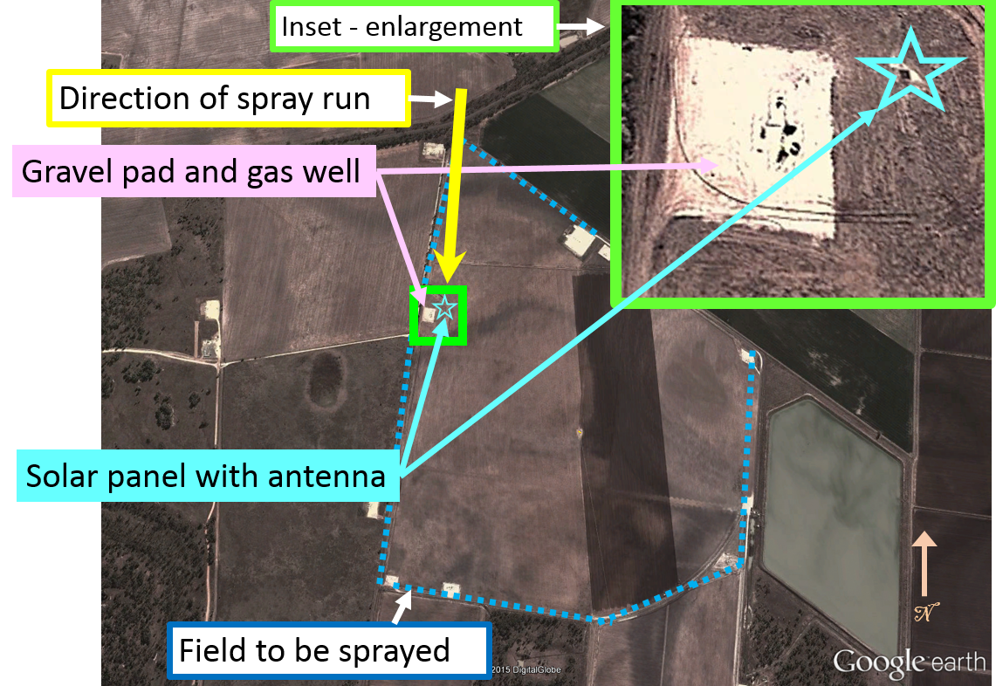
Source: Google earth – annotated by ATSB
The pilot elected to use the solar panel as a reference point and established a plan for the spraying. The aircraft then climbed and tracked a short distance away, and the pilot set up the GPS in readiness to commence the spray run.
The pilot commenced the first spray run, tracking towards the solar panel. As the aircraft came within about 20-30 m of the panel, the pilot noticed a pole behind the panel, protruding about 3 m above the crop, with an antenna on it. The pilot immediately conducted a climb to avoid the pole and antenna, but the aircraft struck the pole (Figure 2).
The pilot’s primary concern was to check that the aircraft was still controllable. The pilot conducted a climb to a safe height and checked the flight controls and all controls responded normally. The pilot could not see any damage to the aircraft or any fuel venting from the tanks. The pilot then checked the engine instruments and all indications were normal. There was a slight vibration, which the pilot assessed as possible damage to a panel on the airframe, or a blade of the spray pump used to disperse the load. The pilot therefore switched the pump off, but the vibration continued.
Figure 2: Bore with solar panels and pole (after collision)
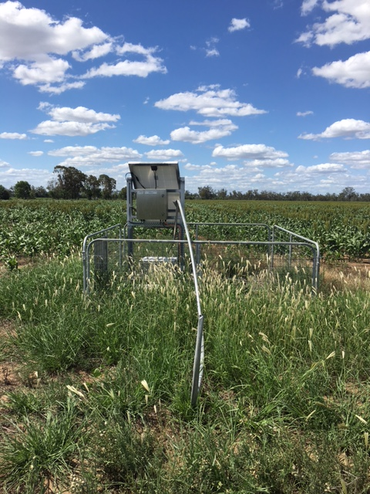
Source: Aircraft operator
At that stage, the pilot decided that it was not necessary to dump the chemical load. The pilot decided to land as soon as practicable and assess the damage to the aircraft. They elected to return to Dalby, where there were emergency services available. The pilot broadcast on the UHF radio advising the company that the aircraft had struck a pole, was still flying normally, and would be returning to the airport. However, as the aircraft was relatively heavy, the pilot elected to spray about 500-600 L of the chemical, at a higher flow rate than normal, to reduce the load prior to returning to land.
During the return flight, the aircraft still had a minor vibration. The pilot overflew the runway at Dalby to check the wind direction and speed before joining the circuit. The pilot conducted the approach about 5 kt faster than normal, due to the weight of the aircraft and the unknown effect of the damage caused by the collision with the pole. The aircraft landed safely at about 1240, and the pilot was uninjured. The aircraft sustained damage to the left wing and the propeller (Figure 3).

Pilot comments
The pilot provided the following comments:
- Most of the gas wells had an antenna on a pole, similar to the one the aircraft struck, however they were of a considerable height and on a gravel pad. The pilot had assumed that the gas company equipment was located on gravel pads.
- The galvanisation on the pole had no shine and it blended into the background of the crop. A line of trees beyond the crop also made the pole difficult to see. It would have stood out more clearly against a blue background of sky.
- The solar panels were located on a ground water quality bore, with the (pole and) antenna for satellite transmission.
- Pilots from the same company had previously conducted spraying operations in that field, but the pole had not been in place then.

Figure 3: Damage to propeller (left) and wing damage (right)
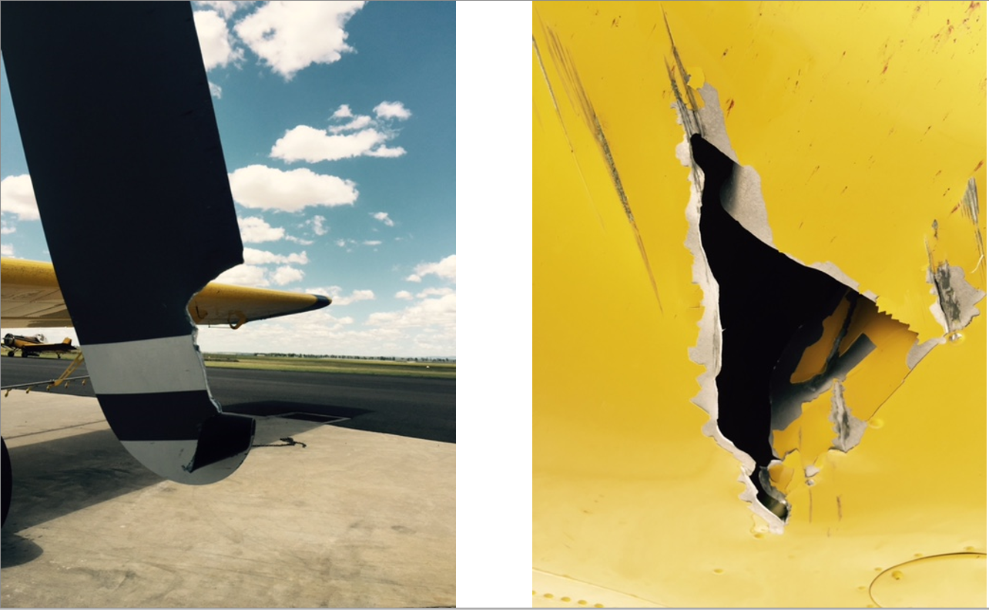
Source: Aircraft operator

Safety message
This incident highlights the importance of communication in identifying risks for low-level flying operations. Additionally, unknown hazards can be very difficult to see. The use of clearly visible markings may help pilots identify hazards during a field inspection. Pilots can then make a plan to avoid them during spraying operations.
The ATSB report Wirestrikes involving known wires: A manageable aerial agriculture hazard, cautioned pilots to conduct an aerial reconnaissance to confirm the location of wires and other hazards. Having a plan and a procedure to minimise the risk of collision with hazards is a valuable mitigation strategy. Further risk management strategies for agricultural operations are detailed in the Aerial Application Pilots Manual.

General details

Occurrence details
Date and time: | 4 December 2015 – 1240 EST
Occurrence category: | Accident
Primary occurrence type: | Controlled flight into terrain
Location: | 24 km SW of Dalby (ALA), Queensland
 | Latitude: 27° 16.43' S | Longitude: 151° 04.13' E

Aircraft details
Manufacturer and model: | Air Tractor Inc. AT-502B
Registration: | VH-PTF
Serial number: | 502B-0404
Type of operation: | Aerial work – Aerial agriculture

Flight crew incapacitation involving a SOCATA TBM 700, VH-YZZ

What happened
SOCATA TBM 700, VH-YZZ
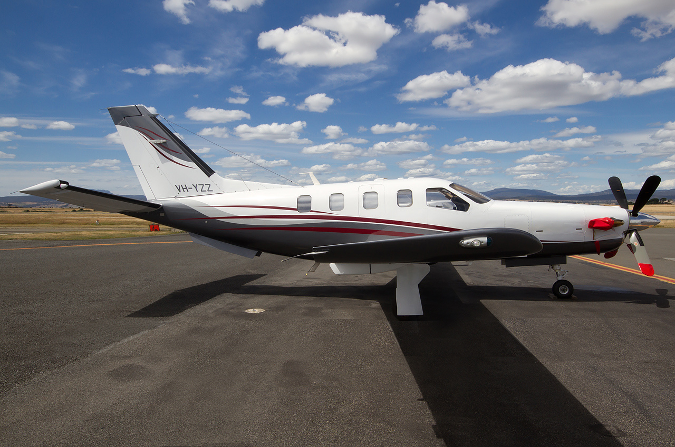
Source: Martin Eadie/Airliners.net
On the morning of 15 December 2015, a SOCATA TBM 700 aircraft, registered VH-YZZ (YZZ), departed Gold Coast Airport, Queensland for Lake Macquarie Airport, New South Wales. On board were the pilot and one passenger.
The flight to Lake Macquarie was uneventful and the pilot reported feeling well.
Having not previously landed at Lake Macquarie, the pilot overflew the aerodrome, at approximately 1,500 ft above ground level, to confirm the airfield layout. After the overflight, the pilot joined the upwind leg and commenced a left circuit for runway 07 (Figure 1). The aircraft was configured for landing during this time and, when on final, the approach speed was set to 80 kt.
Figure 1: Indicative flight path of YZZ overflying Lake Macquarie Airport prior to joining the downwind and final legs of the approach to runway 07
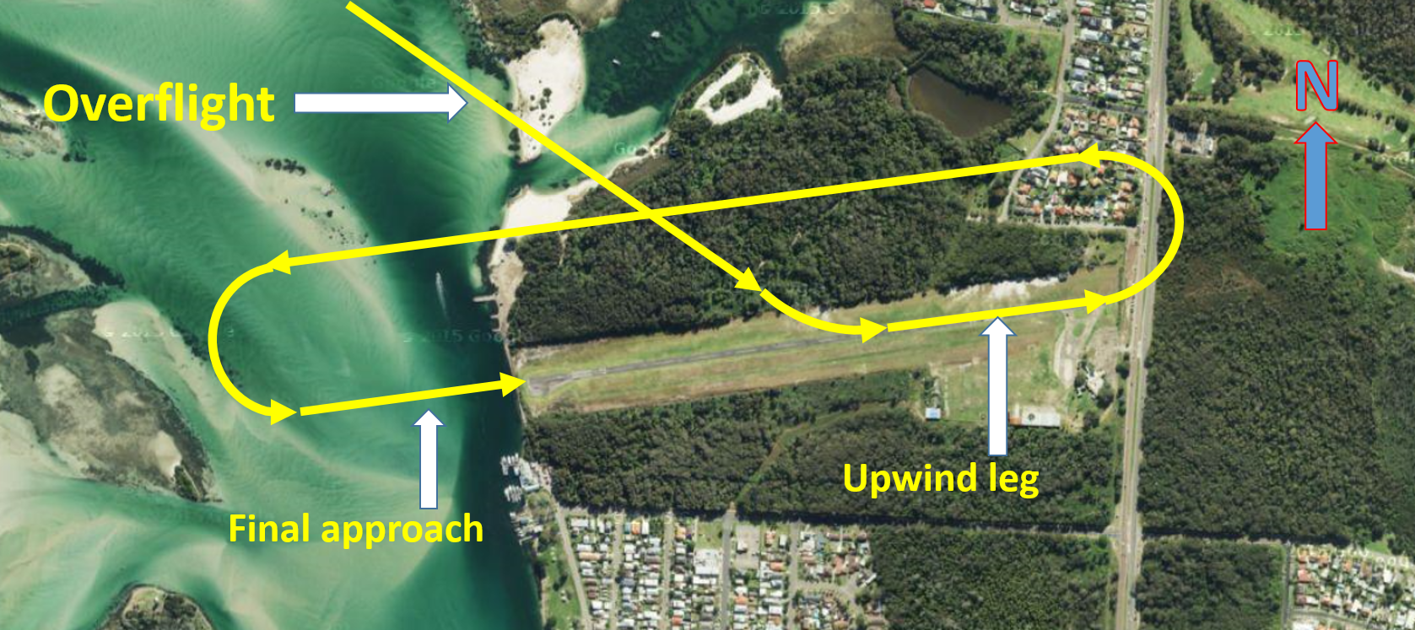
Source: Google maps – modified by ATSB
When YZZ was on short final, the pilot began to feel ‘woozy’ and, shortly after, lost consciousness. Closed circuit television footage showed the aircraft descended onto the runway and bounced before impacting the runway in a nose-low attitude to the left of runway centreline. The nose-low impact collapsed the nose gear and caused the forward section of the aircraft to strike the runway, bending all four propeller blades. It was at this time that the pilot regained consciousness, approximately 5 to 10 seconds after losing consciousness. The aircraft then skidded on the runway before veering to the right, and onto the grass (Figure 2). The aircraft eventually stopped on the grass area next to the runway (Figure 3).
Figure 2: Final approach path of YZZ to runway 07 with the approximate positions the aircraft first impacted the runway, bounced, the second impact and the approximate path YZZ skidded along, and across, the runway before coming to a stop on the grass
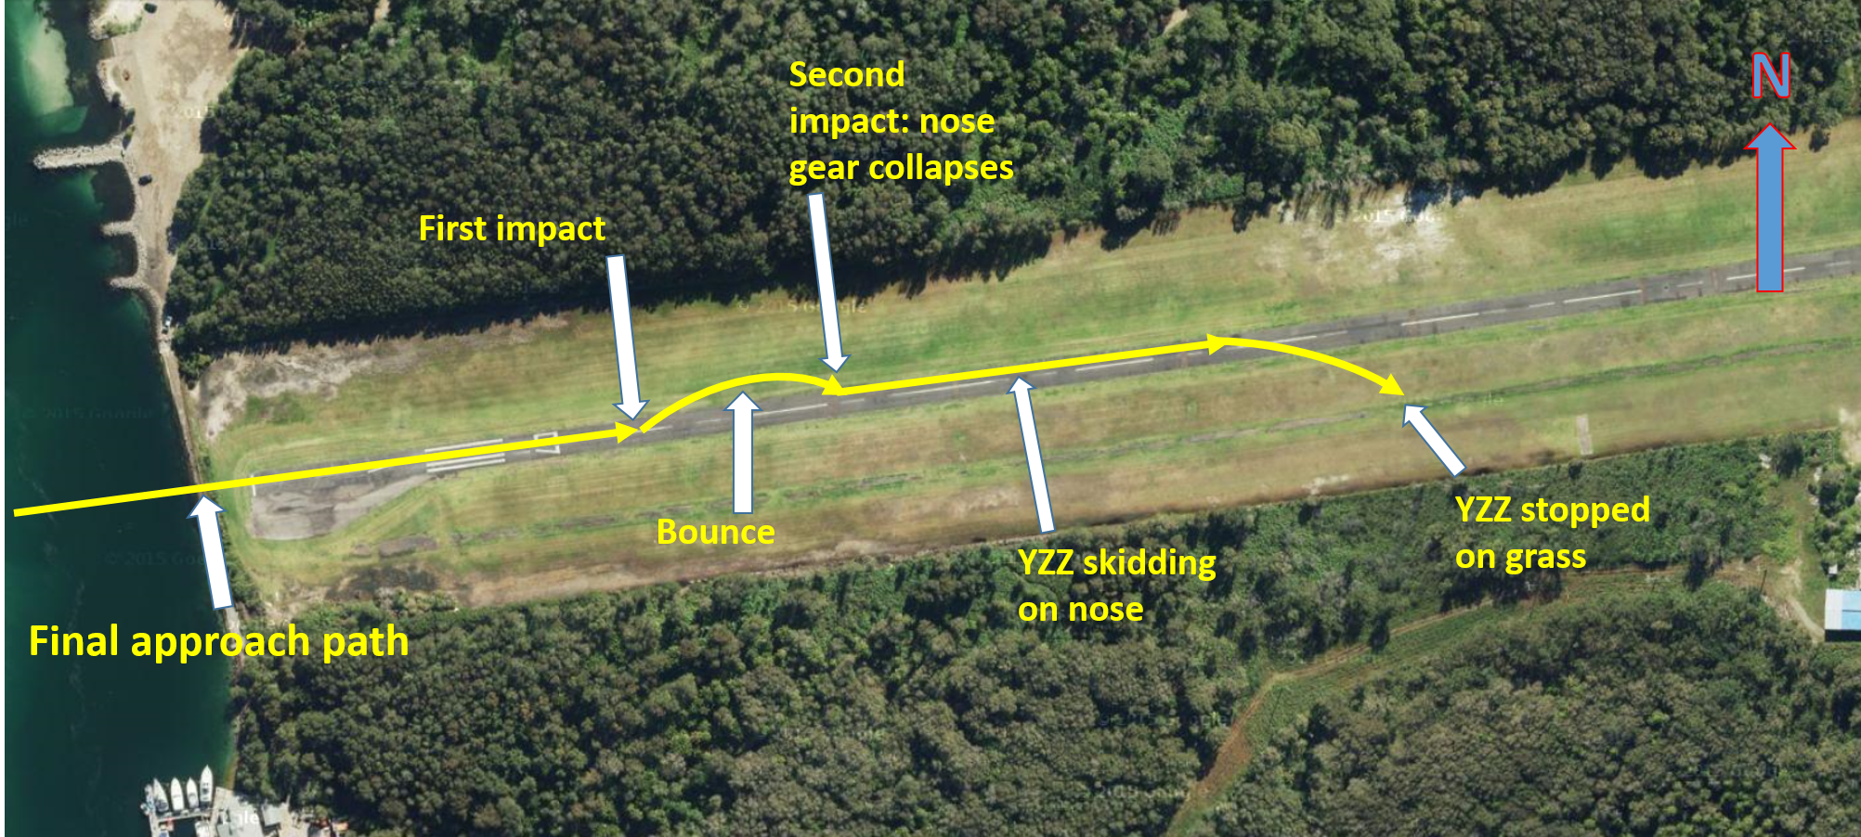
Source: Google maps – modified by ATSB
Figure 3: YZZ post-accident showing the damage to the forward section of the aircraft as a result of the nose gear collapse and skidding on the ground
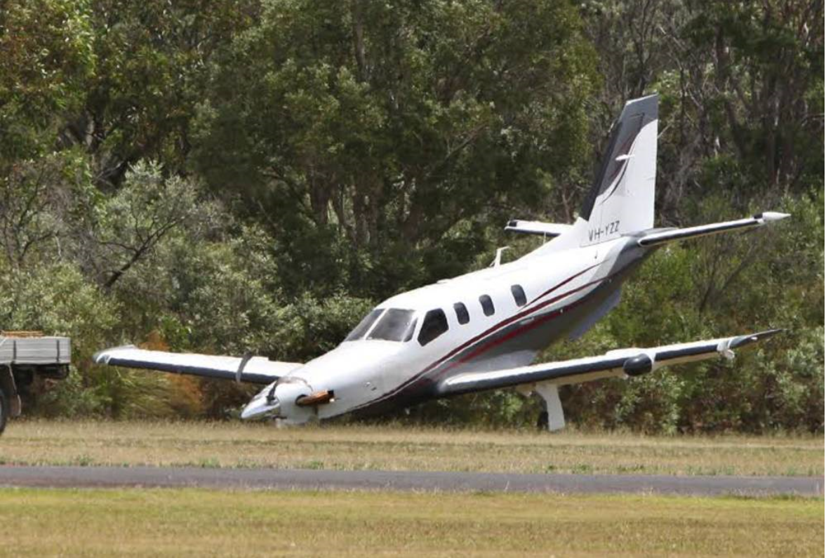
Source: Phil Hearne/Fairfax syndication
After YZZ had come to a stop, the pilot and the passenger detected a burning smell and made an emergency egress from the aircraft. Once they were safely clear of the aircraft, the pilot saw that there was no fire and that the smell was from the nose gear being jammed under the fuselage and skidding on the runway surface. The pilot then re-entered the aircraft and shut down the engine to ensure that the risk of fire was eliminated. Neither the pilot nor the passenger were injured in the accident, however the aircraft was substantially damaged.

Aircraft systems
All systems on the aircraft were functioning normally. There was no fault evident with any system that could have contributed to the pilot’s loss of consciousness.

Pilot comments
The pilot stated they were well rested, had eaten prior to and during flight and were appropriately hydrated. The pilot reported that they had no previous loss of consciousness events, nor were there any extra pressures or distractions that may have affected them during the flight.
Medical tests and monitoring after the accident found that the loss of consciousness was due to a previously undiagnosed heart condition.

Safety message
The health of flight crew is vitally important for the safe operation of aircraft. Ultimately, all flight crew are responsible for monitoring their own health and wellbeing. Any deterioration in health that may affect the performance of flight crew should be taken seriously.
While in this instance, the pilot had no indication of a health concern before to the event, it is important for pilots to assess their fitness to fly prior to flight. The following checklist provides a quick reference. A description of aeromedical factors is available in the US Federal Aviation Authority (FAA) Pilot’s Handbook of Aeronautical Knowledge.
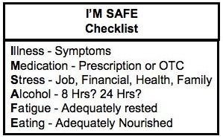
Source: US Federal Aviation Administration
In February 2016, the ATSB released a research report into pilot incapacitation occurrences between 2010 and 2014. The report provides valuable insight into pilot incapacitation occurrences in high capacity air transport, low capacity air transport and general aviation.
The report highlights how pilot incapacitation can occur in any operation type, albeit rarely. Of interest, the research found that around 75 per cent of the incapacitation occurrences happened in high capacity air transport operations (about 1 in every 34,000 flights). With the main causes being gastrointestinal illness and laser strikes. Low capacity air transport and general aviation had fewer occurrences with a wider variation of causes of pilot incapacitation. These ranged from environmental causes, such as hypoxia, to medical conditions, such as heart attack.
Importantly, the report reminds pilots in general aviation, to assess their fitness prior to flight. Assessment of fitness includes being aware of any illness or external pressures they may be experiencing.

General details

Occurrence details
Date and time: | 15 December 2015 – 1300 EDT
Occurrence category: | Accident
Primary occurrence type: | Flight crew incapacitation
Location: | Lake Macquarie ALA, New South Wales
 | Latitude: 33° 04.0’ S | Longitude: 151° 38.9’ E

Aircraft details
Manufacturer and model: | S.O.C.A.T.A. Groupe Aerospatiale TBM 700
Registration: | VH-YZZ
Serial number: | 226
Type of operation: | Private

Piston aircraft

Collision with coral reef involving a de Havilland Canada DHC-2, VH-AWI
What happened
On 25 June 2015, at about 1111 Eastern Standard Time (EST), a de Havilland Canada DHC-2 amphibian aircraft, registered VH-AWI (AWI), taxied at Hardy Lagoon aircraft landing area (ALA), Queensland, for a flight to Shute Harbour with the pilot and seven passengers on board.
The Hardy Lagoon ALA had marker buoys to identify the location of the bommies that were near each of the four take-off and landing areas. The main take-off run (orange run) to the south, started at buoy A, and continued onto buoys B, C, D, E, F (Figure 1, orange line). The take-off run to the east-south-east (yellow run), started at buoy B, and continued onto buoys Q, P, O, N, K (Figure 1, yellow line). As per company policy, the pilot elected to start the take-off at buoy A on the orange run and then turn onto the yellow run. This combination of take-off runs allowed the pilot the maximum take-off distance, for the aircraft’s take-off weight.
Figure 1: Hardy lagoon aircraft landing area
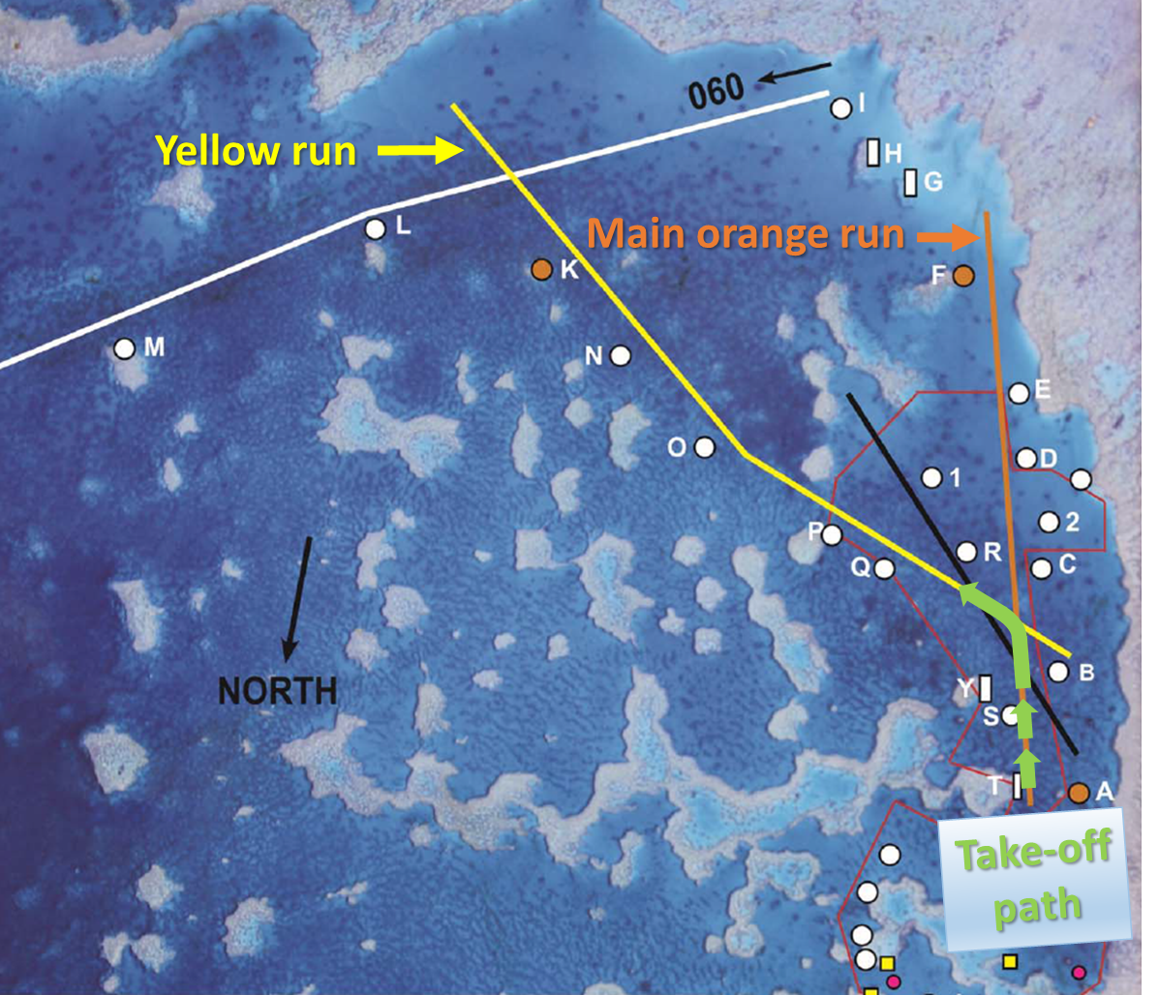
Source: Aircraft operator, modified by the ATSB
The pilot taxied AWI to buoy A and lined up on the orange run. They then advanced the throttle slowly to commence the take-off. As AWI approached buoy B the engine was not at full power. The pilot commenced the turn onto the yellow run utilising the water rudders, which were in the down position. Coming out of the turn the pilot retracted the water rudders and applied right rudder to stop the turn and line up on the yellow run.
The pilot looked inside the cockpit to check the engine instrumentation and to see if the engine had reached full power. At this stage, the aircraft had not risen onto the step (Figure 2). When the pilot looked outside again, they noticed that the nose of the aircraft had drifted too far to the left. The nose had lined up on the left side of the buoy Q, which marked the location of the Q bommie. The pilot attempted to apply more right rudder, but had already applied full right rudder. AWI then hit and passed over the Q coral reef bommie and the pilot closed the engine throttle. AWI continued moving forward and the pilot shut down the engine and lowered the flaps to help slow the aircraft. The left front float slid onto the P bommie and the aircraft came to a stop.
The pilot exited the aircraft and pushed the aircraft off the bommie, before re-entering the cockpit. When AWI had drifted far enough away from the bommie, the pilot restarted the engine and taxied the aircraft to a nearby moored boat, where the passengers disembarked.
The pilot and seven passengers were uninjured and the aircraft sustained minor damage (Figure 3).
Figure 2: AWI conducting a water take-off (not the occurrence take-off). Note the high nose attitude, skids sitting up out of the water as the aircraft is ploughing through the water. AWI has not gained enough speed in the take-off to reach the step, where the nose would be lower and the aircraft would glide along the water on the floats.
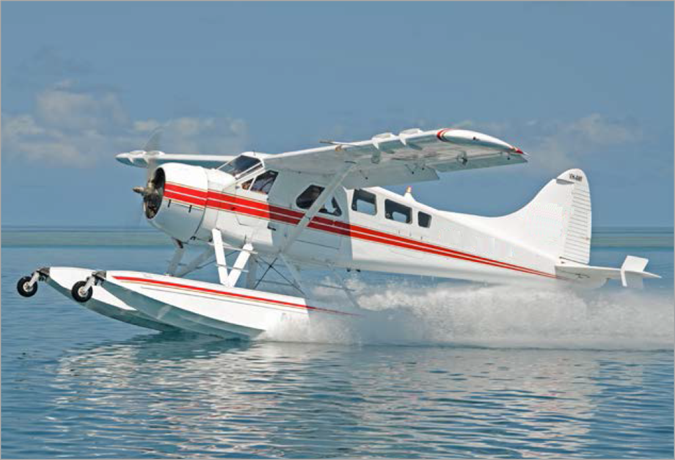
Source: Aircraft operator, modified by the ATSB
Figure 3: Damage to AWI floats included two holes on the bottom side of each float compartment immediately forward of the wheel well.
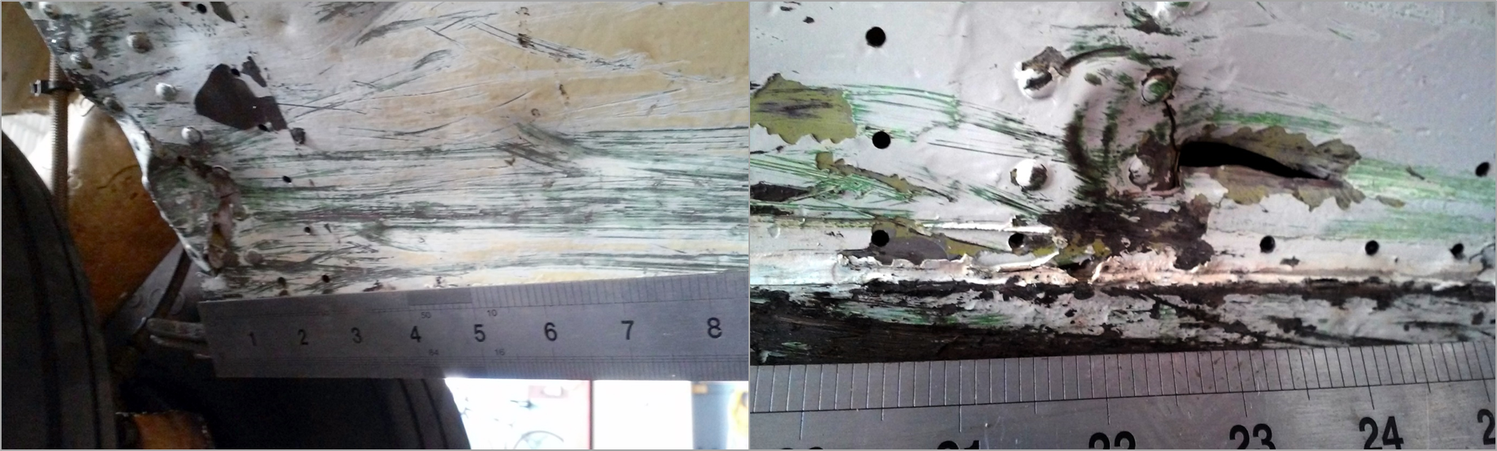
Source: Aircraft operator

Attempt to reposition the aircraft
After consultation with the chief pilot, who was also at Hardy Lagoon, the pilot attempted a second take-off on the orange run, without any passengers on board. The pilot aborted the take-off at about buoy E, as the aircraft would normally be on the step at this point. The pilot taxied back to the moored boat, shut the aircraft down, and then pumped out water from the compartments in the floats (Figure 4). They then attempted another take-off on the orange run, again without success.
Figure 4: Example cross-section view of the float compartments. Note the bilge pump openings to remove water from the float compartments during the pre-flight inspection, the retractable water rudder used for directional control while taxiing and the location of the wheel well for the retractable main landing gear.
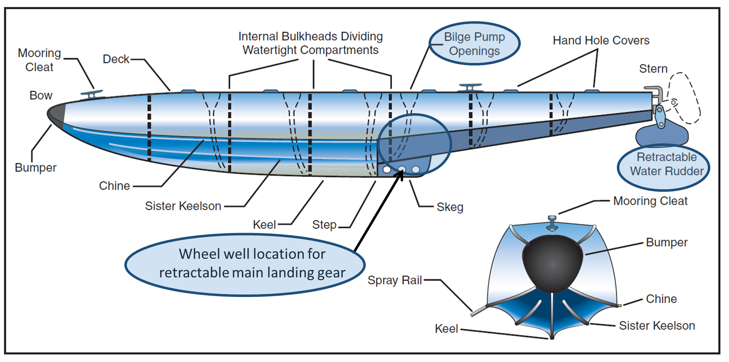
Source: Federal Aviation Administration, modified by the ATSB

Pilot comment
The pilot decided to use a combination of the orange and yellow run to give the maximum take-off distance. The pilot indicated that they did this because the aircraft was close to the maximum take-off weight and it was approaching low tide, so the coral reef bommies were more exposed.
The pilot reported a gentle breeze of about 8 kt from south-east and the water was smooth with small ripples. The wind direction was between the orange and yellow runs.
The pilot indicated that they did not advance the throttle as quickly as they would normally, due to a recent conversation with other another company pilot. The conversation was about managing the aircraft engine to ensure that the engine limits were not exceeded. In retrospect, the pilot thought that for the occurrence flight, the advancement of the throttle was too slow. Normally turning onto the yellow run the engine would be at full power.

Pilot experience
The pilot had a total time of about 904 hours, with 540 hours on the DHC-2 aircraft. Of their total time about 595 hours was on seaplanes, with 941 water landings and take-offs. The pilot had 34 landings at the Hardy Lagoon ALA, including 21 solo landings, and 13 under supervision. The pilot had last landed at the Hardy Lagoon ALA 32 days prior to the occurrence.

Operator comment
In light winds, where the pilot wanted additional take-off length, it was standard company procedure to start the take-off on the orange run and then to turn onto the yellow run. The aircraft had a payload of 440 kg, 10 kg under the company limit weight for the aircraft for take- off.
The chief pilot reported that the pilot had pumped out all the water from the floats prior to taxi on the occurrence flight.
Safety action
Whether or not the ATSB identifies safety issues in the course of an investigation, relevant organisations may proactively initiate safety action in order to reduce their safety risk. The ATSB has been advised of the following proactive safety action in response to this occurrence.

Aircraft operator
As a result of this occurrence, the aircraft operator has advised the ATSB that all company pilots will be made aware of the serious incident and conduct recurrent training on the Hardy Lagoon ALA.
Safety message
This serious incident illustrates that distractions can have a significant impact on flight safety. Distraction is a process, condition, or activity that takes a pilot’s attention away from the task of flying. Even a momentary deflection of attention away from the primary task can have adverse consequences.
The Federal Aviation Administration published a handbook Seaplane, skiplane, and float/ski equipped helicopter operations handbook, for pilots and is available from the FAA website. The handbook discuss the importance of the pilot planning an effective course of action, and mentally staying ahead of the seaplane.
The serious incident highlights the importance of pre-flight decision making and planning for emergencies and abnormal situations for the particular aerodrome. A thorough pre-flight self-brief covering the different emergency scenarios may help to minimise safety critical decisions during a high workload situation such as a take-off.
General details

Occurrence details
Date and time: | 25 June 2015 – 1114 EST
Occurrence category: | Serious incident
Primary occurrence type: | Ground strike
Location: | Hardy Lagoon ALA, Queensland
 | Latitude: 19° 47.70' S | Longitude: 149° 15.50'’ E

Aircraft details
Manufacturer and model: | de Havilland Canada DHC-2
Registration: | VH-AWI
Serial number: | 298
Type of operation: | Charter - Passenger
Persons on board: | Crew – 1 | Passengers – 7
Injuries: | Crew – Nil | Passengers – Nil
Damage: | Minor

VFR into IMC involving a Piper PA28 aircraft, VH-TAU
What happened

Flight planning
On the morning of 8 September 2015, a pilot planned a navigation exercise from Moorabbin Airport, overhead Yarram aircraft landing area (ALA), and then on to Bairnsdale Airport, Victoria (Figure 1). The return flight from Bairnsdale to Moorabbin was to be via Latrobe Valley Airport, Victoria. The pilot had recently passed their Private Pilot Licence, and this solo navigational exercise was part of the training toward a Commercial Pilot Licence.
Figure 1: Planned route for the navigation exercise
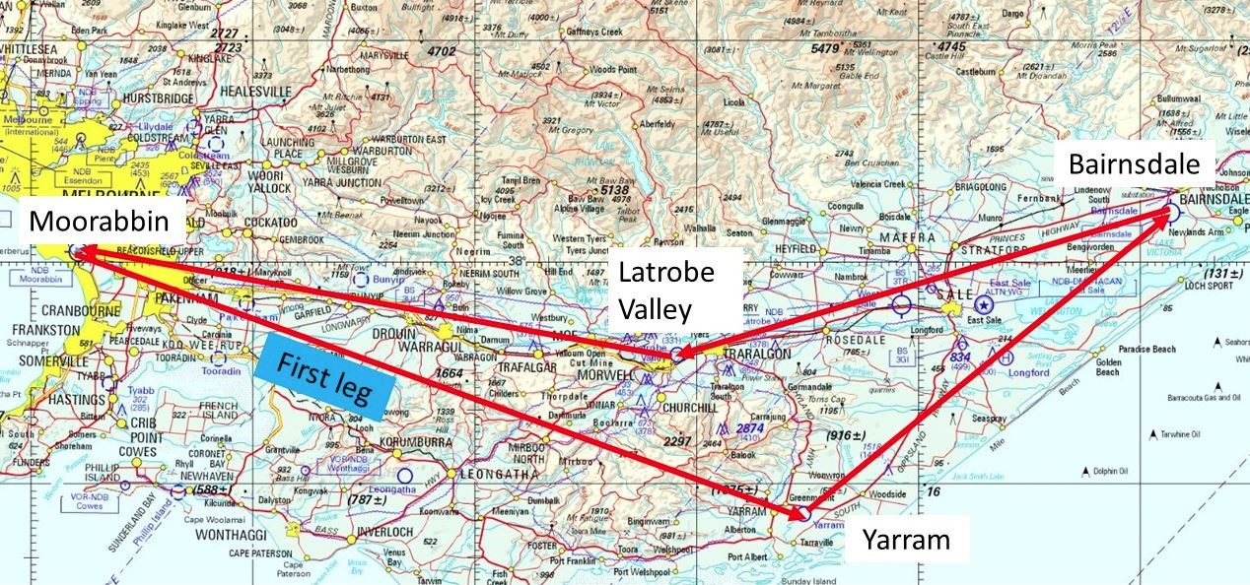
Source: Airservices Australia Melbourne World Aeronautical Chart (WAC)
The pilot reviewed the Area 30 weather forecast, including the terminal area forecasts (TAFs) and METARs for Moorabbin, Latrobe Valley, and Bairnsdale, to assess the suitability of the conditions for the planned visual flight rules (VFR) flight.
The Area 30 Forecast (ARFOR) overview, issued at 0805 Eastern Standard Time (EST), which covered the time of the flight, predicted isolated scattered showers, and snowfalls above 4,000 ft. Low cloud with precipitation particularly on the windward slopes was also forecast. It was expected that this low cloud would contract to the north-east section of Area 30 by 1200, and clear by 1400. The wind below 5,000 ft was forecast as south-westerly and between 20 and 25 kt. A note stated that winds up to 5,000 ft were forecast to be 10-20 kt stronger in the east (including the Bairnsdale region).
Confident that the flight could be safely conducted under the VFR, the pilot then discussed the planned route, and associated weather forecasts with a senior instructor at the flying school. During this discussion, the pilot and instructor decided that due to the METAR at Bairnsdale Airport indicating strong winds of up to 35 kt, the pilot should make an assessment upon arrival there. If the pilot did not assess the wind as suitable/safe for landing, the brief was to overfly the airport and commence the return leg to Latrobe Valley. They also decided to delay the flight’s departure time from Moorabbin, so that the planned arrival time back into Latrobe Valley fell outside the INTER/TEMPO period for this airport.

Pilot recollection of the flight
The pilot prepared a Piper PA28 (Warrior) aircraft, registered VH-TAU (TAU), and then departed Moorabbin at the delayed time of 1239. The pilot reported that both the departure and initial climb went as planned.
To maintain separation from the cloud, the pilot levelled the aircraft at about 3,000 ft above mean sea level (AMSL) and conducted a crosscheck of their calculations. They visually confirmed the aircraft’s location, noting this on the flight plan.
About 15 NM into the initial leg of the flight (Figure 2), the pilot reported noticing some cloud on the ranges around the aircraft, with the base at about 3,000 ft. Still with the mindset that the weather was suitable for the flight, and wanting to continue, the pilot elected to fly around the lower patches of cloud. At this stage, they were confident that they could ‘push on’. The pilot reported that they had accompanied a friend on the same navigation exercise the previous week, in similar weather conditions. The pilot’s friend had had been successful in negotiating the weather and completing the flight.
Figure 2: Initial leg of flight planned track, from Moorabbin Airport to overhead Yarram ALA
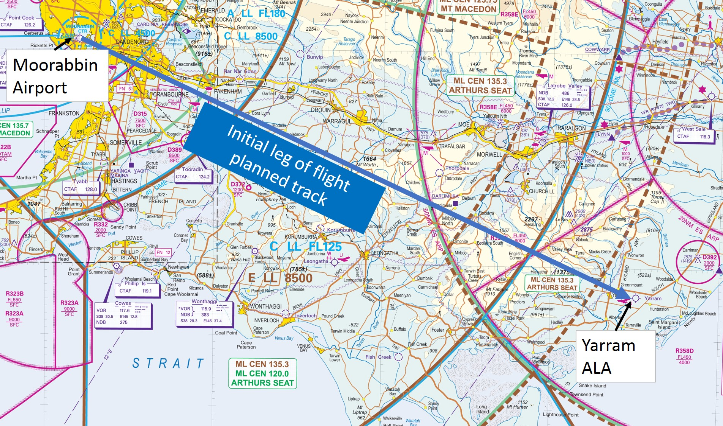
Source: Airservices Australia – Melbourne Visual Navigation Chart annotated by ATSB
In hindsight, the pilot reported an unawareness of how thick and widespread the cloud ahead really was, and how it was different to what had been expected. After manoeuvring around several patches of cloud, the pilot made a decision to conduct a 180° turn onto the reciprocal track, and return to Moorabbin. After logging the diversion time on the flight plan, the pilot initiated a turn to the left. Almost instantly, the pilot realised that the aircraft was now completely engulfed in cloud, and had entered instrument meteorological conditions (IMC). The pilot was not instrument rated, nor was the aircraft approved for flight in IMC. The aircraft was equipped with a Very High Frequency Omnidirectional Range (VOR), but the pilot had not been trained to operate this navigational aid.
Although having completed the mandatory basic instrument flight requirements during earlier training, the pilot had not been in cloud before; and reported feeling totally overwhelmed by such an unfamiliar environment. While trying to control the aircraft solely by reference to the instruments, the pilot reported having an escalating concern about the aircraft’s altitude, the height of the surrounding terrain, and the total loss of visual cues to be able to ascertain the aircraft’s position.

The request for assistance
At about 1313, the pilot reported stopping the turn at a heading of about 300 °M, levelling the wings, and called Melbourne Centre for assistance (see Table 1).
Melbourne Centre clarified the aircraft’s position, and placed an uncertainty phase (INCERFA ) on the aircraft. The air traffic controller (ATC) then contacted the instructor in an instrument flight rules (IFR) Cirrus S22, VH-QQT (QQT), who was conducting dual IFR training at nearby Latrobe Valley Airport. The controller at Melbourne Centre confirmed the in-flight conditions with the instructor in QQT, who advised that the cloud tops were about 6,500 ft. Both the instructor and controller then focussed on assisting the pilot in TAU.

Assistance provided by instructor in QQT
The experienced instructor in QQT began providing assistance over the radio to the pilot in TAU. After establishing the facts, and the pilot’s level of experience, the instructor in QQT began to ‘mentor’ the pilot in TAU. The instructor was concerned about the current altitude, which was below the lowest safe altitude (LSALT) of 3,400 ft in the area, and the possibility of icing. Therefore, the instructor talked the pilot through maintaining a focus on keeping the aircraft wings level (to prevent a turn), while initiating a climb through the thick layer of cloud.
The instructor in QQT was able to work methodically with the pilot in TAU, focusing on reducing the pilot’s workload and keeping them calm. The instructor requested all the required airspace clearances for both aircraft from ATC; and ATC assisted in arranging and expediting these. The pilot in TAU reported clear of cloud at about 6,400 ft, some 15 NM north of the original flight planned track (Figures 3 and 4).
ATC then provided vectors to the instructor in QQT to locate TAU, which was now some distance from the Cirrus. The instructor advised that the transponder paint of TAU on the traffic collision avoidance system (TCAS) in QQT had kept ‘dropping out’.
The instructor in QQT continued to work closely with ATC who again arranged all required clearances for both aircraft in tandem, back to Moorabbin. As part of this assistance, ATC advised the instructor that there was a large break in the cloud over Port Phillip Bay west of Moorabbin. The two aircraft travelled to this area and once the instructor had confirmed that the pilot in TAU was orientated, and able to manage the descent, approach and landing back into Moorabbin, the two aircraft parted and TAU landed uneventfully some minutes later.
Figure 3: Surveillance image at about the time VH-TAU first broke clear of cloud. Note distance from intended waypoint of Yarram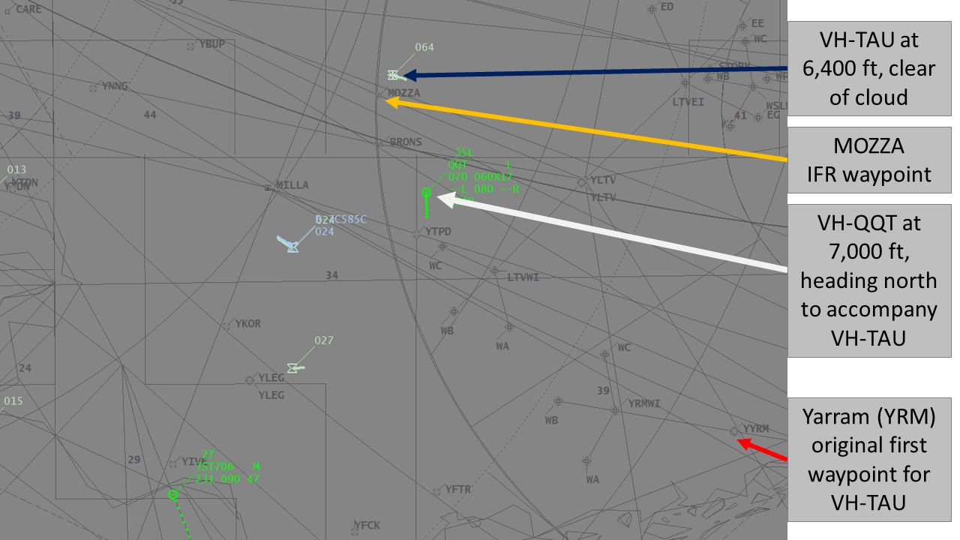
Source: Airservices Australia annotated by the ATSB
Figure 4: Google earth representation of where TAU broke clear of cloud
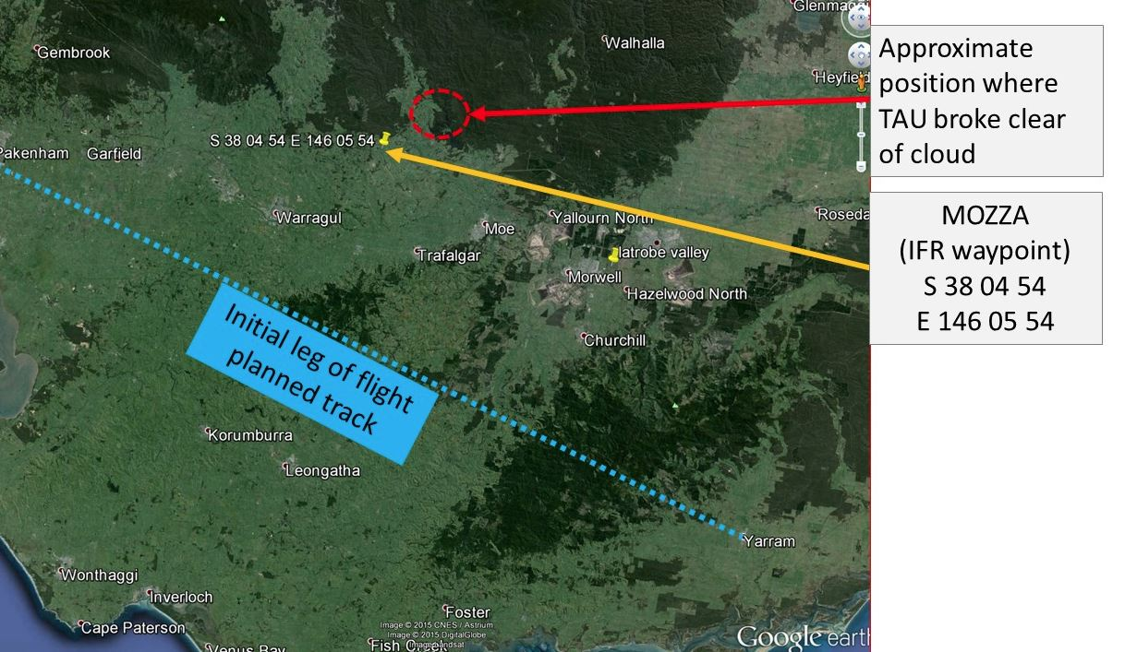
Source: Google earth annotated by ATSB

Actual flight path
The ATSB was provided with surveillance data from Airservices Australia. Table 1 presents a summary of what the surveillance data showed.

Table 1: Surveillance data – main points
Local time | Heading | Altitude | Comment
1239 | TAU departed Moorabbin Airport
1300 | TAU on track for Yarram | Gradually descended from 3,100 ft to 2,400 ft
1303-1307 | Commenced a left turn, took up an easterly heading | Moved between 2,400 ft and 2,800 ft
1309 | Left turn continued through north and around to the south-west | 2,900 ft | This placed TAU almost directly under QQT. QQT is at 5,800 ft in a right hand holding pattern at Latrobe Valley Whiskey Charlie (WC) for the RWY 03 RNAV
 | TAU continued the left turn around to the south-east. Turn then continued back to the north-west | About 3,000 ft
1313 | TAU now heading west-south-west | 3,100 ft | TAU has now completed in excess of 360°; QQT remained in a right-hand hold at WC, now at 3,900 ft. QQT on climb,
1313 | PILOT IN TAU CALLS ATC FOR ASSISTANCE |  | ATC apply an INCERFA PHASE on TAU
1318-1321 | TAU (being mentored) now on climb; changed heading to the right, through west, through north, to north-east | About 5,000 ft | TAU has now passed over IFR waypoint BRONS (south of MOZZA Figure 2);  QQT remained in the hold at WC, and has climbed back to 6,600 ft, continued to 7,000 ft.
1322-1328 | TAU turned to the north | Between 6,200 and 6,400 ft | TAU on top of cloud. Advises QQT and ATC
Source: Compiled by ATSB from Airservices Australia surveillance data

Relevant Terminal Area Forecasts (TAFs)
In addition to the overview of the Area 30 forecast mentioned previously, the relevant TAFs covering the period of the flight are as follows:
Moorabbin: Issued at 0907: Scattered cloud at 3,000-4,000 ft, with deteriorating conditions from 1800.
Bairnsdale: Issued at 1027: Wind from 250°T at 14 kt; 10 km visibility; light rain showers and scattered cloud at 3,000 ft, with broken cloud at 4,000 ft.
Latrobe Valley: Issued at 1030: 10 km visibility, light rain showers. Cloud few at 2,500 ft and scattered at 3,500 ft.
Safety message
The importance of seeking assistance from ATC as soon as a pilot is in difficulty, or preferably before they reach that point, cannot be overstated. This is a common and important message in most of the educational material on VFR into IMC scenarios. It almost certainly led to a good outcome in this occurrence. ATC could prioritise resources and gain assistance from a nearby aircraft. In this occurrence, good teamwork between the pilots of both aircraft and air traffic control ensured a successful outcome.
The ATSB and CASA publications listed below highlight the importance of really understanding the weather you may encounter at the planning stage, making good decisions, knowing your aircraft and all its equipment, and using a personal minimums checklist.

The ATSB SafetyWatch highlights the broad safety concerns that come out of our investigation findings and from the occurrence data reported to us by industry. Flying with reduced visual cues such as in this occurrence remains one of the ATSB’s major safety concerns. https://www.atsb.gov.au/safetywatch/flying-with-reduced-visual-cues.aspx
Number 4 in the Avoidable Accidents series published by the ATSB, Accidents involving pilots in Instrument Meteorological Conditions, lists three key messages for pilots:
- Avoiding deteriorating weather or IMC requires thorough pre-flight planning, having alternate plans in case of an unexpected deterioration in the weather, and making timely decisions to turn back or divert.
- Pressing on into IMC conditions with no instrument rating carries a significant risk of severe spatial disorientation due to powerful and misleading orientation sensations in the absence of visual cues. Disorientation can affect any pilot, no matter what their level of experience.
- VFR pilots are encouraged to use a ‘personal minimums’ checklist to help control and manage flight risks through identifying risk factors that include marginal weather conditions.
Available from CASA’s online store are:
Weather to Fly –This DVD highlights the dangers of flying in cloud, and how to avoid VFR into IMC.
Flight Planning – always thinking ahead. A flight-planning guide designed to help you in planning and conducting your flight. This guide includes a ‘personal minimums checklist.
General details

Occurrence details
Date and time: | 8 September 2015 at 1310 EST
Occurrence category: | Serious incident
Primary occurrence type: | VFR into IMC
Location: | Approximately 18 NM NNW of Latrobe Valley airport, Victoria
 | Latitude: 37° 54.43 S | Longitude: 146° 29.17 E

Aircraft details
Manufacturer and model: | Piper Aircraft Corporation PA28-161
Registration: | VH-TAU
Serial number: | 2842209
Type of operation: | Flying Training - solo
Persons on board: | Crew – 1 | Passengers – Nil
Injuries: | Crew – Nil | Passengers – Nil
Damage: | Nil

Low fuel event involving a Piper PA-31P, VH-OGW

What happened
On 18 December 2015, the pilot of a Piper PA-31P aircraft, registered VH-OGW (OGW), operated patient transfer flights from Bankstown to Merimbula, Wagga Wagga, Griffith and return to Bankstown, New South Wales.
At the start of the day, the aircraft was fuelled to a total of 440 L, which the pilot entered into the on-board fuel computer. After landing at Merimbula, the pilot added fuel to a total of 650 L on board. However, the pilot inadvertently entered a figure equating to about 710 L into the fuel computer at that time, which was 60 L more than the actual fuel on board.
Prior to departing on the final sector from Griffith to Bankstown, the pilot reviewed the fuel requirements for the flight. Based on figures from the fuel computer, there was sufficient fuel on board for the aircraft to land at Bankstown with 140 L remaining; which was in excess of the minimum reserves required. Also on board for the flight were a nurse and a patient.
After departure from Griffith, the aircraft climbed to flight level (FL) 110. However, at FL 110, the aircraft encountered a headwind of about 20 kt. In order to conserve fuel, the pilot elected to descend to 10,000 ft, where the headwind decreased to about 10 to 15 kt.
At about 2300 Eastern Daylight-saving Time (EDT), the aircraft landed at Bankstown Airport. The following morning, prior to the first flight of the day, another company pilot dipped the aircraft’s fuel tanks, and assessed that only about 60 L of fuel remained after the previous flight. A minimum of 45 minutes of fixed fuel reserves, equating to 120 L, was required for the flight, hence the aircraft had landed the previous night with half the required fuel reserves remaining.

Wind
The forecast was for variable winds at 10 kt increasing to 20 kt above 10,000 ft. Based on the wind encountered on the previous sectors, the pilot expected a tailwind for the return flight.

Fuel calculations
The fuel computer provided the fuel flow and fuel consumed for each sector flown. The computer held two units: total fuel on board in US gallons (USG) as entered by the pilot; and fuel flow, which was calculated by fuel flow sensors in the fuel inlet lines. The fuel flow was displayed in USG per hour, and tallied the amount of fuel consumed in USG. The pilot could select to display the quantity of fuel remaining, which the computer calculated by subtracting the fuel consumed from the fuel on board figure entered by the pilot.
Before entering the fuel figures, the pilot converted the amount of fuel on board in L to USG as required for the computer. The incorrect figure entered at Merimbula may have resulted from a conversion error and/or a data entry error.
The pilot planned to land at Bankstown with 140 L of fuel remaining; and reported that the fuel computer indicated that 130-135 L remained after landing. The aircraft fuel gauges indicated that about 40 USG remained (150 L). Those figures corresponded with the pilot’s assessment of the planned fuel consumption and the headwind encountered during the flight.

Pilot comments
The pilot calculated that there was adequate fuel on board to meet the minimum fuel required for the flight plus a small excess; which would ensure the aircraft was below the maximum landing weight for the arrival to Bankstown, with fixed reserves intact.
The pilot had a total of 17.3 hours on the PA-31P aircraft type, although significantly more in the PA-31. The pilot had completed a company check flight in the aircraft that morning, and then operated three sectors prior to the incident flight.
The pilot had previously used the same type of on-board fuel computer in different aircraft, and assumed it was a reliable source for establishing the actual amount of fuel on board. However, the only reliable source approved by the operator, was to fill the fuel tanks to full, or to a known quantity and use a dipstick to crosscheck the fuel on board with the computer figure. The pilot stated that in aging aircraft, the fuel gauges were unreliable.
The pilot also commented that the dipstick provided a reliable indication of the fuel on board for the first flight of the day, but may provide an inaccurate reading if the aircraft was not parked on level ground.

Operator comments
The aircraft operator’s report into the incident stated that the pilot had not followed the fuel crosscheck requirements of the company operations manual.
Company flight crew subsequently verified that the fuel computer in that aircraft was accurate.

Safety action

Aircraft operator
As a result of this occurrence, the aircraft operator has advised the ATSB that they are taking the following safety actions:

Notice to air crew
The aircraft operator issued a notice to air crew (NOTAC) immediately following the incident. The notice reminded company flight crew of the importance of adhering to the company’s fuel cross check requirements. The notice also advised of an impending amendment to the Operations Manual to clarify the specific fuel cross check requirements of the PA-31P.
The amendment stated:
PA31P aircraft have a calibrated dipstick provided and an on-board Shadin fuel computer installed. The dipstick must be utilised for visual confirmation of a known fuel amount to be entered into the Shadin. In the event the dipstick is lost and/or the Shadin is un-serviceable then check if fuel quantity can be visually seen at the bottom of the tank, if fuel is lapping at the entry point the aircraft has 300 litres on-board. A pilot shall not depart on any mission without a visual confirmation of this minimum 300 litres.
Visual fuel crosscheck using the dipstick must be completed to verify the accuracy of the Shadin and the accuracy of pilot input into the Shadin on each subsequent sector where fuel is not added.

Safety message
The ATSB SafetyWatch highlights the broad safety concerns that come out of our investigation findings and from the occurrence data reported to us by industry. One of the safety concerns relates to aircraft fuel management.
Pilots are reminded of the importance of careful attention to aircraft fuel state. ATSB Research report AR-2011-112 Avoidable accidents No. 5 Starved and exhausted: Fuel management aviation accidents, discusses issues surrounding fuel management and provides some insight into fuel related aviation accidents. The report states that ‘accurate fuel management starts with knowing exactly how much fuel is being carried at the commencement of a flight. This is easy to know if the aircraft tanks are full, or filled to tabs’.
This incident highlights the need for pilots to use a known fuel quantity to obtain accurate fuel figures, and not rely on planned fuel consumption or a fuel calculator. Many factors can affect planned fuel consumption, including power and fuel mixture settings, variance in wind direction and strength, and holding or delays due to air traffic control. Furthermore, on-board fuel computers that rely on manual data entry may also be subject to error.

General details

Occurrence details
Date and time: | 18 December 2015 – 2300 EDT
Occurrence category: | Serious incident
Primary occurrence type: | Low fuel
Location: | Bankstown Airport, New South Wales
 | Latitude: 33° 55.47' S | Longitude: 150° 59.30' E

Aircraft details
Manufacturer and model: | Piper Aircraft Corporation, PA-31P-350
Registration: | VH-OGW
Serial number: | 31P-8414044
Type of operation: | Aerial work

Helicopters

Tail rotor strike of slung load involving a Eurocopter AS 350, VH-NPS

What happened
On 19 December 2015, the pilot of a Eurocopter AS 350 helicopter, registered VH-NPS (NPS), was conducting fire control work near Glenbrook, New South Wales, with one crewperson on board. The fire control work included use of a Bambi Bucket (Figure 1) to drop water on the fires, slung under the helicopter by a 100 ft long-line.
Figure 1: Bambi Bucket
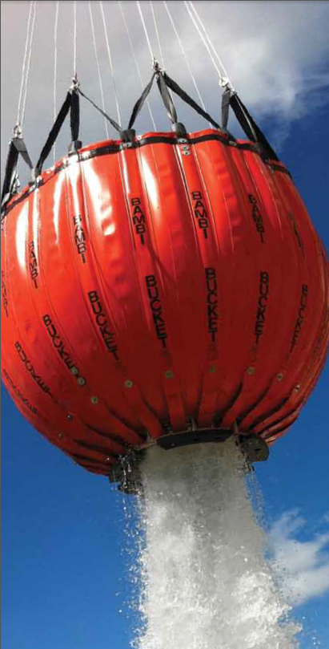
Source: sei.ind.com
Shortly before 1830 Eastern Daylight-saving Time (EDT), the pilot and crewperson decided they would cease operations for the day, due to the limited daylight remaining and the number of hours they had been on duty. The pilot elected to land the helicopter at Glenbrook helipad to refuel, before returning to base.
The helicopter landed with the bucket and line in front of the helicopter, and the fuel drum to the right of the helicopter. While the engine was still running and the rotor blades turning, the pilot realised that the helicopter’s fuel cap was on the left side and therefore needed to turn the helicopter around to access the fuel drum.
The crewperson exited, stood in front of the helicopter and took hold of the long-line to ensure it remained clear during the turn. The pilot then lifted the helicopter to about 2 ft above ground level. The crewperson used hand signals to direct the pilot to conduct a right turn, walking to stay in front of the helicopter, manage the long-line, and remain in the pilot’s sight. After the helicopter had turned 180°, the crewperson gave the signal to lower the helicopter, which the pilot followed. As the helicopter lowered down, the tail rotor struck the bucket, which was on the ground behind the helicopter. The pilot detected the strike as a vibration through the pedals, and immediately moved the helicopter forward slightly, lowered the collective, and landed.
The tail rotor was damaged (Figure 2); the pilot and crewperson were uninjured.

Pilot comments
The pilot was not looking at the bucket, which ended up behind the helicopter, but following the crewperson’s hand signals. The pilot commented that to minimise risk he should have lifted back up, turned the helicopter to the left, to keep the path ahead of the tail rotor in sight, and set the bucket back down in front of the helicopter, keeping the bucket in sight at all times.
While both the pilot and crewperson were highly experienced in helicopter operations, both had limited experience specifically in fire control work.

Operator report
The operator conducted an investigation into the incident, and identified several factors that may have contributed to the incident:
- Due to rostering requirements, an inexperienced fire operations pilot and crewperson were tasked together.
- The pilot was on their ninth successive day of duty.
- The pilot lost situational awareness of the bucket.
- Fatigue may have played a small role in reducing the pilot’s situational awareness of the bucket, and the pilot may not have been aware of this fatigue level.
- Task pressure to get the job done along with high workload due to last light requirements, crew transport and a request for the crew to continue water bombing, may have reduced situational awareness and crew communication.
- Time pressure may have contributed to the incident. As incident work is high-paced, it is important for the crew to slow down to allow all critical checks to be completed in an unhurried manner.
- The day had been extremely hot, highlighting the need for crew to remain well-hydrated, eat and take regular rest breaks.

Figure 2: Damage to VH-NPS tail rotor
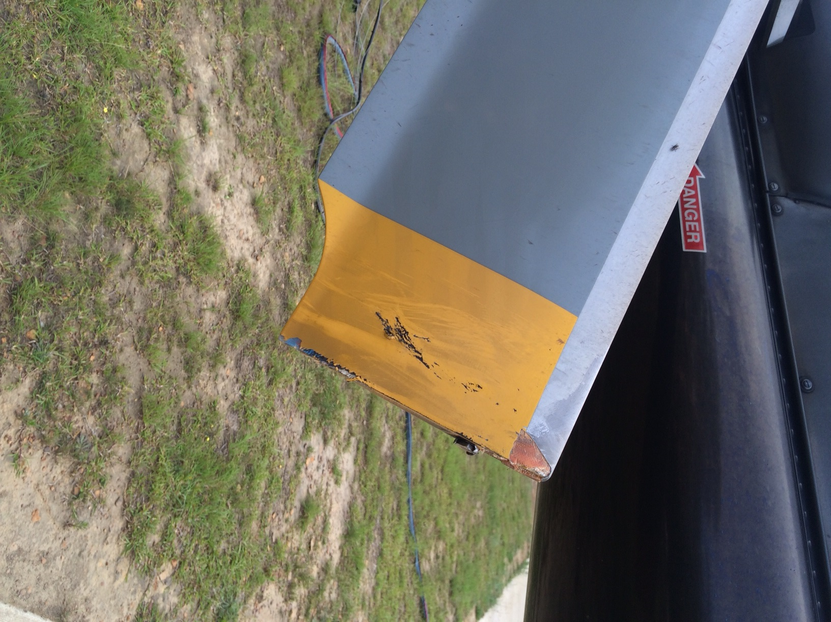
Source: Helicopter operator

Safety action

Helicopter operator
As a result of this occurrence, the helicopter operator has advised the ATSB that they are taking the following safety actions:

Crew pairing
Where possible, pilots who are more experienced with a particular type of operation, such as fire control work, will be rostered with less experienced crewpersons and vice versa.

Fatigue management
The operator will monitor fatigue levels in a more robust manner, including crew self-reporting and managers monitoring their staff.

Training
The operator’s training strategy and practices will be overhauled, with a training package released by 30 March 2016. Pilots and crewpersons will be assessed on their understanding of the operations manual.

Safety message
This incident highlights the importance of effective risk assessment and crew communication. Careful risk assessment is particularly important where a non-standard manoeuvre is planned. Effective crew communication is vital to ensure that potential hazards are clearly identified and understood, and the associated risks are appropriately managed.

General details

Occurrence details
Date and time: | 19 December 2015 – 1830 EDT
Occurrence category: | Serious incident
Primary occurrence type: | Other
Location: | Glenbrook, New South Wales
 | Latitude: 33° 44.98' S | Longitude: 150° 33.93' E

Aircraft details
Manufacturer and model: | Eurocopter AS.350B3
Registration: | VH-NPS
Serial number: | 3239
Type of operation: | Aerial work – Fire control

Wirestrike and collision with terrain involving a Robinson R44, VH-HXY

What happened
On 14 February 2016, the pilot of a Robinson R44 helicopter, registered VH-HXY, conducted a local private flight from a property about 90 km north of Hughenden, Queensland.
After operating for about 1 hour, the pilot landed near a water trough to check a float. During the approach and landing, the pilot sighted powerlines strung across the trough, and manoeuvred to remain clear of them.
While the helicopter was on the ground, the wind veered from a south-west to a southerly direction, so that to take off into wind, the helicopter would track perpendicular to the powerlines. After completing the pre-take-off checks, the pilot turned his attention to a mob of cattle, to ensure the noise of the helicopter would not send them through a fence.
The helicopter lifted off initially parallel to the powerlines, and the pilot then turned the helicopter to manoeuvre around a tree and climbed to about 20 ft above ground level. The tree momentarily obscured the powerlines and the pilot’s attention was on the cattle.
As the helicopter rounded the tree, at an airspeed of about 50 kt, the skids struck the powerlines. The pilot heard the wires contact the helicopter and it decelerated rapidly. The pilot lowered the collective and pulled back on the cyclic control, but the helicopter rolled forwards over the wires, descended rapidly, and collided with the ground left side down in a nose-down attitude.
The wire was hooked on the helicopter’s right skid, with electrical power still running through it. After the blades stopped turning, the pilot exited the helicopter. The pilot was not injured and the helicopter was destroyed (Figure 1).
Figure 1: Accident site
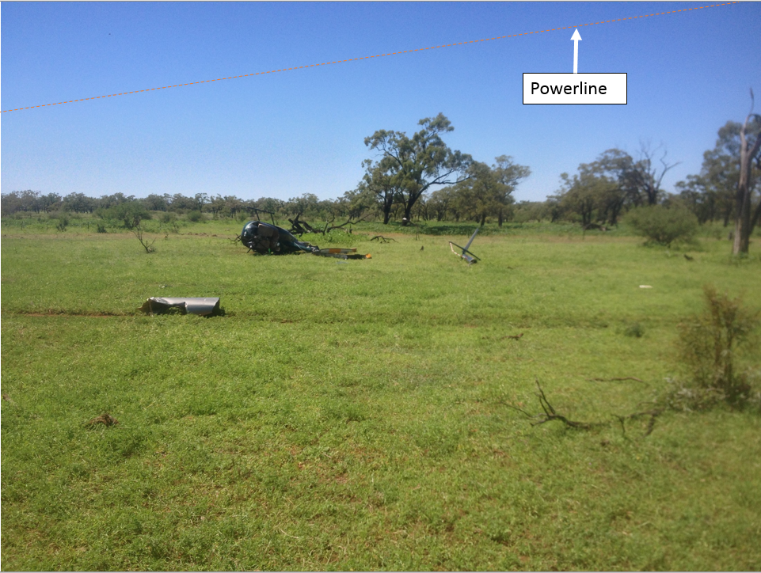
Source: Helicopter owner

Safety message
ATSB research indicates that in 63 per cent of reported wirestrike incidents, pilots were aware of the position of the wire before they struck it. In this instance, the pilot was aware of the powerline however, they were unable to see the wires from the helicopter’s position on the ground due to a tree. The pilot’s attention was then diverted to the cattle and did not maintain awareness of the wires.
The Aerial Agricultural Association of Australia suggests a way to keep focus is to ask yourself:
- Where is the wire now?
- What do I do about it?
- Where am I in the paddock?
For further risk management strategies for agricultural operations, refer to the Aerial Application Pilots Manual.
The ATSB publication Avoidable Accidents No. 2 – Wirestrikes involving known wires: A manageable aerial agricultural hazard, explains strategies to help minimise the risk of striking wires while flying. Pilots are reminded to avoid unnecessary distractions and to refocus when distracted. Distraction, combined with difficulty in seeing wires makes them extremely hard to avoid at the last minute.

General details

Occurrence details
Date and time: | 14 February 2016 – 1521 EST
Occurrence category: | Accident
Primary occurrence type: | Wirestrike
Location: | near Hughenden, Queensland
 | Latitude: 20° 48.90' S | Longitude: 144° 13.52' E

Helicopter details
Manufacturer and model: | Robinson Helicopter Company R44
Registration: | VH-HXY
Serial number: | 0350
Type of operation: | Private

Separation issues

Separation issue involving a de Havilland DH-82A (Tiger Moth), VH-BJE and a Robinson R44, VH-HOQ

What happened
Early in the afternoon on 7 November 2015, a Robinson R44 helicopter, registered VH-HOQ (HOQ), was conducting pilot training on the western end of Redcliffe aerodrome, Queensland. HOQ was conducting a training sortie and had an instructor and student on board. The training involved practicing engine failures in the hover and while taxiing. Their operations were confined within the aerodrome boundary (Figure 1) and clear of the runway and taxiway. They had completed the initial part of the sortie on the grass area to the south of the taxiway.
Figure 1: Redcliffe Aerodrome layout showing the approximate position of the aerodrome boundary (yellow)
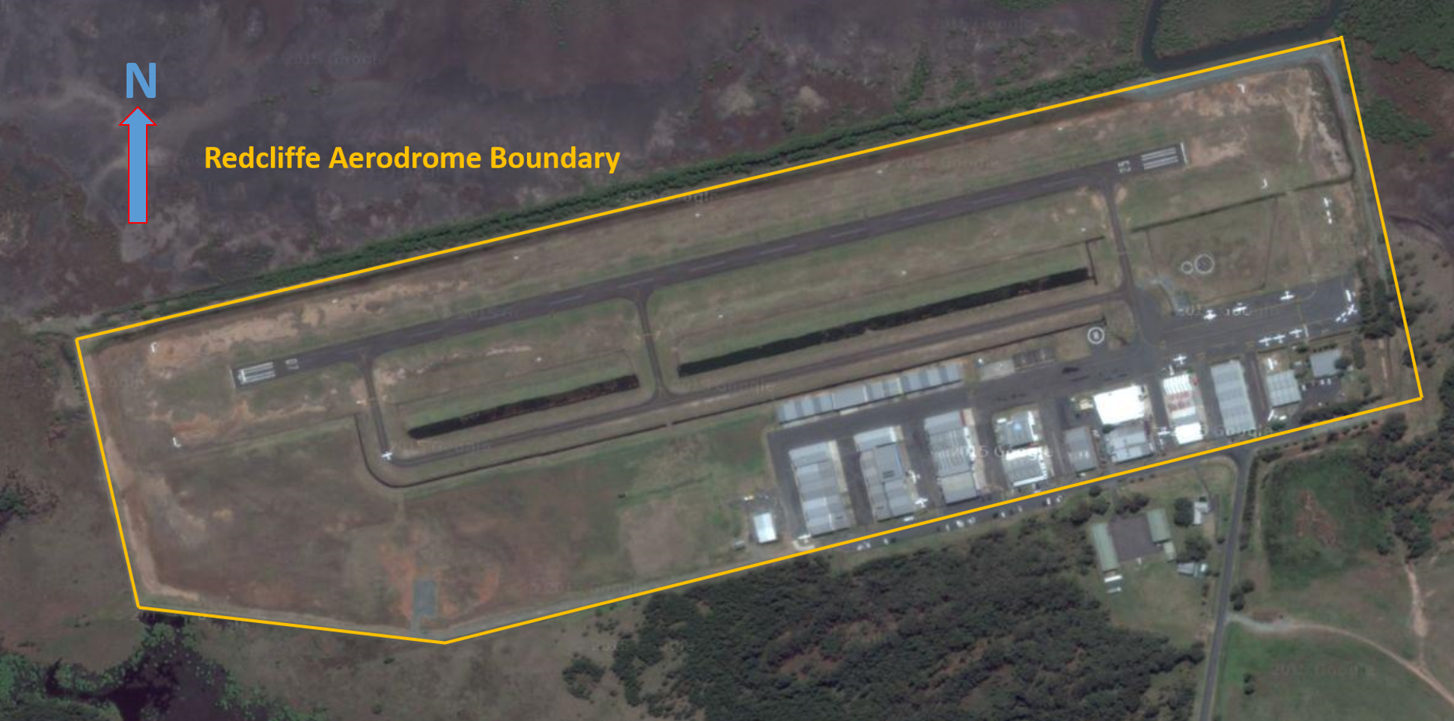
Source: Google Maps. Modified by ATSB
At the same time, a de Havilland DH-82A (Tiger Moth), registered VH-BJE (BJE), was taxiing for departure on runway 07. BJE was departing for a scenic flight with the pilot and one passenger on board. Both aircraft were operating under the visual flight rules, and the weather conditions were fine and clear.
While BJE was taxiing for Runway 07, HOQ moved to the grassed area just north of the taxiway to practice engine failures while taxiing. These manoeuvres involved the helicopter flying at low level parallel to the taxiway and landing on the grass. Once they had reached the eastern end of the grass area the instructor would taxi back to the start point to allow more training to occur.
Due to the nature of the helicopter training being conducted, the focus of the instructor and student was reduced to their immediate operations. During the transit from the grassed area to the area next to the taxiway HOQ did not advise the change in operating area on the common traffic advisory frequency (CTAF) to other aircraft. While they were aware of the Tiger Moth they did not consider it to be a concern. This was because the helicopter operations were going to remain clear of where the Tiger Moth was intending to operate.
The pilot of BJE broadcast their intentions to taxi and enter the runway to other aircraft in the area on the Redcliffe CTAF. There were no other radio transmissions by other aircraft while BJE was taxiing and entering the runway. While taxiing, the pilot of BJE noted the position of the helicopter and saw that it was well clear. The pilot of BJE therefore did not expect that the helicopter would change operating area to conflict with their departure.
The pilot of BJE lined up for departure on the grass beside the runway, because the aircraft was fitted with a tail skid, not a tail wheel. The grass area for BJE’s take off was within the runway strip to the side of the runway closest to the taxiway. BJE commenced the take-off run and, shortly after, the pilot noticed HOQ flying on a parallel track to BJE (Figure 2). The helicopter was to the right, slightly ahead and above BJE, and in close proximity.
Figure 2: BJE during the take-off run just prior to HOQ conducting the left turn
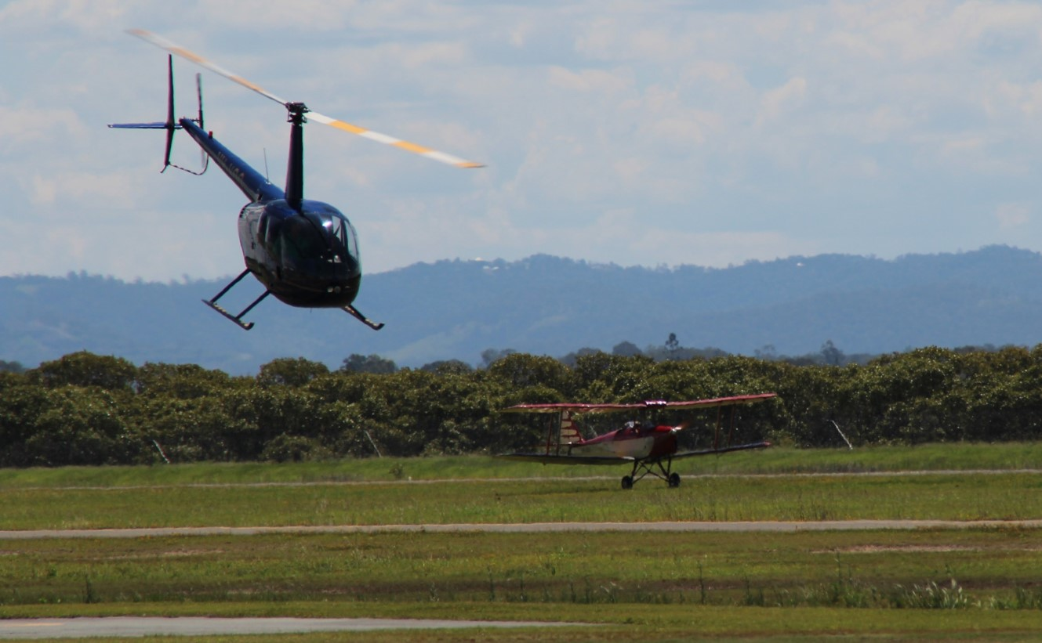
Source: Observer
Shortly after becoming airborne from the grass runway, at about 50 to 60 ft above ground level (AGL), the pilot of BJE saw the helicopter commence a left turn towards the runway. Thinking that there was going to be a collision, the pilot of BJE took avoiding action by conducting a hard left turn, with a high angle of bank, at low altitude. The approximate tracks of the aircraft are depicted in Figure 3.

Figure 3: Redcliffe aerodrome showing the runway strip (white). The take-off run and left turn of BJE is indicated in orange. The track of HOQ when conducting the engine failures during taxi and the reversal turn is indicated in blue.
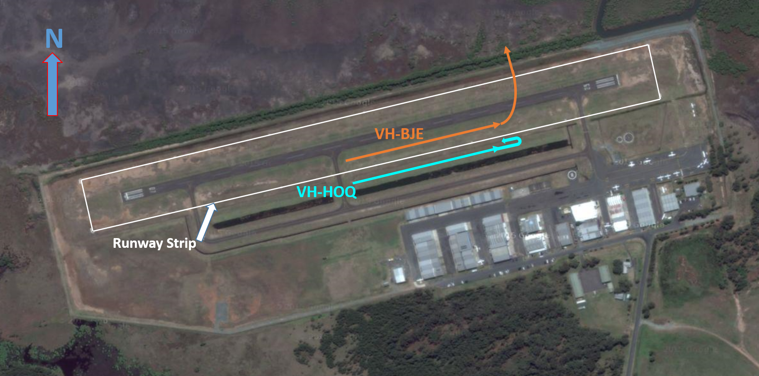
Source: Google Maps. Modified by ATSB
The instructor in HOQ was executing a reversal turn in order to reposition the helicopter for further training (Figure 4). The manoeuvre involved a 180-degree left turn, to reverse the direction of flight, with an increase in height to about 50-60ft and a bank angle of about 50º. The turn and track back down the grassed area would keep the helicopter outside the runway strip and clear of BJE. However, as the instructor had not advised their intentions on the CTAF, the pilot of BJE was unaware that the helicopter was going to remain clear of the aircraft.
Figure 4: View from the Tiger Moth when the helicopter was approximately half way through the reversal turn
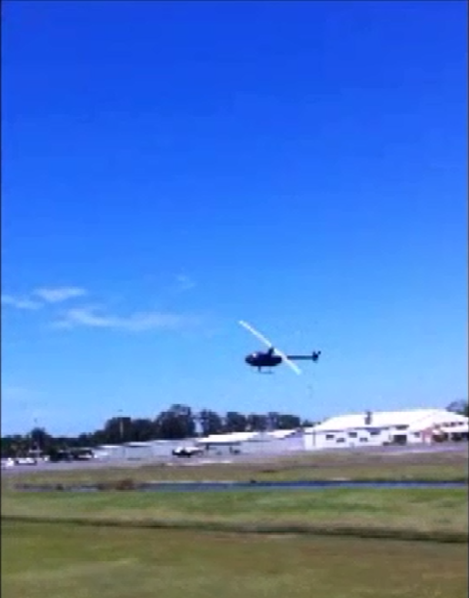
Source: Video from passenger

Pilot comments
Instructor, HOQ: Teaching, demonstrating, and conducting, practice engine failures at low level is a very high demand task. The instructor’s attention is, predominantly, directly ahead of the aircraft and in closely monitoring the student control inputs. This is to ensure that the student is executing the correct technique and safely executing the manoeuvre to avoid damage to the aircraft.
The operations in between the taxiway and the runway strip were going to be conducted so that they would always remain clear of other aircraft operating on the runway. The instructor did not advise the change in operating area as he assessed that there would be no conflict between the aircraft.
Pilot in Command, BJE: During the taxi to the runway the pilot noted the position of HOQ. At this time HOQ was operating to the south of the taxiway and not near the runway. The next time that the pilot of BJE saw HOQ was just after commencing the take-off roll. This surprised the pilot of BJE as he had not heard any transmissions advising that HOQ had changed their operating area. As a result, when HOQ commenced the reversal turn, he assessed that a collision was imminent. To avoid the possibility of a collision, the pilot of BJE turned the aircraft away to the left. The turn was made at low level, with a high angle of bank and at a relatively slow airspeed.

ATSB comment
Both pilots were monitoring the CTAF and the pilot of BJE had transmitted their intentions correctly. However, as the instructor of HOQ did not advise that they were going to conduct the reversal turn, the pilot of BJE did not know that the helicopter would remain outside the runway strip. The avoiding action taken by the pilot of BJE in this case may have been avoided if the helicopter pilot had communicated their intentions.

Safety message
Pilots are encouraged to ‘err on the side of caution’ when considering when to make broadcasts on CTAF, particularly when the aircraft operations are likely to be in close proximity to other aircraft.
The ATSB SafetyWatch program highlights broad safety concerns that emerge from investigations and occurrence data reported to the ATSB by industry. One safety concern relates to operations around non-controlled aerodromes. The ATSB safety watch website page, Safety around non-controlled aerodromes, includes the following relevant comments:
- Insufficient communication between pilots operating in the same area is the most common cause of safety incidents near non-controlled aerodromes.
- A search for other traffic is eight times more effective when a radio is used in combination with a visual lookout than when no radio is used.
The CASA booklet titled Operations at non-controlled aerodromes provides guidance with respect to the limitations of the see-and-avoid principle and relevant radio procedures. Civil Aviation Advisory Publication 166-1 also provides relevant guidance with respect to CTAF procedures.

General details

Occurrence details
Date and time: | 7 November 2015 – 1305 EST
Occurrence category: | Incident
Primary occurrence type: | Separation issue
Location: | at Redcliffe (ALA), Queensland
 | Latitude: 27° 12.40' S | Longitude: 153° 04.07' E

Aircraft details: VH-BJE
Manufacturer and model: | de Havilland Aircraft DH-82A
Registration: | VH-BJE
Serial number: | A17-97
Type of operation: | Charter - Passenger

Helicopter details: VH-HOQ
Manufacturer and model: | Robinson Helicopter Company R44
Registration: | VH-HOQ
Serial number: | 1456
Type of operation: | Flying training

Separation issue between a Kavanagh Balloons E-300, VH-LPG, and freight train 4K26

What happened
Early on the morning of 11 November 2015, a Watco freight train, 4K26, was travelling southbound on the Frenches to East Northam rail line in Western Australia. The train was travelling at about 60 km/hr along a section of track as it approached a left corner, approximately 3 km north of Northam (Figure 1). As the train rounded the corner, the driver saw a hot air balloon in close proximity to the rail tracks. The driver observed that the balloon was low to the ground and inside the rail corridor, to the left side of the track (Figure 2).
Figure 1: Location of incident with rail line (white) showing direction of travel of the train, the approximate width of the rail corridor (yellow), the direction of travel of the hot air balloon (orange dashed line) and the approximate position of the hot-air balloon (red mark)
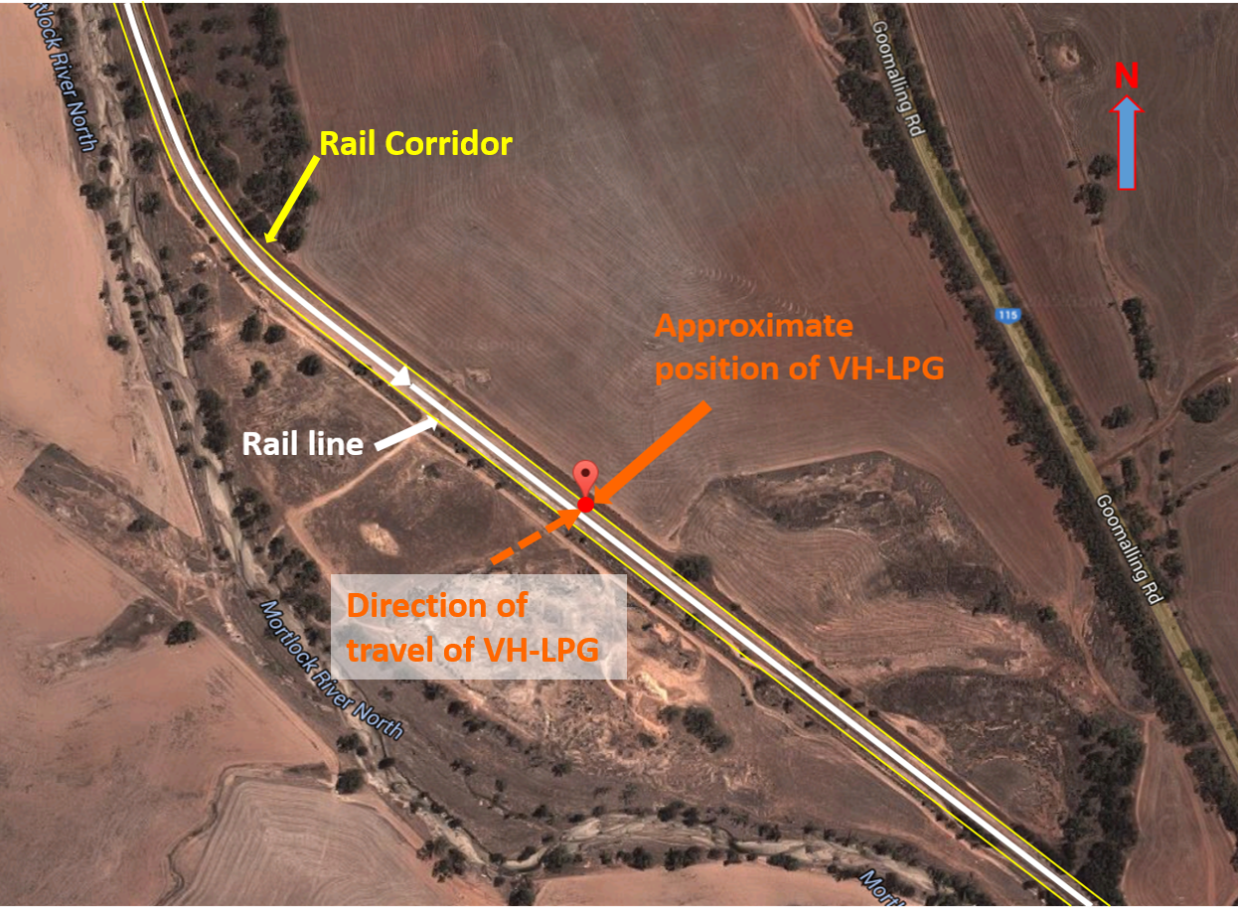
Source: Google maps. Modified by ATSB
Figure 2: View from train driver’s cabin as the train rounded the corner with the approximate position of the fences (yellow) either side of the rail line marking the rail corridor
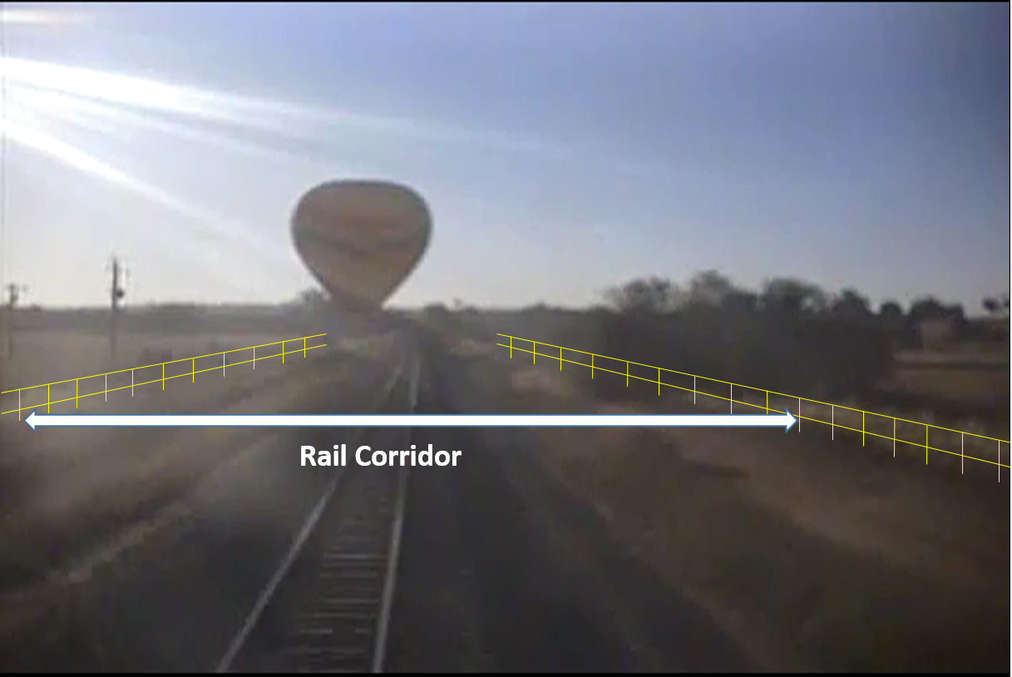
Source: Watco driver’s video, modified by ATSB
The driver estimated that the balloon was approximately 200–300 m in front of the train and applied full service brakes. However, the driver realised there would be insufficient distance for the train to come to a complete stop before passing the balloon. At the same time as applying the brakes, the driver also sounded the train’s horn to warn the balloon that the train was approaching. The driver slowed the train to about 20 km/hr as it passed the balloon.
Figure 3: Picture from the train driver’s cabin just before the train passed the balloon’s position with the approximate position of the fence on the left side (yellow)
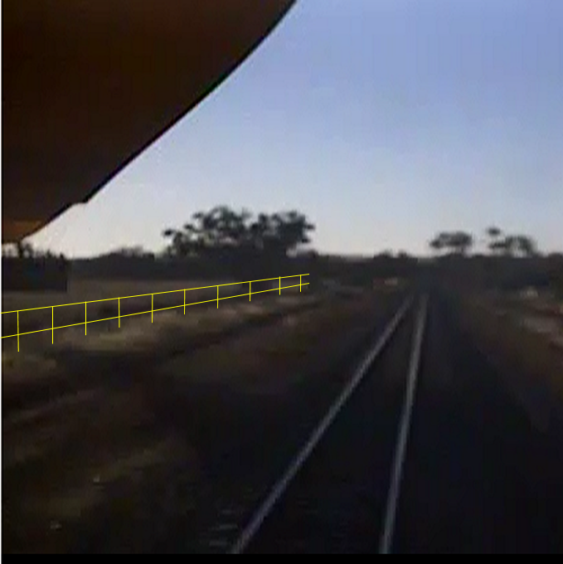
Source: Watco driver’s video, modified by ATSB
The Kavanagh Balloons E-300, registered VH-LPG, had taken off east of Northam earlier in the morning for a scenic flight, with the pilot and 16 passengers on board. The pilot’s initial intention was to land in a paddock to the west of the rail line. However, the prevailing wind meant that this was not an option. Instead, they elected to land in the paddock east of the railway line, as the pilot judged it to be the most suitable location in the area. Also, flying to an alternative landing site may have unnecessarily impinged on fuel reserves with the prevailing winds and weather conditions on the morning.
The pilot crossed the rail line from the south-west to the north-east at a height of approximately 50–60 ft, and then descended to around fence top height. The pilot’s intention was to land inside the paddock, just after the fence line at the edge of the rail corridor. As the train came around the corner, the hot air balloon was on descent to the paddock. When the train passed the balloon, the pilot reported the basket was just above fence height and moving away from the rail tracks. The balloon crossed over the fence and landed in the paddock without incident.

Pilot comments
The pilot of the balloon made the following comments in relation to the event:
- Crops in the centre of the paddock and a powerline limited the available landing space, which meant the pilot was landing close to the fence.
- The pilot had landed in the same paddock on many occasions without problems.
- The pilot did not recall hearing the train horn or brakes until the train passed the balloon.

Train driver and observer comments
The train driver and observer made the following additional comments:
- The driver and observer saw the balloon in the distance, however due to the winding track it was not possible to see the location of the balloon relative to the track, until the train came around the bend.
- They were unable to discern the direction of travel of the balloon.
- When they saw the balloon, they believed a collision was likely.
- They suggested that an awareness of the train schedule by balloon operators may avoid a similar event.

Proactive safety action
Whether or not the ATSB identifies safety issues in the course of an investigation, relevant organisations may proactively initiate safety action in order to reduce their safety risk. The ATSB has been advised of the following proactive safety action in response to this occurrence.

Balloon operator
The balloon operator is amending the Low Flying Operations section of their Operations Manual to include the following:
- A minimum height of 50 feet shall be maintained when the flight path of the balloon will cause it to cross over a road reserve or rail corridor.

Safety message
Rail corridors are areas where access is strictly controlled as the presence of non-authorised or unexpected personnel and/or vehicles may pose a danger to the safety of rail operations and personnel. Trains require significant distance to come to a complete stop and may not be able to avoid colliding with an obstruction that is on, or near, the tracks.
Operators of balloons or other aircraft that may fly at low-level in the vicinity of rail tracks should consider and minimise risks when operating in these environments.

General details

Occurrence details
Date and time: | 11 November 2015 06:05 WST
Occurrence category: | Serious incident
Primary occurrence type: | Separation issue
Location: | Northam (ALA), 358° M 2.9Km WA
 | Latitude: 31° 36' 01.6” S | Longitude: 116° 41' 07.0” E

Aircraft details
Manufacturer and model: | Kavanagh Balloons
Registration: | VH-LPG
Serial number: | E300-361
Type of operation: | Ballooning - other

Train details
Train Operator: | WATCO
Registration: | 4K26
Type of operation: | Freight

Australian Transport Safety Bureau
The Australian Transport Safety Bureau (ATSB) is an independent Commonwealth Government statutory agency. The Bureau is governed by a Commission and is entirely separate from transport regulators, policy makers and service providers. The ATSB’s function is to improve safety and public confidence in the aviation, marine and rail modes of transport through excellence in: independent investigation of transport accidents and other safety occurrences; safety data recording, analysis and research; fostering safety awareness, knowledge and action.
The ATSB is responsible for investigating accidents and other transport safety matters involving civil aviation, marine and rail operations in Australia that fall within Commonwealth jurisdiction, as well as participating in overseas investigations involving Australian registered aircraft and ships. A primary concern is the safety of commercial transport, with particular regard to fare-paying passenger operations.
The ATSB performs its functions in accordance with the provisions of the Transport Safety Investigation Act 2003 and Regulations and, where applicable, relevant international agreements.

Purpose of safety investigations
The object of a safety investigation is to identify and reduce safety-related risk. ATSB investigations determine and communicate the safety factors related to the transport safety matter being investigated. The terms the ATSB uses to refer to key safety and risk concepts are set out in the next section: Terminology Used in this Report.
It is not a function of the ATSB to apportion blame or determine liability. At the same time, an investigation report must include factual material of sufficient weight to support the analysis and findings. At all times the ATSB endeavours to balance the use of material that could imply adverse comment with the need to properly explain what happened, and why, in a fair and unbiased manner.

About this Bulletin
The ATSB receives around 15,000 notifications of Aviation occurrences each year, 8,000 of which are accidents, serious incidents and incidents. It also receives a lesser number of similar occurrences in the Rail and Marine transport sectors. It is from the information provided in these notifications that the ATSB makes a decision on whether or not to investigate. While some further information is sought in some cases to assist in making those decisions, resource constraints dictate that a significant amount of professional judgement is needed to be exercised.
There are times when more detailed information about the circumstances of the occurrence allows the ATSB to make a more informed decision both about whether to investigate at all and, if so, what necessary resources are required (investigation level). In addition, further publically available information on accidents and serious incidents increases safety awareness in the industry and enables improved research activities and analysis of safety trends, leading to more targeted safety education.
The Short Investigation Team gathers additional factual information on aviation accidents and serious incidents (with the exception of 'high risk operations), and similar Rail and Marine occurrences, where the initial decision has been not to commence a 'full' (level 1 to 4) investigation.
The primary objective of the team is to undertake limited-scope, fact gathering investigations, which result in a short summary report. The summary report is a compilation of the information the ATSB has gathered, sourced from individuals or organisations involved in the occurrences, on the circumstances surrounding the occurrence and what safety action may have been taken or identified as a result of the occurrence.
These reports are released publicly. In the aviation transport context, the reports are released periodically in a Bulletin format.
Conducting these Short investigations has a number of benefits:
- Publication of the circumstances surrounding a larger number of occurrences enables greater industry awareness of potential safety issues and possible safety action.
- The additional information gathered results in a richer source of information for research and statistical analysis purposes that can be used both by ATSB research staff as well as other stakeholders, including the portfolio agencies and research institutions.
- Reviewing the additional information serves as a screening process to allow decisions to be made about whether a full investigation is warranted. This addresses the issue of 'not knowing what we don't know' and ensures that the ATSB does not miss opportunities to identify safety issues and facilitate safety action.
- In cases where the initial decision was to conduct a full investigation, but which, after the preliminary evidence collection and review phase, later suggested that further resources are not warranted, the investigation may be finalised with a short factual report.
- It assists Australia to more fully comply with its obligations under ICAO Annex 13 to investigate all aviation accidents and serious incidents.
- Publicises Safety Messages aimed at improving awareness of issues and good safety practices to both the transport industries and the travelling public.

The pilot estimated that the channel bank was about 1.5 m higher than the surrounding paddocks. During the spraying operations, the pilot estimated that the wheels of the aircraft were about 1 m above the ground.
The PAMP was a document prepared by the agronomy company, intended to ensure that spraying operations (including aerial application operations) were conducted in a safe manner. To that end, the PAMP by outlined roles and responsibilities and providing instructions to all relevant personnel.
The aircraft was fitted with a wind-driven spray pump. Occasionally a blade can separate and cause vibration. If the pilot switches the pump off and the vibration ceases, they have isolated the source of vibration,
An aircraft with floats to land on water and retractable wheel-type landing gear that can be extended to allow landing on land. The floats are part of the aircraft landing gear that provide the buoyancy to keep the aircraft afloat
Bommie is a slang name for bombora, an Australian term for an area of large sea waves breaking over a shallow area such as a submerged rock shelf, reef, or sand bank that is located some distance from the shoreline and beach surf break.
Water rudders are retractable control surfaces on the back of each float that can be extended downward into the water to provide directional control when taxiing on the surface. They are attached by cables and springs to the air rudder and operated by the rudder pedals in the cockpit.
The step position is the attitude of the aircraft when the entire weight of the aircraft is supported by hydrodynamic and aerodynamic lift, as it is during high-speed taxi or just prior to take off. This position produces the least amount of water drag. The step is also called the planing position.
A Terminal Area Forecast (TAF) is a statement of meteorological conditions expected for a specified period in the airspace within a radius of 5NM of the aerodrome reference point.
METAR: Routine aerodrome weather report issued at fixed times, hourly or half-hourly.
INTER An intermittent deterioration in the forecast weather conditions, during which a significant variation in prevailing conditions is expected to last for periods of less than 30 minutes duration. TEMPO A temporary deterioration in the forecast weather conditions, during which significant variation in prevailing conditions are expected to last for periods of between 30 and 60 minutes.
INCERFA is the first of three alert phases available to ATC. This is a phase of ‘uncertainty’ in regard to the welfare of the aircraft and its occupant(s).
At altitudes above 10,000 ft in Australia, an aircraft’s height above mean sea level is referred to as a flight level (FL). FL 110 equates to 11,000 ft.
A primary helicopter flight control that simultaneously affects the pitch of all blades of a lifting rotor. Collective input is the main control for vertical velocity.
A primary helicopter flight control that is similar to an aircraft control column. Cyclic input tilts the main rotor disc varying the attitude of the helicopter and hence the lateral direction.
Visual Flight Rules (VFR): Rules that allow a pilot to operate an aircraft in weather conditions that are generally clear enough to allow the pilot to see where the aircraft is going.
The CTAF is the frequency on which pilots operating at a non-controlled aerodrome should make positional radio broadcasts.
Rail corridor: The rail corridor is defined ‘fence line to fence line’ either side of the rail tracks. Where there is no fence line, the corridor may be defined as a specified distance either side of the outside rail of the rail track. Any person/vehicle inside the rail corridor is considered to be in close proximity to the rail tracks

