

VFR flight into IMC involving de Havilland DH-84 Dragon, VH-UXG
36 km SW of Gympie, Queensland, 1 October 2012

ATSB Transport Safety Report
Aviation Occurrence Investigation
AO-2012-130
Final – 19 December 2013

Cover photo: VH-UXG in 2007. David Wilson/PlanePictures.net

Released in accordance with section 25 of the Transport Safety Investigation Act 2003

Publishing information

Published by: Australian Transport Safety Bureau
Postal address: PO Box 967, Civic Square ACT 2608
Office: 62 Northbourne Avenue Canberra, Australian Capital Territory 2601
Telephone: 1800 020 616, from overseas +61 2 6257 4150 (24 hours)
Accident and incident notification: 1800 011 034 (24 hours)
Facsimile: 02 6247 3117, from overseas +61 2 6247 3117
Email: atsbinfo@atsb.gov.au
Internet: www.atsb.gov.au

© Commonwealth of Australia 2013



Ownership of intellectual property rights in this publication
Unless otherwise noted, copyright (and any other intellectual property rights, if any) in this publication is owned by the Commonwealth of Australia.

Creative Commons licence
With the exception of the Coat of Arms, ATSB logo, and photos and graphics in which a third party holds copyright, this publication is licensed under a Creative Commons Attribution 3.0 Australia licence.

Creative Commons Attribution 3.0 Australia Licence is a standard form license agreement that allows you to copy, distribute, transmit and adapt this publication provided that you attribute the work.

The ATSB’s preference is that you attribute this publication (and any material sourced from it) using the following wording: Source: Australian Transport Safety Bureau

Copyright in material obtained from other agencies, private individuals or organisations, belongs to those agencies, individuals or organisations. Where you want to use their material you will need to contact them directly.

Addendum
Page | Change | Date
Safety summary | Clarification of the possibility for flight in instrument conditions in the first paragraph. | 16-01-2014
3 | Corrected ‘south-west’ to ‘south-east’. | 16-01-2014
18 | Corrected ‘south-west’ to ‘south-east’. | 16-01-2014

Safety summary

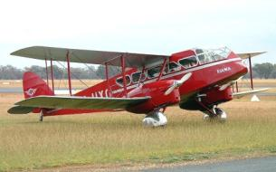
What happened
VH-UXG in 2003
Photo: Glenn Alderton
Source: JetPhotos.net
At about 1107 on 1 October 2012, the pilot-owner of a vintage de Havilland DH-84 Dragon Mk 2, registered VH-UXG, took off on a private flight from Monto to Caboolture, Queensland. On board with the pilot were five passengers, baggage and equipment. The pilot was not qualified and the aircraft not equipped for instrument flight. The weather on the coast and extending inland included low clouds and rain.
At 1315, the pilot radioed air traffic control (ATC) and requested navigation assistance, advising that the aircraft was in cloud. Over the next 50 minutes ATC provided assistance to the pilot and a search and rescue (SAR) helicopter was dispatched to the area. From the pilot’s radio calls it was apparent that he was unable to navigate clear of the cloud. Radio contact was intermittent and no transmissions from the aircraft were received after 1405.
An extensive search was initiated, and the aircraft wreckage was located on 3 October in high terrain. The aircraft was destroyed and there were no survivors.
What the ATSB found
With no or limited visual references available in and near cloud, it would have been very difficult for the pilot to maintain control of the aircraft. After maintaining control in such conditions for about an hour, and being unable to navigate away from the mountain range, the pilot most likely became spatially disoriented and lost control of the aircraft before it impacted the ground.
Due to the limited radio and radar coverage in the area, the ability of ATC and the SAR helicopter to assist was limited. However, the ATSB found that there were areas of potential improvement in the management of in-flight emergencies and coordination between ATC and SAR aircraft.
What's been done as a result
Airservices Australia and the Australian Maritime Safety Authority agreed to conduct a comprehensive review of their existing memorandum of understanding to ensure the effectiveness of collaborative in-flight emergency responses. The review is anticipated to be completed by the first quarter of 2014.
Safety message
Though it remains unclear precisely how the aircraft came to be in instrument conditions, this accident highlights the importance of pre- and in-flight planning and decision-making in limiting exposure to risk. It is important for pilots to incorporate approved weather forecasts, knowledge of the terrain, and diversion options into their flight planning, to plan for contingencies prior to and throughout a flight, and to carry out those plans well before encountering difficulty.
Contents
The occurrence 1
Operations at Monto 1
Take-off and initial track 2
Contact with air traffic control 2
Search and rescue helicopter involvement 4
Last part of the flight 5
Search operation 5
Context 7
Pilot information 7
General information 7
Medical information 7
Aircraft information 8
Overview 8
Maintenance 8
Engines and propellers 8
Weight and balance 9
Fuel 9
Performance and handling 10
Aircraft instruments and equipment 10
Overview 10
Suitability for instrument flight 11
Gyroscopic instruments 11
Compass 12
Radio 12
GPS receiver 12
Personal locator beacon 12
Wreckage and accident site information 13
Accident site 13
Airframe 13
Engines 13
Propellers 13
Instruments and equipment 16
Survivability 16
Pre-flight planning 16
Visual meteorological conditions 16
Flight planning requirements 17
Weather and notices 17
Route planning 18
Meteorological information 18
Bureau of Meteorology forecasts 18
Bureau of Meteorology observations 19
Witness reports of the weather 20
Hazards associated with VFR flight in IMC 21
Geographic disorientation 21
Spatial disorientation 21
Effects of workload and skill fatigue 22
VFR into IMC accidents 23
Guidance to pilots on avoiding flight in adverse weather 24
Air traffic services information 25
Airspace information 25
Radar information 25
Terrain and obstacle avoidance 25
In-flight emergency response 26
Coordination of the in-flight emergency 28
Task briefing 28
AMSA-Airservices Australia memorandum of understanding 28
National search and rescue manual 29
SAR procedures manual for rotary wing units 29
AMSA-SAR helicopter service agreement 30
Other information available to SAR service providers 30
Search operation 30
Safety analysis 32
Introduction 32
Aircraft weight 32
Operational aspects 32
Pre-flight planning 32
In-flight decision-making 33
Flight in instrument meteorological conditions 34
Radio communications 34
In-flight emergency response 35
Lead agency 35
In-flight emergency response by air traffic control 35
In-flight emergency response coordination 36
Search operation 36
Utility of emergency locator transmitters and personal locator beacons 37
Findings 38
Contributing factors 38
Other factors that increased risk 38
Other findings 38
Safety issues and actions 39
Provision of assistance to aircraft in distress 39
Safety issue description: 39
Current status of the safety issue: 40
General details 41
Occurrence details 41
Aircraft details 41
Sources and submissions 42
Sources of information 42
References 42
Submissions 43
Appendices 44
Appendix A – Aviation weather forecasts 44
Area Forecast 44
Terminal Area Forecasts 44
Appendix B – In-flight emergency response checklist 46
Australian Transport Safety Bureau 51
Purpose of safety investigations 51
Developing safety action 51

The occurrence

Operations at Monto
On 29 September 2012, the pilot-owner of a de Havilland Aircraft Pty Ltd DH-84 Dragon Mk 2, registered VH-UXG (UXG), and five passengers flew from Caboolture to Monto, Queensland to attend a recreational aviation ‘fly-in’ meeting (Figure 1). The weather that day was reported to be fine with scattered cloud cover with a base of around 2,000 and 3,000 ft above mean sea level (AMSL).
Figure 1: Overview of the area with the direct route from Monto to Caboolture shown in green
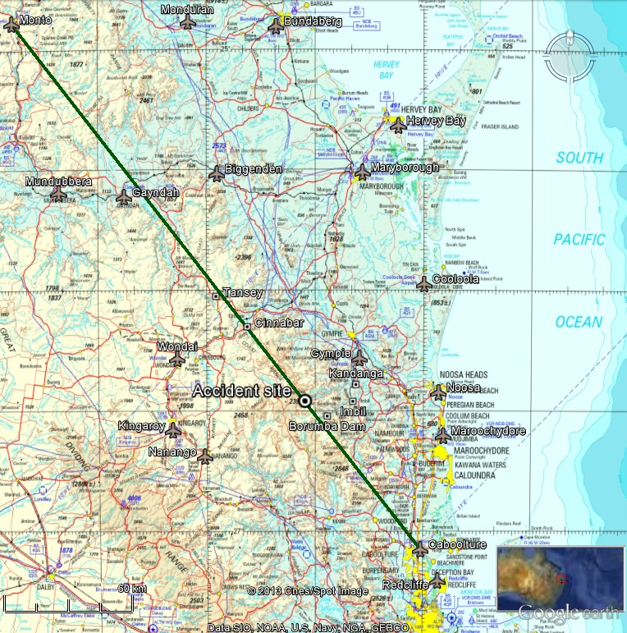
Source: ATSB, Airservices Australia and Google Earth
Over the weekend of 29–30 September, the pilot conducted several local flights in UXG to raise money for charity, returning to the Monto Airport each time. Each morning, the event organiser conducted a pilot briefing that consisted of a weather briefing and advice of the operating procedures for the day. There was no such briefing on 1 October as the event had concluded.

Take-off and initial track
Shortly after 1100 Eastern Standard Time on 1 October 2012, the pilot and the same five passengers that had flown to Monto on 29 September took off from Monto on a return flight to Caboolture under the visual flight rules (VFR) and in uncontrolled airspace. The weather conditions on departure were reported to include a light south-easterly wind with high overcast cloud and good visibility. The estimated flight time was 2.5 hours.
At about 1155, a witness heard the pilot reporting by radio that the aircraft was overhead Gayndah, 97 km south-east of Monto and near the direct track to Caboolture. If the pilot had taken a direct route to Gayndah, the aircraft’s average ground speed over that initial part of the flight would have been about 67 kt. The Australian Transport Safety Bureau (ATSB) calculated that, if the aircraft maintained its track and ground speed from Gayndah, it would have arrived at the Borumba Dam area at about 1300.
Sometime after about 1230, the aircraft was seen near Tansey, in weather described as overcast without low cloud or rain. One witness in the area reported that the aircraft ‘looked to be flying well’ at about 3,000 ft. Another witness reported seeing the aircraft turn south near Glen Echo, 38 km east of Tansey, in conditions that were described as ‘really overcast, cloudy and misty’. Witnesses near Cinnabar also saw the aircraft, though the time of those sightings is uncertain.

Contact with air traffic control
Figure 2 provides a summary of significant events and communications on 1 October from 1300 onwards. The first recorded radio transmission from UXG was at 1315, when the pilot contacted Brisbane Centre air traffic control (ATC) to advise that the aircraft was 37 NM (69 km) north of Caboolture at 2,700 ft. In response, ATC provided the area QNH. The pilot then requested navigation assistance. At 1318, in response to a query from ATC, the pilot reported that the aircraft was in ‘full cloud’. ATC advised the pilot to maintain wings level and initiated in-flight emergency response (IFER) procedures. ATC advised the pilot that the lowest safe altitude (LSALT) in the aircraft’s likely grid location was 4,300 ft and suggested that he climb to a safe altitude to establish terrain clearance, if able. Although the pilot had not formally declared an emergency, ATC declared an alert phase at 1320.
Figure 2: Partial occurrence timeline
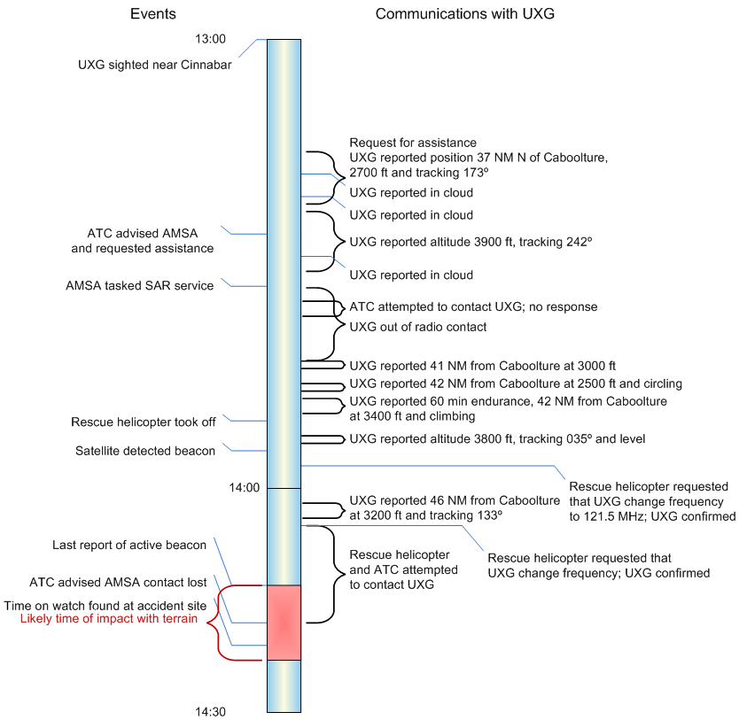
Source: ATSB
In accordance with the procedures in the IFER checklists, the controller emphasised the need for the pilot to maintain wings-level flight. The controller then attempted to determine the nearest suitable weather that might allow the pilot to regain visual flight. In response to this effort by the Brisbane Centre controller to understand the surrounding weather, the tower controller at the Sunshine Coast Airport at Maroochydore advised via landline that the weather conditions there were not suitable for VFR flight. In addition, pilots of a number of overflying aircraft reported over the radio that there was solid cloud below about 10,000 ft with breaks to the north and west of Kilcoy.
Recordings of radar information showed five radar returns about 10 km south-east of Borumba Dam between 1317 and 1321, at between 2,400 and 2,900 ft. From the absence of other aircraft in the area and the correlation of those radar returns with the pilot’s reported position and altitude at the time, it is very likely that they were from UXG. ATC observed the returns and asked the pilot to squawk IDENT and later assigned a unique transponder code to the aircraft to facilitate ongoing identification, which the pilot acknowledged. However, due to limited radar coverage at low altitude in the area, no further radar returns likely to be from UXG were observed or recorded, and ATC were subsequently unable to positively identify the aircraft or provide position information to the pilot.
Numerous witnesses reported sighting or hearing an aircraft within a 60-km radius of the eventual accident location, though not all reports were confirmed and some were not of UXG. However, consistent reports from witnesses around the Borumba Dam, Imbil and Kandanga areas indicated that UXG was most likely in the area between about 1315 and 1415.
Communications between the pilot of UXG and ATC were on the promulgated Brisbane Centre area very high frequency (VHF) frequency of 129.0 MHz. Several other pilots in the area were also communicating with ATC on that frequency. At times, communications between ATC and UXG were hampered by the limited ATC radio coverage in the area at low altitude and some messages were relayed via other flights in the area. The controller later reported being unsure as to whether the pilot of UXG was not responding due to high workload or the limited radio coverage.

Search and rescue helicopter involvement
At about 1326, ATC requested the assistance of a search and rescue (SAR) helicopter through the Australian Maritime Safety Authority (AMSA). AMSA passed the request on to the area SAR coordination agency, Queensland Health, which in turn tasked a SAR helicopter service based in Maroochydore.
AMSA provided a briefing to the pilot of the SAR helicopter by telephone prior to departure. The briefing instructed the SAR helicopter crew to ‘try and identify his location, give him assistance to get out of cloud, and be available for rescue if needed.’ The verbal briefing was followed by a hard copy task briefing, which was delivered to the helicopter service’s base after the helicopter’s departure due to the urgency of the rescue task.
Following a request from ATC at 1336, someone on board UXG activated a personal locator beacon (PLB). Overflying aircraft reported receiving a signal from an emergency beacon on VHF frequency 121.5 MHz from 1339 onwards. The PLB also produced an ultra high frequency (UHF) 406 MHz digital beacon that was received by SAR satellites, and an audible tone that could be heard in the background of some of the radio calls made by the pilot of UXG.
The SAR helicopter was equipped with homing equipment that could provide steering guidance towards the source of a signal, such as an emergency beacon. The equipment was activated shortly after take-off from Maroochydore at 1351 and immediately detected a PLB signal, indicating that UXG was to the west to south-west of Noosa. As was the case between ATC and UXG, direct radio communications were intermittent between the pilots of the helicopter and UXG, and the SAR pilot sometimes communicated with ATC and the pilot of UXG via relay through other aircraft in the area.
At 1347, the pilot of UXG advised ATC that he was ‘going around in circles’ and that the aircraft had about 1 hour’s endurance. At about 1357 the pilot of the SAR helicopter requested via relay through the pilot of another aircraft that the pilot of UXG change from 129.0 MHz to 121.5 MHz. The pilot of UXG reportedly confirmed the frequency change and the crew of a commercial flight later reported to ATC that they had received a transmission from UXG on 121.5 MHz. The SAR helicopter continued to receive the PLB tone on 121.5 MHz but no voice transmissions. No recordings of transmissions on 121.5 MHz were available.

Last part of the flight
ATC re-established communication with the SAR helicopter via relay at 1400 and with UXG on the area frequency (also via relay) at 1403. At that time, the pilot of UXG advised that the aircraft was 45 NM (83 km) north of Caboolture and tracking 134° at an altitude of 3,200 ft. Some witnesses in the valley to the south-east of the accident site saw and heard the aircraft at very low level at around 1400 and reported that it sounded as though it was circling around the valleys for several minutes.
At 1405, the pilot of the SAR helicopter requested the pilot of UXG to change radio frequency to 123.45 MHz. The SAR pilot later reported that this frequency was chosen instead of 121.5 MHz because the continual sound of the PLB beacon would have made communications on that frequency difficult. The pilot of UXG acknowledged without reading back the requested frequency change, and the SAR helicopter pilot selected 123.45 MHz. No transmissions on that frequency, or on the Brisbane Centre area frequency, were received by the SAR helicopter or ATC. At 1407, the SAR pilot re-established communications with ATC over the area frequency and it was ascertained that no further transmissions from UXG had been received.
No further voice transmissions from the pilot of UXG were received on any frequency. This included the Brisbane Centre area frequency and the emergency frequency of 121.5 MHz, which were both monitored by ATC and other aircraft, and 123.45 MHz, which was intermittently monitored by other aircraft.
The emergency beacon was last reported active at 1413.

Search operation
ATC declared a distress phase and coordination of the SAR operation was assumed by AMSA at 1447 on 1 October.
The aircraft wreckage was sighted at about 1330 on 3 October, within the main search area. The wreckage was on the northern side of a steep, densely-wooded ridge near the western end of Upper Kandanga valley (Figure 3), about 87 km (47 NM) north-west of Caboolture. The accident site was at an elevation of about 1,660 ft, 60 ft below the ridgeline.
The aircraft was destroyed in the impact with terrain and there were no survivors. Based on recorded information, reports from nearby aircraft about the PLB signal, and the time captured on a personal watch found on-site, the ATSB determined that the aircraft most likely impacted terrain between about 1413 and 1423 on 1 October 2012.

Figure 3: Aerial view of the accident site
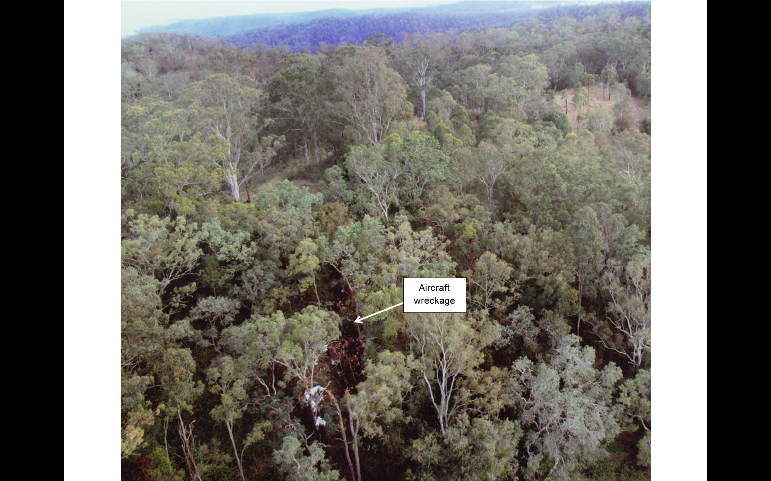
Source: Queensland Police Service

Context

Pilot information

General information
The pilot held a Private Pilot Licence (Aeroplane) that was issued on 25 June 1998. He was endorsed on the DH-84 aircraft type in April 2003 and most recently completed an aeroplane proficiency check in UXG on 15 September 2012.
The pilot’s logbook showed a total flying experience of 1,128.4 hours to the last entry dated 15 September 2012. His total experience on type was 662.6 hours, representing almost all of his flying experience since March 2003. In the previous 90 days the pilot had flown 6.4 hours, all in UXG. In the 3 days prior to the accident, he had flown 5.7 hours that included the flight from Caboolture to Monto and several local flights around Monto.
The pilot did not hold an instrument rating and had recorded only 3.7 hours of instrument flight time, most of which was gained during training for his licence. The most recent instrument flying was recorded in March 1998.
Airservices Australia (Airservices) advised that the pilot did not have a National Aeronautical Information Processing System (NAIPS) user identification. This identification would have enabled the pilot to access the system to obtain flight briefing information.
A Civil Aviation Safety Authority (CASA)-approved test officer, who had completed the pilot’s proficiency checks over several years, suggested that the pilot was not likely to have deliberately flown in adverse weather conditions. Others who knew the pilot described him as cautious, and reported that he took great care with respect to the maintenance and operation of UXG. It was reported that there was no apparent time pressure on the pilot or passengers to return to Caboolture.

Medical information
The pilot held a Class 2 Medical Certificate. A review of his last five medical examinations for the renewal of the certificate did not reveal any issues that may have contributed to the accident. The pilot’s last medical examination was conducted on 25 July 2012 and was valid until 22 August 2014.
The pilot was reported to have displayed normal behaviour on the morning of the flight and was said to be well rested. Other than having a prescription for hypertension, he had no reported medical condition that might have affected his ability to fly that day.
A post-mortem examination was conducted but due to the extent of the pilot’s injuries the pathologist was unable to assess the pre-existence of natural disease. Toxicological analysis identified no traces of drugs, though a test for alcohol could not be performed.
The pilot’s Medical Certificate required him to have vision correction available for reading while flying. The ATSB was unable to determine whether near vision correction spectacles were worn or carried by the pilot at the time of the accident.

Aircraft information

Overview
The aircraft, a de Havilland Aircraft Pty Ltd DH-84 Dragon Mk 2, serial number 6077, was a twin-engine medium transport biplane manufactured in the United Kingdom in 1934, and was first registered in Australia in 1936. It was substantially damaged in an accident in 1954 and later underwent an extensive rebuild, which was completed in about 2003 (Figure 4).
Figure 4: VH-UXG in 2003
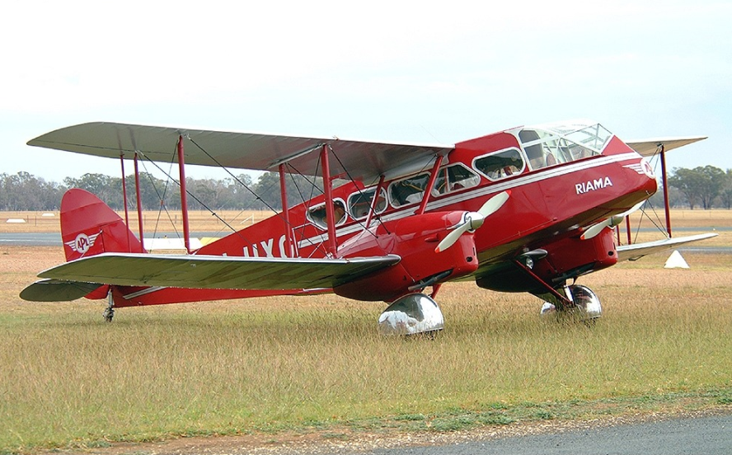
Photo: Glenn Alderton
Source: JetPhotos.net
The aircraft structure was primarily fabric-covered timber, including the control surfaces. The wings and tail were braced with external wires and struts. Both the upper and lower wings had ailerons and no flaps. At the time of the accident, the aircraft was fitted with a single, central pilot’s seat and five passenger seats in a staggered, side-by-side configuration.

Maintenance
Maintenance records for the aircraft indicated there were no outstanding defects or maintenance. All applicable engine and airframe airworthiness directives were recorded as carried out.
The maintenance records showed that the aircraft last underwent a periodic inspection on 8 September 2012, at 16,255 hours airframe time. The aircraft’s maintenance release was valid until 8 September 2013 or 16,355 hours, whichever came first. The ATSB estimated that at the time of the accident the aircraft’s total time in service was about 16,265 hours.

Engines and propellers
The aircraft was powered by two four-cylinder, 145 hp de Havilland Gipsy Major 10 Mk II engines. Each drove a Fairey Reed A67960/X1 two-blade, fixed-pitch aluminium propeller.
The engines were more powerful than the original 130 hp Gipsy Major 10 Mk I engines and incorporated electric starters. They were fitted with a carburettor heating system that automatically activated at low throttle settings.
Both engines were last overhauled on 3 October 2002 and were next due for overhaul at 17,068 hours airframe time.

Weight and balance
According to the aircraft’s Manual of Instructions for Operation, Maintenance and Rigging, its maximum take-off weight (MTOW) was 1,907 kg. The ATSB estimated the aircraft’s weight using information from:
- the aircraft load sheet
- the pilot’s weight as recorded during his last medical examination
- standard passenger weights
- an estimate of the remaining fuel based on the initial fuel and estimated fuel burn rates
- an estimation of the weight of the luggage, tools and aircraft equipment on board at the time.
Based on this information, the aircraft’s weight was estimated to have been 2,042 kg at take-off and near the aircraft’s MTOW at the time of the accident.
There were no charts in the aircraft’s documentation that permitted a calculation of the aircraft’s centre of gravity, but a loading system was provided on the aircraft’s load data sheet. That loading system advised that the:
- manufacturer’s maximum weights and loadings must not be exceeded
- passengers should be loaded from the rear to front, with the heaviest passengers at the rear
- maximum load of 125 kg (plus battery) in the baggage compartment should not be exceeded.
The distribution of passengers and baggage for the flight probably would have conformed to the recommended loading system with regard to the centre of gravity limits.

Fuel
The aircraft was fitted with two fuel tanks, one behind each engine, which were interconnected by a balance feed tube under the fuselage. It used 100LL AVGAS (aviation gasoline) and the total capacity was 273 L.
Witnesses reported that the aircraft’s fuel tanks were filled from drum stock at about 1035 on 1 October 2012. The associated hand pump was fitted with an in-line paper filter and witnesses indicated that the fuel was also passed through a funnel that was fitted with a screen filter. There were no reports of fuel problems with other aircraft that had refuelled from the same drum stock.
The aircraft’s endurance was reported to be about 4.5 hours on full tanks. Based on the aircraft’s total fuel capacity, reported fuel consumption rates and the pilot’s estimate of endurance as reported to ATC, the investigation estimated that the aircraft had at least 1 hour’s endurance remaining at the time of the accident.
Examination of the aircraft wreckage showed that both of the aircraft’s fuel tanks ruptured during the impact sequence. About 7 L of fuel remained in the right fuel tank and there was evidence that fuel drained from the left fuel tank after the impact with terrain.

Performance and handling
There was no manufacturer’s pilot operating handbook for the DH-84. Information on the aircraft’s performance and handling was obtained from pilots who had flown this aircraft type, and from a pilot who had flown UXG following its rebuild.
Due to its more powerful engines and wheel spats, UXG’s performance was reported to be slightly better than the standard DH-84. A pilot who had flown UXG reported that the aircraft would cruise at a true airspeed of about 85 kt and at a typical fuel consumption of 30 L/h for each engine.
At its maximum weight, the maximum rate of climb was about 250 ft/min. The coarse pitch propellers fitted to UXG, probably to give better fuel economy or cruise speed, adversely affected climb performance. The standard DH-84 was reported to typically cruise at about 5,000 ft, weather permitting.
It was reported that the aircraft required constant, minor control inputs to fly straight and level. Roll control was heavy and required considerable and coordinated use of the rudder. Pitch control was not as heavy, but required constant attention, regardless of whether the aircraft was trimmed. The aircraft was fitted with rudder trim, though it was reported that its effectiveness was limited.
Pilots also reported that they had only ever flown the aircraft in visual flight conditions and postulated that instrument flight in it, although possible, would not be easy and would require a pilot’s constant attention. They reported that the DH-84 was not an easy aircraft to control in any turbulence, requiring almost full aileron deflection at times and a lot of coordinated use of rudder. It was slow to respond to lateral control inputs and the additional drag created by aileron deflection could account for up to 5 kt reduction in airspeed.

Aircraft instruments and equipment

Overview
The aircraft’s instrument panel layout was close to the original, including mostly period instruments with the addition of modern radios (VHF transceiver and transponder), a cradle for a mounted handheld-style global positioning system (GPS) receiver, and two air temperature gauges (Figure 5). The cockpit was fully enclosed, with extensive glazing providing excellent forward and side visibility but limited ‘aircraft reference’ (parts of the aircraft that can be used as visual points of reference to aid in determining the aircraft’s attitude relative to the horizon).
Figure 5: VH-UXG cockpit in 2006
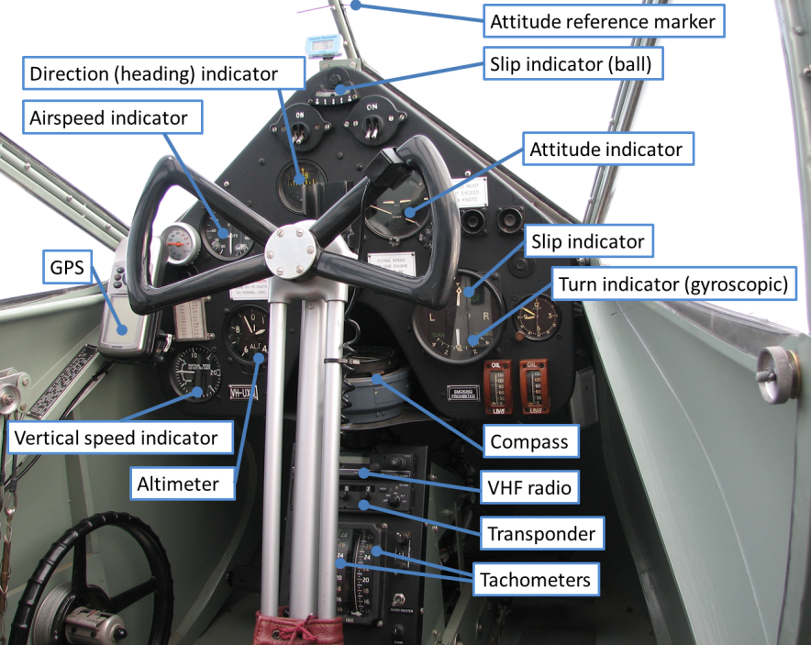
Source: ATSB

Suitability for instrument flight
The aircraft was not equipped or approved for operations under the instrument flight rules (IFR) and was not maintained to that standard. However, it included an airspeed indicator, altimeter, vertical speed indicator, turn and slip indicator and attitude indicator. In the case of inadvertent entry into instrument meteorological conditions (IMC), control of the aircraft was possible by reference to these instruments. The aircraft was not fitted with an autopilot.
The layout of the instrument panel was typical of aircraft of that era and did not conform to the standard panel arrangement of modern aircraft that makes instrument scanning faster and easier. In UXG, the most central flight instrument in a pilot’s normal, forward line of sight was a ball-type slip indicator, and some instruments were obscured by the control wheel and column.

Gyroscopic instruments
The aircraft was fitted with three gyroscopic instruments typical of the 1930s. These were driven by vacuum pressure from airflow passing through externally-mounted venturis.
An attitude indicator is used to indicate an aircraft’s attitude with reference to the horizon. In UXG, a fixed aeroplane symbol indicated the aircraft’s pitch and roll relative to a moving white horizon bar, and could be adjusted in pitch. Index marks either side of the top centre of the instrument provided an indication of 10°, 20°, 30° and 60° bank angles. A caging knob was used to secure the gyroscope when not in use and to reset the instrument after it had ‘toppled’.
A direction indicator indicates an aircraft’s heading and generally provides a steadier heading reference than a compass, which is subject to turning and acceleration errors. The direction indicator in UXG displayed the aircraft’s heading on a rotating card that showed the compass heading in the ‘reverse’ direction when viewed (that is, bearings to the aircraft’s left are shown on the instrument’s right side). The direction indicator had to be manually aligned to the magnetic compass regularly to compensate for the earth’s rotation and maintain accuracy. That required the integral caging knob to be engaged in order to rotate the card until the desired heading appeared under the reference line, before uncaging the gyroscope by pulling the knob out.
A turn and slip indicator is a combined instrument showing the rate and direction of a turn, and the amount and direction of any sideslip. The instrument fitted to UXG consisted of a gyroscopically-operated turn needle and pendulum-type slip/skid needle. The needles were positioned vertically above one another with the upper needle indicating the slip/skid and the lower needle the rate of turn. A ‘ball’ type slip indicator was also installed at the top of the panel.

Compass
The aircraft was fitted with a P8-type magnetic compass that was mounted horizontally beneath the instrument panel. This type of compass was common to many British aircraft in the 1930s. To obtain the aircraft’s heading, a pilot rotates a bezel until two parallel indicator wires are aligned with the compass needle, and then reads the heading from the bezel at the instrument’s lubber line. To set a course using the compass, the pilot rotates the bezel until the desired course is indicated at the lubber line, then locks the bezel in place and turns the aircraft until the compass needle is aligned with the indicator wires.

Radio
The aircraft was fitted with a single Icom IC-A200 VHF radio that had the capability to have an active and standby frequency. The radio was mounted on a pedestal forward of and partly impeded by the control column.

GPS receiver
The cradle-mounted, handheld-style Garmin GPSMAP 96 GPS receiver was capable of providing position information (as latitude and longitude or distance and bearing from a waypoint), groundspeed, flight time, moving map display, and a horizontal situation indicator-type display. It included an internal aviation navigation database, which provided position and facility information for airports and navigation aids and could also store user-defined waypoints.

Personal locator beacon
The pilot carried a GME Accusat MT410 personal locator beacon (PLB) that met the requirements of Civil Aviation Regulation 252A for flights requiring the carriage of an emergency locator transmitter. The PLB required manual activation and transmitted a 406 MHz signal for satellite detection and a 121.5 MHz signal for ground- and air-based detection and homing. The 406 MHz signal incorporated digitally-encoded information including a unique identification code. A suitably-equipped search aircraft could detect the 121.5 MHz signal and locate the PLB once tuned to the correct frequency.
The Cospas-Sarsat international satellite-aided tracking system detected distress signals and relayed those signals to AMSA through ground receiver stations. The satellite system could also provide estimates of the beacon position based on the characteristics of the signal. Satellite location using the 406 MHz signal had a nominal accuracy of about 5 km for a stationary target. A PLB equipped with GPS could determine its own position and pass that information onto the Cospas-Sarsat system for much greater accuracy. The PLB carried on board UXG was not equipped with GPS.

Wreckage and accident site information

Accident site
The damage to the tree canopy and the approximate aircraft location and attitude at the time of the initial impact with trees are illustrated at Figure 6. The tree damage indicated that the aircraft’s direction of travel at impact was to the south with a descent angle of about 30°. Sections of the outer left wings remained caught in a tree to the left of the flight path and, along with an undamaged tree immediately to the right of the flight path and the wreckage scatter pattern, indicated that the aircraft collided with trees while banked to the left at about 35°.
One of the trees struck by the aircraft sustained a sharp, 8-cm deep slash, consistent with impact by a rotating propeller (Figure 6 and Figure 7). The geometry of the aircraft’s path through trees indicated that the left propeller caused this slash.

Airframe
The airframe was extensively damaged as a result of impact forces and the tendency for the timber structure to break rather than bend (Figure 8). The damage was consistent with a collision at a moderate to high speed combined with a steep angle relative to the terrain. There was no fire.
All of the aircraft’s major components, including all flight control surfaces, were located at the accident site and were severely damaged. The remnant aircraft structure and flight controls were inspected on-site with no pre-accident defects identified.

Engines
The left engine impacted terrain heavily and the propeller and hub were partially embedded in the ground. The left engine nacelle, including the left fuel tank and landing gear, remained attached to the engine. The right engine separated from its nacelle and tumbled several metres before coming to rest near the end of the wreckage trail.
Both engines were removed from the accident site and were later partially disassembled and inspected by the ATSB. This inspection did not identify any pre-impact damage or defects.

Propellers
Analysis of propeller damage can provide evidence of the operational state of an aircraft’s engine(s) at the time of any collision with terrain. In this instance, examination of the propellers found no evidence of pre-impact damage to either propeller. The propeller hubs remained attached to the respective crankshaft flanges and one blade on each propeller was detached at the hub.
Both propellers showed significant chordwise markings that were indicative of propeller rotation. The blades from each propeller also exhibited a degree of bending and twisting consistent with both propellers being driven with significant engine torque at impact with terrain. The slashed tree provided additional strong evidence of high rotational energy in the left propeller.
A comparison of the damage signatures between the two propellers, allowing for the differences in impact with the uneven terrain and the passage of the propellers through trees, suggested that the engines were probably producing comparable levels of power at the time of the accident.
Figure 6: Representation of the aircraft’s path through the trees (approximate scale)
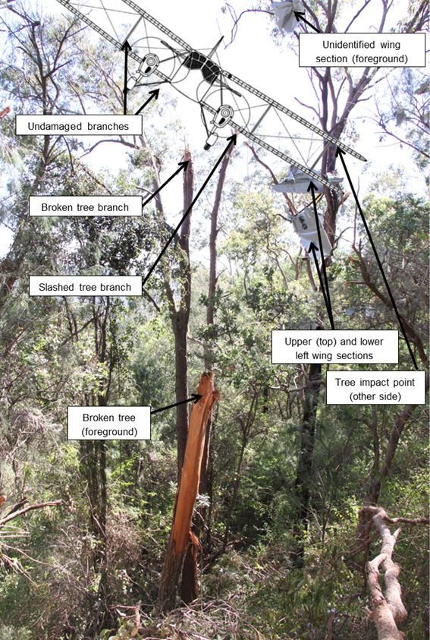
Source: ATSB
Figure 7: Slash-type cut to one of the trees at the accident site

Source: ATSB
Figure 8: Aircraft wreckage
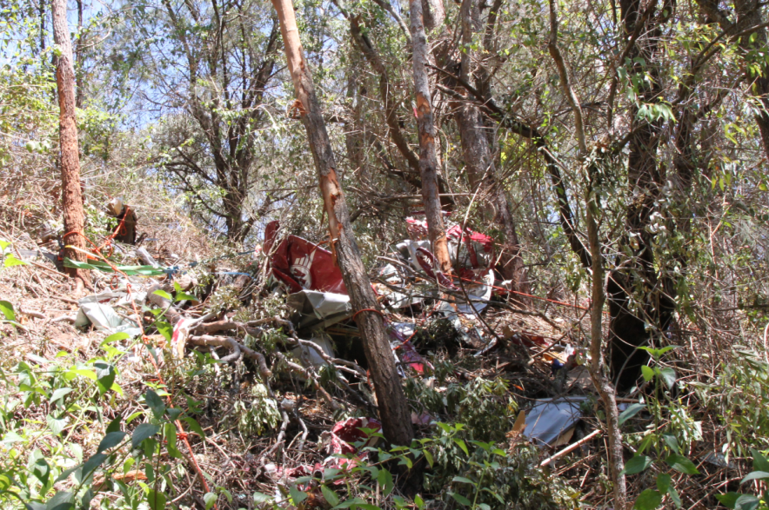
Source: ATSB

Instruments and equipment
The aircraft’s radio was identified but impact damage prevented determination of the selected frequency.
A handheld Garmin 12 GPS receiver was recovered from the accident site and its stored data extracted by the ATSB. This included recorded data from previous flights but not the accident flight, indicating that it was not in use at the time.
The aircraft was fitted with a cradle for a separate Garmin GPSMAP 96 GPS receiver on the left of the instrument panel. The accompanying GPS receiver was not found at the accident site.
A number of flight instruments were recovered from the accident site for subsequent detailed disassembly and inspection by the ATSB. The following is a summary of the findings from these inspections:
- The heading, turn and attitude indicators contained gyroscopes that rotated at high speed when the instruments were in operation. There was evidence of rotational gyroscope scoring in the turn and attitude indicators, consistent with their operation at the time of impact. The heading indicator was not identified at the accident site.
- Examination of the engine tachometers, altimeter face, aircraft clock, attitude indicator, compass and vertical speed indicator found no evidence that could be used to determine a possible reading at impact.
The pilot’s PLB was located within the wreckage. An examination of the PLB revealed that its batteries had sufficient charge remaining for normal operation and that the damage sustained during the accident sequence rendered the unit inoperable.

Survivability
Modern light aircraft generally afford a higher level of survivability than vintage aircraft, primarily due to improved design standards to address the main survivability requirements. These include that the:
- forces imparted on an aircraft’s occupants must be within human tolerance
- occupants must be restrained to prevent flail-type injuries
- aircraft’s liveable space must be maintained
- occupants must have a means of escape.
In the case of UXG, the entire aircraft structure was significantly disrupted during the impact sequence, to the extent that there was negligible occupant protection afforded by the cabin, seating, and seatbelts. In addition, calculations using a range of probable speeds and angles of impact indicated that the deceleration forces imparted on the aircraft occupants were outside human tolerance limits. For those reasons the accident was not considered to be survivable.

Pre-flight planning

Visual meteorological conditions
Flights can either be conducted under the VFR or the instrument flight rules (IFR). Civil Aviation Regulation (CAR) 172 stated that a flight could only be conducted under the VFR if it was conducted in visual meteorological conditions (VMC). Aeronautical Information Publication Australia (AIP) section ENR 1.2 VISUAL FLIGHT RULES contained the requirements for VMC. For flight below 10,000 ft in non-controlled airspace – Class G, these included:
- minimum visibility of 5,000 m
- clear of cloud 1,500 m horizontally and 1,000 ft vertically.
The VMC requirements applicable to a flight at or below 3,000 ft AMSL or 1,000 ft above ground level (whichever was higher) were:
- minimum flight visibility of 5,000 m
- clear of cloud and in sight of the ground or water.

Flight planning requirements
CAR 239 required that, before beginning a flight, a pilot in command must study all available information appropriate to the intended operation. The AIP, section ENR 58 ALTERNATE AERODROMES, stated that a pilot of a day VFR flight must provide for a suitable alternate aerodrome when the forecast weather at the projected time of arrival at the destination was less than the applicable alternate minima, which was:
- visibility continually below 8 km, or
- total cloud amount below 1,500 ft continually greater than ‘scattered.’
A suitable alternate aerodrome was defined as one which itself was a suitable destination for the flight, and for which the forecast weather was greater than the above minima. In addition, as part of the Day VFR Syllabus (Aeroplane), pilots were taught a precautionary search and landing procedure so that any suitable area may be considered an alternate if there was an unforecast deterioration of conditions at the planned destination.

Weather and notices
The pilot obtained a weather briefing through a pilot official of Recreational Aviation Australia (RA-Aus) at 0917 at the Monto Airport. The official reported that he accessed NAIPS on his smartphone and showed the pilot the Area 40 forecast (ARFOR) and NOTAM information relevant to the flight. He also showed the pilot the Brisbane (Marburg) radar images from the Bureau of Meteorology (BoM) website showing rain patches along the coast, including at Caboolture. The pilot was reported to have mentioned that he wanted to leave early because of the possibility of cloud developing in the ranges to the south. The pilot did not make a copy of the weather information.
The RA-Aus official indicated that they discussed a NOTAM advising of remotely piloted aircraft activity that had closed Kingaroy Airport and the surrounding area. The NOTAM advised that the airport could be used in emergencies, or if 30 minutes’ notice of an intended landing was given to the reporting officer. The pilot made note of a contact phone number for this officer. Telephone records indicated that the pilot did not call that number on 1 October.
At 0942 on 1 October, one of the aircraft passengers rang a friend to ask what the weather was like in Brisbane. The friend relayed that there would be rain and storms between Bundaberg and Caboolture and that they ‘should go further out to avoid it.’ The passenger was reported to have indicated that they would check the BoM website personally. A laptop computer was available to the pilot, but it was not possible to determine whether it was used to obtain weather information for the flight.
No pre-flight weather planning documents were found with the wreckage. There was no record of the pilot requesting in-flight weather information from either air traffic control or from other pilots.

Route planning
A significant portion of the direct route from Monto to Caboolture passes over a mountain range (Figure 1). About 85 km south-east of Monto, near Gayndah, a gap in the range provides a low-terrain route from the direct track to the coast. Further south and for most of the direct track, the topography is rugged, with thickly forested and mountainous terrain, at elevations up to 2,848 ft. The terrain along the coastal route from Bundaberg to Caboolture is generally quite flat.
There were several airports and aerodromes in the region, as marked with aeroplane symbols in Figure 1. A small private airfield was located in Kandanga valley, 2.5 km north-east of the accident site at an elevation of about 650 ft. The airfield was unlicensed and was not included in the En Route Supplement Australia or any of the charts found in the aircraft wreckage.
On the night of 30 September the pilot mentioned to a friend that, for the return trip to Caboolture, he was planning to fly east towards the coast and then south. The RA-Aus official who talked with the pilot on the morning of the flight reported that although the pilot preferred taking a coastal route to Caboolture, he agreed with the official that a route to the west of the ranges would be preferable to avoid the forecast coastal weather (see the subsequent discussion titled Meteorological information). The official understood the pilot’s plan was to take the inland route but could not recall discussing how the pilot would then reach the coast.
Aeronautical charts recovered from the wreckage were only marked with direct lines between Monto and Caboolture and no flight plan or flight log was found. There was no evidence of the pilot having left a flight note with a responsible person or that he had submitted a SARTIME flight notification. Because the flight was a private flight in daytime, not over water or in a designated remote area, the pilot was not required under regulation to provide a flight note or SARTIME.

Meteorological information

Bureau of Meteorology forecasts
The relevant Area 40 forecast (appendix A) was issued at 0734, and was valid for the period from 0900 to 2100. It forecast isolated thunderstorms near the coast north of Maroochydore with scattered showers and drizzle along the coast and extending to the west after midday. The forecast wind at 2,000 ft was from the south-east at 15 kt, a direct headwind along the intended track, and was forecast to be up to 30 kt near the coast north of Maroochydore. Visibility was forecast to be 8 km in smoke haze from fires in the area and down to 3 km in showers and rain.
An amended Area 40 forecast was issued at 1317, and indicated broadly similar conditions but without thunderstorms.
There was no aerodrome forecast (TAF) for Caboolture. The nearest airports for which forecasts were available (appendix A) were Brisbane Airport, 54 km to the south and the Sunshine Coast Airport at Maroochydore, 55 km north.
The Sunshine Coast Airport TAF, valid from 0900, forecast a south-easterly wind of 16 kt, visibility greater than 10 NM (19 km), showers and scattered cloud with a base of 2,500 ft and broken cloud base 4,000 ft. Intermittent deteriorations in conditions of up to 30 minutes’ duration were forecast after 1000, with visibility reduced to 4,000 m in showers and an overcast cloud base of 1,000 ft.
The Brisbane Airport TAF, valid from 0400, was for similar conditions but with scattered cloud base 3,500 ft and broken cloud at 6,000 ft. From 1100, the cloud was forecast as scattered at 2,000 ft and broken at 5,000 ft, with intermittent deteriorations in visibility and cloud base expected until 1000.
The Kingaroy TAF, valid from 0600, was for a light southerly wind with scattered cloud base 2,500 ft and broken cloud at 5,000 ft. From 1100, the wind was forecast to back to a stronger south-easterly. Throughout the day, from 0600 until 1800, intermittent deteriorations in conditions of up to 30 minutes’ duration were forecast with visibility reduced to 3,000 m in rain showers and broken cloud base 1,200 ft.

Bureau of Meteorology observations
A BoM aerological diagram for Brisbane Airport at 0900 on 1 October 2012 showed a saturated atmosphere from just above the surface up to 10,000 ft. The saturated atmosphere and prevailing wind conditions produced overcast cloud in the area.
The BoM produced a meteorological report for the ATSB. It stated that there were no BoM weather stations near the accident site and that the Automatic Weather Stations (AWS) in the area were not fitted with ceiling and visibility sensors. The report noted that the Beerburrum AWS (near Caboolture) reported temperature and humidity readings that are typical of moist air associated with fog or low cloud.
Radar imagery indicated isolated or scattered showers from around Kingaroy to the coast throughout the day. The weather radars were effective for detecting rain but could not indicate the presence of clouds or of reduced visibility. Radar returns from small droplets in light rain or drizzle may not be sufficient to show the full extent of the area affected.
The BoM reported that while there were no recorded observations or measurements of the height and amount of cloud that was reported by witnesses in the vicinity of the accident site, it is reasonable to state that at the time and location of the accident, there was overcast cloud at or below the top of the mountain range and up to 10,000 ft. An infra-red satellite image taken at 1330 showed overcast cloud along the coast and ranges, as far west as Kingaroy (Figure 9).
The BoM indicated that the forecasts and warnings were consistent with the available observations at the time of the accident. A BoM official who was familiar with the region advised that, while this weather pattern was not unusual, it was not a regular occurrence.
Based on the application of the BoM forecast/observed conditions to a CASA icing probability chart, the likelihood of carburettor icing, at cruise power and without carburettor heat having been selected by the pilot, was moderate.
Figure 9: Infra-red band satellite image taken at 1232
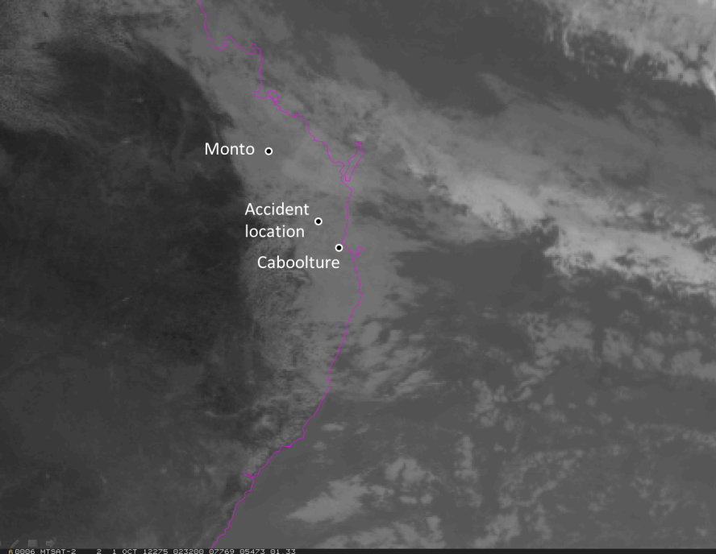
Source: Bureau of Meteorology. Locations inserted by the ATSB.

Witness reports of the weather
Witnesses reported a high overcast at Monto during the morning, with good visibility and a light south-easterly wind.
At Tansey, the weather was reported to be overcast with good visibility. The clouds were lower over the mountains and were moving very quickly in from the coast and building over the range. Witnesses around the accident site later reported that the weather in the area on the day was overcast, cloudy and misty.
The weather in the Borumba Dam area, about 10km south-east of the accident site, was reported to be overcast and misty with occasional patches of sunlight. The SAR helicopter pilot reported that there was a lot of low cloud around the tops of the terrain in the area, and that the cloud base was typically between 500 and 2,500 ft with scattered showers. Witnesses in the areas around the accident site reported that the weather was poor all day, with thick, low cloud obscuring the hilltops and visibility that was reduced in mist or drizzle. Based on a report that a specific low peak in the valley to the south-east of the accident site was just visible, the cloud base was at about 750 ft AMSL in that location.
The pilot of a commercial aircraft overflying the area reported that there was solid cloud with no breaks or ‘holes’ visible, and that the cloud tops were over 10,000 ft. The pilot of the SAR helicopter reported that the coastal weather included a south-easterly wind with a cloud base between 1,000 ft and 2,500 ft and a visibility of 5 km. This pilot recalled that toward the mountain range the conditions were considerably worse, with cloud on the hilltops and visibility reduced to 1 to 2 km in drizzle and mist.
Other pilots departed Monto for Caboolture earlier that morning. One pilot who flew from Monto to Toowoomba on a route that went west of Kingaroy reported that the weather deteriorated faster than he anticipated, and that there were several radio transmissions from other pilots along the coast reporting poor conditions.
A pilot who flew from Monto to Caboolture reported that, after departing Monto at about 0730 in good weather, he turned towards the coast from Tansey then followed a highway to Gympie, gradually descending due to the lowering cloud base, but in good visibility. The pilot recalled that south of Gympie the weather appeared much worse but as he could see the coast he tracked east and, although forced to descend to 1,000 ft, he was able to continue and flew to Caboolture in clear conditions below the cloud base, landing there at about 1010. He later reported that the weather in the area continued to deteriorate and was squally at around midday.
Another pilot who departed Monto at about 0730 reported that after studying the forecast that morning, he judged that conditions would not permit flight under the VFR along the coast and planned to track west of the ranges to Caboolture. He reported that he was forced to descend due to a lowering cloud base and diverted to Nanango at about 0920. Although visibility was good, he could see to the east that low cloud and mist was obscuring the ranges in the area of UXG’s track. The pilot made another attempt to reach Caboolture at around 1100 but this second attempt was abandoned due to poor weather soon after departure.

Hazards associated with VFR flight in IMC

Geographic disorientation
A pilot conducting a VFR flight is required to establish the aircraft’s position using external visual cues such as geographical features, and can also use ‘dead reckoning’ as well as aircraft instruments and equipment such as GPS and radio navigation aids. VFR-only pilots are not qualified for operations in IMC, and a VFR pilot may find navigation difficult or impossible in those conditions, depending on the aircraft’s equipment and the pilot’s ability to operate it and correctly assimilate the information.
Geographic disorientation in aviation operations results from ‘the failure of an aircrew to recognize and/or maintain the desired position relative to the external ground and airspace environment’ (Antuñano 1989). In other words, the pilot is either unsure of the aircraft’s location with respect to the outside world or has an incorrect mental picture of it. It may occur as the result of insufficient, incorrect, or ambiguous navigation information being available, or inadequate assimilation of that information. Geographic disorientation can lead to the pilot being unable to follow an appropriate route to the desired destination, locate and navigate away from hazards such as mountainous areas and other ground obstacles, or find a suitable place for landing.

Spatial disorientation
Spatial disorientation occurs when a pilot does not correctly sense the position, motion and attitude of an aircraft relative the surface of the Earth. Maintaining spatial orientation relies heavily on the visual system correcting for incorrect cues from the other sensory systems. When conflicting information is received or subconsciously misinterpreted, a pilot may experience extreme difficulty maintaining spatial orientation. Maintaining spatial orientation with limited or no visual references is difficult even for pilots with appropriate training and experience in instrument flight. McGrath and others (2003) stated:
When a pilot looks away from the horizon (loss of focal and peripheral visual cues), or looks away from his artificial horizon in instrument weather (loss of focal visual cues), the central nervous system computes spatial orientation with the remaining information at its disposal, vestibular and somatosensory. The vestibular and somatosensory information are concordant, but frequently incorrect. In such circumstances, it is physiologically normal [original emphasis] to experience spatial disorientation.
Principal environmental and flight manoeuvre factors that can lead to spatial disorientation in the context of a VFR flight include flight into IMC (including cloud penetration), prolonged angular motion, changes in attitude at rates too low for the body’s senses to detect, and workload (Benson 1999). Research from the United States has shown that pilots without an instrument rating are five times more likely to have accidents in degraded visual conditions than pilots with instrument ratings (NTSB 2005). The FAA Light Aircraft Handbook (2004) stated:
Accident statistics show that the pilot who has not been trained in attitude instrument flying, or one whose instrument skills have eroded, will lose control of the airplane in about 10 minutes once forced to rely solely on instrument reference.
Spatial disorientation can lead to accidents. A relatively common effect is the spiral dive, also known as the ‘graveyard spiral’ as described by the FAA (2003):
[It] is associated with a return to level flight following an intentional or unintentional prolonged bank turn. For example, a pilot who enters a banking turn to the left will initially have a sensation of a turn in the same direction. If the left turn continues (~20 seconds or more), the pilot will experience the sensation that the airplane is no longer turning to the left. At this point, if the pilot attempts to level the wings this action will produce a sensation that the airplane is turning and banking in the opposite direction (to the right). If the pilot believes the illusion of a right turn (which can be very compelling), he/she will reenter the original left turn in an attempt to counteract the sensation of a right turn. Unfortunately, while this is happening, the airplane is still turning to the left and losing altitude. Pulling the control yoke/stick and applying power while turning would not be a good idea–because it would only make the left turn tighter. If the pilot fails to recognize the illusion and does not level the wings, the airplane will continue turning left and losing altitude until it impacts the ground.

Effects of workload and skill fatigue
Workload varies as a function of the number and complexity of the task demands and the capacity of the individual to meet those demands. High workload leads to a reduction in the number of information sources an individual will search, and the frequency or amount of time these sources are checked (Staal 2004). It can result in an individual’s performance on some tasks degrading, tasks being performed with simpler or less comprehensive strategies, or tasks being shed completely. In some cases tasks can be shed efficiently by eliminating performance on lower priority tasks or they can be shed inefficiently by abandoning tasks that should be performed (Wickens and Hollands 2000).
Stress can arise from exposure to a range of factors including workload, environmental stresses such as noise and vibration, perceived danger, and personal factors (Tepper 1979, in Gawron 2004). The amount of stress, its effect, and the reaction to stress varies widely between individuals, potentially affecting an individual’s attention, memory, perceptual-motor performance, and judgement (Staal 2004). Research has also shown that decision-making is one of the leading causes of stress, and is particularly true of pilots faced with decisions to turn around or to wait out due to unsuitable weather patterns (Jensen 1995).
Skill fatigue refers to the deterioration in performance caused by work that demands persistent concentration and a high degree of skill. It can also lead a pilot to concentrate on movements or objects in the centre of vision and neglect those in the periphery. This is accompanied by loss of accuracy and smoothness in control movements (FAA 2008).

VFR into IMC accidents
VFR flight into IMC can result in a controlled flight into terrain, loss of control and in rare occasions an in-flight breakup. VFR into IMC accidents account for a significant proportion of fatal general aviation accidents.
During the period 1991–2000, 26 of the 210 fatal Australian general aviation accidents involved VFR flight into IMC (12 per cent). The rate for private flights was higher (21 out of 119 fatal accidents, or 18 per cent). During the period 2001–2012, at least 14 of the 167 fatal accidents involved VFR into IMC (8 per cent), with the rate for private flights being higher (12 out of 91 fatal accidents, or 13 per cent). Overall, during the period 1991–2012, 88 people were fatally injured in VFR into IMC accidents in Australia.
In addition to fatal accidents, there are also many incidents involving VFR into IMC. The 2011 ATSB publication Accidents involving Visual Flight Rules pilots in Instrument Meteorological Conditions stated that, from 2006–2010, 72 occurrences of VFR pilots flying into IMC were reported to the ATSB. Of these, seven resulted in fatal accidents. However, when a VFR into IMC episode results in an accident, the consequences are usually severe. The United States National Transportation Safety Board (NTSB) stated that when accidents occur in IMC, about two thirds result in fatalities (NTSB 2005).
In June 2012, a Cessna 182 impacted a rock face in mountainous terrain near Tooraweenah, New South Wales, while operating in or near conditions of limited visibility. The aircraft was destroyed and the pilot was fatally injured. The ATSB found that the pilot planned a direct track over high terrain, and stated:
A diversion to a more conservative flight path that allowed for greater height between terrain and the cloud base would have provided more time and opportunity to manage further weather deterioration. This included any decision to divert to a different aerodrome with weather conditions more suitable for VFR flight.
In April 2013, a Cessna 210 with four people on board disappeared on a flight from Bullo River to Emkaytee, Northern Territory. Bodies and a small amount of wreckage were later found washed ashore. There were no survivors. The ATSB found that:
…the pilot continued to track along the planned coastal route towards a thunderstorm, probably encountering conditions such as low cloud, reduced visibility and turbulence, and as a result of one or more of those factors the aircraft descended and collided with water.
While that investigation highlighted lack of surface definition when over water as a risk when conducting coastal flights in marginal weather conditions, it emphasised the importance of accessing detailed weather briefings to assist with understanding the conditions at the time as well as the immediate trend. The ATSB report stated:
Once the flight was underway the pilot needed to regularly reassess the weather situation with regard to the view outside the cockpit and any other available information such as pilot reports… [It] is not possible to fully appreciate the pilot’s view of the weather on the approach to Cape Ford. That said, there doesn’t seem to have been any impediment to a course reversal but the pilot didn’t take it or decided to take it too late.

Guidance to pilots on avoiding flight in adverse weather
In 2010 the ATSB published a study titled Improving the odds: Trends in fatal and non-fatal accidents in private flying operations, which found that assessing and planning problems contributed to 46 per cent of fatal accidents involving Australian private flights between 1999 and 2008. The report stated that:
Assessing and planning issues associated with collision with terrain and/or loss of control accidents mostly involved pilots failing to plan for the weather conditions, not properly assessing the weather during flight, or deciding to continue to fly in marginal weather.
The study provided many useful ideas to help avoid getting caught out by adverse weather, including:
- Once you have identified the likely threats and errors you may encounter during your flight, decide how you will deal with them as part of your pre-flight planning (and don’t forget to discuss these with your copilot if you have one).
- Making decisions beforehand will also reduce your workload in-flight if and when these threats and errors occur, and may reduce your chances of making a poor in-flight decision under stress and time pressure.
- Be mindful of the pressures you may face while making your decisions, whether you are making them pre- or in-flight. These pressures may be to arrive on-time, pressure from passengers to continue with the flight, or monetary pressures.
- Know your personal minimums. These are your set of rules and criteria for deciding if and under what conditions to fly or to continue flying based on your knowledge, skills and experience (adapted from Parson 2006). They act as a ‘safety buffer’ between the demands of the situation and the extent of your skill.
- Don’t forget that decision making is an evolving process. Do not lock yourself into your plan. Instead, keep your plan dynamic and have other options to give yourself an out when conditions change. If you find that the decisions made are inappropriate to the current conditions, adapt them using the information and the resources available to you. Pilots should always obtain up-to-date weather information before and during flight. The more doubtful the weather, the more information you will need to get and the more planning is required. Cancel the flight if the flight conditions exceed your personal minimums.
- Even though you may have decided on a course of action in case of marginal weather, decision making is a dynamic process, particularly when it comes to weather, and requires continuous assessment of conditions en route.
The fourth booklet in the ATSB’s Avoidable Accidents series, titled Accidents involving Visual Flight Rules pilots in Instrument Meteorological Conditions, was published in 2011. It provided several examples of VFR into IMC occurrences and advised that pressing on into IMC conditions with no instrument rating carries a significant risk of severe spatial disorientation due to powerful and misleading orientation sensations in the absence of visual cues. Disorientation can affect any pilot, no matter what their level of experience.
The United States Federal Aviation Administration General Aviation Pilot’s Guide to Preflight Weather Planning, Weather Self-Briefings, and Weather Decision Making advised:
Head for the nearest airport if you see clouds forming beneath your altitude, gray or black areas ahead, hard rain or moderate turbulence, or clouds forming above that require you to descend. It is much easier to reevaluate conditions and make a new plan from the safety of an airport.
CASA produces a wide range of safety materials designed to assist VFR pilots, including a:
- Weather to Fly DVD. This DVD highlights the dangers of flying in cloud, and how to avoid VFR into IMC.
- Flight Planning Kit. This kit is designed to assist low-hour VFR pilots develop good flight planning habits. It includes a handbook outlining eight stages of a flight, kneeboard, flight planning notepad, personal minimums card, ‘time in your tanks’ card and more.
- Look out! Situational Awareness DVD. This DVD discusses situational awareness and why it is vital to flying safety.
Information on obtaining these safety materials is available on the CASA website at www.casa.gov.au.

Air traffic services information

Airspace information
After passing Gayndah, the pilot of UXG was operating in the Burnett (BUR) ATC sector, part of the Fraser Group managed/administered by Airservices from the Brisbane ATC Centre. The BUR controller was responsible for a mix of aircraft types and operations in complex airspace, which included arrivals and departures from Brisbane Airport and Sunshine Coast Airport at Maroochydore.
Radio communication within the sector was conducted on separate frequencies for low- and high-altitude traffic and managed concurrently by the BUR controller. The BUR ATC console had a pre-programmed communications system that was tailored to be sector-specific. This enabled one controller to manage the two BUR frequencies in a combined configuration and allowed pilots on both frequencies to hear one another. There were also a series of separate communication lines for ATC coordination.

Radar information
There were two radars available for use in the area by ATC, both located south-east of Caboolture. The Brisbane primary radar at Mount Hargreave (MHV) was unserviceable at the time of the accident as it was being upgraded. This necessitated the use of the secondary Brisbane Terminal Area Radar (BNTAR), and the controller reported that its radar coverage in the mountain range was degraded in comparison with the normal coverage.
Simulations of radar coverage in the area of the accident indicated that the lower limit of the MHV and BNTAR radars in the Borumba Dam, Imbil and Kandanga areas was about 3,000 ft, though the MHV radar could theoretically detect an aircraft at 3,000 ft several kilometres further north-west than BNTAR in those areas. The locations and altitudes of the five recorded radar returns that were likely to be from UXG at 1317 to 1321 aligned with the simulated radar coverage in the area for both radars.

Terrain and obstacle avoidance
The grid lowest safe altitude (LSALT) is the lowest altitude that will provide safe terrain clearance within a given grid. Though it is a concept usually only applicable to aircraft under the IFR, it can be used as a minimum safe altitude for any aircraft in IMC to assure clearance from terrain and obstacles. The LSALT for a given grid is either:
- 1,000 ft above the highest obstacle, where the highest obstacle is more than 360 ft above the height determined for terrain, or
- 1,360 ft above the height determined for terrain, where the highest charted obstacle is less than 360 ft above the determined terrain height.
In the grid in which UXG was operating, the LSALT was 4,300 ft. That increased to a grid LSALT of 5,100 ft in the area commencing about 5 NM (9 km) south of Kingaroy and including the airspace directly overhead Caboolture. The grid LSALT to the west, overhead Kingaroy, was 5,200 ft.

In-flight emergency response

Workload and resources
A number of other operational ATC personnel assisted the controller during the IFER, including the shift manager, a Brisbane Approach controller who held a pilot’s license and listened on frequency, and another Fraser Group controller who opened the planning position console to assist with monitoring the BUR frequency and airspace. A high degree of interaction between the ATC personnel was reported as they attempted to assist the pilot of UXG.
The controller reported being ‘busy’ leading up to the occurrence. In an attempt to reduce frequency congestion and controller workload, at the commencement of the IFER, the BUR controller transferred jurisdiction of a number of scheduled public transport aircraft to adjoining sector controllers. In addition, ATC managers arranged for aircraft departing Brisbane that planned to track through BUR airspace to be rerouted to avoid the sector. The BUR controller was still required to manage a number of other aircraft in the sector, mostly IFR operations within controlled airspace. This included scheduled transport aircraft departures and arrivals that required sequencing via holding patterns throughout the IFER period.
It was reported that there were about 18 other aircraft on frequency and within the BUR airspace during the IFER period. The controller was mindful that they were required to provide those aircraft with ATC services, in addition to managing the response for UXG. Due to airspace design restrictions, there was no capacity for ATC to split control jurisdiction and transfer the aircraft operating within airspace classes A, C and E to another controller, or to de-combine the frequencies.

IFER checklists
Airservices had an IFER checklist to be used by controllers in response to in-flight emergency situations (see extracts in appendix B). This included a number of sub-checklists to be followed depending on the type of emergency situation.
On first identifying that UXG’s pilot required assistance, the BUR controller used the first component of the IFER checklists, the ‘Critical Initial Actions’ checklist, before applying the ‘VFR in IMC’ checklist. The ‘Uncertain Of Position’ checklist was reportedly not used as the operation of the VFR aircraft in IMC was considered to be the more critical issue at that time, although the BUR controller did use procedures in the ‘Uncertain of Position’ checklist in an attempt to identify UXG on radar before providing navigation assistance. The ‘Uncertain Of Position’ checklist noted that, in the event that an aircraft’s position was not determined prior to fuel exhaustion and/or the onset of unsuitable in-flight conditions, the situation may result in fuel shortage, forced landing or ditching, VFR on top of cloud or day VFR at night operations. However, it did not reference the ‘VFR in IMC’ checklist.
The ‘General’ section of the IFER checklist indicated that controllers should balance acquiring information with keeping communications to a minimum. It was also noted that the optimum response to in-flight emergencies varied with each situation, and that controllers should consider alternative courses of action and ‘resist any inclination to a predetermined approach’. The ‘VFR in IMC’ checklist noted that controllers should keep instructions simple and to a minimum, as the affected pilot may be emotionally distressed or inexperienced.
The controller performed most of the actions on the relevant checklists. For example, ATC sought the relevant information from the pilot and provided appropriate advice, such as to keep wings level, maintain normal airspeed, and climb above the LSALT. ATC also examined a number of available sources in an attempt to determine if there were any areas near UXG suitable for VFR flight. This included pilots of a number of other aircraft, weather radar images, observations from the Sunshine Coast Control Tower and BoM weather reports, relevant parts of which the controller then attempted to pass on to the pilot. However, with their performance potentially influenced by radio communications difficulties (see the following discussion) and workload, ATC did not explicitly provide encouragement or ongoing flying advice to the pilot (such as to keep wings level) after 1325.

Radio communications
Communications between ATC and the pilot of UXG were severely hampered after about 1333, with the controller attempting to contact the pilot at 1335, 1336, 1337 and 1340 but without success. In response, the BUR controller commenced relaying communications via other aircraft at 1343, following a period of about 10 minutes when radio transmissions from UXG were not being received. Direct contact from then on was intermittent though relayed communications appeared to be relatively reliable.
During the IFER, some ATC transmissions combined multiple requests for information and/or actions and UXG’s pilot generally responded to only one of the items. In addition, there were periods of between about 30 seconds and 2 minutes where there was no direct or relayed communication between ATC and UXG, either due to the BUR controller managing other traffic or discussions between ATC personnel about the IFER. These could not be heard on the area frequency.

Post-IFER review
Airservices conducted an IFER review meeting on 12 October 2012, attended by operational ATC managers and staff from the Airservices safety department. The controller on duty at the time of the occurrence was not involved. The meeting was not intended to be a formal, documented post-activation review. Its objective was to ensure that the welfare of the involved ATC personnel was considered and to determine if there were any ‘learnings from the occurrence management’ that might be applied to enhance future IFERs.
Informal notes of the meeting recorded findings that the IFER was ‘reasonably well managed in terms of task allocation’, that coordination with AMSA was effective and that the critical actions in the IFER checklist were followed and considered appropriate. Identified areas for improvement included the possibility of isolating UXG on one frequency and the observation that the rescue helicopter pilot requested UXG’s pilot to change frequency without ATC approval.
The ATSB considers that the review may not have made full use of available information to evaluate the IFER. For example, the meeting notes stated that ‘departures from Brisbane were stopped during the IFER management’ and that ‘all aircraft were held in [other] airspace’, but recorded data indicated that aircraft departures out of Brisbane continued and that aircraft were tracking through and holding within that airspace during the IFER period. This increased the workload for the controllers while they were providing assistance to the pilot of UXG.
The IFER involving UXG was an unusual occurrence: a long-duration example of IFER management in practice with significant air traffic services involvement as well as contribution by external agencies. A formal, well-documented and comprehensive review of the process in action could have increased the potential for procedural improvement.

Coordination of the in-flight emergency

Task briefing
The verbal task briefing given to the SAR helicopter pilot stated that ‘it is an AusSAR[] task’. The SAR helicopter pilot and the AMSA briefing officer had a short exchange of information, including that the pilot of UXG had been asked to activate his aircraft’s emergency beacon. The SAR pilot later sought clarification by asking ‘So he’s transmitting on 121.5 [MHz], correct?’ and the response was ‘We will get him to, if he’s not already, yes.’ The SAR helicopter pilot later reported that after the briefing, the SAR crew were of the understanding that AMSA were the lead agency, and that the crew were expected to contact the pilot of UXG on 121.5 MHz.
The air traffic controller later reported being under the impression that the SAR crew were going to assist by homing onto UXG’s beacon and identifying areas clear of cloud for UXG.
The emergency frequency of 121.5 MHz could not be monitored or recorded by ATC. Similarly, there was no ATC capability to monitor or record transmissions over the 123.45 MHz frequency as it was designated as an air-to-air communications frequency. The controller reported that they were not expecting the SAR helicopter pilot to request UXG’s pilot to change frequency and that ATC would have been unable to hear any transmissions between the helicopter and UXG on frequencies other than the area frequency. However, the controller did not query or countermand either of the frequency change requests made by the SAR pilot, later reporting being unsure whether Airservices had been in communication with AMSA in relation to a frequency change.

AMSA-Airservices Australia memorandum of understanding
A memorandum of understanding (MoU) existed between AMSA and Airservices that detailed the mutual and respective responsibilities of each agency, including in the case of an aircraft emergency or SAR incident. It stated:
When handling an aircraft emergency or responding to a SAR incident, there is a need for AMSA and Airservices to be working cooperatively and effectively together or acting independently depending on the circumstances. However, there is a need for there to be no ambiguity about which agency is the lead agency and which is providing support in responding to an incident. The lead agency role is determined by mutual agreement using the following descriptions of the division of responsibilities.
With regard to the management of an IFER, the MoU stated that Airservices would provide the following service:
In-Flight Emergency Response to provide reasonable advice to assist pilot to:
- operate in safe airspace (eg providing directions to aircraft lost in cloud to regain visual contact with the ground, providing Lowest Safe Altitude information),
- resume normal operations; or
- land the aircraft safely.
The MoU included the following AMSA responsibilities in the case of an aircraft emergency:
- Responsibility for coordination of appropriate SAR response operations for missing aircraft except those which are subject of an IFER action.
- Provide assistance to Airservices … when Airservices is the lead agency, provide general assistance where resources are available.
- In coordination with Airservices when it is the lead agency, AMSA may provide a parallel SAR response to an incident.
The MoU did not provide detail about the procedural interactions between AMSA and Airservices during an IFER, or what types of ‘general assistance’ AMSA were to provide.

National search and rescue manual
The National SAR Council, which was formed by federal and state SAR authorities, formulates, discusses and ratifies national search and rescue policies. It produced the National Search and Rescue Manual, a standard reference document for the conduct of SAR activities by Australian SAR authorities. In terms of an IFER, the manual stated:
RCC Australia[] performs operations other than search and rescue, which, if not carried out, could result in a SAR incident. These operations include: a) Assisting a vessel or aircraft that is in a serious situation and in danger of becoming a casualty, thereby endangering persons on board. This assistance may be by way of direct action, or by way of notification to, and coordination with, other SAR authorities.
In terms of the division of responsibility between Airservices and AMSA, the manual stated:
ATS units are responsible for providing in–flight emergency response (IFER) services. ATS units are required to refer incidents likely to culminate in a forced landing, ditching or crash to RCC Australia at the earliest opportunity.
Chapter 9 of the manual provided information on ‘other emergency assistance and services available from RCC Australia’. The list of ‘other’ operations included:
Assisting a vessel or aircraft that is in a serious situation and in danger of becoming a casualty, thereby endangering persons on board. This assistance may be by way of direct action, or by way of notification to, and coordination with, other SAR authorities.

SAR procedures manual for rotary wing units
AMSA provided a SAR standards and procedures manual to SAR service providers to ensure the effective and safe conduct of SAR and related operations. The manual provided detailed information on a range of subjects including operations, communications, safety, training, and audits.
Section 2 of the procedures manual dealt with SAR communications. It included generic communication procedures as well as a list of frequencies approved for SAR operations. The manual stated that, when communicating with a federal authority:
The emergency frequency VHF 121.5 MHz may also be considered, changing to VHF 123.1 MHz (or 123.2 MHz), if possible, once communication is established.
Section 10 of the manual was titled Assistance and Services other than SAR and listed the same ‘other’ operations as Chapter 9 of the National Search and Rescue Manual.
Section 10.3, titled Intercept and Escort Operations, included instructions on methods for intercepting and escorting an aircraft in distress with the main purpose being ‘to minimise the delay in reaching the scene of distress and to eliminate a possible search for survivors’. It stated:
The following assistance can be provided by an escort aircraft:
a. Moral support to the persons on board the distressed craft, assuring them that assistance is immediately available;
b. Navigation and communication functions for the distressed craft, permitting its crew to concentrate on coping with the emergency;
c. Inspection of the exterior of the distressed craft;
d. Advice on procedures for aircraft ditching, including ditching heading, or for abandoning or beaching a vessel;
e. Illumination during aircraft ditching or vessel abandonment, or assistance in the approach procedure at the destination.
The manual did not clarify how such assistance should be rendered, discuss other types of assistance that may be provided, or provide specific information about any interaction with ATC during an IFER.

AMSA-SAR helicopter service agreement
An agreement for the provision of helicopter SAR services existed between AMSA and the operator of the SAR helicopter. Schedule 2 of the agreement detailed capability specifications for the equipment used by the SAR service; for example, that the aircraft used by the SAR service provider was to be capable of conducting visual searches during the day and rescuing persons with a rescue winch. In terms of crew requirements, it stated that the helicopter crew ‘must have the necessary qualifications and currency to meet the specified capability in Schedule 2’ without providing additional detail.
The agreement did not include any specific requirements for the provision of assistance to aircraft in distress, or specific training or knowledge requirements in relation to IFER situations.

Other information available to SAR service providers
The helicopter SAR service advised that it did not provide training or written guidance to its crews with regard to the provision of assistance to aircraft in distress, and that no training or guidance was provided by AMSA on that topic. Another SAR service provider reported that its crews were not provided with training or guidance on the provision of assistance to aircraft in distress, either internally or by any other agency.

Search operation
On 1 October 2012, the SAR helicopter searched for UXG around the mountain range based on three search locations provided by AMSA. The search was hindered by poor weather conditions, with the cloud base reported to be at 200 ft above ground level in the valleys. The helicopter then returned to base, landing at 1538 as updated search areas were being designated.
The next phase of the search involved three specially-equipped aircraft: one aeroplane and two helicopters. The helicopter search was postponed after dusk, while the aeroplane continued a night search using electronic, infrared, and night vision equipment.
A search coordination and logistics control base was set up in the local area and the search resumed the next day, continuing until the wreckage was found on 3 October. Although the weather improved from the second day, the dense bushland and mountainous terrain hindered the search.
The crews of three aeroplanes and 17 helicopters, mostly non-specialist volunteers, participated in the ongoing search. Two of the helicopters were used for additional searches with special electronic equipment to detect signals from mobile phones on board UXG. In addition, the Queensland Police Service coordinated a surface and shoreline search of Borumba Dam.
Multiple search zones were designated each day by AMSA, each up to 2,000 km² in area. The search zones were based on information from many sources such as the pilot’s position reports, witness reports, and signals from the PLB and aircraft occupants’ mobile telephones. Within each zone, individual aircraft were allocated specific search areas or patterns. Later examination of the search areas showed that most covered the wreckage location.
On 5 February 2013, AMSA held an operational debrief to assess the effectiveness of the search and rescue operation. It include representatives from AMSA, the Queensland Police Service, the two SAR service providers that were involved in the search, and the telecommunications company that assisted in the mobile telephone search. ATSB personnel attended primarily as observers, and also as advisers for accident site safety. Some of the topics that were discussed included search methods and technologies, coordination, logistics, and accident site hazards. A number of proposals to address the issues identified during the debrief were evaluated.

Safety analysis

Introduction
The circumstances of the accident were consistent with the pilot encountering instrument meteorological conditions (IMC), resulting in an eventual collision with terrain. The propeller damage and slashed tree branch indicated that both propellers were being driven by significant engine power at the time of impact with terrain. Furthermore, the pilot did not report experiencing any mechanical difficulties to air traffic control (ATC) and mechanical problems were not considered likely under the circumstances.
The aircraft took off from Monto in visual conditions and travelled at least two thirds of the distance to Caboolture, Queensland without apparent difficulty. However, the aircraft eventually entered low-visibility conditions including forecast and reported low, layered cloud with patchy rain, almost certainly IMC. The pilot requested navigation assistance from ATC but since the aircraft was not visible on radar for most of the flight, ATC had insufficient position information to guide the pilot away from the cloud and high terrain.
The elevation of the accident site and local weather observations indicated that the aircraft was most likely in cloud at the time of the collision. The on-site evidence was consistent with a high descent angle, relatively steep angle of bank and significant speed at impact, suggesting that the aircraft was not under control at the time.
After maintaining control in poor weather for about an hour, unable to navigate away from the mountain range, and with continually decreasing fuel, the pilot probably experienced an increasingly high workload and levels of stress for a long period of time, which can lead to degradation in the ability to maintain aircraft attitude. It is likely that the pilot became spatially disoriented and lost control due to a combination of factors such as the absence of a visible horizon, cumulative workload, stress and/or distraction.
However, the Australian Transport Safety Bureau (ATSB) could not completely eliminate other possibilities, such as the aircraft having stalled or otherwise descending steeply while in a turn, possibly as the result of the pilot manoeuvring in an attempt to avoid cloud and/or terrain.

Aircraft weight
The aircraft was almost certainly above its maximum take-off weight (MTOW) at the commencement of the flight, and its weight at the time of the accident was estimated to have been close to the MTOW. Increased weights have an effect on an aircraft’s structural integrity and performance, especially climb performance. However, there was no evidence to suggest that UXG’s structural integrity was compromised in-flight, and the cruising altitude for a standard DH-84 was reported to be about 5,000 ft, which was higher than the lowest safe altitude in the area. Furthermore, UXG was fitted with more powerful engines than standard, which might have alleviated the performance loss associated with the heavier weight to some degree. As a result, the ATSB considered that the aircraft’s overweight condition, although undesirable, did not have a significant bearing on the event.

Operational aspects

Pre-flight planning
Visual conditions existed at Monto when the flight departed. However, the weather forecast viewed by the pilot about 2 hours previously predicted scattered showers and drizzle with isolated thunderstorms along the coast and inland west of the ranges. There was a forecast headwind along the intended track, with visibility of 3 to 8 km and heavy cloud as low as 1,000 ft.
There were no indications that there was any time pressure to reach Caboolture and it is not known whether the pilot considered abandoning or delaying the flight to wait for better weather. Though the pilot was apparently aware that the weather was likely to be unsuitable for visual flight along the coast and had selected a different route, it is not known to what extent he considered options for a diversion if the flight encountered bad weather. It is advisable to avoid mountainous areas when there is deteriorating weather, and more alternate landing options were available further to the west. In this respect, although Kingaroy Airport was only available with advance notice, there were other aerodromes in the area that were shown on the maps carried by the pilot.
Pre-flight planning is one of the most important tasks in carrying out a safe flight. A pilot is more likely to foresee difficulties and abandon or delay a flight as necessary if careful consideration is given to all aspects of the flight in advance. Pilots should carefully consider the chosen route for any cross-country flight, taking into account factors such as terrain, the availability of navigational aids, weather, pilot familiarity, fuel, and options for diversion or emergency landing. If any problems arise once the flight is underway, having a detailed flight plan helps a pilot to carry out the optimal course of action without undue delay. Bringing a printed copy of the weather forecasts, or requesting forecast or observed weather and other information in-flight, would facilitate the selection of appropriate diversion options and then carrying out the diversion.

In-flight decision-making
Adverse weather poses a serious risk to visual flight rules (VFR) flights. In 2005, the ATSB published an aviation research investigation report titled General Aviation Pilot Behaviours in the Face of Adverse Weather. The researchers observed that:
A VFR pilot may exhibit a range of behaviours when faced with adverse weather. For example, at the first hint that conditions are deteriorating, a pilot may decide that discretion is the better part of valour and immediately return to their point of departure and recount their brush with danger to an instructor or to fellow pilots in the clubrooms. At the other extreme, a pilot may ‘press on’ into deteriorating weather, either unable or unwilling to see the increasing danger of their actions, until the aircraft suddenly enters IMC… A more typical scenario might involve a pilot who, in response to deteriorating conditions, initially continues the flight as planned, but subsequently decides to return, divert, or perhaps even carry out a precautionary landing.
The report found that the majority of occurrences took place during the second half of the planned flight. Since the halfway point relates to different actual distances for different flights, the study concluded that psychological factors are likely to be the primary influence on a pilot’s decision-making in such situations. The chances of a VFR into IMC encounter increased as the flight progressed until they reached a maximum during the final 20 per cent of the flight distance.
Wiegmann and Goh (2000) found that the accuracy of a pilot’s visibility estimates has a significant impact on a decision to continue or divert from a VFR flight into IMC situation, suggesting that pilots who continued with the flight may have done so because they did not perceive visibility conditions to be as bad as they were. A possible reason for this is the insidious effect of gradual changes in visibility, as described by the United States Federal Aviation Administration (FAA 2009):
…scientists who study human vision have determined that weather transitions are sometimes too subtle for the limits of the visual system. Like other sensory organs, the eye responds best to changes. It adapts to circumstances that do not change, or those that change in a gradual or subtle way, by reducing its response. Just as the skin becomes so acclimated to the “feel” of clothing that it is generally not even noticed, the eye can become so accustomed to progressive small changes in light, color, and motion that it no longer “sees” an accurate picture. In deteriorating weather conditions, the reduction in visibility and contrast occurs quite gradually, and it may be quite some time before the pilot senses that the weather conditions have deteriorated significantly.
It is unlikely that the pilot of UXG would have chosen to fly into instrument conditions, having had no significant or recent instrument training and flying an aircraft that was not appropriately equipped for such flight. He had earlier indicated that he wished to avoid the bad weather, and took an otherwise less favourable route to do so.
Most likely, the pilot continued the flight into gradually deteriorating weather conditions without fully recognising the danger until he was unable to continue or divert. A decision to divert was either not made or made too late. In low visibility conditions, the pilot’s ability to see and avoid worsening weather would have been impeded.
Some nearby airfields may have been an option for diversion, though the ATSB could not determine whether the pilot attempted to divert. The nearby private airfield was likely to have been obscured by cloud and the pilot was probably not aware of its existence.

Flight in instrument meteorological conditions
The aircraft was most likely flying around the Borumba Dam, Imbil, and Kandanga areas between about 1300 and the impact with terrain at some time after 1405. Most of the witnesses gained only fleeting glimpses of the aircraft, seen through breaks in the cloud, suggesting that the cloud was layered and that the pilot had some visual cues from cloud formations and ground features. These may have enabled him to maintain control of the aircraft, possibly with an occasionally visible horizon.
It was likely that, at times, the pilot would have had to rely solely or primarily on reference to the aircraft’s instruments for aircraft control. As a pilot with minimal instrument flight experience, no instrument flight recency and operating an aircraft not fully equipped for flight in IMC, and with no or limited visual references available in and near cloud, it would have been very difficult for the pilot to maintain control of the aircraft. Accumulating stress and skill fatigue over time would have made otherwise simple tasks increasingly difficult.
At times, ATC advised the pilot to climb, which would have permitted greater clearance with terrain and probably improved radar and radio contact for improved ATC assistance. However, the altitudes reported by the pilot were all below those recommended by ATC. It is likely that the pilot could not climb due to factors such as cloud above the aircraft, difficulties establishing a climb when in cloud, or slow climb rate with a heavy load.
The non-central positioning of the relevant flight instruments would have increased the time taken and difficulty experienced scanning and interpreting the information as presented. The direction heading indicator would have drifted throughout the flight, and the pilot might not have had an opportunity to realign it during a period of straight and level flight. In addition, its potentially counter-intuitive bearing display might have led to difficulties in navigating, particularly under high workload. In this respect, the compass was not a direct-reading type, further adding to the pilot’s workload. Though global positioning system (GPS) equipment was available, its display was relatively small and the pilot may have experienced difficulty using it if he was focusing on maintaining control or trying to remain under or clear of cloud.

Radio communications
As the aircraft’s radio was located low and forward of the control column, the pilot would have needed to reach forward and down, and possibly to one side, in order to see and manipulate the equipment. If in cloud and reliant on the aircraft’s primary flight instruments to maintain aircraft control, any head movement, inadvertent control movement, or diversion of attention away from those instruments would have interrupted the pilot’s instrument scan and affected his ability to maintain the aircraft’s attitude.
The pilot acknowledged a request to change radio frequencies shortly before the accident. However, the ATSB was unable to determine whether attempting to change radio frequencies contributed to spatial disorientation or some other problem (such as task shedding), which in turn led to the pilot being unable to complete the action. Alternatively, any subsequent transmissions from the aircraft may have been blocked by terrain, or the pilot may have tuned to a frequency that was not monitored, or he may not have actually made any transmissions.

In-flight emergency response

Lead agency
The Australian Maritime Safety Authority (AMSA)-Airservices Australia (Airservices) memorandum of understanding (MoU) emphasised the need for ‘no ambiguity about which agency is the lead agency and which is providing support in responding to an incident.’ However, the MoU did not explicitly state the lead agency in the case of an in-flight emergency response (IFER), though it implied from the division of responsibilities that Airservices was the lead agency in such circumstances. The national Search and Rescue (SAR) manual stated that ‘ATS units are responsible for providing in-flight emergency response (IFER) services’. The ATSB interpreted the MoU and other information to mean that the lead or responsible agency in the case of IFER was Airservices.
The task briefing that was provided to the SAR helicopter crew did not state that Airservices was the lead agency, but it did state that it was ‘an AusSAR task’, most likely with the intent to convey that the tasking was formalised and provided by AMSA. Without adequate background knowledge regarding inter-agency operations, the statement could be readily interpreted to mean that AMSA were the lead agency. As a result, there was the potential for inefficient communication and coordination between agencies, which could lead to inconsistent planning and execution of IFER management tasks. Identification of the lead agency to all rescue participants would alleviate any ambiguity as to which agency held authority for the planning and management of an IFER.

In-flight emergency response by air traffic control
The pilot did not formally declare an emergency, and the controller was proactive in identifying that there was an abnormal situation and initiating an IFER. Unable to identify UXG on radar due to limited coverage, the controller identified the aircraft’s possible location from the pilot’s reports and took appropriate action to advise the lowest safe altitude in the area and suggest a climb, if possible, to establish the aircraft at a safe height above obstacles and terrain, and to activate the on-board personal locator beacon (PLB). All of this was intended to support and ‘unload’ the pilot.
ATC also used external resources effectively, including other aircraft and the SAR service, to relay information and monitor the emergency frequency. However, given the circumstances, there was limited opportunity for ATC to assist UXG.
Due to the controller’s already high workload in managing normal aircraft operations in a busy airspace sector, the additional requirement to manage an aircraft in distress subjected the controller to increased pressure and workload. While a number of actions were taken to reduce the controller’s workload, the nature of the IFER itself required intensive cognitive processing and significant time.
Although the IFER checklist noted that communications with a pilot in an emergency situation should be simple and kept to a minimum, the likelihood that the optimum response would vary with each situation was highlighted. Under high workload and performing multiple tasks concurrently, including interacting with other ATC personnel, the controller made a number of transmissions that requested multiple pieces of information from the pilot and/or suggested action by the pilot. The response might have been improved had it been possible to isolate UXG onto a single radio frequency, and to de-combine the uncontrolled portion of the sector from the other airspace classifications.
The 10-minute period in which the pilot of UXG was not contactable and ATC did not attempt other means to contact the pilot, such as relaying communications through other flights, was a potential indicator of elevated controller workload. High controller workload may have affected ATC’s effectiveness in forming and carrying out action plans and resolving developing issues. In the event, relayed communications, once established, were relatively reliable.
For a pilot experiencing a high workload in an emergency situation such as VFR in IMC, ATC can be a comforting and reassuring guide. While it is not advisable to inundate a pilot in trouble with constant instructions and queries, regular reminders to keep the aircraft’s wings level and speed constant, to trust their instruments, as well as providing reassurance that ATC is working to provide all possible assistance, can help reduce workload and stress.

In-flight emergency response coordination
A typical SAR service provider searches for, provides medical assistance to, and transports people in need. On occasion, a SAR service provider may be called upon to assist in the case of an IFER or other developing emergency, which is significantly different to the other missions. Two SAR service providers reported that they would typically provide assistance to one or two aircraft in distress each year, usually a lost aircraft and sometimes a VFR aircraft in IMC or on top of cloud.
For IFER missions to be conducted effectively, it is important for SAR crews to understand contextual and detailed information about the types of assistance that can be provided, their interactions with ATC and the crews of distressed aircraft, and other procedural details about IFERs. Given the limited briefing, training and instruction provided to the SAR service provider in the management of an IFER, the SAR helicopter crew’s decision-making primarily relied on personal experience and initiative. This increased the risk of inconsistent approaches by SAR crews and of the ineffective provision of assistance to distressed pilots. Although IFER missions are inherently varied and dynamic, requiring a flexible approach, the provision of additional guidance to SAR operators and crews would increase the reliability of any IFER assistance provided.
It is apparent that ATC, AMSA and the SAR crew each held a slightly different understanding of the situation with regard to which agency had control, what approach was to be taken, and what each other’s roles would be. For example, the SAR helicopter crew understood their tasking to include attempting to contact the pilot of UXG on the emergency frequency, while the controller did not expect the frequency change request.
In any communications there is always the potential for misunderstanding, especially where key participants are separated by several intermediaries: information can be unwittingly lost, added to or changed with each exchange of information. This is particularly the case when there is limited time and opportunity for participants to share information and to develop and implement an effective and coordinated response. Although participants do need to be careful to ensure that the correct information is always passed on, vigilance alone will not prevent errors. If the participants have a pre-existing understanding of their respective roles, responsibilities, and capabilities, they are more likely to take a common and therefore more efficient approach.
The MoU between AMSA and Airservices did not clearly state the extent to which assistance was to be provided by AMSA and in particular, was ambiguous as to whether airborne SAR service providers were expected to provide assistance to Airservices when aid was being given to a distressed pilot. The provision of assistance appeared to be provided almost on an ad hoc basis, with no prior consideration apparent to ensure that, if provided, assistance from AMSA and SAR service providers was consistent and appropriate to Airservices’ role as the lead agency.

Search operation
In any search operation, there is a trade-off between the size of the search area and how thoroughly it can be searched with the available resources. In this case, the search area was initially established on the basis of fairly limited information. This included the recorded radar positions, PLB beacon positions as reported by satellite and the pilot’s position reports to ATC. However, the pilot was unable to provide his exact location to the controller and only a distance and approximate compass direction from Caboolture. Furthermore, some of the position information became less relevant over time due to the aircraft’s movement.
The collision with terrain occurred several minutes after the last signal from the PLB was received by the satellites. Consequently, the initial estimates of the most likely aircraft position were broad, but the search areas did encompass the actual location of the accident site. The mountainous, heavily-wooded terrain probably contributed to the difficulty in locating the aircraft.

Utility of emergency locator transmitters and personal locator beacons
A report released by the ATSB in 2013 titled A review of the effectiveness of emergency locator transmitters in aviation accidents stated:
At little additional expense, GPS-equipped ELTs significantly increase the accuracy of positional resolution from approximately 5 km (non-GPS) to approximately 120 m for GPS-enabled ELTs. Incorporation of GPS technology into ELT and PLB units is not presently mandatory.
Australian search and rescue (AusSAR) advise that if a pilot is attempting a forced landing, is having serious control difficulties, or becomes disorientated by flying into instrument or dangerous weather conditions, proactively activating an ELT could greatly increase the likelihood of the search and rescue coordination centre knowing the exact position of the aircraft. If the emergency is alleviated, simply turn the unit off and notify AusSAR as soon as possible.
If using a personal location beacon (PLB), ensure it is on your person. Having it ‘close at hand’ or in your flight bag will not help you if you cannot reach it after an accident, or if it (or you) is thrown from the aircraft. For other occupants of the aircraft, a PLB is of little use if none of the survivors of a crash is aware of its location, or if they are stowed in a location that is difficult to access in an emergency.
One of the people on board UXG activated the on-board PLB during the flight, and the beacon was used to aid in locating and assisting the flight. However, the PLB was not a GPS-enabled model and the detecting satellites could only obtain an approximate fix, the accuracy of which was probably degraded due to the aircraft’s movement. A better fix could not be obtained after the accident because the PLB was damaged by impact forces.
The carriage and use of a GPS-enabled emergency beacon could improve position information received by the respective agencies during an in-flight emergency and, in the event of a survivable accident, expedite the arrival of medical and other assistance.

Findings
From the evidence available, the following findings are made with respect to the visual flight rules into instrument meteorological conditions accident involving de Havilland Aircraft Pty Ltd DH-84 Dragon, registered VH-UXG, that occurred 36 km south-west of Gympie, Queensland, on 1 October 2012. These findings should not be read as apportioning blame or liability to any particular organisation or individual.
Safety issues, or system problems, are highlighted in bold to emphasise their importance. A safety issue is an event or condition that increases safety risk and (a) can reasonably be regarded as having the potential to adversely affect the safety of future operations, and (b) is a characteristic of an organisation or a system, rather than a characteristic of a specific individual, or characteristic of an operating environment at a specific point in time.

Contributing factors
- The pilot unintentionally entered instrument meteorological conditions and was unable to reattain and maintain visual conditions.
- It is likely that the pilot became spatially disoriented and lost control due to a combination of factors such as the absence of a visible horizon, cumulative workload, stress and/or distraction.

Other factors that increased risk
- Though it probably did not have a significant bearing on the event, the aircraft was almost certainly above its maximum take-off weight (MTOW) on take-off, and around the MTOW at the time of the accident.
- Though airborne search and rescue service providers were regularly tasked to provide assistance to pilots in distress, there was limited specific guidance on the conduct of such assistance. [Safety issue]

Other findings
- The aircraft wreckage was not located for 2 days as the search was hindered by difficult local weather conditions and terrain, and the cessation of the aircraft’s emergency beacon due to impact damage.

Safety issues and actions
The safety issues identified during this investigation are listed in the Findings and Safety issues and actions sections of this report. The Australian Transport Safety Bureau (ATSB) expects that all safety issues identified by the investigation should be addressed by the relevant organisation(s). In addressing those issues, the ATSB prefers to encourage relevant organisation(s) to proactively initiate safety action, rather than to issue formal safety recommendations or safety advisory notices.
All of the directly involved parties were provided with a draft report and invited to provide submissions. As part of that process, each organisation was asked to communicate what safety actions, if any, they had carried out or were planning to carry out in relation to each safety issue relevant to their organisation.

Provision of assistance to aircraft in distress
Number: | AO-2012-130-SI-01
Issue owners: | Airservices Australia  Australian Maritime Safety Authority
Operation affected: | Aviation: Other
Who it affects: | Aeroplane and helicopter search and rescue (SAR) service providers

Safety issue description:
Though airborne search and rescue service providers were regularly tasked to provide assistance to pilots in distress, there was limited specific guidance on the conduct of such assistance.

Proactive safety action taken by: Airservices Australia
Following notification of the safety issue by the ATSB, on 11 October 2013 Airservices Australia advised that:
In response to the incident, Airservices conducted a managerial review of In-Flight Emergency Response (IFER) procedures. The review identified potential opportunities for improvement relating to the operational interface and transfer of responsibility between Airservices and AMSA [the Australian Maritime Safety Authority] (i.e. ATC [air traffic control] and SAR [search and rescue] aircraft). As a result Airservices and AMSA have agreed to conduct a comprehensive review of the existing MoU [Memorandum of Understanding] to ensure the effectiveness of collaborative Airservices-AMSA IFERs. The review is anticipated to be completed by the end of Q1 2014 [the first quarter of calendar year 2014].
Action number: AO-2012-130-NSA-025

Proactive safety action taken by: the Australian Maritime Safety Authority
Following notification of the safety issue by the ATSB, on 14 November 2013 the Australian Maritime Safety Authority advised that:
AMSA and Airservices have agreed to conduct a comprehensive review of their existing Memorandum of Understanding (MoU), including the air traffic service requirements for support from Search and Rescue (SAR) aircraft, to ensure the effectiveness of collaborative in-flight emergency responses. The review is anticipated to be completed during the first quarter of 2014.
AMSA will also update its SAR procedures manual in consultation with Airservices and if appropriate will issue updated guidance on communications between SAR aircraft and the air traffic service.
Action number: AO-2012-130-NSA-026

ATSB comment in response:
The ATSB is satisfied that a joint review of inter-agency agreements, with a focus on coordination of in-flight emergency responses and communication, should lead to improvements that adequately address the safety issue. The ATSB will continue to monitor the safety issue.

Current status of the safety issue:
Issue status: Details of the current status of this safety issue are available at www.atsb.gov.au.

General details

Occurrence details
Date and time: | 1 October 2012 – 1405 EST
Occurrence category: | Accident
Primary occurrence type: | VFR into IMC
Type of operation: | Private
Location: | 36 km SW of Gympie, Queensland
 | Latitude: 26° 27.375’ S | Longitude: 152° 27.300’ E

Aircraft details
Manufacturer and model: | de Havilland Aircraft Pty. Ltd. DH-84 Dragon Mk 2
Registration: | VH-UXG
Operator: | Private
Serial number: | 6077
Type of operation: | Private
Persons on board: | Crew – 1 | Passengers – 5
Injuries: | Crew – 1 fatal | Passengers – 5 fatal
Damage: | Destroyed

Sources and submissions

Sources of information
The sources of information during the investigation included:
- Airservices Australia (Airservices)
- the Australian Maritime Safety Authority (AMSA)
- the Bureau of Meteorology (BoM)
- the Civil Aviation Safety Authority (CASA)
- the aircraft restoration organisation
- the aircraft maintenance organisation
- two search and rescue (SAR) helicopter service providers
- a number of witnesses.

References
Antuñano, MJ Mohler, SR & Gosbee, JW 1989, ‘Geographic disorientation: approaching and landing at the wrong airport’, Aviation, Space, and Environmental Medicine, vol. 60, pp. 996-1004.
Australian Transport Safety Bureau 2011, Accidents involving visual flight rules pilots in instrument meteorological conditions, publication AR-2011-050.
Australian Transport Safety Bureau 2005, General aviation pilot behaviours in the face of adverse weather, publication B2005/0127.
Benson, AJ 1999, ‘Spatial disorientation – general aspects’, in J Ernsting, AN Nicholson & DJ Rainford (Eds.), Aviation Medicine (3rd ed.), Oxford, England, Butterworth Heinemann, pp. 419-436.
Federal Aviation Administration 2003, Spatial disorientation: Why you shouldn’t fly by the seat of your pants, publication AM-400-03, Washington DC.
Federal Aviation Administration 2004, Airplane Flying Handbook, publication FAA-H-8083-3A, Washington DC.
Federal Aviation Administration 2008, Pilot’s handbook of aeronautical knowledge, publication FAA-H-8083-25A, Washington DC.
Federal Aviation Administration 2009, General aviation pilot’s guide to preflight weather planning, weather self-briefings, and weather decision making, version 1.3, Washington DC.
Gawron, V 2004, ‘Psychological factors’, in FH Previc & WR Ercoline (Eds.) Spatial disorientation in aviation, Lexington MA, American Institute of Aeronautics and Astronautics, Inc, pp. 145-195.
Jensen, RC 1995, Pilot judgement and crew resource management, Hants England: Aldershot.
National Transportation Safety Board 2005, Risk factors associated with weather-related general aviation accidents, Safety Study NTSB/SS-05/01.
Parson, S 2006, Getting the maximum from personal minimums, FAA Aviation News, May-June 2006, pp. 1-8.
Staal, MA 2004, Stress, cognition, and human performance: A literature review and conceptual framework, National Aeronautics and Space Administration technical memorandum 212824.
Wiegmann, D & Goh J, 2000, Visual flight rules (VFR) flight into adverse weather: An empirical investigation of factors affecting pilot decision making, Technical report RL-00-15/FAA-00-8, Aviation Research Lab Institute of Aviation, Illinois.

Submissions
Under Part 4, Division 2 (Investigation Reports), Section 26 of the Transport Safety Investigation Act 2003 (the Act), the Australian Transport Safety Bureau (ATSB) may provide a draft report, on a confidential basis, to any person whom the ATSB considers appropriate. Section 26 (1) (a) of the Act allows a person receiving a draft report to make submissions to the ATSB about the draft report.
Submissions were received from Airservices, AMSA, the duty air traffic controller, and the search and rescue helicopter pilot. The submissions were reviewed and where considered appropriate, the text of the report was amended accordingly.

Appendices

Appendix A – Aviation weather forecasts

Area Forecast
AREA FORECAST 302300 TO 011100 AREA 40.
OVERVIEW:
ISOLATED THUNDERSTORMS SEA AND NEAR COAST N OF YBSU. SCATTERED SHOWERS AND DRIZZLE AREAS SEA AND NEAR COAST EXTENDING INLAND TO E OF YBAB/YSPE AFTER 02Z. ISOLATED SHOWERS AND DRIZZLE AREAS ELSEWHERE NE OF YINJ/YTFD, EXTENDING WEST THROUGHOUT AFTER 02Z. AREAS OF SMOKE BELOW 9000FT, LOCALLY THICK NEAR FIRES.
WIND:
2000 5000 7000 10000 14000 18500
140/15 150/15 VRB/10 300/15 PS02 290/15 MS05 270/30 MS12
REMARKS:
WINDS AT 2000FT SEA AND NEAR COAST N OF YBSU 10-15 KNOTS STRONGER
CLOUD:
ISOL CB 3500/30000 SEA AND NEAR COAST N OF YBSU
BKN ST 1000/3000 IN PRECIPITATION
SCT CU/SC 2500/8000 SEA/COAST, BKN NEAR SHRA WITH ISOL CU TOPS TO 20000
BKN AC/AS ABOVE 8000 NE YBTR/YBBN, CONTRACTING SEA NE
WEATHER:
FU, TSRA, SHRA, DZ
VISIBILITY:
2000M IN THICK SMOKE AND TSRA, 3000M IN SHRA AND DZ, 8KM IN SMOKE HAZE
FREEZING
11500FT
ICING:
SEV IN CB
MOD IN AC/AS
TURBULENCE:
SEV IN CB
MOD IN AC, CU
MOD IN THERMALS AND DUST DEVILS BELOW 6000FT FAR WEST DAYLIGHT HOURS
REMARKS:
FOR MORE INFORMATION CALL (07) 3229 1854.

Terminal Area Forecasts

Kingaroy Airport
TAF YKRY 301841Z 3020/0108
20006KT 9999 -SHRA SCT015 BKN050
FM010000 12010KT 9999 -SHRA SCT025 BKN060
INTER 3020/0108 3000 SHRA BKN012
RMK
T 10 18 20 19 Q 1022 1023 1022 1021

Sunshine Coast Airport
TAF AMD YBSU 301549Z 3015/0106
20006KT 8000 -DZ -SHRA OVC020
FM302300 13016KT 9999 -SHRA SCT025 BKN040
TEMPO 3015/3024 3000 SHRA OVC010
INTER 0100/0106 4000 SHRA BKN010
RMK
T 15 15 17 22 Q 1020 1019 1022 1022

TAF AMD YBSU 302254Z 3023/0112
19012KT 9999 -SHRA SCT025 BKN040
FM010100 13016KT 9999 -SHRA SCT025 BKN040
INTER 3023/0108 4000 SHRA BKN010
RMK
T 19 20 20 19 Q 1023 1022 1022 1023

TAF AMD YBSU 010323Z 0103/0112
15014KT 8000 -SHRA -DZ SCT020 BKN040
FM010800 18012KT 9999 -SHRA SCT020 BKN040
TEMPO 0103/0108 3000 SHRA BKN012
RMK
T 19 19 18 15 Q 1022 1022 1024 1025

Brisbane Airport
TAF AMD YBBN 301642Z 3018/0124
20005KT 9999 -SHRA BKN025
FM302300 13014KT 9999 -SHRA SCT035 BKN060
FM011000 20005KT 9999 SCT020 BKN050
INTER 3018/3024 3000 SHRA BKN012
RMK
T 15 18 22 21 Q 1020 1022 1023 1022

TAF YBBN 302307Z 0100/0206
13015KT 9999 -SHRA SCT025 BKN040
FM011000 20010KT 9999 -SHRA SCT020 BKN035
FM012300 14017KT 9999 SCT030
RMK
T 20 21 20 19 Q 1024 1023 1022 1024

TAF AMD YBBN 010107Z 0102/0206
15012KT 8000 -SHRA -DZ SCT020 BKN040
FM010300 13015KT 9999 -SHRA SCT025 BKN040
FM011000 20010KT 9999 -SHRA SCT020 BKN035
FM012300 14017KT 9999 SCT030
TEMPO 0102/0103 3000 SHRA DZ BKN015
RMK
T 20 21 19 18 Q 1023 1022 1023 1025

Appendix B – In-flight emergency response checklist
The Airservices Australia in-flight emergency response (IFER) checklists for critical initial actions, in case of a pilot being uncertain of position and of flight under the visual flight rules (VFR) into instrument meteorological conditions (IMC) are reproduced below.
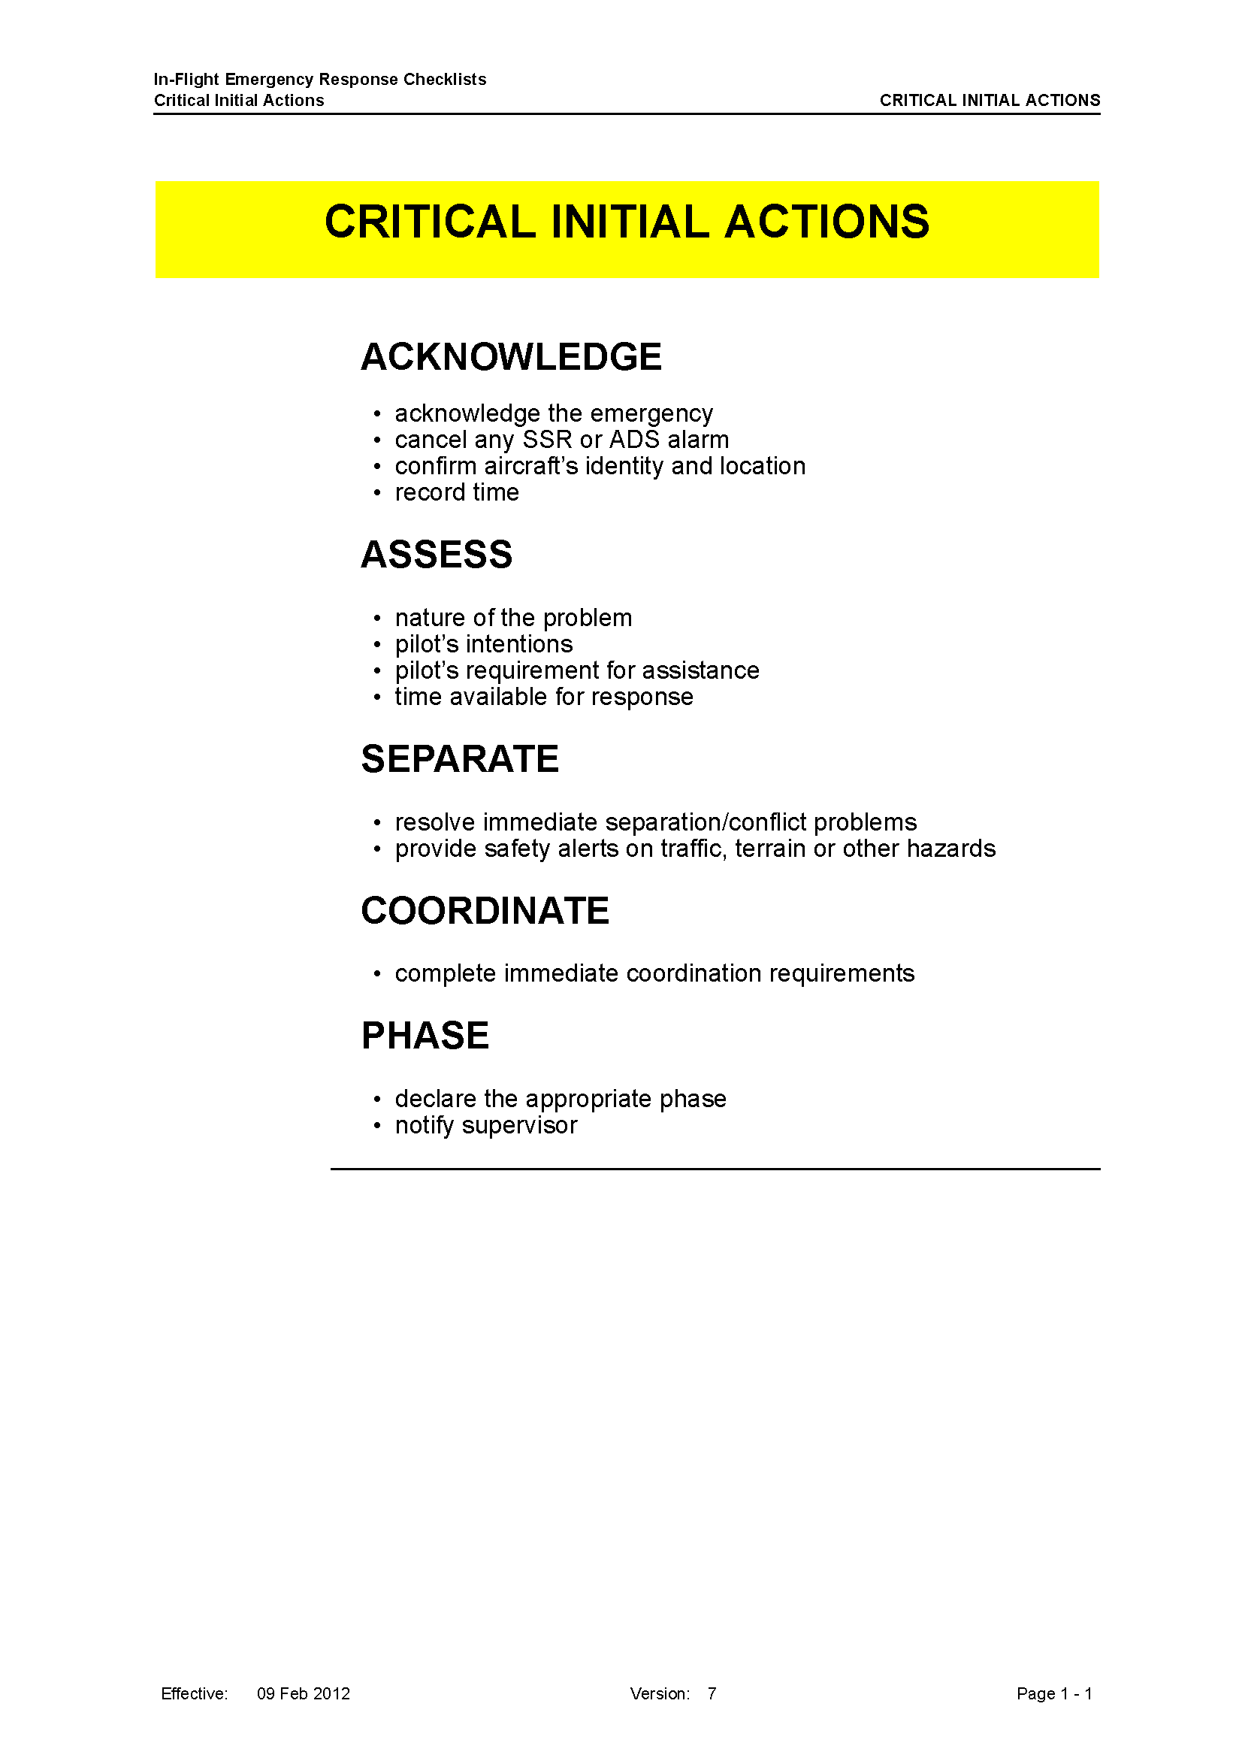
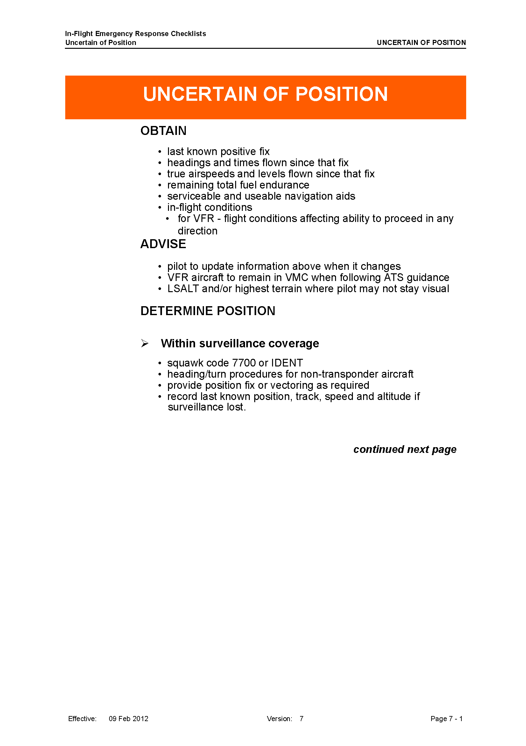
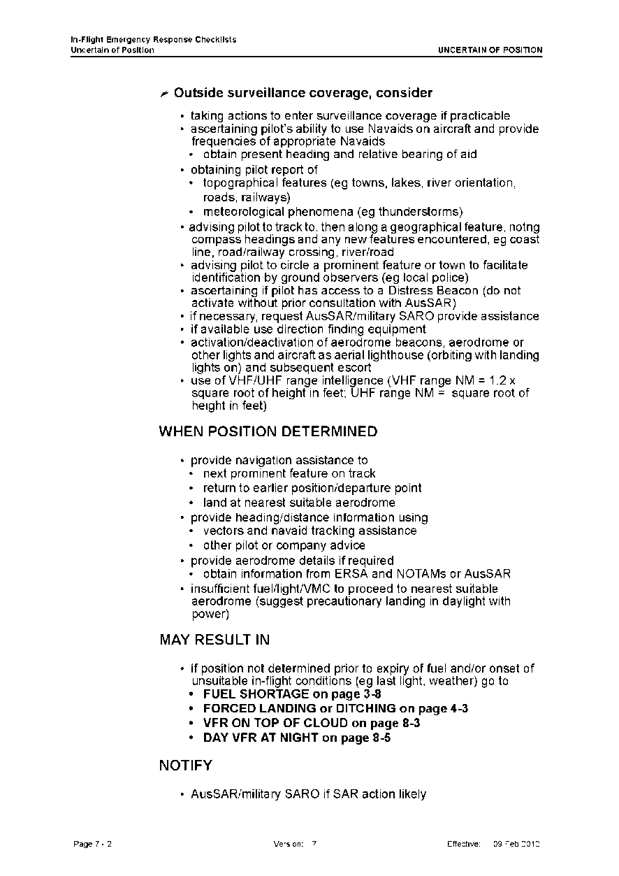
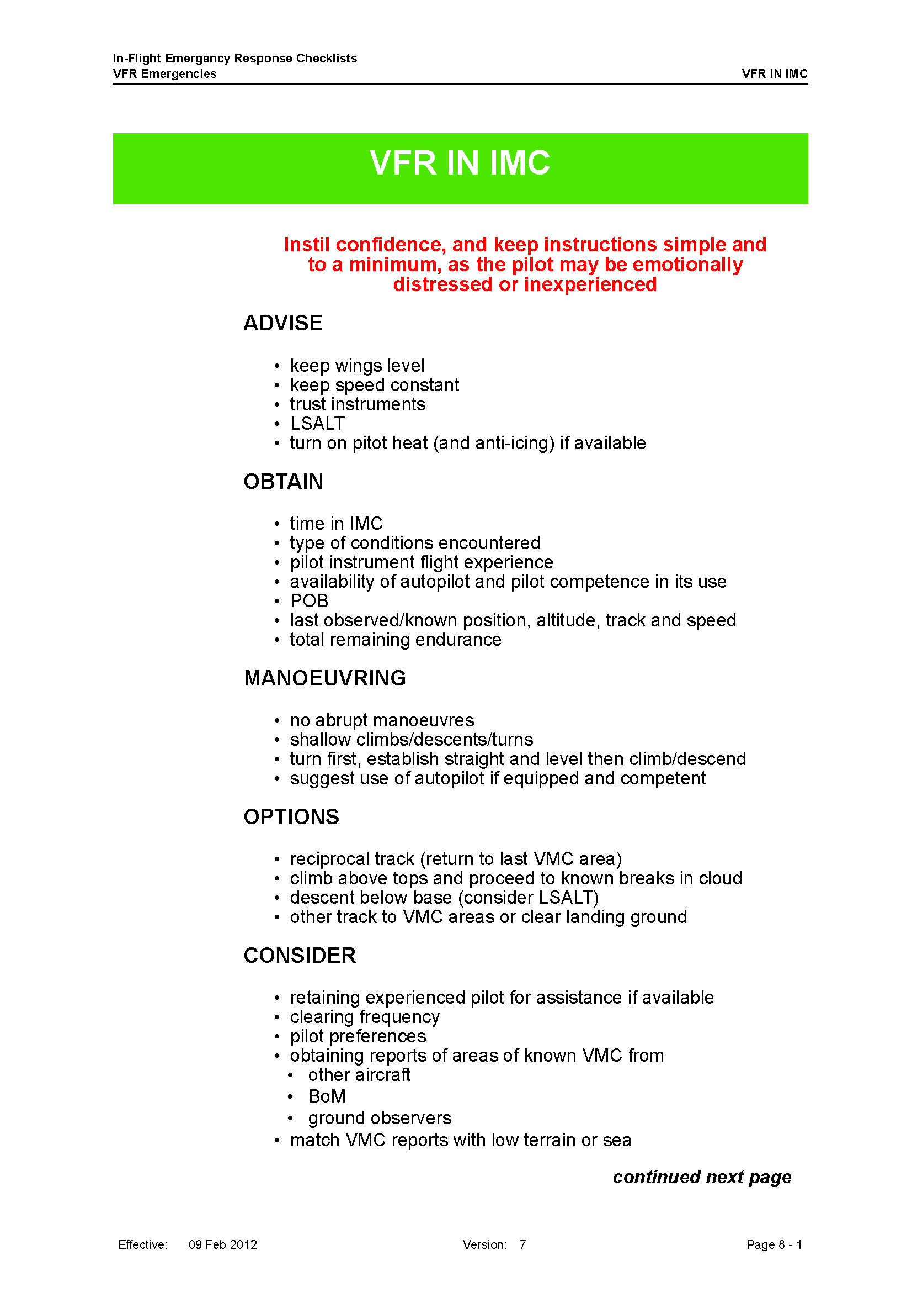
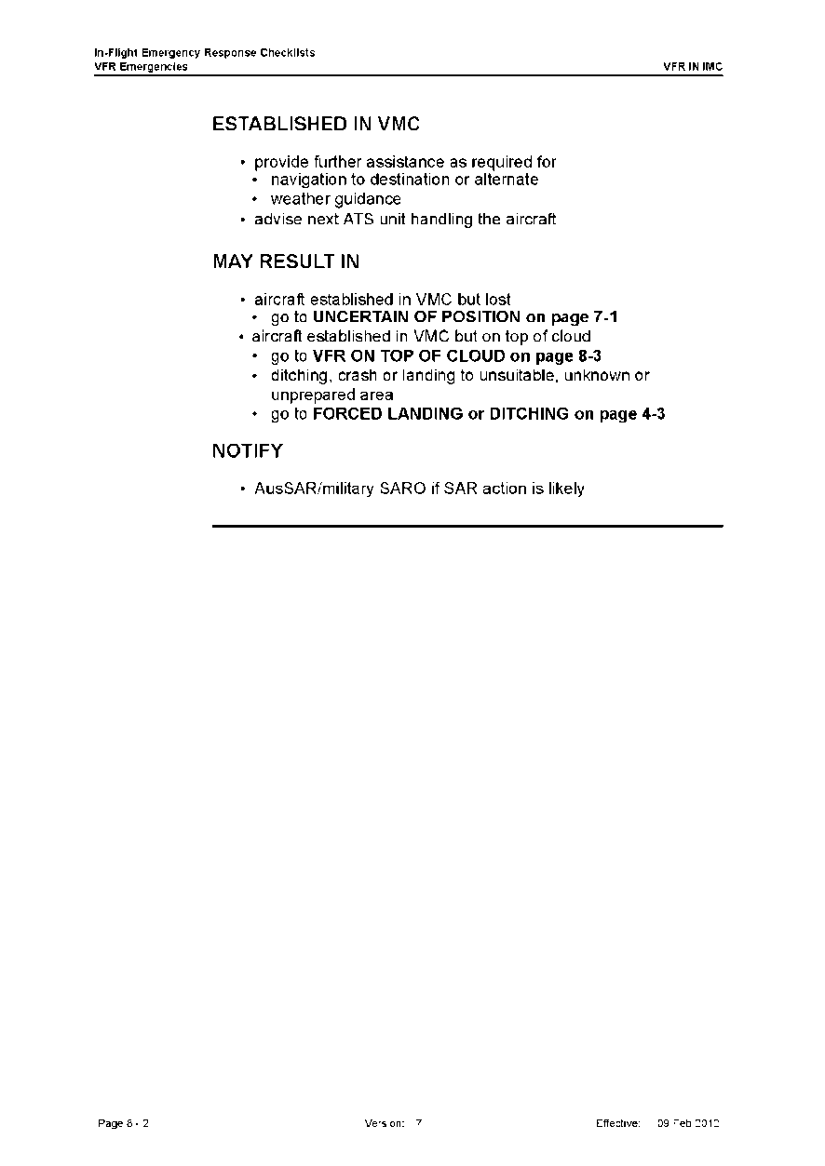

Australian Transport Safety Bureau
The Australian Transport Safety Bureau (ATSB) is an independent Commonwealth Government statutory agency. The ATSB is governed by a Commission and is entirely separate from transport regulators, policy makers and service providers. The ATSB’s function is to improve safety and public confidence in the aviation, marine and rail modes of transport through excellence in: independent investigation of transport accidents and other safety occurrences; safety data recording, analysis and research; fostering safety awareness, knowledge and action.
The ATSB is responsible for investigating accidents and other transport safety matters involving civil aviation, marine and rail operations in Australia that fall within Commonwealth jurisdiction, as well as participating in overseas investigations involving Australian registered aircraft and ships. A primary concern is the safety of commercial transport, with particular regard to fare-paying passenger operations.
The ATSB performs its functions in accordance with the provisions of the Transport Safety Investigation Act 2003 and Regulations and, where applicable, relevant international agreements.

Purpose of safety investigations
The object of a safety investigation is to identify and reduce safety-related risk. ATSB investigations determine and communicate the safety factors related to the transport safety matter being investigated. The terms the ATSB uses to refer to key safety and risk concepts are set out in the next section: Terminology Used in this Report.
It is not a function of the ATSB to apportion blame or determine liability. At the same time, an investigation report must include factual material of sufficient weight to support the analysis and findings. At all times the ATSB endeavours to balance the use of material that could imply adverse comment with the need to properly explain what happened, and why, in a fair and unbiased manner.

Developing safety action
Central to the ATSB’s investigation of transport safety matters is the early identification of safety issues in the transport environment. The ATSB prefers to encourage the relevant organisation(s) to initiate proactive safety action that addresses safety issues. Nevertheless, the ATSB may use its power to make a formal safety recommendation either during or at the end of an investigation, depending on the level of risk associated with a safety issue and the extent of corrective action undertaken by the relevant organisation.
When safety recommendations are issued, they focus on clearly describing the safety issue of concern, rather than providing instructions or opinions on a preferred method of corrective action. As with equivalent overseas organisations, the ATSB has no power to enforce the implementation of its recommendations. It is a matter for the body to which an ATSB recommendation is directed to assess the costs and benefits of any particular means of addressing a safety issue.
When the ATSB issues a safety recommendation to a person, organisation or agency, they must provide a written response within 90 days. That response must indicate whether they accept the recommendation, any reasons for not accepting part or all of the recommendation, and details of any proposed safety action to give effect to the recommendation.
The ATSB can also issue safety advisory notices suggesting that an organisation or an industry sector consider a safety issue and take action where it believes it appropriate. There is no requirement for a formal response to an advisory notice, although the ATSB will publish any response it receives.

Cloud cover is normally reported using expressions that denote the extent of the cover. The expression Few indicates that up to a quarter of the sky was covered, Scattered indicates that cloud was covering between a quarter and a half of the sky. Broken indicates that more than half to almost all the sky was covered, while Overcast means all the sky was covered.
Eastern Standard Time (EST) was Coordinated Universal Time (UTC) + 10 hours.
Visual flight rules (VFR) are a set of regulations that allow a pilot to only operate an aircraft in weather conditions generally clear enough to allow the pilot to see where the aircraft is going.
Altimeter barometric pressure subscale setting to provide altimeter indication of height AMSL in that area.
A more detailed examination of ATC actions and communications is provided in the section titled Air traffic services information.
See the section titled Terrain and obstacle avoidance for more information.
There are three emergency phases defined by the level of perceived or real uncertainty about the safety of an aircraft: uncertainty phase, alert phase, and distress phase. An alert phase (or ALERFA) is a search and rescue term used to describe a situation where apprehension exists as to the safety of an aircraft and its occupants.
A pilot can momentarily select IDENT (identify) on an aircraft’s transponder, which causes the aircraft’s radar return to be highlighted to ATC for identification purposes.
Standard VHF voice radios could receive and transmit on this frequency.
The maximum time in the conditions that the aircraft could remain airborne without fuel exhaustion.
In accordance with regional agreements, 123.45 MHz is designated as the air-to-air VHF communications channel. Use of this channel enables aircraft engaged in flights over remote and oceanic areas out of the range of VHF ground stations to exchange necessary operational information and to facilitate the resolution of operational problems. The frequency is not monitored by ATC or recorded.
A distress phase (or DETRESFA) is used to describe a situation there is reasonable certainty that an aircraft and its occupants are threatened by grave and imminent danger or require immediate assistance.
The National Aeronautical Information Processing System (NAIPS) is a multi-function, computerised, aeronautical information system produced by Airservices. The services available from NAIPS include pre-flight briefing, area briefing, general meteorological forecasting and reporting and flight notification.
Since actual occupant weights were not available, the investigation used the standard weights for aircraft with seating for 7-9 occupants as listed in Civil Aviation Advisory Publication 235-1(1), Standard Passenger and Baggage Weights.
A substantial amount of spare parts and tools were on board the aircraft, and a photograph of some of the passengers prior to the flight showed 12 items of baggage.
Aerodynamic fairings over fixed landing wheels. The associated reduction in aerodynamic drag could be expected to enhance aircraft performance.
The global positioning system (GPS) is a space-based global navigation satellite system (GNSS) that provides location and time information in all weather, anywhere on or near the Earth, where there is an unobstructed line of sight to four or more GPS satellites.
Instrument meteorological conditions (IMC) describes weather conditions that require pilots to fly primarily by reference to instruments, and therefore under the IFR, rather than by outside visual references. Typically, this means flying in cloud or limited visibility.
Traditional gyro instruments can be ‘toppled’ by aerobatics or any rotation of the parent aircraft beyond defined limits. In such cases, these instruments are no longer of use as an attitude reference until their gyro has settled again into normal operation.
A reference index, usually parallel to the aircraft’s longitudinal axis.
A package of documents that provides the operational information necessary for the safe and efficient conduct of national (civil) and international air navigation throughout Australia and its Territories.
Formerly known as the Australian Ultralight Federation.
An area forecast issued for the purposes of providing aviation weather forecasts to pilots. Australia is subdivided into a number of forecast areas. The planned flight from Monto to Caboolture was in Area 40.
A Notice To Airmen (NOTAM) advises personnel concerned with flight operations of information concerning the establishment, condition or change in any aeronautical facility, service, procedure, or hazard, the timely knowledge of which is essential to safe flight.
En Route Supplement Australia is an airport directory for Australian aerodromes. It has pictorial presentations of all licensed aerodromes and includes aerodrome physical characteristics, hours of operation, visual ground aids, air traffic services, navigation aids, and lighting.
A method by which a pilot can leave details of a planned flight with a responsible person to be used for search and rescue purposes if required.
Time nominated by a pilot for the initiation of SAR action if a report from the pilot has not been received.
An aerodrome forecast is a statement of meteorological conditions expected for a specific period of time, in the airspace within a radius of 5 NM (9 km) of the aerodrome.
Available at www.casa.gov.au/wcmswr/_assets/main/pilots/download/carburettor_icing_chart.pdf.
Care must be taken in interpreting infra-red band satellite images. Clouds show as shades of grey, which vary corresponding to temperature, with darker shades indicating warmer cloud at lower altitudes. The images can only show the highest level of cloud and cannot be used to reliably determine height. For more information, see www.bom.gov.au/australia/satellite/about_images.shtml.
Refer to Figure 1 for orientation.
Although implied by the definition, errors of geographical orientation, or incorrectly perceiving an aircraft’s distance or bearing from a fixed location, are generally not considered as examples of spatial disorientation.
The data includes all fatal accidents involving VH registered aeroplanes and helicopters operating charter, aerial work or private flights in Australia. Private flights included non-commercial ‘business’ flights. Regular public transport and sports aviation accidents were not included, and accidents with the fatalities occurring to people external to the aircraft were not included.
www.atsb.gov.au/publications/investigation_reports/2012/aair/ao-2012-076.aspx.
www.atsb.gov.au/publications/investigation_reports/2013/aair/ao-2013-063.aspx.
Since UXG was primarily constructed of fabric-covered timber, it might have presented a smaller radar cross-section than a metal aircraft. Accordingly, UXG might not have been visible on radar under the same conditions that a similarly-sized metal aircraft would be visible. The simulations were made using an aeroplane of metal construction.
In this context, a grid area has boundaries separated by 1° latitude and longitude. The grid over Gympie is about 111km north-south by 100 km east-west.
Australian Search and Rescue, a former name for AMSA’s Rescue Coordination Centre (RCC).
Australian Maritime Safety Authority and Airservices Australia Memorandum of Understanding, version 4, 8 October 2009.
National Search and Rescue Manual, revision 11, 20 July 2011.
Rescue Coordination Centre Australia, the part of AMSA that coordinates aviation and maritime SAR activities. Formerly AusSAR.
Search and Rescue Standards and Procedures Manual for Tier 2/3- Rotary Wing SAR Units, issue 3, 2012.
Available at www.atsb.gov.au.

